CQC People Survey 2021
Response rate: 73% 2211 responses out of 3017

About this survey


CQC Overall
This survey included questions on all aspects of working for CQC, the majority of which were last asked in our previous main survey in November 2019. The results from this survey will enable us to measure our progress since then and will supplement the feedback from recent theme-based pulse surveys that have been undertaken.
This survey was open to the whole organisation for three weeks, between 16 November and 7 December 2021.
This report provides a line-by-line breakdown of the results, how they compare to the previous annual survey in November 2019, and a summary of key themes from comments provided. Spend some time discussing these results in your teams and consider whether the outcomes resonate with you and/or if are there any surprises. It is also important to have regular 1:1 conversation to understand how your team members are feeling and how you work together to support their positive wellbeing.
Employee Engagement Index

Key Engagement Questions % Positive
5. I would recommend CQC as a good place to work 57%


This Index is calculated based on the average sentiment of questions 3-6. This includes a number of factors indicating how employees think and feel, how this impacts their behavior, and their desire to recommend or stay at CQC.
64%
4. Working here inspires me to do the best work I can 64%
9. Overall, I am satisfied working at CQC 63%
3. I feel proud to work for CQC 71%
6. I would like to be working for CQC in 12 months’ time 65%
Change from People Survey 2019 -3%
CQC People Survey 2021 Page 1 SocialOptic Ltd • socialoptic.com
In This Report


Key Sections
Headlines - your Employee Engagement Index and Key Engagement Questions
At a glance - top and bottom questions and those that have most and least improved
All results - a detailed look at the entire question set
Comparisons - a look at the results across your teams
Comparisons
Where questions also appeared in the 2019 survey, they are shown alongside, with an indication of the change in sentiment. Significant changes are marked with a bold up or down arrow. Some questions have also been asked in pulse surveys conducted since the 2019 survey. It may be helpful to review this data alongside this report.
Key Engagement Questions
These are the questions which are having the greatest impact on engagement and in particular on the four questions which make up the Engagement Index. Focus on these areas will make the biggest impact on engagement overall.
Rounding
Percentages on graphs are shown rounded to the nearest significant whole percentage point. Due to this rounding, figures may not always add up to 100% and the agree/strongly agree figures may not always total the ‘Sentiment’ figure. The positive scores are rounded to the nearest whole percentage point.
Anonymity
Open Comments
This survey was completely confidential. Reports are not generated if there are less than 10 responses, and any individual questions with less than 10 responses are also masked, to further protect anonymity.
Responses to open questions have been grouped into themes. Where a number of comments are grouped under a theme, these are shown, ordered by their frequency. Comment theme graphs are only generated when a minimum of ten comments were provided per question/free text box.
CQC People Survey 2021 Page 2 SocialOptic Ltd • socialoptic.com

 | At a Glance

Top 5 Questions | Sentiment
- In my team, I can rely on support from my colleagues when I need it | 92%
23. My line manager trusts me to do my job | 89%
- In my team, I feel that we all respect each other | 89%
10. The values of CQC are relevant to my work | 89%
35. My team works together to produce effective outcomes | 87%

5 Most Improved Questions | Change
34. I feel that leaders in my part of the organisation are sufficiently visible (all three definitions) | +21%
31. Executive leaders in CQC (CEO and Executive Team) provide clear direction and leadership | +17%
18. I have the equipment/technology to carry out my role | +15%
48. I am encouraged to seek and participate in training in Quality Improvement tools and techniques | +13%
12. I believe the values and behaviours of Executive leaders are consistent with the values of CQC | +13%

Bottom 5 Questions | Sentiment
53. I believe that changes are effectively implemented in CQC | 27%
- I believe action will be taken on the results of this survey | 33%
74. Compared with other people doing a similar role in other organisations I think I am rewarded fairly | 35%
- I am aware that activity as a result of Our People surveys has led to change | 35%
51. I have the opportunity to contribute my views before decisions are made that affect me | 40%

5 Least Improved Questions | Change
- I have a clear understanding of my contribution to achieving the objectives of CQC | -7%
4. Working here inspires me to do the best work I can | -6%
- I am clear about what I am expected to achieve in my role | -6%
3. I feel proud to work for CQC | -6%
8. I believe that CQC makes a positive difference to people's lives | -6%

CQC People Survey 2021 Page 3 SocialOptic Ltd • socialoptic.com
Individual Wellbeing

1. Which description best matches how you have been feeling in the past week? | Me on a good day | 37%

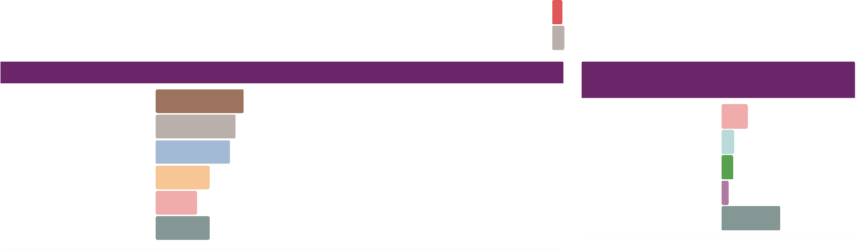

I'm not feeling  myself  Unwell | 43%
I'm not feeling  myself  Unwell | 12%

Ill
3%
11%
10%
6%
51%
23%
High workload
Ill health
Change
Enjoying work
All Other Responses
Prefer not to say
2. What has been the greatest influence on how you are feeling?
Sense of purpose or
motivation
Sense of purpose or  motivation | 23%
Ability to do work | 20%
Something else | 19%
Sense of achievement  (work) | 14%
Relationships (personal) | 11%
All Other Responses | 14%

4%
2a. Themes for "Please feel free to
expand upon your response"
The following graphs show the answers to 'What has been the greatest influence..?' for responses to each of the descriptions of 'How have you been feeling..?'
CQC People Survey 2021 Page 4 SocialOptic Ltd • socialoptic.com

Me on a good day
Sense of purpose... | 26%
Ability to do work |  | 18%
Relationships... |  | 16%
Sense of... |  | 14%
All Other... | 26%

Not feeling myself
Something else |  | 23%
Ability to do work |  | 22%
Sense of purpose... |  | 22%
Sense of... |  | 16%
All Other... |  | 18%

Unwell
Something else | 32%
Ability to do work | 26%
Sense of purpose... | 18%
Sense of... | 8%
All Other... | 15%

Ill
Ability to do work |  | 24%
Something else |  | 23%
Sense of purpose... |  | 19%
Relationships... | 12%
All Other... |  | 23%

Overall Perceptions


People Survey 2019 CQC People Survey 2021 Sentiment Change
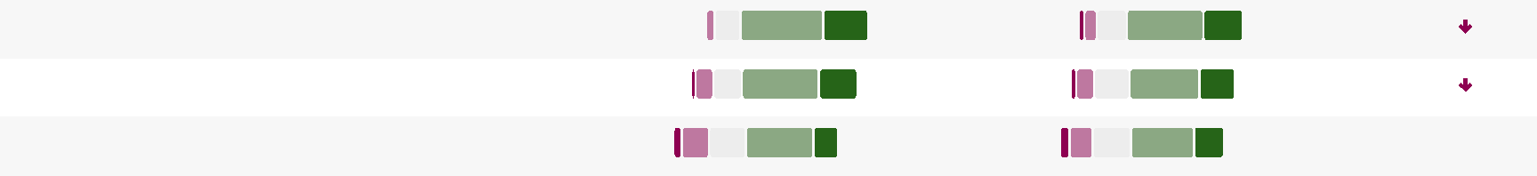

28% 3%
- I feel proud to work for CQC 2%
49%
23% 3%
47%
15% 6%
41%
46% | 25% | 71% | -6%
 |  | 64% | -6%
43% | 21% | 64% | -6%
 |  | 57% | +1%
38% | 18% | 57% | +1%

- Working here inspires me to do the best work I can 2%
- I would recommend CQC as a good place to work 5%
Strongly disagree Disagree Neither agree or disagree Agree Strongly agree

 | Significant reduction in  sentiment |  | Reduction in sentiment Increase in sentiment Significant increase in  sentiment

The following graphs show the themes to 'Please could you provide more detail' for negative, neutral and positive responses to 'I would recommend CQC as a good place to work'

Negative
High workload 13%
Poor pay and 12%
conditions
Poor change 9%
management
Does not value people 9%
Poorly led Poor culture Does not listen All Other Responses |  | 8%
Poorly led Poor culture Does not listen All Other Responses |  | 7%
Poorly led Poor culture Does not listen All Other Responses |  | 6%
Poorly led Poor culture Does not listen All Other Responses | 36%

Neutral
High workload Uncertainty
Poor change management Poor pay and conditions Unspecified
Poorly led
Does not value people All Other Responses
13%
12%
12%
9%
8%
6%
5%
35%
Positive
Supports flexible
working
Supports flexible  working |  |  | 17%
Supportive team |  |  | 17%
Worthwhile role |  | 14%
Good culture | 9%
Supports wellbeing | 6%
Good pay and conditions |  | 6%
Good development opportunities | 5%
All Other Responses | 27%

CQC People Survey 2021 Page 5 SocialOptic Ltd • socialoptic.com
Overall Perceptions

People Survey 2019 CQC People Survey 2021 Sentiment Change
Strongly disagree Disagree Neither agree or disagree Agree Strongly agree
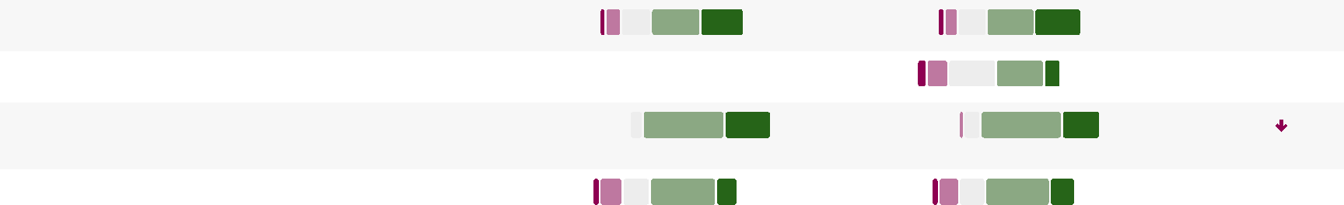

32%
33%
35%
65% +1%
30% 5%
- I would like to be working for CQC in 12 months’ time 5%
33%
33%
12% 45%
- I feel positive about CQC's strategic direction 6%
1%
1%
-6%
32%
57%
57%
27% 83%
- I believe that CQC makes a positive difference to people's lives
45%
46%
15% 5%
18% 63% +3%
- Overall, I am satisfied working at CQC 5%

 | Significant reduction in  sentiment |  | Reduction in sentiment Increase in sentiment Significant increase in  sentiment

CQC People Survey 2021 Page 6 SocialOptic Ltd • socialoptic.com
Strongly disagree Disagree Neither agree or disagree Agree Strongly agree
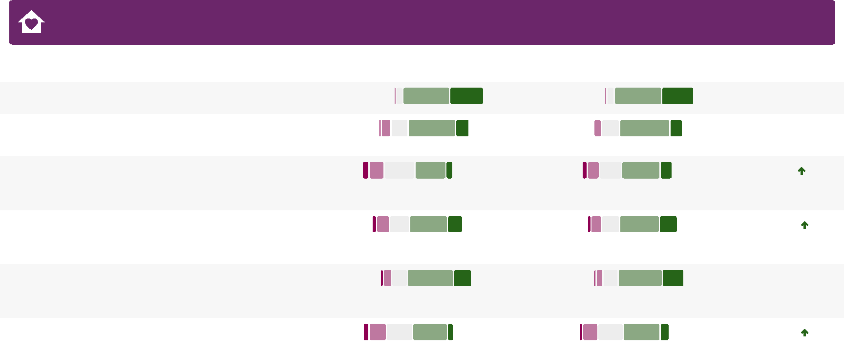

Values and Behaviours
3%
56%
53%
15% 2%
6%
42%
45%
17% 4%
- I believe CQC employees display the values and behaviours
- I believe the values and behaviours of Executive leaders (CEO and Executive Team) are consistent with the values of CQC
- I believe the values and behaviours of senior leaders in my part of the organisation (Director and “Heads of”) are consistent with the values of CQC
- I believe the values and behaviours of leaders (anyone who leads a team - Managers and Team Leaders) are consistent with the values of CQC
- I believe internal policy and procedures are consistent with the values of CQC
10. The values of CQC are relevant to my work 1%
People Survey 2019 CQC People Survey 2021
51%
38%
1%
53%
 | Sentiment
 | 89%
36% | 89%
14% | 70%
 | 55%
13% | 55%
 | 65%
20% | 65%
 | 73%
24% | 73%
10% | 50%

Change
+1%
+3%
8%
34%
34%
8%
6%
42%
+13%
+7%
3%
51%
20% 3%
49%
+2%
7%
7%
4%
38%
40%
+5%

 | Significant reduction in  sentiment |  | Reduction in sentiment Increase in sentiment Significant increase in  sentiment

CQC People Survey 2021 Page 7 SocialOptic Ltd • socialoptic.com

 | My Role

People Survey 2019 CQC People Survey 2021 Sentiment Change
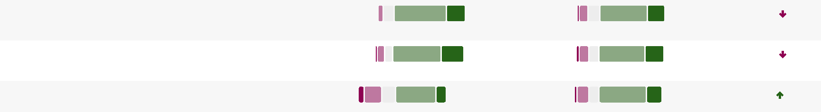
19. I am able to make improvements happen in my area of work | 4% |  | 42% |  | 13% 4% |  | 47% |  | 14% 61% +6%

1%
54%
59%
22% 2%
20% 74% -7%
- I have a clear understanding of my contribution to achieving the objectives of CQC
2%
52%
55%
25% 3%
22% 74% -6%
- I am clear about what I am expected to achieve in my role
12%
3%
+15%
46%
54%
18% 72%
- I have the equipment/technology to carry out my role 7%

- My role gives me a sense of personal accomplishment 4% |  | 49% |  |  | 21% 4% |  | 47% |  |  | 20% 67% -2%

- I believe that CQC values my work 8% |  | 40% |  |  | 14% 54%
Strongly disagree Disagree Neither agree or disagree Agree Strongly agree

 | Significant reduction in  sentiment |  | Reduction in sentiment Increase in sentiment Significant increase in  sentiment

CQC People Survey 2021 Page 8 SocialOptic Ltd • socialoptic.com

 | Leadership and Management

People Survey 2019 CQC People Survey 2021 Sentiment Change

Strongly disagree Disagree Neither agree or disagree Agree Strongly agree
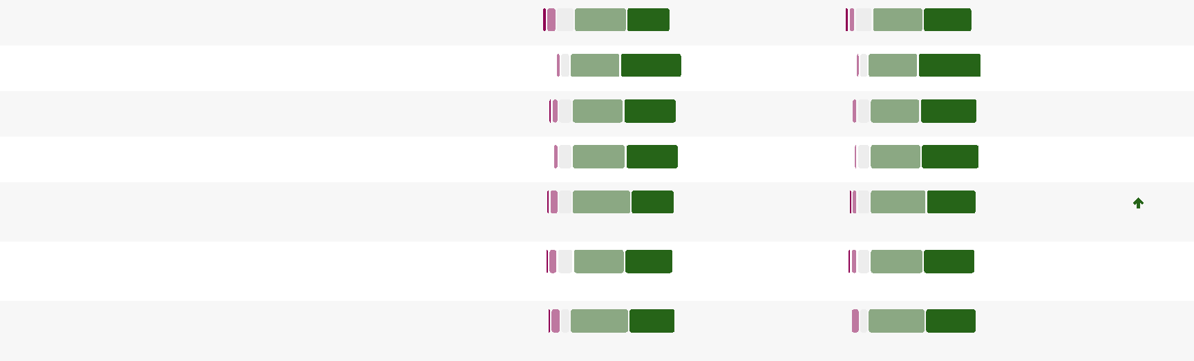

3%
34%
- My line manager motivates me to do my role well 3%
+4%
2%
- My line manager trusts me to do my job 2%
+2%
2%
- My line manager supports me in carrying out my role 3%
+2%
2%
- My line manager is open to my ideas and suggestions 2%
+3%
2%
3%
+5%
- My line manager keeps me informed sufficiently to undertake my role
2%
3%
+4%
- My line manager gives praise and recognition for my contribution
2%
3%
+2%
- I have regular 1:1 performance and development discussions with my line manager
40% | 39% | 79%
 |  | 89%
39% | 50% | 89%
 |  | 84%
39% | 45% | 84%
 |  | 86%
40% | 46% | 86%
 |  | 84%
44% | 40% | 84%
 |  | 82%
41% | 41% | 82%
 |  | 84%
45% | 39% | 84%

40%
39% | 48%
40% | 41%
41% | 42%
46% | 34%
40% | 38%
46% | 37%

 | Significant reduction in  sentiment |  | Reduction in sentiment Increase in sentiment Significant increase in  sentiment

CQC People Survey 2021 Page 9 SocialOptic Ltd • socialoptic.com

Leadership and Management

People Survey 2019 CQC People Survey 2021 Sentiment Change
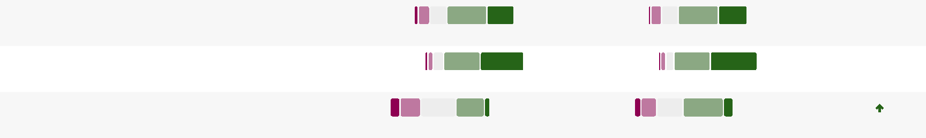

3%
40%
40%
27% 3%
30% 70% +3%
- I receive regular feedback which helps me to improve my performance
3%
2%
84%
+3%
37%
37%
44%
48%
- My line manager shows a genuine interest in my wellbeing
9%
5%
7%
+17%
35%
41%
10% 51%
- Executive leaders in CQC (CEO and Executive Team) provide clear direction and leadership
- Senior leaders (Director, Deputy Chief Inspectors and “Heads of”) in my part of the organisation provide clear direction and leadership | 7% |  | 38% |  | 11% | 6% |  | 43% |  | 13% 56% |  | +6%

- I have confidence in the decisions made by managers and team leaders in my part of the organisation | 6% |  |  |  |  |  |  | 43% |  |  | 13% 5% |  | 46% |  |  | 15% 61% +5%

- I feel that leaders in my part of the organisation are sufficiently visible (all three definitions of leadership apply) | 8% |  | 40% |  | 10% | 4% |  | 52% |  |  | 19% 71% |  | +21%

Strongly disagree Disagree Neither agree or disagree Agree Strongly agree

 | Significant reduction in  sentiment |  | Reduction in sentiment Increase in sentiment Significant increase in  sentiment

CQC People Survey 2021 Page 10 SocialOptic Ltd • socialoptic.com

 | Teamwork

People Survey 2019 CQC People Survey 2021 Sentiment Change

Strongly disagree Disagree Neither agree or disagree Agree Strongly agree
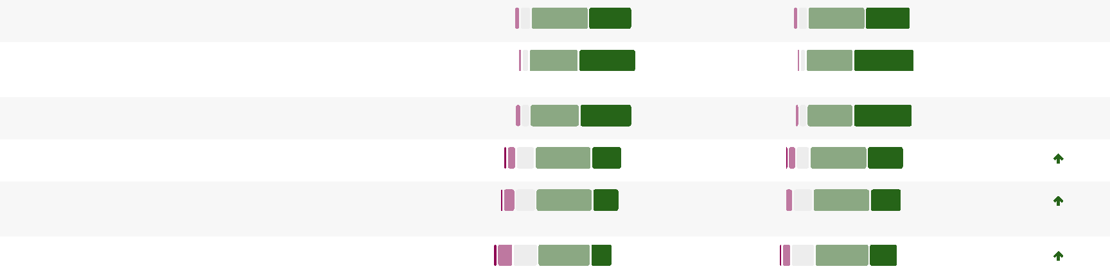

1%
1%
41%
48%
36. In my team, I can rely on support from my colleagues when I need it
47%
26% 3%
- My team meetings are useful and effective 3%
4%
18%
2%
44%
- My team collaborates effectively with teams from other directorates with whom we interact
49% | 38% | 87%
 |  | 92%
40% | 52% | 92%
 |  | 89%
39% | 50% | 89%
 |  | 79%
48% | 31% | 79%
 |  | 75%
49% | 26% | 75%
 |  | 70%
46% | 24% | 70%

35. My team works together to produce effective outcomes 1%
49%
36%
1%
37. In my team, I feel that we all respect each other 2%
41%
44%
1%
- My team collaborates effectively with other teams across my directorate
3%
47%
22% 2%
+2%
+2%
+3%
+5%
+5%
+8%

 | Significant reduction in  sentiment |  | Reduction in sentiment Increase in sentiment Significant increase in  sentiment

CQC People Survey 2021 Page 11 SocialOptic Ltd • socialoptic.com
Strongly disagree Disagree Neither agree or disagree Agree Strongly agree
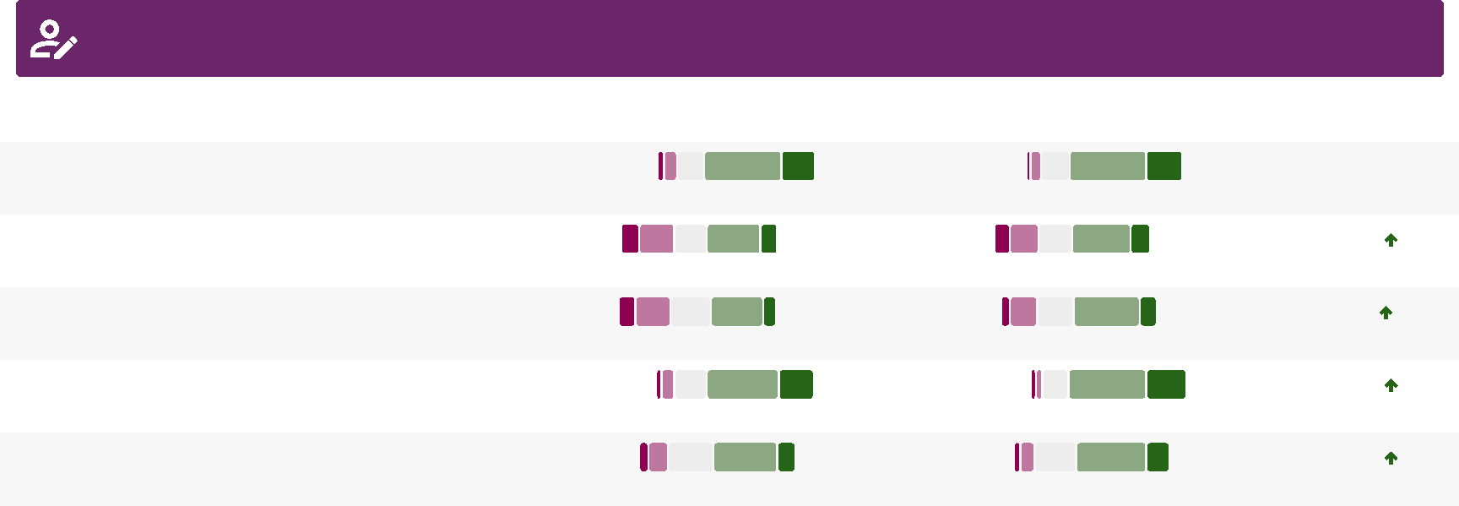

Learning and Development
12%
3%
3%
22%
38%
11% 10%
- I feel fully involved in my performance and development reviews
- I believe there are opportunities for development and growth within the organisation
- I am able to access the right learning and development opportunities when I need to
- My line manager is supportive of me finding time in my role to pursue learning and development needs
- I have had the opportunity to transfer the learning and development I have undertaken to the workplace
34%
33%
45%
41%
43%
50%
45%
People Survey 2019 CQC People Survey 2021
4%
49%
21% 3%
49%
 | Sentiment
 | 72%
23% | 72%
12% | 50%
 | 54%
11% | 54%
 | 76%
26% | 76%
 | 60%
15% | 60%

Change
+2%
10%
6%
8%
12%
6%
4%
+12%
+5%
+7%
+8%

 | Significant reduction in  sentiment |  | Reduction in sentiment Increase in sentiment Significant increase in  sentiment

CQC People Survey 2021 Page 12 SocialOptic Ltd • socialoptic.com

 | Quality Improvement

People Survey 2019 CQC People Survey 2021 Sentiment Change
Strongly disagree Disagree Neither agree or disagree Agree Strongly agree
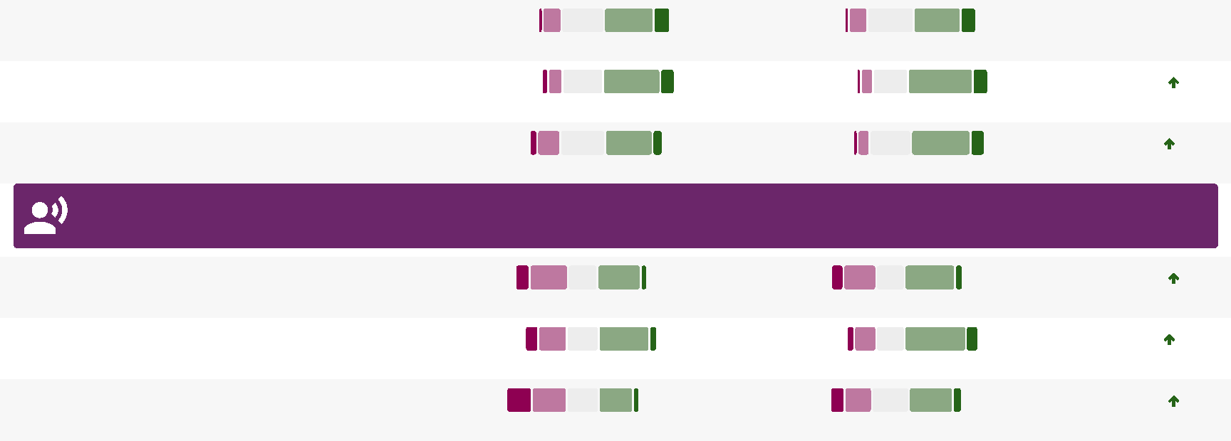

3%
33%
34%
36%
37%
13% 4%
11% 48% -2%
- I actively seek the opportunity to engage in Quality Improvement projects
5%
43%
50%
10% 4%
11% 61% +7%
- Senior Leadership are supportive and encouraging of the drive for continuous improvement in CQC
5%
8%
3%
+13%
31%
35%
35%
45%
11% 56%
- I am encouraged to seek out and participate in training in Quality Improvement tools and techniques
Communication
11%
5%
9%
+7%
32%
38%
6% 45%
- It is easy for me to find information I need to carry out my role
10%
6%
6%
+12%
38%
47%
9% 56%
- I feel I am kept informed about matters affecting me in a timely manner
19%
+9%
33%
7% 40%
5% 11%
- I have the opportunity to contribute my views before decisions are made that affect me

 | Significant reduction in  sentiment |  | Reduction in sentiment Increase in sentiment Significant increase in  sentiment

CQC People Survey 2021 Page 13 SocialOptic Ltd • socialoptic.com

 | Managing Change

People Survey 2019 CQC People Survey 2021 Sentiment Change

- I understand why CQC is changing for the future 4% |  | 54% |  |  | 13% 3% |  | 55% |  |  | 17% 72% +5%

- I believe that changes are effectively implemented in CQC | 20% |  |  | 33% |  | 3% | 15% |  |  |  |  | 31% |  | 5% 27% |  | +6%

- I feel informed about the changes that are happening as part of our transformation programme | 11% |  |  |  |  |  |  | 36% |  | 5% | 7% |  |  |  |  |  |  | 46% |  |  | 8% 54% |  | +12%

- We have regular conversations with my manager and team about the major changes happening in CQC | 4% |  | 52% |  | 11% | 3% |  | 58% |  |  | 17% 74% |  | +11%

 | Service Focus

- I believe that my work helps to improve care for people who use services | 1% |  | 55% |  | 33% | 2% |  | 55% |  |  | 30% 85% | -3%

- My team has a culture of ensuring effective service delivery to other teams across CQC | 2% |  | 51% |  |  | 26% 1% |  | 51% |  |  | 28% 79% +2%

Strongly disagree Disagree Neither agree or disagree Agree Strongly agree

 | Significant reduction in  sentiment |  | Reduction in sentiment Increase in sentiment Significant increase in  sentiment

CQC People Survey 2021 Page 14 SocialOptic Ltd • socialoptic.com

 | Inclusion and Wellbeing

People Survey 2019 CQC People Survey 2021 Sentiment Change

- I believe that CQC promotes equality, diversity and human rights in all our work | 3% |  | 54% |  |  | 18% 3% |  | 54% |  |  | 22% 76% +3%

- I believe that CQC provides equal opportunities for career progression or promotion | 9% |  | 37% |  | 11% 8% |  | 36% |  | 13% 49% +1%

- I work in an inclusive working environment, where individual differences are valued | 4% |  | 54% |  |  | 20% 3% |  | 54% |  |  | 21% 76% +2%

61. I think it is safe to challenge the way things are done in CQC | 10% |  | 37% |  | 10% 9% |  | 38% |  | 11% 49% +2%

The following graphs show the themes to 'Please expand on what enables or prevents you from feeling safe' for negative, neutral and positive responses to 'I think it is safe to challenge the way things are done in CQC'
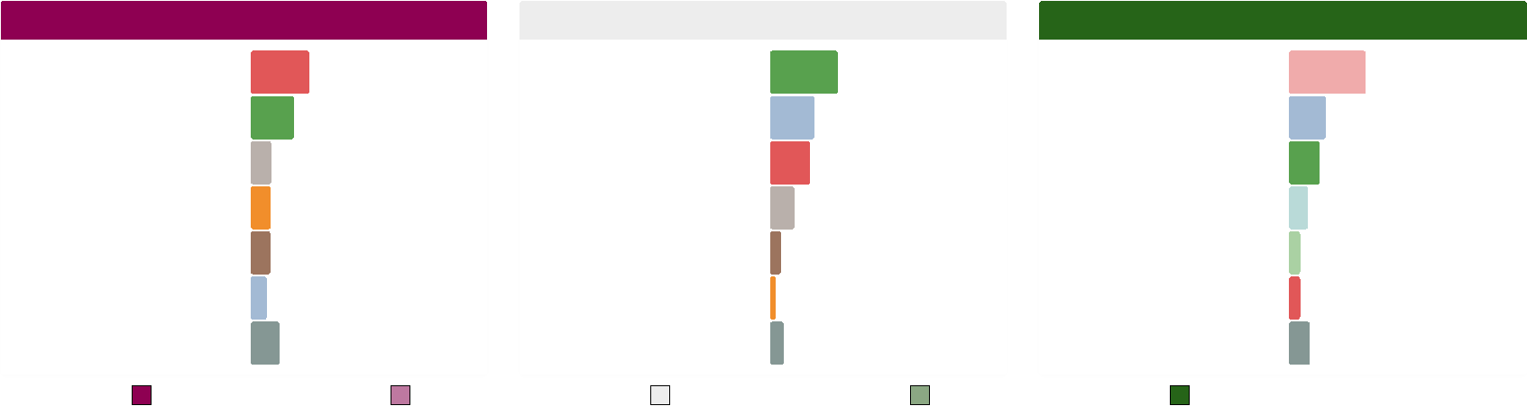
Positive
Supportive, trusting, respectful culture
Supportive, trusting, respectful culture | 38%
Unspecified |  | 18%
Lack of action |  | 15%
Forums and guardians | 9%
Personal confidence | 5%
Fear of repercussions | 5%
All Other Responses |  | 10%

Strongly agree
Negative
Fear of repercussions
Fear of repercussions | 29%
Lack of action |  |  | 21%
Uncomfortable culture |  | 10%
Experience of repercussions |  | 10%
Resistant culture |  | 9%
Unspecified |  | 8%
All Other Responses |  |  | 14%

Neither agree or disagree
Agree
Strongly disagree Disagree
Neutral
Lack of action Unspecified Fear of repercussions Uncomfortable culture Resistant culture
Experience of repercussions
All Other Responses
33%
21%
19%
12%
5%
3%
6%

 | Significant reduction in  sentiment |  | Reduction in sentiment Increase in sentiment Significant increase in  sentiment

CQC People Survey 2021 Page 15 SocialOptic Ltd • socialoptic.com
Strongly disagree Disagree Neither agree or disagree Agree Strongly agree
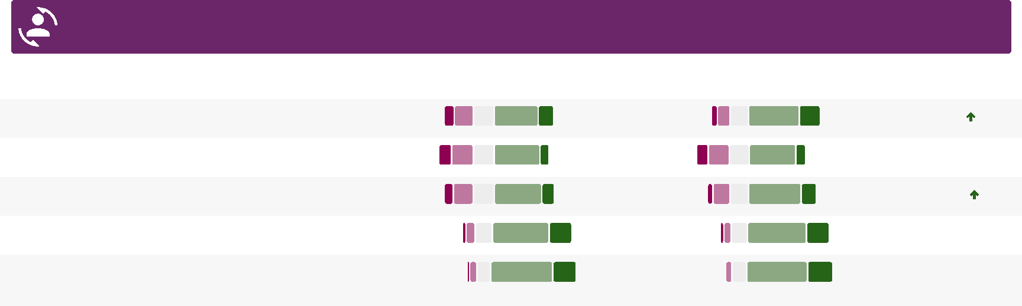

Inclusion and Wellbeing
42%
43%
8% 11%
63. I have a manageable workload 11%
52%
55%
21% 3%
65. I am treated fairly at work 4%

 | Sentiment
 | 66%
19% | 66%
9% | 52%
 | 62%
14% | 62%
 | 76%
21% | 76%
 | 79%
23% | 79%

People Survey 2019 CQC People Survey 2021
62. I believe CQC supports the health and wellbeing of staff 10%
40%
14%
6%
47%
64. I achieve a good work-life balance 8%
43%
12%
5%
48%
66. I am treated with respect by the people I work with across CQC
2%
56%
22% 2%
56%
Change
+12%
+3%
+7%
+4%
+1%

 | Significant reduction in  sentiment |  | Reduction in sentiment Increase in sentiment Significant increase in  sentiment

CQC People Survey 2021 Page 16 SocialOptic Ltd • socialoptic.com
CQC People Survey 2021 Page 17 SocialOptic Ltd • socialoptic.com
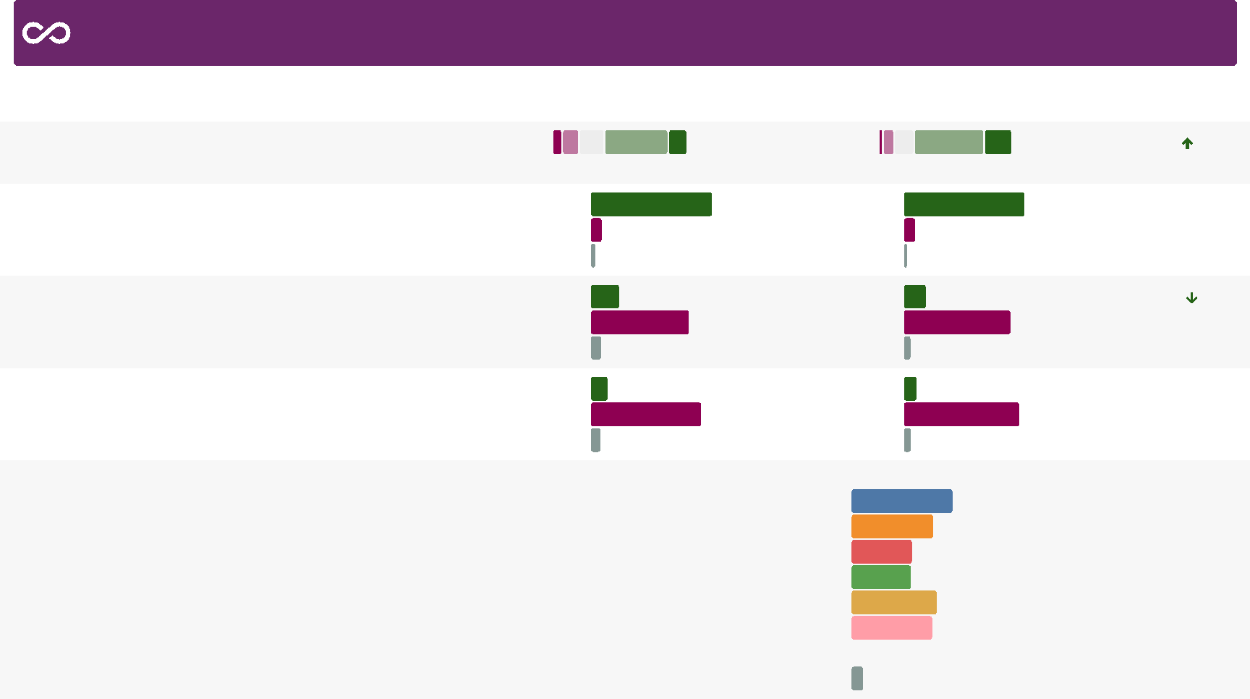

Behaviour at Work
5%
7%
Prefer not to say
Prefer not to say
43%
54%
44%
32%
32%
46%
Email tone and style Excessive criticism Humiliation or degrading... Ignoring or ostracising you Microaggressions Unfair treatment changing meeting minutes to...
a) What form did this take? 202 Responses
6%
All Other Responses
 | Sentiment
 | 73%
20% | 73%
 | 90%
90% | 90%
 | 16%
80% | 16%
 | 9%

People Survey 2019 CQC People Survey 2021
67. I feel that CQC is committed to an environment which is free from bullying, harassment or abuse
7%
47%
14%
4%
53%
69. In the last 12 months, I have witnessed bullying, harassment or abuse from other CQC colleagues
Yes
No
72%
21%
Yes
No
16%
Prefer not to say
7%
Prefer not to say
5%
86%
Change
+12%
+1%
-5%
-3%
9%
68. I know how to report bullying, harassment or abuse at work
Yes
No 8%
Prefer not to say 3%
Yes
No 8%
Prefer not to say 2%
89%
Yes
Yes
No
No
70. In the last 12 months, I have experienced bullying, harassment or abuse from other CQC colleagues
12%
81%

Behaviour at Work

People Survey 2019 CQC People Survey 2021 Sentiment Change

- From which colleague did you receive this behaviour? 202 Responses (308 previously) | Peer | 30% |  |  |  | Peer |  | 18%
 | Line manager | 34% |  |  |  | Line manager Senior manager... Other colleague | 31%
 |  |  |  |  |  | Line manager Senior manager... Other colleague | 29%
 | Senior manager... Other colleague Prefer not to say |  | 23%  20%  13% |  |  | Line manager Senior manager... Other colleague
 | Senior manager... Other colleague Prefer not to say |  |  |  |  | Line manager Senior manager... Other colleague |  | 21%
 | Senior manager... Other colleague Prefer not to say |  |  |  |  | Prefer not to say |  | 12%

- Have you reported the bullying, harassment or abuse? 202 Responses (307 previously) | Yes | 39% |  | Yes | 33%
 | No | 44% |  | No | 53%
Prefer not to say 17% Prefer not to say 14%

- Were you satisfied with how the bullying, harassment or abuse was dealt with?
94 Responses (197 previously)
Yes
No
Prefer not to say
Yes
No
Prefer not to say

NA | 36% | NA | 53%

9%
32%
23%
24%
18%
CQC People Survey 2021 Page 18 SocialOptic Ltd • socialoptic.com

Behaviour at Work

People Survey 2019 CQC People Survey 2021 Sentiment Change
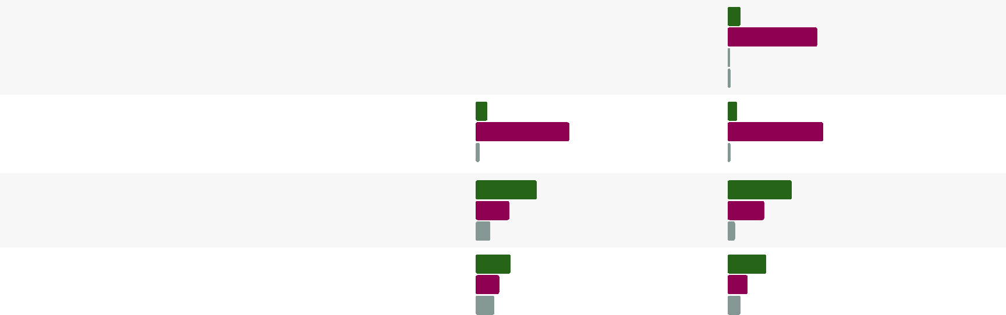
Yes
12%
12%
No
83%
11%
9%
-2%
9%
Yes
Yes
No
No
86%
89%
2%
3%
Prefer not to say
Prefer not to say
72. In the last 12 months, I have experienced harassment, bullying or abuse at work from people other than CQC colleagues (e.g. members of the public and service users)
71. In the last 12 months, I have witnessed bullying, harassment or abuse at work from people other than CQC colleagues (e.g. members of the public and service users)
2%
Prefer not to say
NA
3%
56%
31%
13%
59%
34%
7%
Yes No
Prefer not to say
Yes No
Prefer not to say
- Have you reported the bullying, harassment or abuse? 195 Responses (275 previously)
- Were you satisfied with how the bullying, harassment or abuse was dealt with?
129 Responses (193 previously)
Yes
No
Prefer not to say
Yes
No
Prefer not to say
32%
22%
17%
36%
18%
12%
NA | 30% | NA | 34%

CQC People Survey 2021 Page 19 SocialOptic Ltd • socialoptic.com
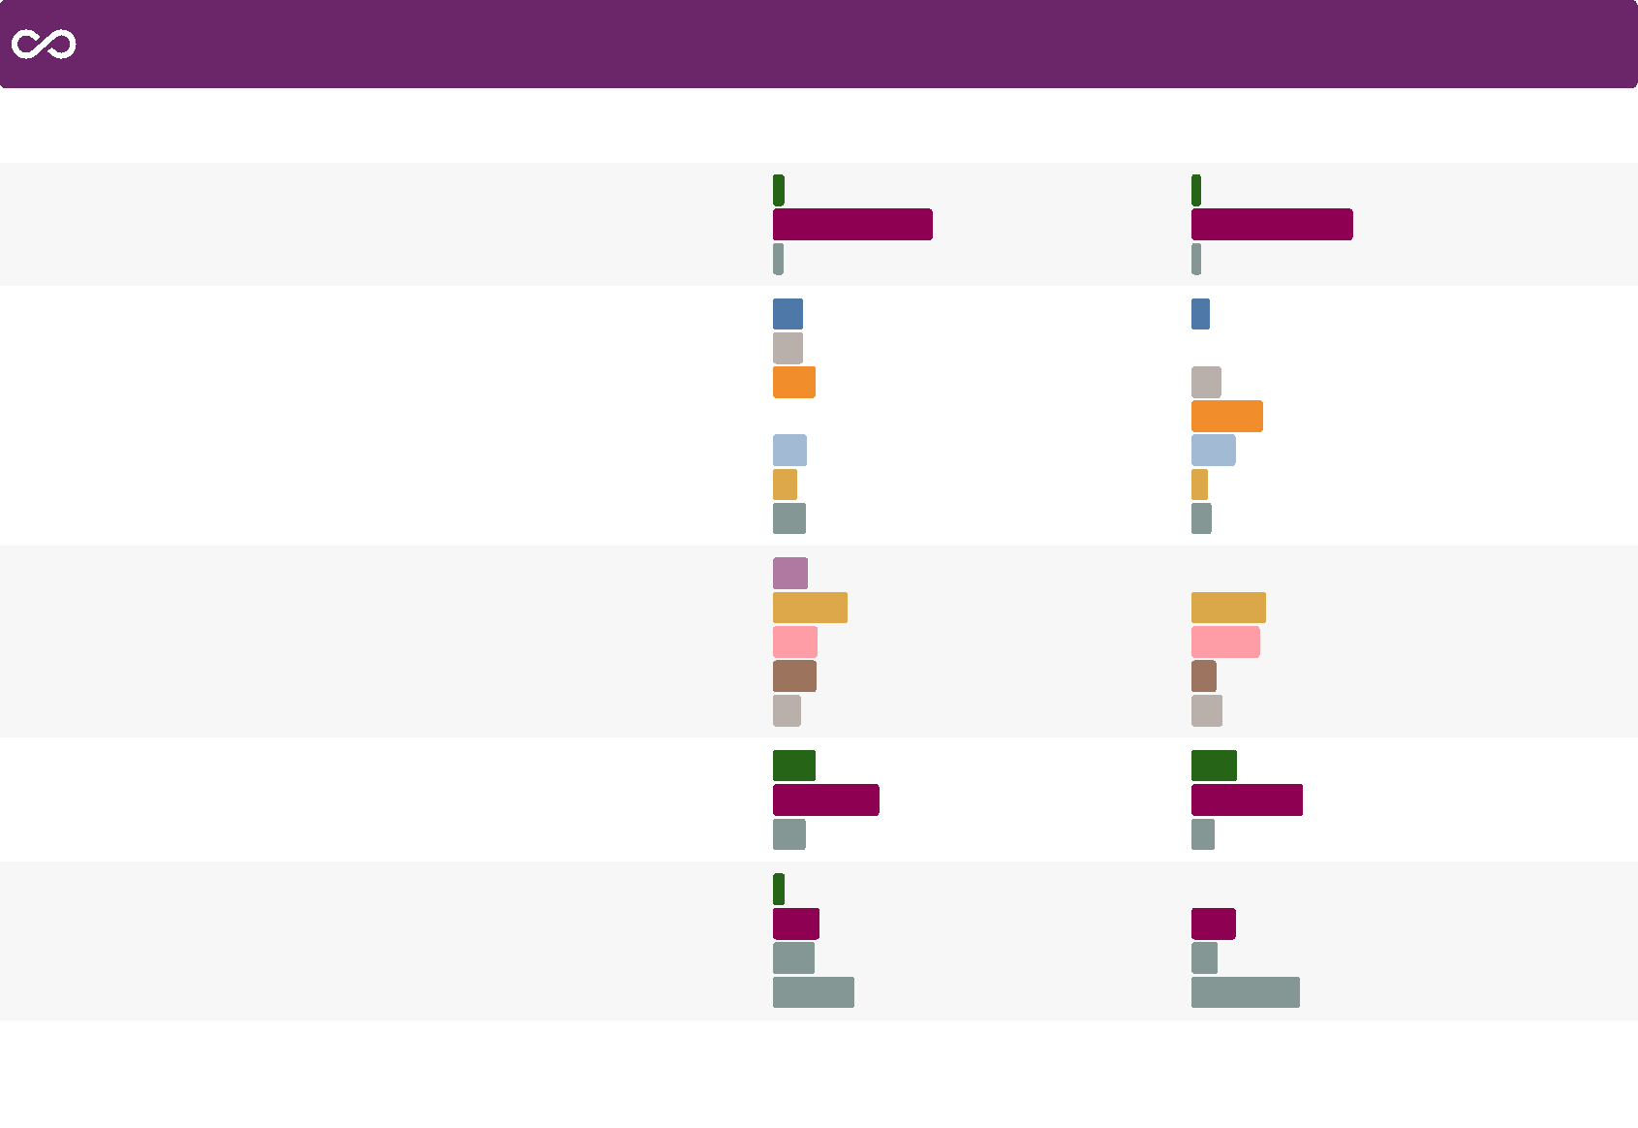

Behaviour at Work
10%
People Survey 2019 CQC People Survey 2021 Sentiment Change
Yes No  Prefer not to say | 6% |  |  | Yes No  Prefer not to say
Yes No  Prefer not to say | 88% |  |  | Yes No  Prefer not to say
Yes No  Prefer not to say | 6% |  |  | Yes No  Prefer not to say
Age |  | 17% |  | Age
Caring responsibilities |  | 17% |  | As a contractor I feel I...
Disability |  |  | 23% | Caring responsibilities
I prefer not to say |  |  |  | Disability
Prefer not to say |  | 19% |  | Prefer not to say
Race |  | 13% |  | Race
All Other Responses |  | 18% |  | All Other Responses
Peer |  |  |  | Peer
Peer |  | 19% |  | Peer
Line manager | 41% |  |  | Line manager
Senior manager... |  |  | 25% | Senior manager...
Other colleague |  |  | 24% | Other colleague
Prefer not to say |  | 15% |  | Prefer not to say
Yes |  |  |  | Yes
Yes |  |  | 24% | Yes
No | 59% |  |  | No
Prefer not to say |  | 18% |  | Prefer not to say
Yes |  | 6% |  | Yes
No |  |  | 26% | No
Prefer not to say |  | 23% |  | Prefer not to say
NA | 45% |  |  | NA

CQC People Survey 2021 Page 20 SocialOptic Ltd • socialoptic.com
73. In the last 12 months, I have personally experienced discrimination at work from any of the following: my manager/ team leader or other colleagues
- On which of the following grounds do you feel the discrimination was based?
111 Responses (145 previously)
- From which colleague did you receive this behaviour? 111 Responses (151 previously)
- Have you reported the discrimination? 111 Responses (157 previously)
- Were you satisfied with how the discrimination was dealt with?
44 Responses (86 previously)
5%
90%
5%
16%
40%
24%
9%
11%
41%
38%
14%
17%
25%
62%
13%
24%
14%
60%
5%
-1%
Strongly disagree Disagree Neither agree or disagree Agree Strongly agree
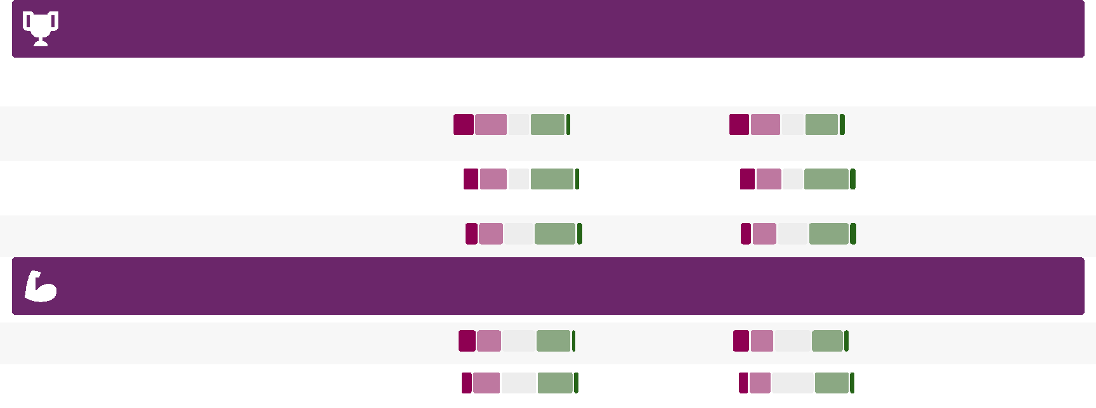

Reward and Recognition
14%
6%
38%
39%
5% 14%
- I am satisfied with my overall reward package (e.g. benefits, pension, annual leave, etc.)
10%
5%
36%
4% 9%
- I am aware that activity as a result of Our People surveys has led to change
Sentiment | Change
35% | +1%
45% | +2%
42% | +1%
33% | -1%
35% | 0%

People Survey 2019 CQC People Survey 2021
74. Compared with other people doing a similar role in other organisations, I think I am rewarded fairly
18%
4% 19%
5%
- I feel recognised for my contribution at CQC 11%
35%
6% 10%
36%
7%
Survey Actions
- I believe action will be taken on the results of this survey 15%
4% 15%
31%
5%

 | Significant reduction in  sentiment |  | Reduction in sentiment Increase in sentiment Significant increase in  sentiment

CQC People Survey 2021 Page 21 SocialOptic Ltd • socialoptic.com

 | Making CQC a great place to work

Review pay, scales and overtime | 16%
Listen and act | 9%
Improve systems | 6%
Improve progression possibilities | 5%
Improve change management | 5%
Improve communication | 5%
Lighter workload | 4%
Improve management | 4%
Embed the values | 4%
Recruitment drive |  | 4%
Create permanent roles |  | 3%
Improve training |  | 3%
All Other Responses | 31%

0% 20% 40% 60% 80% 100%
CQC People Survey 2021 Page 22 SocialOptic Ltd • socialoptic.com

