

Medicines in community mental health services

April 2025
Rachel Burkitt, Kate Duxbury,
Louise Adkins, Alicia May
24-096400-01 CQC MH Meds | Version 2 | Internal Use Only | This work was carried out in accordance with the requirements of the international quality standard for Market Research, ISO 20252, and with the Ipsos Terms and Conditions which can be found at https://www.ipsos.com/en-uk/legal. © Ipsos 2025

Contents

Executive summary 4
Background and methodology 7
2 Adherence and engagement 14
3 Supporting people taking psychotropic medicines 19
4 Communication and collaboration 33
5 Health inequalities 43
6 Support and training 53
7 Conclusion and implications 61
Appendix 64

Executive summary
Background
The Care Quality Commission (CQC) asked Ipsos to undertake research on what good care looks like in relation to the optimisation of psychotropic medicines in the community. Psychotropic medicines work in the brain. They affect behaviour, mood, consciousness, thoughts or perception. They are used to treat a range of mental health conditions.
The aims of the research were to explore:
- What good care looks like for people who are receiving medicines for mental health conditions.
- The challenges and risks associated with caring for people taking psychotropic medicines.
- How CQC can regulate more effectively in the space of medicines and community mental health.
The study was conducted between January and April 2025. It employed a mixed-methods approach, combining an online survey of 314 healthcare professionals, with 13 in-depth qualitative interviews.
Adherence and engagement
- The most common concern people have about taking psychotropic medicines is the risk of side effects. This was also the leading reason given for non-adherence.
- Other factors contributing to non-adherence include: a lack of understanding about medicines, fear of dependency, the complexity of medicines regimens, and stigma.
- Systemic issues, such as overstretched mental health services and long waiting times, were also seen as major barriers to engagement. This was felt to be limiting the ability of healthcare professionals to provide more proactive, personalised and supportive care.
Supporting people taking psychotropic medicines
The aspects of good care discussed in the research focussed on:
- Medication reviews, particularly those conducted annually, which are seen as a highly effective mechanism for supporting patients.
- Access to specialist expertise, especially from Community Mental Health Pharmacists and Pharmacy Technicians, although the availability of these professionals varied across regions.
- A multi-disciplinary approach, with teams coming together to plan people’s care.
- Continuity of care, so that healthcare professionals can get to know their patients, and patients can build trust with their key contacts.
- Proactive outreach, as this cohort of patients may be less likely to come forward for care and may lack insight into their condition.
- Good communication and sharing the right information about care between organisations.
Participants also discussed several innovative practices, including the use of Artificial Intelligence (AI) to identify high-risk patients, two-way texting services to enhance communication, and shared computing systems between primary and secondary care. Other innovations included community transformation programmes aimed at improving the interface between primary and secondary care, the implementation of wraparound teams, and crisis care provided by local charities.
The main challenges in providing good care were: workforce shortages and limited capacity issues within community mental health teams and primary care, and poor joint-working between services.
Health inequalities
- Groups that consistently face barriers to care, identified by participants, included people with who do not speak English as their first language, individuals experiencing homelessness, autistic and neurodivergent individuals, people with learning disabilities, and individuals from ethnic minority backgrounds.
- The types of barriers discussed were largely communication issues, including language barriers and a lack of culturally sensitive care. Participants also discussed practical challenges such as unstable housing, stigma, and difficulties navigating complex healthcare systems.
- Adaptations to services to overcome these barriers, discussed in the research, focussed on improved communication between services, proactive outreach, and culturally sensitive care. However, participants also noted that resource constraints and capacity limitations (within both NHS and voluntary sector services) remain significant barriers to effectively addressing these inequalities.
Communication and collaboration
- Positive examples of collaborative working reported in the research included: shared IT systems, and virtual and wraparound multi-disciplinary teams.
- Effective communication and collaboration were often seen as dependent on the initiative of individual healthcare staff rather than embedded in a formalised, system-wide approach. Nonetheless, more structured models of collaboration were beginning to emerge through community transformation initiatives.
- Challenges related to communication and collaboration were reported as persistent. This included fragmented communication (exacerbated by siloed IT systems), inconsistent approaches between providers, and a lack of clarity around roles and responsibilities.
Participants were divided on the effectiveness of shared care agreements. This was a common source of concern in the open-ended survey responses and interviews.
- Positive examples included: the presence of robust systems and improved communication between primary and secondary care.
- Several concerns were raised, particularly around GP willingness to implement shared care agreements. Concerns were also raised by GPs about a lack of timely advice and support from secondary care in managing patients supported by care agreements.
To improve communication and collaboration, participants would like to see:
- More integrated IT systems.
- Better joined-up working.
- Dedicated staff to support medicines optimisation.
- For shared care: clearer guidance, standardised protocols, and targeted support for GPs.
Support and training
- To improve the support to people accessing mental health services, participants would like: better workload capacity, improved information sharing, and more joined-up working between organisations.
- Participants highlighted the need for enhanced support, training and resources, particularly specialist knowledge for GPs and non-specialist pharmacists. This included topics such as side effects, drug interactions, and other pharmacological aspects of psychotropic medicines. Participants also highlighted the importance of developing skills to support patient adherence and engagement, including training on motivational interviewing techniques and trauma-informed care.
- Participants emphasised the potential role of the CQC in disseminating best practice examples, reporting on emerging trends and themes, and working collaboratively to provide clearer guidance on medicines optimisation.

Background and methodology
This chapter outlines the context for the research including the background and objectives. It details the methodology used for the research. It also summarises the overall structure of the report.
  - Background and objectives
This report presents the findings from research carried out by Ipsos between January and April 2025, on behalf of the Care Quality Commission (CQC). The research aimed to explore what good care looks like in relation to the optimisation of psychotropic medicines in the community.
Concerns around access to community mental health services and quality of care have been highlighted, for example by CQC’s State of Care report 2024 and the special review of Nottinghamshire Healthcare NHS Foundation Trust’s provision. This has led CQC to commit to a broader review of community mental health service provision.
The appropriate and effective optimisation of medicines within community mental health services is an important part of this. Medicines optimisation is central to minimising risks, and empowering individuals to actively participate in their own care. In contrast, suboptimal practices (such as inadequate monitoring of side effects and poor adherence) can have detrimental consequences. These include reduced treatment efficacy, increased hospitalisations, and a diminished quality of life.
To address these concerns and promote best practices, CQC commissioned this research to explore:
- What good care looks like for people who are receiving medicines for mental health conditions, through:
  - Exploring how services support people taking psychotropic medicines in the community. This includes the professional support and training available for healthcare professionals and the skill mix of staff supporting people with their medicines in community settings.
  - Identifying examples of best practice, innovation and improvement projects.
- The challenges and risks associated with caring for people taking psychotropic medicines across a range of areas. This includes monitoring, medication reviews, communication, alignment of care between services and the practical implications of shared care. CQC were also keen to explore these areas with a health inequalities lens.
- How CQC can regulate more effectively in the space of medicines and community mental health in order to influence improvement, including:
  - CQC’s role in supporting good care for people taking medicines in the community for their mental health.
  - How CQC can utilise its regulatory levers to help improve this area of care.
  - Methodology
This research employed a mixed-methods approach, combining quantitative data from a survey with qualitative insights gathered through in-depth interviews.

Survey
An online survey was sent to a diverse range of individuals involved in supporting people in the community with their psychotropic medicines. A sample of 6,400 individuals was provided to Ipsos by CQC. The sample included a range of professions within different organisations, including patient facing and non-patient facing roles. The main organisations covered included:
- Primary care services
- NHS mental health trusts
- Integrated Care Boards (ICBs) and Integrated Care Systems (ICSs)
- Charities that support mental health causes
- Independent healthcare organisations
The professions covered included:
- Members of community mental health teams within NHS trusts, including doctors and nurses
- General practitioners (GPs)
- Pharmacists in primary care services, NHS trusts or integrated care teams
- ICB Chairs and Chief Executives
- Individuals working as advocates for people with mental health conditions in charities or support organisations
The survey was shared as an open link, and recipients were asked to disseminate the link with others involved in supporting people in the community with psychotropic medicines. As well as sending the survey directly to individuals CQC holds contact details for, the open survey link and information about the research were also disseminated through CQC’s newsletters and LinkedIn.
A total of 314 participants responded to the survey, with 250 completing it in full and 64 providing partial responses. The survey fieldwork period was 14th February to 17th March 2025. The survey lasted approximately 15 minutes. It comprised of 20 closed questions, and five open-ended questions designed to explore specific issues in more depth. A copy of the questionnaire is included in the appendix. The survey data are not weighted due to the lack of a defined population for the research. The research was intended to engage a range of different people involved in providing care for people taking psychotropic medicines in the community, rather than to produce a representative sample.

Profile of completed responses
A breakdown of survey participants by role, organisation, and region is provided below:
      - Professional Background
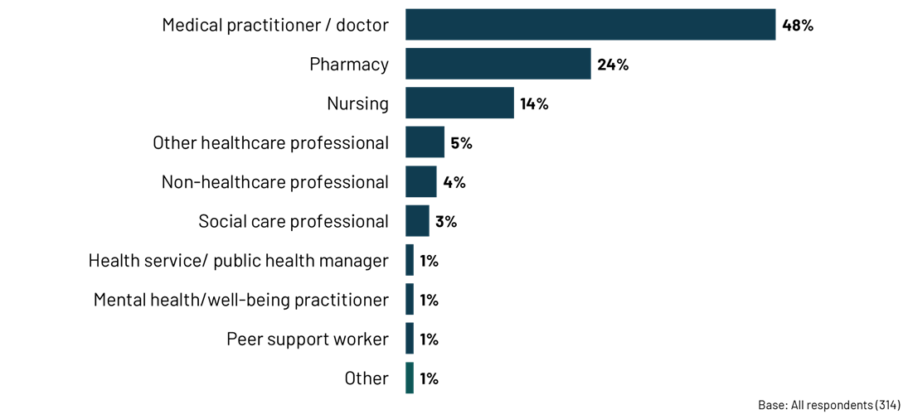
      - Organisation
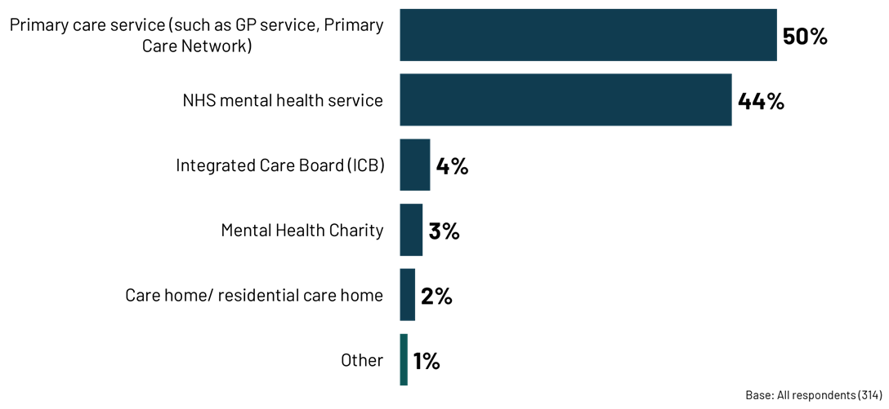
      - Region
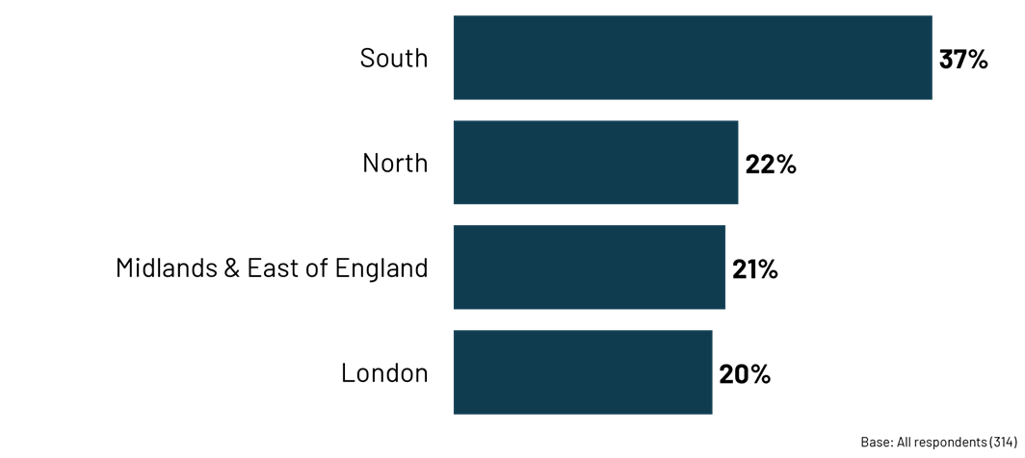

Qualitative interviews
Depth interviews were conducted with 13 participants who had indicated their willingness to be recontacted for further research during the survey phase. The interviews were designed to explore the topics covered in the survey in greater depth. The discussion guide is available in the appendix. Quotas were set based on organisation, role, and location. The profile of participants is provided in the following table.
        - Depth interviews – profile
Quota |  | Number of interviews
Role/ organisation | GP | 3
 | Practice manager | 1
 | Pharmacist | 5
 | Nurse in an NHS Mental Health Service | 1
 | ICB | 1
 | Patient advocate/ charity representative | 1
 | Academic | 1
Region | South | 2
 | London | 0
 | Midlands & East of England | 4
 | North | 7
  - Strengths and limitations of the methodology
Strengths:
- The mixed-methods approach, combining a survey of 314 healthcare professionals with 13 in-depth qualitative interviews, offers a comprehensive understanding of both the prevalence of issues and the nuanced experiences of those involved in providing care.
- The inclusion of diverse perspectives, from GPs and pharmacists to patients' advocates and charity representatives, strengthens the findings and ensures a holistic view of the challenges and opportunities.
Limitations:
- The open survey link methodology, while allowing for a broader reach, may have introduced bias through self-selection of participants in both the survey and the interviews.
- The survey data are not weighted and therefore not representative of the wider population of healthcare professionals involved in psychotropic medicines optimisation.
- The relatively small number of qualitative interviews, while providing rich insights, are not generalisable to a wider population.
- The research focuses primarily on the perspectives of healthcare professionals, with limited direct input from patients.
  - Structure of the report
The report structure is as follows
- Chapter 2 (Adherence and engagement) explores participants’ views on the key concerns people have about taking medicines, non-adherence, and reasons for disengaging from mental health services.
- Chapter 3 (Supporting people taking psychotropic medicines) discusses the support available for people taking psychotropic medicines. This includes what is currently available, gaps in this support, and views of best practice.
- Chapter 4 (Health inequalities) discusses specific population groups facing more barriers to accessing support, and how these barriers are being addressed.
- Chapter 5 (Communication and collaboration) brings together findings on how well participants feel communication is working, views and experiences of shared care agreements, and what improvements were identified.
- Chapter 6 (Support and training) explores the advice and training that is offered to providers, the support needed by healthcare professionals, and the role CQC can play in supporting the optimisation of psychotropic medicines in the community.
- Chapter 7 (Conclusions and implications) brings together key implications for CQC from this research.

Main findings

- Adherence and engagement
This chapter examines participants’ views of people’s concerns surrounding their psychotropic medicines. It also looks at reasons for non-adherence, and disengagement from mental health services.
Chapter summary
Side effects are seen as the most common concern that people have regarding taking their psychotropic medicines. This can impact adherence and lead to disengagement from services. Participants noted that patients frequently struggle to discuss these side effects openly with healthcare providers. A lack of understanding about their medicine and a fear of dependency are also seen as barriers to adherence.
In terms of engagement with mental health systems, participants identified systemic issues such as strained mental health services and long waiting lists as key factors. These were thought to be contributing to patients’ disengagement with services as limited capacity reduced opportunities to build close and trusting relationships with patients, or implement earlier interventions. Individual factors, including the symptoms of mental illness, practical barriers, and a lack of trust in healthcare providers, also play a significant role.
  - Concerns about psychotropic medicines
Participants were asked to report the three biggest concerns people have about taking their psychotropic medicines. The most prevalent concern reported by far is side effects, with four in five participants (80%) identifying this. Linked to side effects, the impact on their physical health (39%) was identified. Participants in the depth interviews also raised side effects and physical health impacts, such as those impacting weight, energy levels, and sexual function, as a major concern. Participants said that people taking psychotropic medicines can often struggle to discuss these side effects openly with healthcare providers, leading to feelings of isolation and frustration.
      - The biggest concerns people have about taking their psychotropic medicines
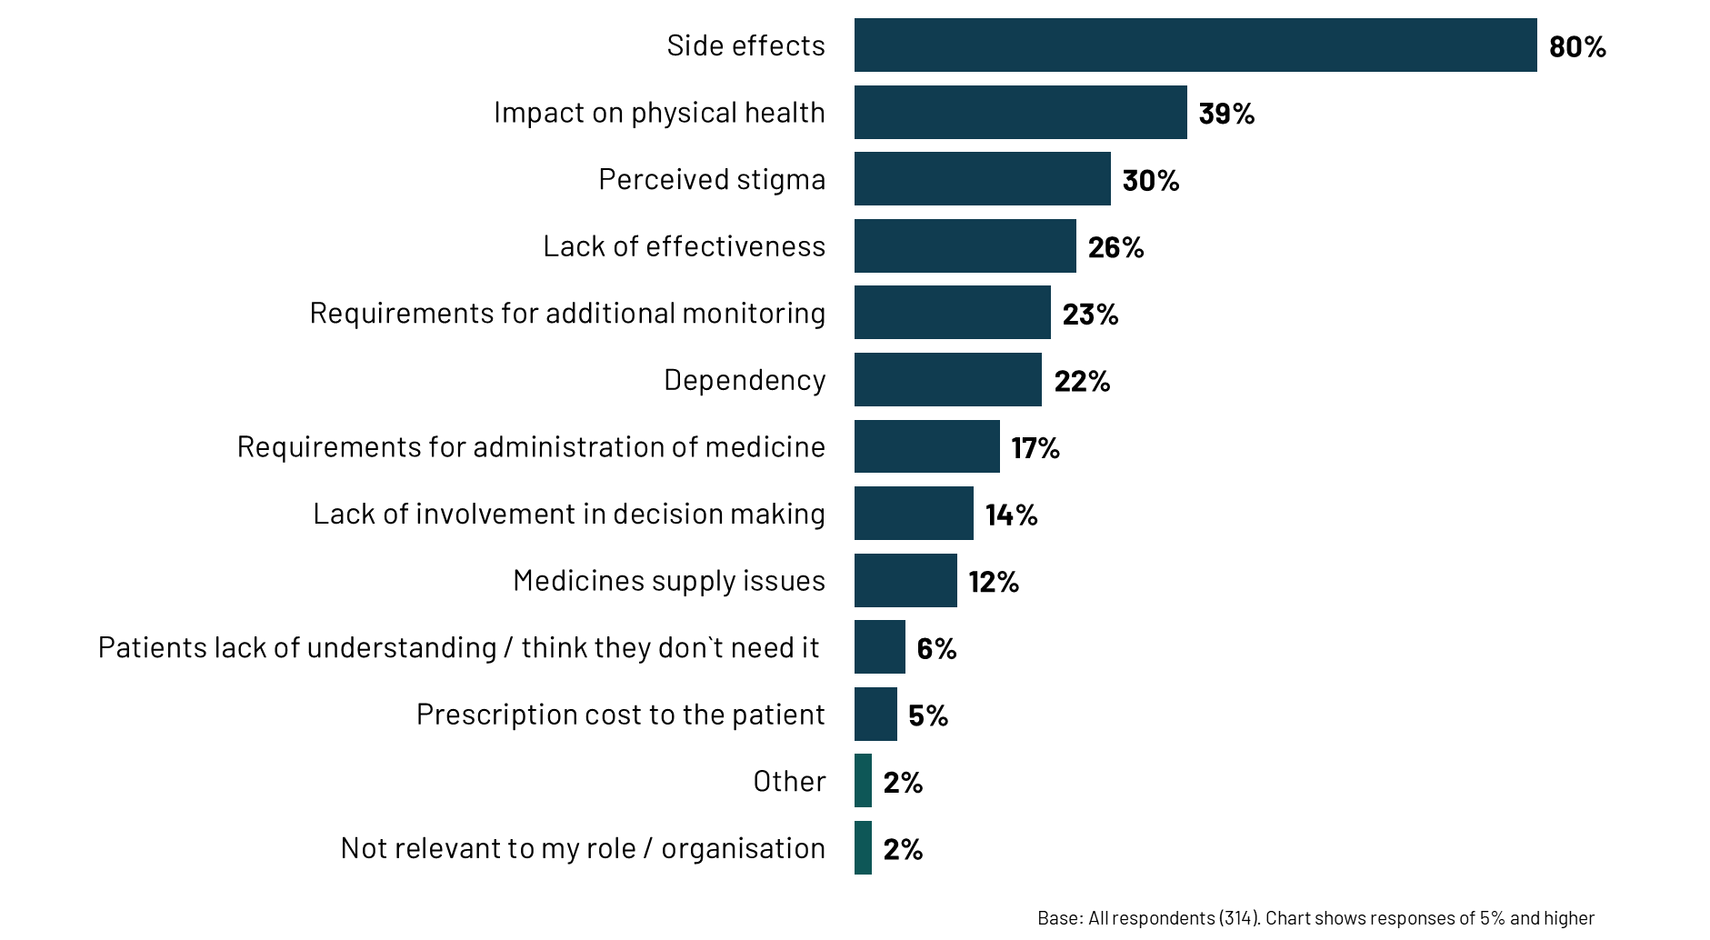
Another common concern among people taking psychotropic medicines was perceived stigma (30%). Interview participants explained that the stigma associated with mental illness and medicine use, and patients’ desire to manage their condition without medicine, can also lead to non-adherence. Participants described a reluctance among patients to discuss their mental health medicine and side effects. They also explained that this can be compounded by healthcare professionals’ hesitancy to discuss mental health medicines with their patients if they are not a specialist.
"So people are quite happy to talk about their heart medicines or their blood pressure medicines, but once you start talking about mental health medicine, people act a bit differently… [healthcare professionals] might not provide the same level of advice generally." Pharmacist, NHS Mental Health Service
Further concerns noted in the survey are about the lack of effectiveness of these medicines (26%). Linked to this, in the depth interviews, participants raised a lack of comprehension among people taking psychotropic medicines. They noted that patients can feel insufficiently informed about their medicines, including potential side effects, long-term risks, and alternative treatment options. This lack of knowledge can contribute to fear, mistrust, and reluctance to adhere to treatment plans. Uncertainty about the appropriate duration of treatment and the potential for dependence on psychotropic medicines can also weigh heavily. This can lead to a fear of dependency, which 22% of survey participants identified as a concern.
  - Adherence
Side effects are one of the most prevalent reasons given in the survey for people not adhering to their medicine regimen (74%). Participants in the qualitative interviews also frequently cited side effects as the major deterrent to consistent medicine use. They also said frustration with experiencing similar side effects from a range of different psychotropic medicines can lead individuals to disengage from treatment altogether.
“I think a lot of people disengage because they get frustrated about the side effects they experience…we work with a lot of people who’ve gone from one drug to another drug to another drug and got similar side effects…some people do just disengage altogether in terms of their treatment." Nurse, NHS Mental Health Service
      - Reasons for non-adherence
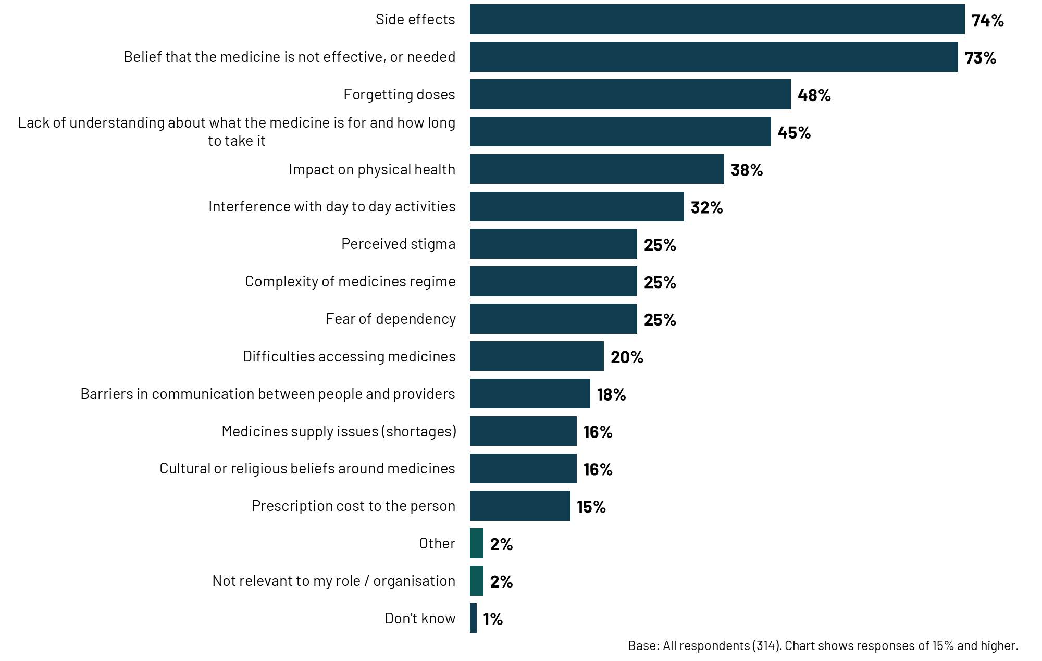

Lack of insight and understanding about the need for medicine was a major cause for disengagement from treatment. This is also prevalent in the survey findings: around three-quarters (73%) state that a belief that the medicine is not effective, or needed, is one of the main three reasons for non-adherence, and 45% say a lack of understanding about what the medicine is for and how long to take it is a main reason.
"For some patients, a lack of understanding about their illness and the need for medicine contributes to non-adherence. This can lead to situations where patients require community treatment orders to ensure they take their medicine." Nurse, NHS Mental Health Service
The complexity surrounding medicine regimes in this population is also a factor (25%). In the survey, around half (48%) also cited forgetting doses as a main reason for non-adherence. In the qualitative interviews, participants discussed the intricate medicine regimens as a key factor in non-adherence. This could be compounded by the unpredictable nature of conditions and the presence of multiple, interlinked physical and mental health needs. They noted that this complexity is further exacerbated by practical barriers in the lives of those taking psychotropic medicines, including unstable housing, demanding work schedules, and chaotic lifestyles, making consistent medicine routines even more challenging.
For example, one community mental health pharmacist discussed the challenge of supporting a patient who had recently been discharged from an inpatient ward. The transition from structured inpatient care to self-management at home presents significant challenges, made harder by practical barriers such as navigating medicine refills, understanding complex regimens, and integrating medicine routines into daily life.
Participants in the qualitative interviews also discussed a shortage of staff trained in effectively communicating about medicines, addressing concerns, and providing support for patients struggling with adherence. Additionally, healthcare professionals may not always be adequately transparent about potential side effects, particularly sensitive ones, which can lead to patients discontinuing medicine.
  - Disengaging from mental health services
The factors leading to disengagement with mental health services, discussed in the qualitative interviews, can be broadly categorised as systemic issues (primarily related to service capacity), and individual factors (encompassing the personal circumstances and experiences of those seeking care).
Systemic factors: Participants frequently cited the strain on mental health services as a significant barrier to engagement. Limited resources and lengthy waiting lists can limit the amount of preventative, proactive care that services can offer patients.
“We know that the waiting lists to get into services are extremely long…it's hard to get into mental health services when you need it and it can take a lot of time unless you are very, very unwell or very risky." Pharmacist, NHS Mental Health Service
Individual factors: The interviews also emphasised the challenges inherent to experiencing mental illness that can impact engagement. The symptoms of conditions like anxiety, depression, and psychosis, such as low mood, fatigue, and difficulty concentrating, can make it challenging for individuals to attend appointments and actively participate in treatment. Furthermore, practical barriers such as demanding work schedules, unstable housing, and the complexities of daily life can further hinder engagement. Trust in healthcare providers and services also emerged as a crucial factor, with participants acknowledging that negative past experiences, or a lack of culturally sensitive care, can deter individuals from seeking support.
“It's probably the most common one we get is people's lives are busy, slightly chaotic, and appointments are at times and places where…life gets in the way and they just drop out of services." GP, Primary Care

- Supporting people taking psychotropic medicines
This chapter explores the current support available for people taking psychotropic medicines, identifies where there are perceived gaps in this support and challenges, and explores best practice.
Chapter summary
Medication reviews were consistently identified as being effective mechanisms to support patients taking psychotropic medicines. Mostly these are conducted annually, though participants recognised the benefits of more frequent reviews where possible. Access to specialist pharmacological expertise – such as from Community Mental Health Pharmacists and Pharmacy Technicians – was also considered a critical component of effective support to patients. However, the availability of these specialised professions is not universal, with some participants reporting a lack of access to them in their local area.
Best practice approaches to supporting patients on psychotropic medicines also include: multi-disciplinary working, including non-medical professions such as those working in housing agencies; continuity of care with patients able to build trust over time with named individuals; and good communication and shared documentation between organisations working to support patients collectively.
However, challenges persist. Workforce shortages and capacity constraints are viewed as impacting the quality of care for patients. Fragmented communication between different parts of the system, and inconsistent implementation of shared care agreements are also causing frustration for staff and patients. Participants highlighted that certain population groups, such as individuals experiencing homelessness, those with learning disabilities, and those from ethnic minority backgrounds, face additional barriers to accessing support and adhering to their medicine regimens.
  - Reviewing and monitoring
Having regular medication reviews is seen as one of the most effective methods of reviewing and monitoring people who are taking psychotropic medicines (mentioned by 68% of participants in the survey). Related to this, nearly three in five (57%) mention the monitoring and management of side effects specifically as being effective.
Ensuring good communication and clear information (that is documented) between professionals is a recurring theme in the survey. Clear communication and documentation across the healthcare professionals involved is mentioned by 61% of participants. Additionally, 44% mention multidisciplinary teams, 41% say having shared care agreements in place, and 39% say having access to records and results. Half (49%) of participants mention the need to support and educate family members and carers about the condition, medicines and potential risks.
      - The most effective approaches when reviewing and monitoring people who are taking psychotropic medicines in the community
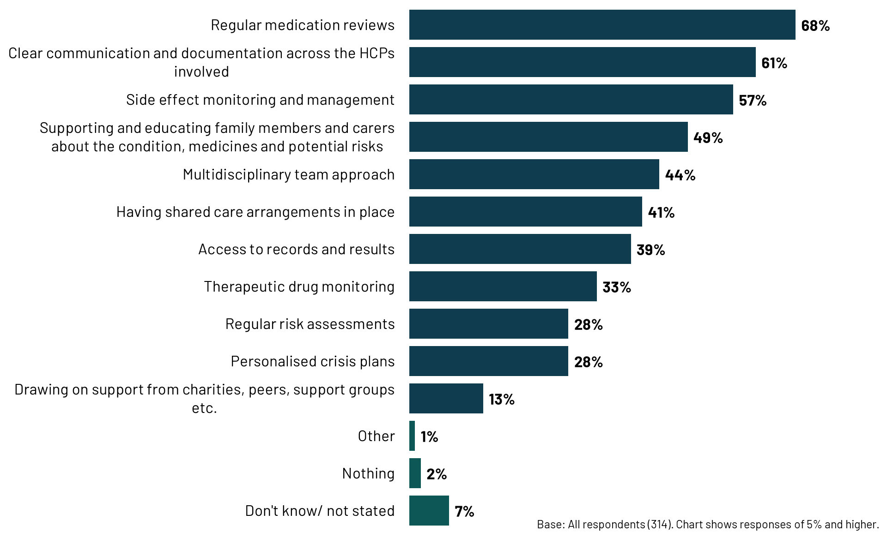
Pharmacists are more likely to say side effect monitoring and management, clear communication and documentation, and supporting and educating family and carers are effective.
Just 38% of participants working in primary care say supporting and educating family members and carers is the most effective approach to reviewing and monitoring people (vs. 49% overall).
  - Best practice and innovation in supporting people with psychotropic medicines
This section of the report takes data from the qualitative interviews and open-ended responses from the survey to look at best practice in supporting people on psychotropic medicines. It also provides examples of more innovative practices in this area.

Best practice
Participants were asked to reflect on what is working well in their organisation or local area to support people to continue to engage with mental health services and treatment in the community. The following themes were apparent:
- Regular reviews: As consistently highlighted in the survey results, regular medicine or mental health reviews were seen as essential for maintaining patient engagement. Examples were given of these reviews being conducted by GPs, specialist mental health pharmacists, and nurses. Often these reviews were annual, though participants acknowledged that more frequent reviews (such as quarterly) would be more effective.
“In our local area, we have integrated regular follow-up medication reviews with a focus on building trust and rapport with patients. These reviews are personalised, and we make sure to address any concerns about medicines, side effects, or treatment goals.” Pharmacist, NHS Mental Health Service (survey)
  - Proactive outreach: Reaching out to individuals, especially those with a history of disengagement, was considered important in securing continued engagement. Some participants talked about using assertive outreach teams or an assertive outreach approach to do this. For example, having a designated individual to invite all patients on the severe mental health register for a physical health check and following up with non-responders. In addition, one interviewee mentioned a clinic where patients were invited by telephone, and given a reminder the day before via a phone call, resulting in high attendance levels.
“So we have a team called Assertive Outreach Team who are specifically for those types of patients who are revolving door, keep on coming in and out of hospital and trying to break that cycle of repeated admissions.” Pharmacist, NHS Mental Health Service
  - Continuity of care: Having a consistent point of contact, like a named mental health practitioner/ CPN or care coordinator, was thought to help build trust and facilitate ongoing engagement. Examples were given of care coordinators attending medication reviews and being able to identify any issues and communicate with the patient between reviews. This helped to secure better patient engagement.
“Care coordinators will often be the first people who recognise that perhaps something's not quite right or somebody needs additional support or that they're experiencing a side effect. And they will then liaise with the prescriber and possibly pharmacy.” Pharmacist, NHS Mental Health Service
  - Multidisciplinary Team (MDT) approach: MDTs were thought to be effective in enabling coordination between various healthcare professionals in support of patients. It was seen as particularly valuable when pharmacists were part of MDT discussions on patients taking psychotropic medicines. Some participants noted that the involvement of a broader spectrum of professionals (such as those working in housing agencies) was more commonplace now since Covid, and this was welcomed.
"Multi-disciplinary work - for some people there is a complex psychosis team made up of mental health nurses, social workers, housing specialists, psychiatrists and OTs. This wraparound support allows for reactive support as needed, and a proactive approach to providing care plans and support." Social care professional, Charity (survey)
  - Community Mental Health Pharmacists and Pharmacy Technicians: Some participants specifically mentioned the involvement of Community Mental Health Pharmacists and Pharmacy Technicians helping to embed pharmacy expertise in community care. They felt this gave patients better care and support around their treatment. One pharmacist working in a Community Mental Health Trust talked about having longer appointments with patients, allowing them to have a better understanding of patients’ histories, and enabling them to provide personalised support. However, it was noted that these specialist roles were not consistently available throughout the country.
  - Specialised clinics: Clozapine clinics were mentioned by a number of qualitative participants as examples of best practice. In these clinics, patients are seen more frequently, due to the need for regular blood tests. This allows patients to build stronger relationships with professionals. As a result, community mental health teams could be alerted sooner than might happen otherwise if a patient was starting to relapse or needed greater support. Participants also mentioned depot clinics, and the benefit of patients having injectable medicine – given the challenge of monitoring patients on oral medicine. Where these injections could be administered close to patient’s residence, then adherence was likely to be bolstered.
  - Empowered patients: Making sure patients feel empowered when it comes to their care was mentioned by some as being an important part of sustaining adherence. This means patients having the same information as the professionals caring for them and actively involving them in the decision-making process. Accessible patient information was an important factor in this. One pharmacist working in a mental health trust mentioned the value of their subscription to a website with information leaflets for all the psychotropic medicines that might be prescribed. The main benefits of this resource were that trusts did not have to write their own patient leaflets, and the leaflets could be easily tailored according to accessibility and language needs.
“I think it's just about them being centre of everything and them being fully engaged in all of the decision-making about their own care, really. I think if people feel disempowered and like they're being done to, they're less likely to take their medicine.” Nurse, NHS Mental Health Service
- Family and carer support: The involvement of family and carers was acknowledged as being important, with them needing to be educated about mental health conditions and the role of mental health services/ treatment.

Innovation
In the qualitative interviews, participants were asked to share examples of more innovative practices to support people taking psychotropic medicines in the community. In the main, these examples were provided by one or two participants each:
- Use of AI: Though they did not have direct experience themselves, one participant was aware of a mental health trust that was piloting the use of AI to scan their caseload and identify high risk patients that were likely to benefit from proactive outreach.
- Texting service: One GP described the use of a two-way texting service as a hugely beneficial way to keep in contact with their patients on psychotropic medicines. They use the service whilst reauthorising psychotropic medicines to check how patients are getting on. They reported that such messages were well received by their cohort of patients.
- Shared computing systems: Having the same computing system used within primary care and mental health trusts has been valuable for one participant, who talked about understanding patients’ care journeys better. This better allowed them to safely care for them in the community. For example, they would be able to tell if a patient had missed an appointment within the trust and could follow up accordingly.
- Community transformation programmes: One pharmacist described a programme of work to provide an interface between secondary care and specialist services, and primary care and GPs. In the long term, the ambition is that this team will act as a triage service, deciding whether patients require assistance with their medicine or more holistic support for their wellbeing, and can refer accordingly.
- Complex Psychosis teams: These are wraparound teams comprising a wide range of professions such as psychiatry, psychology, mental health nurses, housing and social workers. The teams have a focus on shared information and group case reviews. These teams are designed to help those with the most complex needs or individuals in crisis.
- Crisis care from a local charity: Where patients require additional support but are not at the threshold of requiring an inpatient admission, a local charity is addressing that gap. The charity is also working with primary care networks to ensure patients on psychotropic medicines attend GP appointments and their annual health checks.
- Trauma-informed care and motivational interviewing: These two approaches were mentioned by some participants as important ways to think more holistically about patients’ lives, also empowering patients and encouraging better adherence as a result.
- User and carer groups: One participant talked about user and carer groups as a way to empower patients by allowing them to connect with others facing similar experiences These groups also provide an opportunity to learn from one another in a safe environment. However, as discussed later in this chapter, the survey findings show that, overall professionals do not view support groups as an effective mechanism of support compared to other mechanisms.
  - Approaches to supporting people with psychotropic medicines
This section explores the survey data on specific types of support considered most effective in helping people manage their psychotropic medicines in the community. It also examines which types of support are perceived to be lacking in local areas, highlighting potential gaps in service provision.
In summary, two main themes emerge across different types of support (supporting people to be involved in decisions about their care, supporting adherence to medicine, and supporting physical health needs):
- Medication reviews are consistently identified as a highly effective mechanism for supporting individuals taking psychotropic medicine.
- Access to specialist expertise, particularly from mental health pharmacy professionals, is considered crucial for optimising medicine management and addressing complex needs. However, the availability of these specialised services varies, with some participants reporting a lack of access in their local areas.

Support to be involved in decisions
When thinking about what supports people to be involved in decisions about their own care and treatment with psychotropic medicines, there are three clear factors. Support from mental health specialist teams is considered effective (mentioned by 71% of participants), as are medication reviews (mentioned by 69%), and providing continuity in their care team (mentioned by 67%). Around half (53%) pointed to providing accessible information as an effective approach.

      - The most effective approaches to supporting people to be involved in decisions about their care and treatment with psychotropic medicines
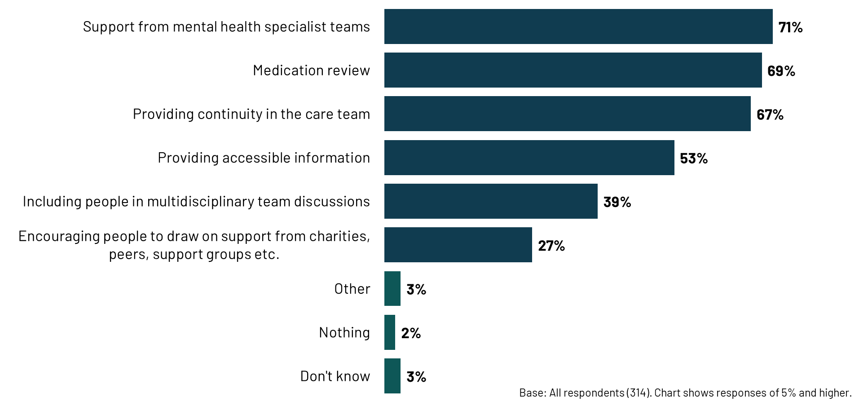

Support to take psychotropic medicines as prescribed
Most commonly thought to be effective in helping people take psychotropic medicines in the community as prescribed are medication review clinics, mentioned by half of participants (52%).
Support from mental health pharmacy professionals (from local mental health services) is mentioned by 45% of participants as being effective, and in particular by pharmacy participants (66%). This is more so than for other named health professionals, namely GP-based pharmacy professionals (mentioned by 34%), and community pharmacy professionals (27%).
Also considered effective in helping people take their psychotropic medicines as prescribed is providing education and support for carers (mentioned by 44%), as is providing support for people to order and receive their medicines (mentioned by 39%).
      - The most effective approaches to helping people to take their psychotropic medicines in the community as prescribed
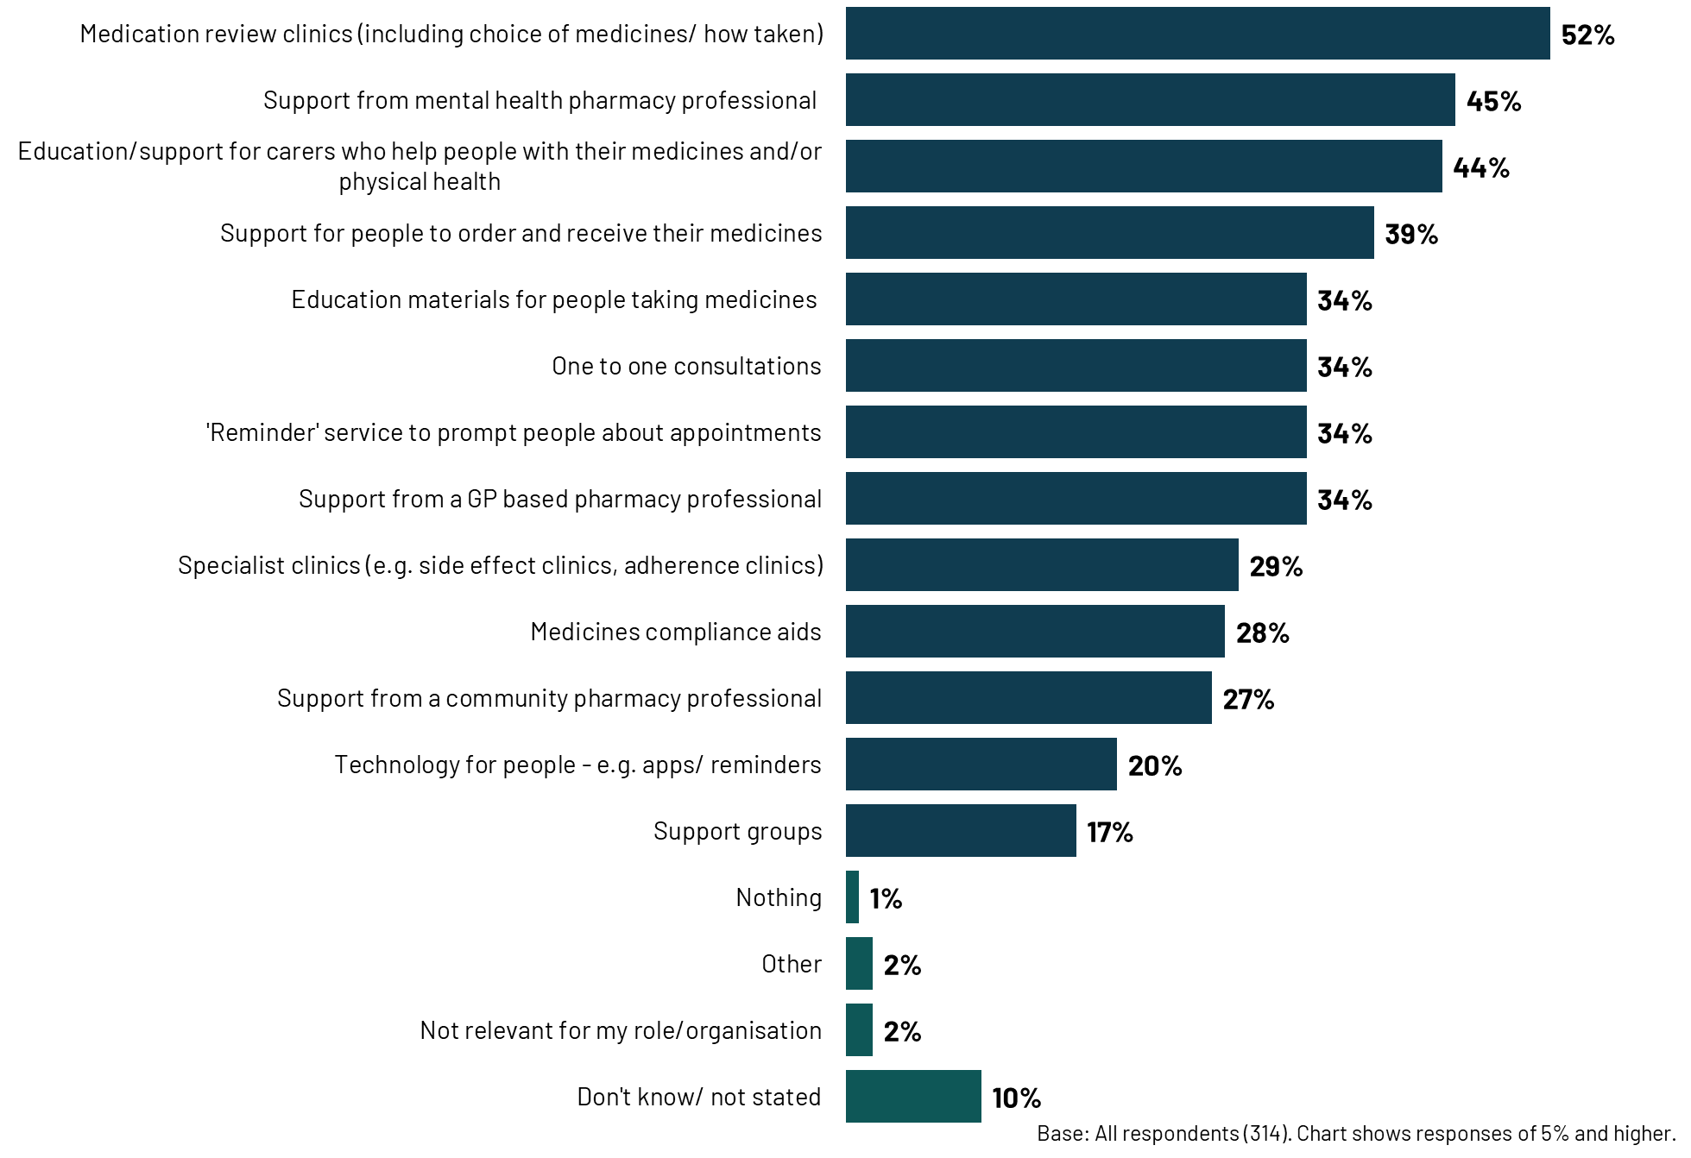
Participants considered types of support that are not available in their local area, that they would like to be made available. Most commonly, participants say they would like specialist clinics (e.g. those on side effects or adherence) to be available in their local area, where such services are currently lacking (52% say this). Support from mental health pharmacy professionals (from a local mental health service) is mentioned by two in five (43%).
Given the importance participants place on medication reviews as an effective means to support people taking psychotropic medicines in the community, only a quarter (25%) say they would like them to be available in their local area as they are not currently, perhaps suggesting these are already widely available in many areas.
There is some appetite among participants for the use of technology to support people (e.g. apps/ reminders) – 27% say this is not available locally but they would like it to be. Other key gaps include education or support for carers (31%), support from a community pharmacy professional (28%), support for people to order and receive their medicines (27%) and support groups (26%).

      - Types of support that are not available in the local area, that they would like to be made available
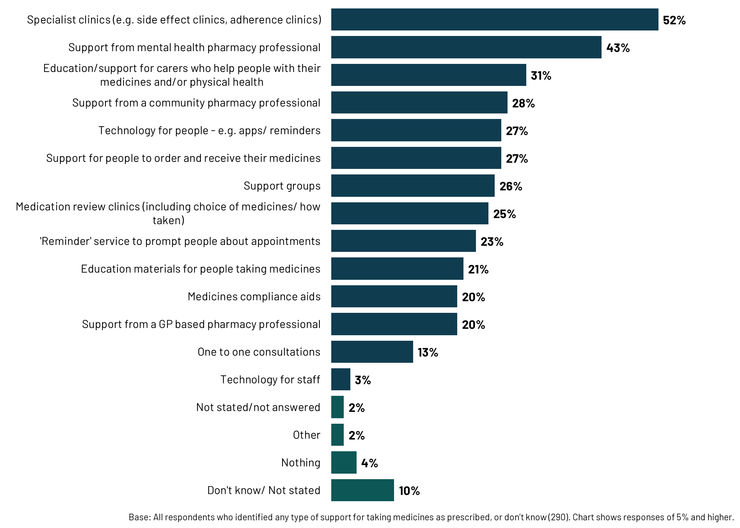

Support with physical health
‘Access to health checks’ is seen as an effective approach to support people taking psychotropic medicines with their physical health (mentioned by 56%). Medication reviews are again commonly seen as effective ways to support people on psychotropic medicines (mentioned by 53% of participants). Almost half (48%) of participants also mention access to physical health nurses as being effective.
As mentioned earlier, education and support for carers is thought to be effective in helping people take their medicines in the community as prescribed. It is also thought to be effective in helping people on psychotropic medicines with their physical health (mentioned by 44% of participants).
Support groups are less commonly mentioned as being effective in supporting people with their physical health (23% mention them). As has already been discussed, support groups were also not commonly considered effective in supporting people to take their psychotropic medicines as prescribed in the community, despite one participant in the qualitative interviews emphasising their value.
      - The most effective approaches to supporting people on psychotropic medicines with their physical health
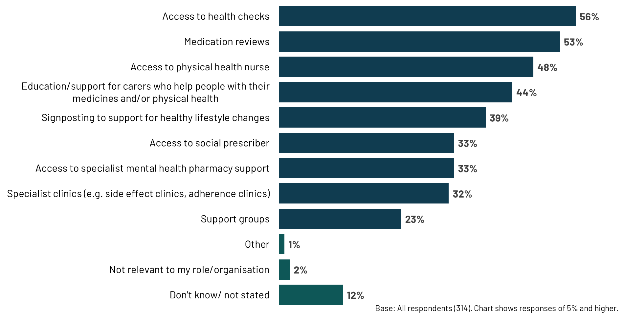
Most commonly, participants mention specialist clinics (54%) and access to specialist mental health pharmacy support (46%) as the support they would like to be available in their local area to help people on psychotropic medicines with their physical health. These are also the two most common types of support participants want to see in their local area to help people take their psychotropic medicines in the community as prescribed (as reported earlier).
Less commonly mentioned are signposting to support healthy lifestyle changes (15%), access to social prescribers (13%), access to health checks (13%) and medication reviews (10%) – either because these are already available in participants’ local areas or because they are not considered as important forms of support as others.
      - Types of support with physical health that are not available in the local area, that they would like to be made available
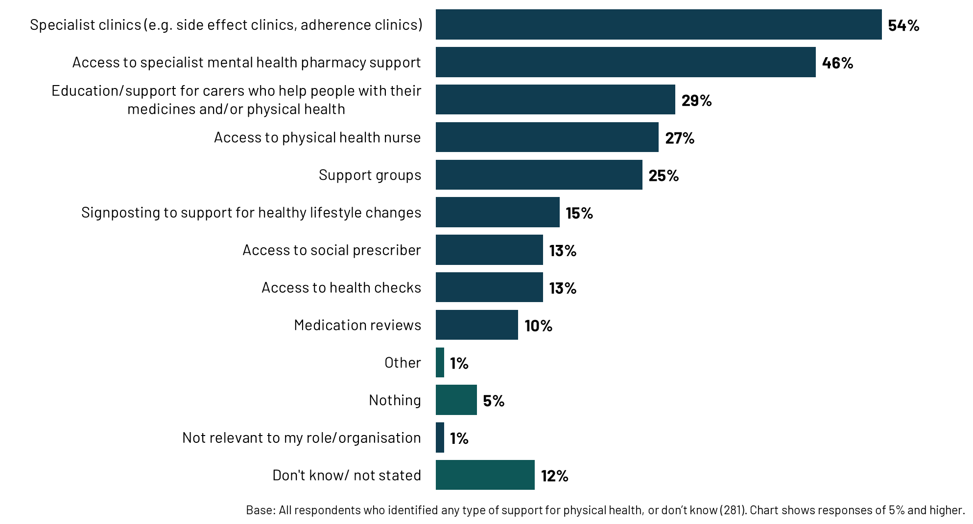

Differences by subgroup: There are some consistent themes by subgroup across these questions around support.
Pharmacists and participants working in NHS mental health services were more likely to emphasise certain types of support. There is crossover in the sample among these two groups – pharmacists who took part in the survey are also likely to be working in NHS mental health services.
For example, both groups consistently highlighted the importance of medication review clinics for different types of support. They were also more likely to say that sharing educational materials are effective for involvement and adherence, and MDT discussions for involvement.
Pharmacists were more likely to say specialist support, and support from mental health pharmacy professionals are effective for helping people to take medicines as prescribed, and access to physical health nurses for support with physical health. Those working in NHS mental health services were more likely to identify medicine compliance aids as effective in adherence.
There was a key regional difference regarding access to specialist mental health pharmacy support. Participants in the North of England were more likely to report a lack of access to this type of support, both for promoting adherence (60% vs. 45% overall) and addressing physical health needs (60% vs. 45% overall). Participants in the South were more likely to say that there is no access to health checks for support with physical health needs (19% vs. 13% overall) and to support people to take medicines as prescribed (19% vs. 13% overall).
  - Challenges supporting people
A number of challenges persist in the optimisation of psychotropic medicines. In the survey, the most common challenge reported is the inability to access care, or delayed access, due to a lack of services offered or waiting lists, reported by one in three participants (33%). Around one in four participants report a lack of patient engagement as a challenge (27%), poor communication across services (27%) and challenges with shared care arrangements (26%). Similar proportions report delayed or inability to access care due to clinicians' referrals being rejected (25%), and a lack of time (24%).
      - The main challenges services face when supporting people who are taking psychotropic medicines in the community
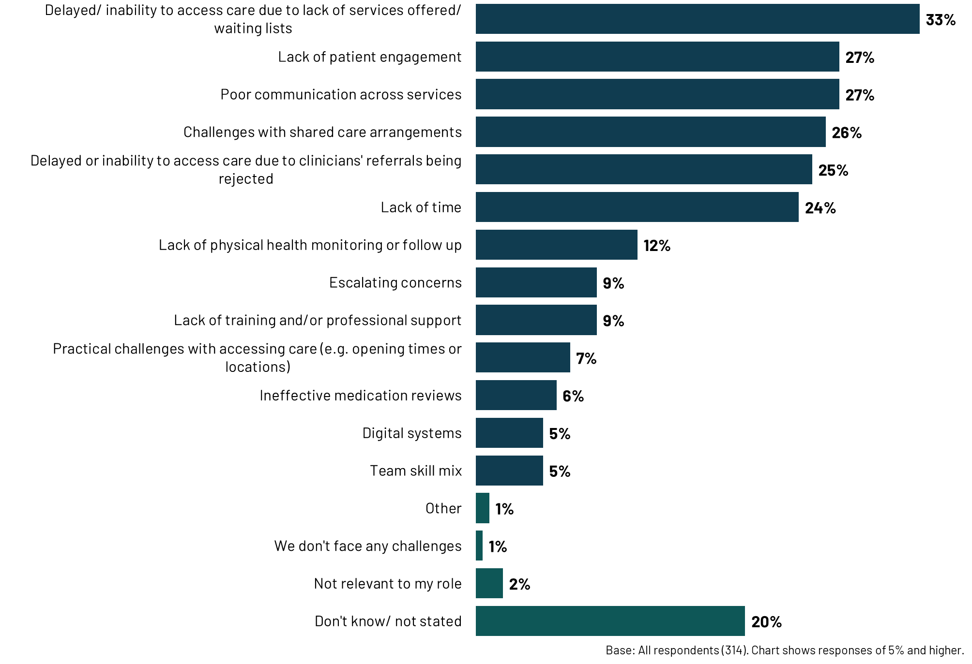
Issues around access and referrals are mainly reported by primary care participants. They are more likely to identify the following challenges, compared to participants from NHS mental health services:
- Delayed or inability to access services/ waiting lists (45% vs. 22%)
- Rejected referrals (40% vs. 12%)
- Escalating concerns (15% vs. 3%)
Pharmacists are more likely to say that communication across services (38% vs. 27% overall), and shared care (39% vs. 26% overall), are a challenge.
Participants in the qualitative interviews also identified these as the main challenges, and provided more information about the sources of these challenges:
- Strained capacity and workforce shortages: Participants consistently highlighted the strain on community mental health services, with limited resources and staff shortages leading to high caseloads, long waiting lists, and difficulties in providing personalised support. This lack of capacity is seen to restrict opportunities for meaningful patient interactions, proactive monitoring, and timely interventions. It was thought this could potentially contribute to disengagement and medicine non-adherence.
- Fragmented communication and siloed working: A lack of effective communication and collaboration between different parts of the system was identified as a key challenge. Participants highlighted the reliance on outdated communication methods, the absence of shared electronic health records, and the prevalence of siloed working practices. These could lead to duplicated efforts, missed information, and potential risks to patient safety. This is explored in more depth in chapter 5.
- Inconsistent implementation of shared care agreements: A lot of frustration was expressed in the interviews, and in the survey open responses, regarding the inconsistent implementation of shared care agreements. GPs’ reluctance to prescribe (including mentions of how this had changed recently under collective action), including for stable patients, was a key challenge discussed in the interviews. This inconsistency can create confusion for both patients and providers, leading to disruptions in medicine access and monitoring. This is explored in more depth in chapter 5.
- Health inequalities and additional barriers to support: Participants acknowledged that certain population groups (such as individuals experiencing homelessness, those with learning disabilities, and those from ethnic minority backgrounds) face additional barriers to accessing support and adhering to their medicine regimens. Other groups facing barriers are those with severe mental illness, and those living alone with no support network. These barriers can be difficult to overcome given persistent capacity challenges in the NHS and wider system. This is explored in more depth in chapter 4.
  - Patient feedback
In the qualitative interviews, participants were asked if they collect patient feedback on mental health services in their area. Very few individuals mentioned any formal mechanisms for capturing patient feedback. Those that did, mentioned the Friends and Family Test as a way to capture patient experiences but acknowledged completion rates could be low for patients engaging with services on a regular basis. One GP also mentioned a patient participation group they run which includes some patients with mental health conditions, and patient feedback that is periodically collected for GP appraisals. None of the more formal feedback mechanisms mentioned were specific to feedback on mental health services in the local area.
Beyond these formal mechanisms, participants talked about informal feedback that is secured through interactions with patients. This could be through the complaints process, or simply in interactions as part of patient care.
No examples were provided of how patient feedback had been used within organisations or local systems to effect change – though this was not a focus for the interviews and so was not always discussed.
“There's always friends and family, you know, questionnaires that we tend to send them regularly… and, of course, direct, you know, feedback after their experience. If there's a complaint or a compliment, you know, we get quite a lot of those.” GP, Primary Care

- Communication and collaboration
This chapter explores communication and collaboration in the context of managing psychotropic medicines. It looks at perceptions and experiences of collaboration and communication in local systems, experiences of implementing shared care, and improvements identified in the research.

Chapter summary

Several positive examples of collaboration were identified in the research, including the implementation of shared IT systems, the establishment of multidisciplinary forums, and community transformation initiatives that aim to foster a more integrated and holistic approach to care. However, while positive examples of collaboration exist, these often rely on individuals’ initiative and strong interpersonal relationships rather than being indicative of systematic, widespread good practice.

Participants cited a lack of consistent and comprehensive information sharing, hampered by siloed IT systems, outdated communication methods, and a lack of clarity around roles and responsibilities, particularly within shared care agreements. This was felt to be leading to fragmented care, duplication of efforts, and a risk of patients falling through the gaps. A more integrated approach to information sharing, clearer communication pathways, and a greater emphasis on building relationships and shared understanding between healthcare professionals were identified as key priorities.

Shared care agreements present significant challenges. Positive aspects identified include robust systems for monitoring and review, promotion of collaboration between providers, and consistency in medicines optimisation across a local area. However, GPs' reluctance to accept these agreements, stemming from concerns about workload, expertise, and funding, were seen to pose a significant obstacle. Suggestions for improvements included fostering a more collaborative approach to developing and implementing shared care agreements, improving digital record sharing, and providing greater clarity on roles and responsibilities within shared care agreements.
Some aspects of interprofessional communication were perceived as generally good and improving, particularly with the increased use of shared electronic systems and virtual MDTs. Positive examples of collaboration were described in the interviews, and included:
- Shared IT systems across primary and secondary care (described in one interview), that was supporting accurate and seamless information sharing between providers.
- Multidisciplinary forums, such as virtual MDTs between GPs and community mental health teams, and forums emerging through community transformation (see below).
- Multi-agency working, as described in chapter 2; for example, one participant described a Complex Psychosis team of psychiatry, psychology, mental health nursing, housing and social workers, provided by the mental health trust.
"We have really good sort of wraparound support with Complex Psychosis team which only a few people are under…they work with people that are…in a chronic sort of mental illness cyclone, and they're trying to break it…they can respond extremely quickly to any concerns." Social Care Professional, Charity
"There are starting to be community transformation places where people [healthcare professionals] can actually have these discussions with people in the right room rather than reaching out with email or a letter." GP, ICB and Primary Care
Changes as part of the community transformation of mental health services were discussed as a positive step to address the fragmentation of patient care. One initiative mentioned was a "Living Well" service: a service being set up as a central point of referral for patients with mental health needs. This service assesses patients’ individual requirements and directs them to appropriate support, which could include medication reviews, consultant appointments, or connections to voluntary sector and charity partners. The aim is to provide a more coordinated and holistic approach to care, ensuring patients receive the right support at the right time. These initiatives also seek to embed mental health practitioners within GP practices to improve access to specialist expertise, and promote more multi-disciplinary working.
While these efforts were seen to show promise in enhancing collaboration and communication, participants highlighted significant challenges in their implementation. The process of transforming community mental health services was described as complex, with entrenched systems and siloed working practices hindering progress. The process of transformation was also perceived to be patchy – with small pockets of transformation showing promise, but this transformation being inconsistently implemented and prioritised.
“Community transformation has been very, very difficult. You're moving a tanker. If we'd been starting at the beginning, we wouldn't have built it that way. And I think every time there's: no, you're not for my service, actually, you're too complex for my service. Oh yeah, we don't want you…. people lose faith.” GP, Primary Care
Participants also pointed to examples of good collaborative working between GPs and specialist teams in areas other than mental health medicines optimisation, for example around eating disorders. It was therefore evident that positive working relationships and clear communication pathways are possible and can facilitate good patient care. However, this was harder to achieve in relation to the optimisation of medicines (for reasons outlined below).
The examples of good practice discussed in the interviews were limited, and often participants noted that good communication could be down to individual relationships, and on a case-by-case basis. On the whole, participants in the qualitative interviews described communication and collaboration as poor, variable, and inconsistent, with several barriers hindering collaboration. These centred on:
- A lack of consistent and comprehensive information sharing between different parts of the system. Participants pointed to the limitations of siloed IT systems, and reliance on outdated communication methods like telephone calls.
- A lack of clarity around roles and responsibilities, particularly within shared care agreements, resulting in a lack of accountability, or healthcare professionals pushing back on activities that are seen as discretionary.
- The absence of a robust, formalised system for collaboration – instead, cases of good collaboration described in the qualitative interviews tended to centre on individual initiative and case-by-case circumstances.
“The GP is on a completely different system, mental health services are on a completely different system, and neither can see what the other one's doing. So actually, there is a lot of duplication." Pharmacist, NHS Mental Health Service
"I think it varies place to place and person to person because you know, healthcare workers are human and have their own personalities, don’t they? So it does vary." Nurse, NHS Mental Health Service
The result was felt to be a lack of integrated information sharing, holistic approaches to patient care, fragmented care, duplication, and the risk of people falling through the gaps. Participants emphasised the need for a more integrated approach to information sharing, clearer communication pathways, and a greater emphasis on building relationships and shared understanding between different healthcare professionals.
"Working with such complex people, lots of people, they may have like a gastro specialist, they might have a mental health specialist... it’s very, very, very difficult to get all of those systems to connect, basically almost impossible." Social Care Professional, Charity
  - Shared care agreements
Two in five survey participants (38%) feel that the implementation of shared care agreements is very or fairly effective. This includes 6% who say they are very effective.
A similar proportion (42%) feel that they are not very or not at all effective.
      - How effective is the implementation of shared care agreements in relation to psychotropic medicines

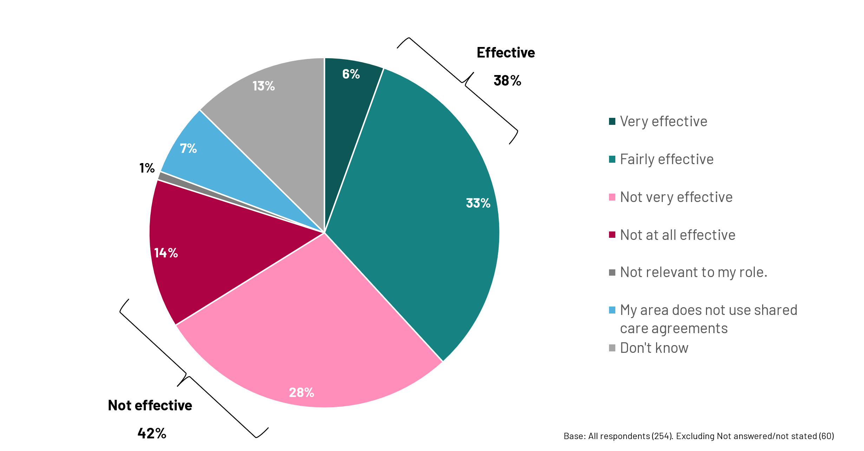
Participants in medical practitioner/ doctor roles and pharmacy roles are more likely to say shared care agreements are not very/ at all effective compared to those in nursing roles (45% and 49% respectively, vs. 28% respectively). Participants working in primary care are more likely to say their area does not use shared care agreements (11% vs. 7% overall).
Shared care agreements were explored in more depth in two open-ended questions in the survey (what is working well/ less well), and in the qualitative interviews. This is discussed below.
Areas working well
Areas of shared care agreements that were felt to be working well centred on:
Having robust systems in place: There were good examples of shared care being supported by clear documentation, efficient systems for monitoring and review, and readily available protocols for commonly prescribed medicines.
"Once a shared care agreement has been accepted by us, the GP practice, we have a robust system with our in-house pharmacy team to ensure the medicine is prescribed appropriately on the clinical system and all monitoring and review requirements are put in place." GP, Primary Care (survey)
Good communication and collaboration: Almost a quarter (23%) of the open-ended responses in the survey focussed on good communication or collaboration being in place. When implemented successfully, shared care agreements were felt to foster positive relationships and communication between primary and secondary care. This was thought to lead to a more holistic and coordinated approach to patient care. For example, participants highlighted instances where shared care facilitated seamless transitions for patients, ensuring better communication between primary and secondary care, and continuity of medicines optimisation and ongoing support.
“The one thing [shared care] does do is it encourages better communication, the best we can get between primary care and the relevant specialist service… it's encouraged better contact, detail sharing…I've got better means of contacting psychiatrists to make them aware maybe of what's happening to their patient or asking questions." GP, Primary Care
Supporting consistency in medicines optimisation across a local area: Centralising shared care agreements at a regional level was seen as beneficial in ensuring consistent access to medicines across different geographical areas, preventing a "postcode lottery" where access varies depending on location.
Challenges implementing shared care agreements
However, several challenges around implementing shared care agreements were discussed.
A significant concern raised by participants was the lack of clarity surrounding roles, responsibilities and accountability when it comes to shared care. This was discussed in a quarter (25%) of the open-ended responses about what does not work well with shared care agreements.
A key issue was the increasing reluctance of GPs to accept shared care agreements. Issues with GPs onboarding with shared care was noted in one in five (19%) responses. This reluctance often stemmed from escalating workloads, GPs’ perceived lack of specialist knowledge in managing psychotropic medicines, and inadequate funding to support the additional responsibilities associated with shared care. A few participants noted that this had been exacerbated following recent industrial action, with GPs "working to rule". It manifested as refusing new shared care requests, or limiting their involvement in monitoring and follow-up. This was creating a substantial tension between providers – which are outlined in the following table:
GPs’ frustrations and concerns included:  - Limited expertise to support complex patients.  - Limited capacity in primary care to take on additional work, and inadequate funding.  - Reliance on referrals back to specialists for advice/ support; access to secondary care being limited due to capacity/ workload; referrals taking time and creating fragmented patient care.  - A perceived lack of monitoring of patients by secondary care – particularly of physical health. | Secondary care frustrations and concerns included:  - GP refusal to manage stable patients who no longer need regular secondary care input.  - Capacity being further stretched in secondary care by having to manage stable patients.  - A perceived lack of monitoring in primary care.  - Perceived lack of willingness among GPs to change doses following a secondary care review.
“Should there be any concerns, the GP has to refer back and for the patient to have an appointment to access specialist review may take unacceptable waiting period… This creates unnecessary delays and risks to patients.” GP, Primary Care (survey)  “Primary care? don't have the resources or skills to monitor these complex patients in the community, so ideally a specialist mental health team should take responsibility…of these complex patients.” GP, Primary Care (survey) | “Many psychotropic medicines, particularly antipsychotics and mood stabilisers, can have significant physical health side effects…However, in some cases, GPs do not regularly monitor these.” Pharmacist, NHS Mental Health Service (survey)  "The GP’s been prescribing their [medicine] for 10 [years]. And then we say, ‘we’ve done a review, can you just slightly increase the dose for us?’ And they say, no, and actually we’re handing it back to you." Nurse, NHS Mental Health Service
Participants emphasised that patients frequently find themselves caught in the middle of a fragmented and confusing system. Reported challenges for patients included:
- Uncertainty and frustration due to variations in how shared care agreements are implemented across different GP practices and regions.
- Confusion as to why a GP is reluctant to prescribe or why they need to attend specialist appointments even when feeling stable. Participants suggested that patients would prefer to be managed within primary care because it is closer to home and more familiar, and avoids the stigma attached to accessing mental health services.
- Disruptions in medicine access and monitoring, with the associated risk of treatment breaks, potential relapse, and adverse events.
"It's just confusing for patients. Like, they don't understand shared care necessarily. Why should they have to understand shared care and the ins and out and complexities of it." Pharmacist, NHS Mental Health Service
“Trying to get people on antipsychotics reviewed in secondary care is near impossible (even those in crisis!) despite the promises in a shared care agreement, and GPs carry all the risk…Mental health services are simply so poorly funded that they cannot provide anything close to the service they are commissioned for.” GP, Primary Care (survey)
Compounding this issue was poor communication between mental health services and GPs. Poor communication and collaboration was a key barrier discussed in the survey (30% mention this). A similar proportion (27%) also discussed referrals being rejected, or lack of continuity or follow-up after discharge from secondary care. Participants noted "Delayed letters. Rejected referrals", and "Total lack of communication". In the qualitative interviews, participants said that communication to primary care can be delayed, inconsistent, unclear or missing information that can lead to confusion and errors among GPs. This was a point particularly observed by pharmacists. Despite information on side effects and management being available within shared care agreements, GPs also noted that access to specialists for further support can be challenging because of their limited capacity.
“There can often be confusion or delays in transferring key information, such as changes in prescribed psychotropic medicines or updates on treatment goals. This disconnect is especially problematic when it comes to monitoring the physical health of patients on long-term psychotropic medicines.” Pharmacist, NHS Mental Health Service (survey)
The process of implementing shared care agreements was also criticised for lacking genuine collaboration and shared decision-making. Participants highlighted instances where GPs felt pressured to accept agreements without sufficient input or opportunity to raise concerns, or even the correct paperwork.
"If we're sharing care with someone, it's about working collaboratively, but the process of doing it doesn't always feel collaborative, you know, and GPs feel like they're almost expected to take it on.” Pharmacist, NHS Mental Health Service
There were also instances where shared care agreements were not being implemented consistently across a whole area – creating further confusion. For example, inconsistencies in how trusts are communicating decisions about shared care, and variation in the documentation being shared/ required by providers.
“Each locality sort of does things a bit differently, depending on their consultant. I don't see why they can't streamline all their processes.” Pharmacist, Primary Care
Other issues noted in the survey included challenges around poor medication reviews (9%) and monitoring and following up (4%). Participants also discussed the lack of medical training and knowledge to carry out roles required of shared care (8%) and the need for specialists to oversee complex cases (7%).
Workload pressures and lack of funding were again identified as the root cause for many of the challenges around implementation of shared care agreements. Participants in the survey discussed shortages of staff/ lack of resources or funding (12%), secondary care services not working well or failing (10%), and poor access/ availability of certain services (5%) as key barriers.
  - Improving communication and collaboration
Survey participants were asked how communication between health and care providers could be improved. Almost three in five participants (59%) believe that shared electronic records or IT systems would improve communication.
      - Improving communication about people, care, and treatment between different health and social care providers
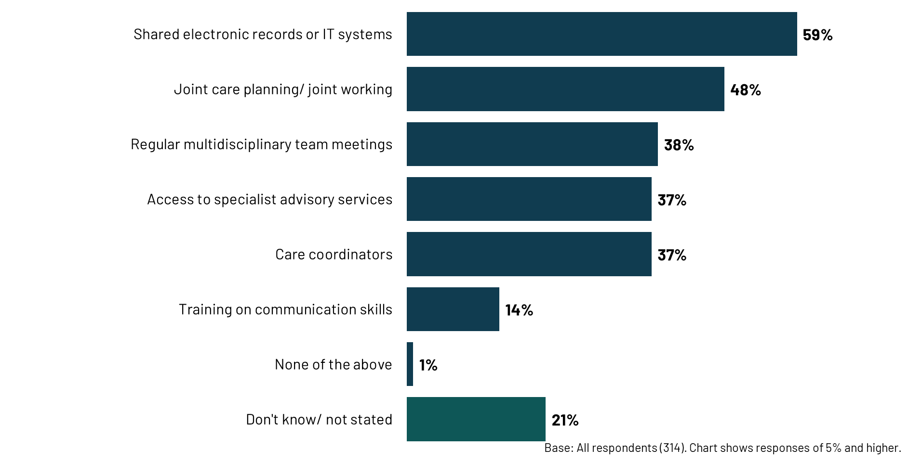
Around half (48%) suggested joint care planning/ joint working would support better communication, and over one in three (38%) suggested regular multidisciplinary team meetings. Those in mental health services were more likely to say joint working is important (60% vs. 48% overall). Participants in the qualitative interviews also discussed the importance of fostering strong relationships and trust between mental health teams and GPs. Approaches found to work well include regular face-to-face meetings, joint training opportunities, and informal interactions. Participants felt this would promote understanding, shared decision-making, and a more collaborative approach to patient care.
“The team manager and service manager have gone to their monthly meeting and just said, this is who we are and has anyone got any issues? And you get to know Dr. Smith and, and you know, once you've met each other and had a cup of tea together…you know each other a bit. And I think those sort of things just thaw relations a little bit, don't they?” Nurse, NHS Mental Health Service
Over one in three say that care coordinators (37%) and access to specialists (37%) would support communication. Those in primary care services were particularly likely to say both these would help (47% of those in primary care say access to specialists would improve communication; 44% say care coordinators would). This was not discussed in the qualitative interviews as a means of supporting communication. However, care coordinators (or a named medical practitioner) were discussed as a feature that is working well in supporting patients to continue to adhere with medicines (discussed in chapter 3). And, as discussed previously, access to specialists was identified as a key challenge in service delivery, and where specialists were embedded directly into community teams, this was felt to be working well.
Improving shared care
Participants would like to see more dedicated funding for monitoring and reviewing of patients on psychotropic medicines within primary care, and more robust specialist support for both patients and GPs.
Other suggestions for improving shared care agreements focussed on:
- Fostering a more collaborative approach: Participants emphasised the importance of genuine collaboration and shared decision-making in the development and implementation of shared care agreements. This included actively involving GPs in the process, addressing their concerns, and ensuring they feel supported and respected.
"I think there just needs to be that collaborative approach. Better record sharing, improvement in quality of information that's provided across the interface, back and forth...And let's have some rational work done on that." Pharmacist, NHS Mental Health Service
- Improving digital record sharing and interoperability between systems would also facilitate information flow and reduce duplication of efforts.
"As a mental health trust we think the GP prescribes, the GP thinks we prescribe, there is no joined-up system to see what is happening. I have seen patients that are under the care of the GP and Trust and have not been prescribed medicines for months and no one has flagged it up until they start to relapse." Pharmacist, NHS Mental Health Trust (survey)
- Greater clarity on roles and responsibilities, and expectations: Ambiguity around roles and responsibilities within shared care agreements is currently creating confusion and frustration for both GPs, pharmacists and specialists. Suggestions to rectify this included creating guidelines on different aspects of shared care, for example the information to be provided in discharge summaries and agreements, and to clarify the process for GPs to follow around monitoring and follow-up.
“There needs to be some standards, I think, around a good outpatient letter to a GP around shared care. What does good look like in terms of shared care?" Pharmacist, NHS Mental Health Service

- Health inequalities
This chapter explores the barriers facing specific population groups that are more likely to experience health inequalities. It summarises the barriers they face, and the approaches that are being taken in different local areas to address these barriers.
Chapter summary
A range of different groups were identified as facing more barriers to accessing support when taking psychotropic medicines in the community. These groups were most commonly people who don’t speak English as their first language, people experiencing homelessness, autistic or neurodivergent people, people with a learning disability and people with multiple long-term health conditions.
The barriers facing these population groups are similar to those discussed throughout the report, though they can be exacerbated for groups more likely to experience health inequalities. The approaches being taken to address them include: improving communication and coordination between services, more proactive outreach and early intervention including extending beyond health services, improved relationships with patients including through continuity of care, and removing other practical barriers. However, despite these efforts, ongoing resource and capacity constraints – for both NHS services and the voluntary sector – mean that these barriers are difficult to overcome.
Participants identified a wide range of population groups in their local areas that face barriers to accessing support when taking psychotropic medicines. The groups most commonly cited in the survey included people who don’t speak English as their first language (53%), people experiencing homelessness (52%), autistic or neurodivergent people (48%), people with a learning disability (46%) and people with multiple long-term health conditions (46%).

      - The population groups that face barriers to accessing support when taking psychotropic medicines
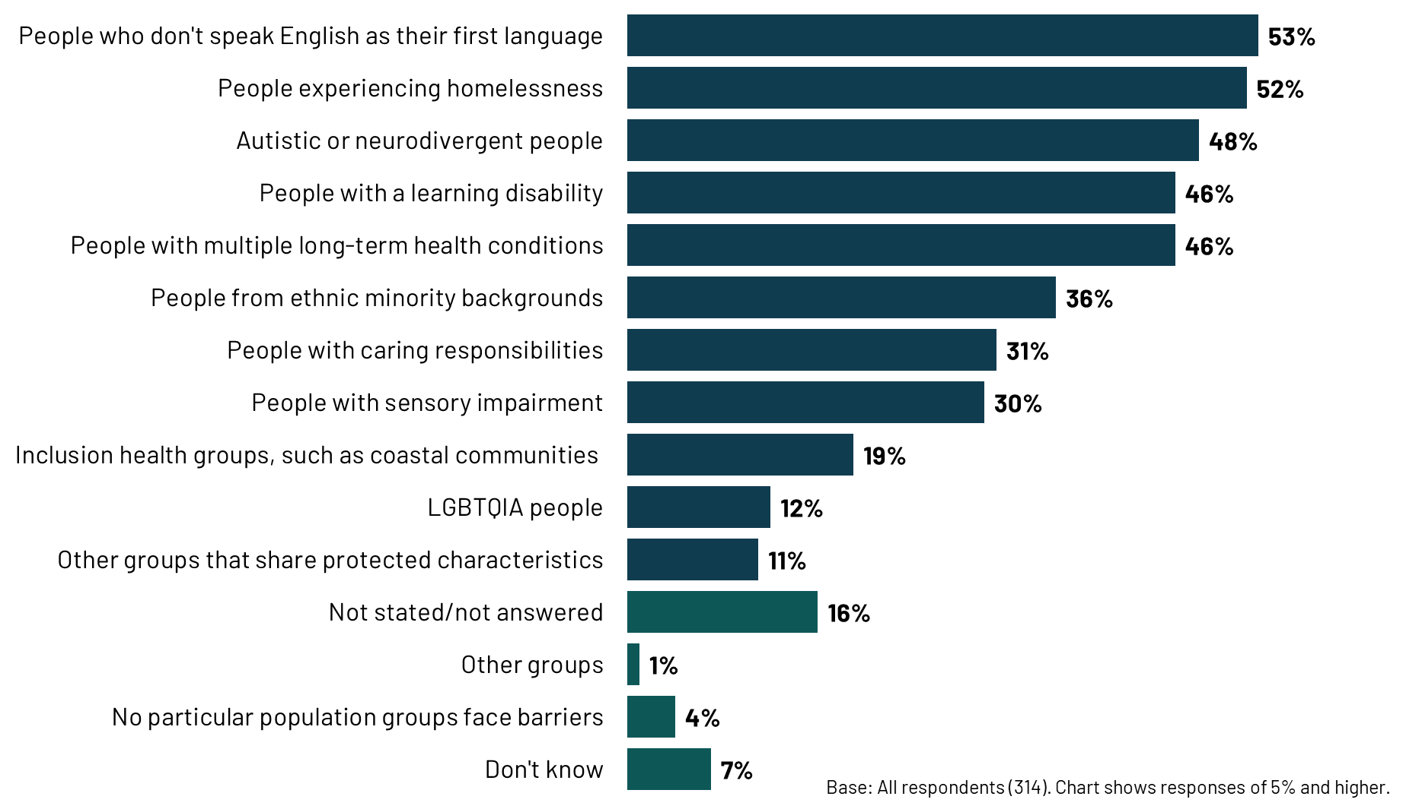
Participants were asked to provide further details about the barriers that specific population groups face in accessing support, with an example showing how these are being addressed in their local areas.
A range of different barriers were identified both in the survey and the depth interviews. These tended to be broader challenges related to supporting all people taking psychotropic medicines in the community, as described throughout this report. However, there were many examples given of where this had specific (and at times, an exacerbated) impact on groups more likely to experience health inequalities.
In the survey, communication issues were the most commonly identified barrier, such as language or interpreter issues (4%), literacy or education issues (3%), and reaching people such as those with no fixed address (1%). There were also seen to be barriers around poor communication between the organisations involved in people’s care, with a lack of information sharing and joined-up working (3%). Another barrier reported was a lack of capacity in services, with long waiting times (6%).
  - Overview of approaches to address barriers
Some key themes emerged across the different population groups in terms of the approaches being taken to address the barriers to accessing support. This section of the report provides an overview of approaches being taken to specific populations, before a more detailed exploration of the barriers and approaches to address these barriers for particular groups.
Improving communication and coordination between services: Often, participants described approaches that meant there was better communication and collaboration between different service providers, including GPs, mental health teams, social services, and community organisations. This included mechanisms such as multi-disciplinary team meetings (facilitated since the Covid pandemic by use of video conferencing), shared care agreements, and integrated care models. Improved cross-team collaboration was also mentioned by 6% of survey participants.
More proactive outreach and early intervention, including looking beyond health services: Other approaches focused on more proactive outreach, rather than expecting some within these population groups to come forward themselves. This was mentioned by 7% of survey participants. Examples given in the interviews included early contact from mental health teams after referral, and working through community-based initiatives and faith and community leaders to reach people who might not otherwise seek help (mentioned by 5% of survey participants). It also meant looking beyond mental health issues to look at wider social needs.
Improved relationships with patients, including through continuity of care: The relationships between healthcare professionals or other staff such as support workers, with individual patients, was a core approach to removing barriers to accessing support. In the survey, 5% noted staff training and education, or cultural awareness, as approaches to address the barriers facing specific population groups.
At times, this was about culturally competent care and communication including training staff on diverse cultural perspectives on mental health, engaging with communities, and developing culturally tailored interventions for addressing disparities. However, beyond culturally competent care, participants talked about providing patients with clear and transparent information, taking the time to talk them through it, and involving patients and carers in decision-making as ways of improving relationships and empowering patients. Being able to provide continuity – for example, through a small team each with a trusted relationship with the patient as in the example below – was also seen as important among these population groups.
“You have a team of people, maybe four or five people that know you really well. So it doesn't matter who's on shift that day. You can phone up and they understand you and they get you and it's like a team approach around you. I think when you've got that type of setup with people that you've grown to trust as professionals around you, then you're more likely to listen to what they're saying and take their advice, and prioritise yourself, and also they'll advocate for you.” Nurse, NHS Mental Health Service
Removing other practical barriers: Participants also described a range of practical approaches to improve access to support, such as improving transport, longer appointments, translations, and reminders about appointment dates.
“You know, if somebody doesn't turn up, it's all they DNA'd. But actually you didn't explore with them that the reason they didn't turn up was because, I don't know, they've got autism. And actually they needed some reasonable adjustments put in place.” Pharmacist, NHS Mental Health Service
  - Barriers to addressing health inequalities in access to support
In the survey, 44% of participants who identified specific populations facing barriers in their local areas, said that they could not identify any examples of how these barriers were being addressed. Participants across the survey and the interviews identified barriers to addressing inequalities, specifically pointing to resourcing constraints and, staff shortages, discontinuing services due to funding, and overall capacity constraints - all which contribute to poorer access to support for those more likely to experience health inequalities. This applies both to NHS services and the voluntary sector. One specific issue raised was the rise in patients needing support for neurodivergence, placing additional pressure on the system.
“Neurodivergent patients face an enormous number of barriers to accessing care, and continuing to access care. The vast increase of ADHD diagnoses and treatment nationally, both NHS and in the private sector, is overwhelming the system presently, meaning those who really need the continued care within current services run the risk of being overlooked.”
Pharmacy, Primary Care (survey)
  - Barriers, and the approaches to overcoming them, for specific population groups
The following sections highlight specific barriers and approaches for some of the key population groups facing barriers.
People who don’t speak English as a first language
People who don't speak English as a first language face significant barriers, with 53% in the survey identifying them as a population group facing barriers to accessing mental health support. These barriers are more prevalent among participants in the North and Midlands (62% and 59% respectively, compared with 53% overall). The most prominent barrier is the language barrier itself, making effective communication challenging, with it being more difficult for people taking psychotropic medicines to understand diagnoses and treatment plans, and access information about available services.
“I think we do see a lot of patients who can't speak very good English and then it's obviously really hard to then have those conversations with them about their medicine and to communicate the importance of the medicine culturally as well.” Pharmacist, NHS Mental Health Service
To address this barrier, participants typically used translation services (mentioned by 8% in the survey), whether in-person or via a telephone service such as Language Line, and these were sometimes seen to work well. This required longer appointment times to allow for the translation. However, challenges were raised with this approach. Some participants in the survey mentioned that access to interpreters was becoming more difficult, and this could lead to relying on family members for translation. Others noted that remote interpretation can be problematic as it misses crucial non-verbal cues, or there could be a lack of clarity via the speakerphone.
Other approaches being taken were to recruit multilingual staff and try to match up patients to staff who speak their language. At times, technology was used, such as translation apps. In addition, information leaflets were available in different languages. A website giving information in different languages was mentioned as one resource that would better support communication with people who don’t speak English as a first language.
People from ethnic minority backgrounds
Individuals from ethnic minority backgrounds were identified as a population group encountering barriers to accessing support by 36% of survey participants. This was particularly the case for participants in the North and Midlands (46% and 41% respectively, compared with 36% overall).
One of the specific barriers mentioned is cultural stigma surrounding mental health. This can lead to a reluctance to seek help, disclose symptoms and engage with medicine. Differing cultural beliefs and practices related to mental health and well-being can also lead to misunderstandings and misdiagnoses. Additionally, it can lead to practical implications such as women wanting appointments with women rather than men.
To address these challenges, participants talked about providing culturally competent services, including providing training for staff on different cultural perspectives on mental health. A small number said they are recruiting a more diverse healthcare workforce that reflects the communities they serve, fostering trust and understanding. In some areas, services are engaging faith groups and community leaders and working through charities to develop culturally tailored interventions and outreach that resonate with the specific needs and beliefs of different ethnic groups.
“It's not perfect by any means, but there is more outreach going on into communities, particularly ethnic minority communities, to say, look, these services are available, you can access interpreters or you can speak to somebody who's from a similar background to you if you don't want to.” Pharmacist, NHS mental health survey

People who are homeless
Around half (52%) of survey participants identified homeless people as a population group facing barriers to accessing support. Numerous obstacles were identified for this group when trying to access support for their mental health and medicines optimisation. These barriers include:
- A lack of stable housing and contact information, making it difficult for healthcare providers to reach people in need, and maintain consistent care.
- Practical challenges related to storage, access, and administration of medicine.
- Miscommunication and unclear pathways within the support system, leading to confusion and difficulty navigating services coupled with less consistent engagement with health services.
- Less commonly, strict criteria for accessing support from certain services, potentially excluding individuals who are not actively street homeless.
A range of local initiatives have been put in place to address these barriers, often including collaboration across NHS services, the Council, charities and the police. Examples include:
- Community mental health trusts offering injections in temporary accommodation or shelters, or on the streets, so that those taking depot antipsychotics can remain on medicine.
- A collaboration across services and agencies, with joint case reviews and the sharing of information, ensuring a ‘no wrong door’ approach for homeless people in which they can access care where it’s needed.
- A charity working alongside the NHS trust to offer outreach and drop-ins.
- A dedicated service for homeless people who are admitted to hospital that engages with them during their stay and, where possible, continues that contact after discharge.
- A specialised homelessness team focused on providing care for homeless people, monitoring their mental health and addressing any issues related to compliance or medicine treatment.
- A young homeless project, providing support with mental and physical health including dental services.
Other practical interventions included homeless people using the practice as a postal address if needed, setting alerts on the patient’s home screen to alert colleagues whenever they present to the surgery in case they need to speak to them, and using local pharmacy colleagues to get in touch with them. Another practice offers walk-in appointments and has four slots per day available with GPs for vulnerable patients who may need to be seen on the day but are unable to call in at 8am or access digital services to book online.
Autistic and neurodivergent people
Autistic and neurodivergent individuals face distinct challenges in accessing mental health support, with 48% of survey participants identifying them as a population group facing barriers to accessing support. Some of the barriers relate to sensory sensitivities, which can mean alternatives to tablets are needed such as liquid or injectable medicines. Communication differences, such as difficulties with social interaction and delayed information processing, can hinder engagement with healthcare professionals. This can be exacerbated by a lack of understanding from some healthcare professionals, and a lack of continuity of care, which can lead to mistrust and difficulty building rapport.
Finally, longer waiting times or a lack of specialised services, can also be barriers for this population group. It can lead them to be referred into mental health services that can be less appropriate for them.
Training such as the Oliver McGowan training, which aims to increase awareness and understanding of neurodiversity among healthcare professionals, was seen to help address these barriers. Another participant talked about the need to make reasonable adjustments to make services work for this population group.
“So I'm just thinking back to when we did, like the COVID vaccine programme. We had patients with autism who we vaccinated in the car park because they couldn't actually come into the building because of whatever was going on with their autism. We adjusted to them.”
Pharmacist, NHS Mental Health Service
In one area, a mental health pharmacist takes the time to review the medicine of autistic or neurodivergent people, offering longer appointments that allow for more tailored communication. They can also provide tailored written information to the patient for afterwards, for those with delays in processing information. In another area, primary care can refer neurodivergent patients to a team within the trust, which provides additional support to both staff and patients to help improve patient outcomes.
People with learning disabilities
People with learning disabilities were identified as another population group facing barriers to accessing support (noted by 46% of survey participants). The barriers they face include: struggling to attend appointments (meaning they can be dependent on others for access); difficulties understanding and discussing their condition and treatment, leading to less involvement in decision-making; and challenges advocating for their needs and navigating complex healthcare systems.
To address these barriers, patients with learning disabilities who are taking psychotropic medicines in the community are asked to attend reviews (often annually). Some areas are making concerted efforts to ensure every individual has one of these, and to improve the quality of the consultation.
In some areas, there are teams providing specialised support to individuals with learning disabilities. These teams are set up differently but can facilitate better access to support, for example with nursing staff able to support adherence or support workers coordinating their care.
Some participants mentioned training, so that healthcare professionals are better equipped to manage this patient group, while practical approaches included having longer consultations, sending reminders about appointments, and offering home visits.
People who are misusing substances
People who are misusing substances such as drugs and alcohol were identified in the depth interviews as another population group facing barriers to accessing support. The barriers they face include getting appointments, attending appointments and medicine adherence. Attitudinal barriers were also mentioned – for example, a view that self-medicating with drugs was a more effective route to recovery than using prescribed medicine.
“They tend to be some of the harder patients to treat and in a way they may feel that actually they don't need the medicines which we're trying to push that they think actually by taking cannabis or whatever medicine illicits they're taking, that they feel that's a better treatment for them.” Pharmacist, NHS Mental Health Survey
To address this, one participant would try to see these patients with a support worker from the Council or housing team and build a relationship with the support worker (including getting their contact details) to make sure that appointments are made and attended.
However, the few participants commenting on this group describe a lack of joined-up services, exacerbated by the range of organisations that can be involved (for example, including the police and drug and alcohol teams) which can impact on their care.
People with severe mental illness
Some participants in the depth interviews identified people with severe mental illness (SMI) as struggling to access the support they need, due to a complex interplay of factors. The key barrier is the ‘lack of insight’ that can accompany these conditions alongside stigma, making it difficult for individuals to recognise their need for treatment, proactively seek help, or follow medicine regimens. Again, it could be difficult for these patients to navigate complex, often fragmented health services.
Participants explained how this is compounded by the pervasive stigma surrounding SMI, both within healthcare settings and society at large. This can deter individuals from disclosing their symptoms or engaging with services. Additionally, systemic issues such as long wait times for specialised care, fragmented services, and a lack of coordinated support can further marginalise this vulnerable population.
To address these challenges, many of the approaches already mentioned were considered to be important. Proactive outreach and assertive engagement strategies from mental health services are crucial for reaching individuals who may not seek help on their own. This includes early intervention programs, community-based outreach initiatives, and close collaboration with other agencies. Equally important is tackling the stigma surrounding SMI through public awareness campaigns, education for healthcare providers, and fostering supportive environments that encourage help-seeking behaviours.
“I think, they lack insight into their health. Just part of having a psychosis or bipolar is part of that condition. And so they won't come forward, they tend not to come forward, they tend not to go to their GP practice like the rest of the population might do if they've got a niggle or a pop or something. And so there is a real need for services to reach out to people with severe mental illness rather than expecting them to come to us.” Pharmacist, NHS Mental Health Service
Other population groups
In addition to those already mentioned, a range of other population groups were identified by one or two participants as experiencing particular barriers. These include people with co-morbidities, immigrants, people with demanding work schedules, people who have recently moved into an area, people who lack family or a strong social support network and who live alone, people who are housebound, single mothers, people living in areas of greater deprivation, and people living in more rural areas.
“The other thing I would really like is for those that are housebound because of their mental health condition, for them to have some form of befriending service, you know, so that somebody can visit them… at home and get them moving again, because there's no real service for them at the moment.” Pharmacist, NHS Mental Health Service
Intersectionality
While this section of the report has looked at the barriers facing specific population groups, and how they are being overcome, it is important to remember that some people taking psychotropic medicines in the community will be part of several population groups. This means there are patients requiring support in the community who have particularly complex lives and require greater support.
“The cohort of patients that I used to look after… who were in a revolving door to our psychiatric wards, got in themselves and bothered with the police, usually had drug and alcohol problems as well, which inevitably led to issues with their housing and their relationships. And those people whose lives have just sort of spiralled, really, probably because they've become mentally unwell. I think they're the most vulnerable people in society, because they're really isolated. And ostracised. And I think for all of those reasons, they stop being offered the support.” Nurse, NHS Mental Health Service
In addition, the group characteristics are not uniform – there will be significant variation within the groups too. For example, some cultures have stronger extended family and community networks helping individuals overcome language barriers, while other do not.
“We've got a Bengali population, but a lot of the Bengali population, they live in extended families, so they get a lot of support. So, I think for them usually there's somebody within the family who speaks English and they bring them in. So, I don't think there's that much of a barrier there. It's more people who are here alone, you know, from Eastern Europe, Polish community, Romanian. So I think sometimes, that's the population that struggles to access.”
GP, Primary Care

- Support and training
This chapter explores the training, advice and support that healthcare professionals are providing on psychotropic medicines. It also looks at the support and resources healthcare professionals would welcome on this topic, and examines the potential role of the CQC in improving care.
Chapter summary
GPs were the most likely recipients of training, advice and support on psychotropic medicines. Pharmacists and those working in mental health services were more likely to provide external training than other staff groups.
To best support community mental health engagement, participants called for reduced workloads, improved inter-organisational communication, and a more collaborative, integrated care approach. Participants identified a need for enhanced specialist knowledge regarding psychotropic medicines, particularly among GPs and non-specialist pharmacists. This included: targeted training on pharmacological aspects, side effects, and monitoring protocols, alongside training on motivational interviewing techniques to improve patient engagement and adherence. Participants also highlighted the importance of trauma-informed care and suggested training on recognising and addressing the impact of trauma on patient engagement.
Participants felt CQC could play a valuable role in disseminating best practice examples, such as successful community mental health team models and patient-centred approaches. Clearer guidance on managing complex medicine regimens, clarifying roles within shared care agreements, and supporting disadvantaged patients was also recommended.
  - Advice and training offered to providers
One in four participants (23%) provide training, advice, and support around psychotropic medicines to GPs. One in ten (11%) provide training, advice, and support to care homes (adult social care), while around one in five (19%) provide support only within their own organisation. A similar proportion (18%) do not provide this support to any external providers.
      - The providers participants’ organisations provide training, advice, and support to
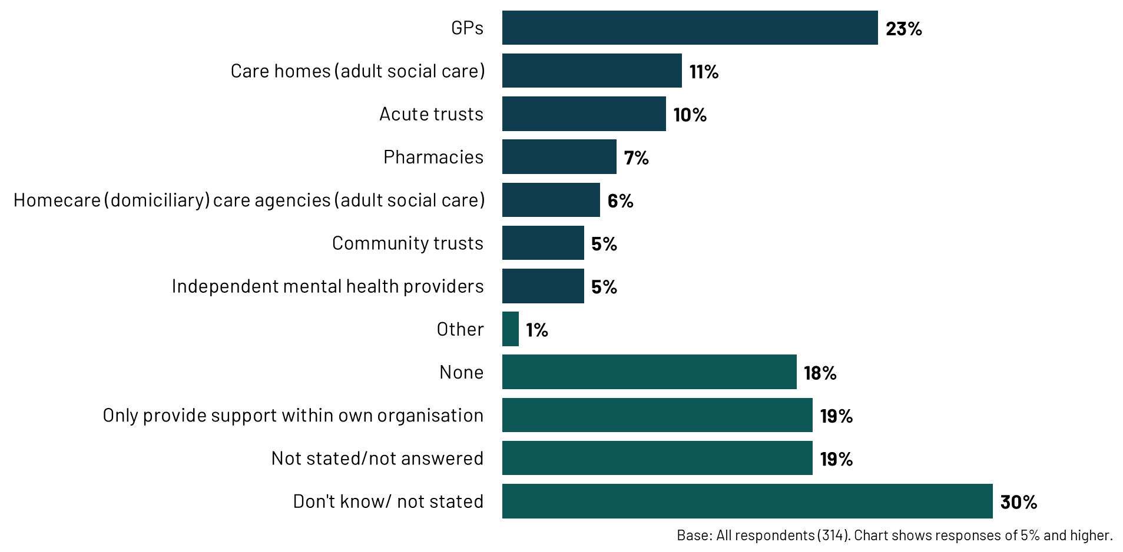
Among survey participants, pharmacists and those working in NHS mental health services are most likely to provide training, advice, and support around psychotropic medicines to external providers:
- Over one in four (27%) participants from NHS mental health services provide support to GPs, 23% to other acute trusts, 13% to care homes, and 10% to pharmacies.
- Pharmacist participants are more likely to be providing training than medical practitioners/ doctors or nursing staff. For example, a third (33%) of pharmacists provide training to acute trusts, compared to 10% overall.
Among participants working in primary care services, one in five (22%) provide support to GPs and one in ten (11%) to care homes.
  - Support and resources for healthcare professionals
When considering how healthcare professionals could be best supported to help people engage with mental health services and treatment in the community, participants most commonly highlighted the need to improve staff workload capacity (mentioned by 64%) and enhance information sharing and joined-up working between organisations (60%).
Around half mentioned that an improved staff skill mix would help (53%), likewise 47% mentioned an improved understanding of other services/ organisations in the area.
While training and development was not the most commonly mentioned improvement, two in five (40%) still think it would support healthcare professionals. In contrast, improved policies and procedures was not commonly mentioned as a way to support healthcare professionals help people engage with mental health services and treatment in the community (22%).
      - Support healthcare professionals need to help people continue to engage with mental health services and treatment in the community
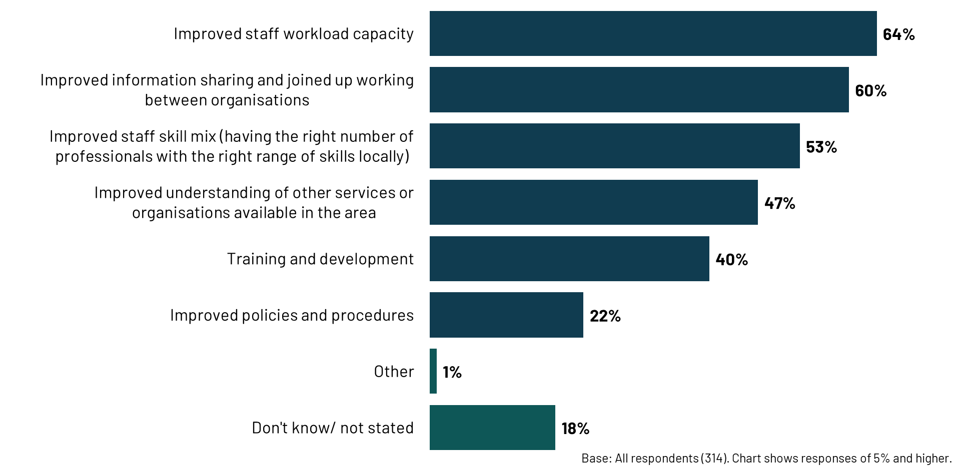
Pharmacists were more likely to say an improved staff skill mix would support them to help people to continue to engage (64% vs. 53% overall), improved understanding of other services or organisations available in the area (63% vs. 47% overall), and training and development (55% vs. 40% overall) would support in the optimisation of medicines than those overall.
The training available to healthcare professionals to support people taking psychotropic medicines, and their needs in this regard, was discussed further in the qualitative interviews.
Some of the professionals interviewed had benefitted from training on medicines optimisation given by pharmacists. However, mostly participants described any training available to healthcare professionals as being inconsistent and non-standardised. With a lack of formal training programmes available, participants talked about healthcare professionals relying upon experience, self-directed learning, and informal mentorship. Some GPs said the training they received on supporting mental health patients came from their time at medical school, and from doing specialty rotations.
As mentioned in both the qualitative interviews and the survey, GPs in particular expressed a concern about not having the specialist expertise required to support patients that have been discharged from mental health services. However, training was not always seen as the answer, with some GPs querying why the responsibility for these patients’ care and prescribing needs falls to them.
Participants discussed areas where support, training and resources could help healthcare professionals in managing psychotropic medicines. Their suggestions were as follows:
Specialist medicine knowledge: Participants identified a knowledge gap among non-specialist pharmacists and GPs regarding psychotropic medicines, their side effects, and monitoring protocols. They suggested targeted training to address this gap would help, focusing on pharmacological aspects, to improve confidence in managing these medicines.
“I think there needs to be more of an awareness from the prescriber about side effects and interactions of medicine with each other…at the moment it's done incorrectly and people then don't recognise withdrawal symptoms.” Pharmacist, NHS Mental Health Service
Motivational interviewing was seen as an effective way of having good quality conversations with patients and supporting patients to feel informed and empowered in their care and treatment. It was suggested that training for all mental health staff in this could improve communication, support patient decision-making, and enhance adherence. In particular, it could tackle the challenge of patients struggling to gain the insight into their condition, and need for medicine (discussed in chapter 2 as a key challenge for maintaining adherence).
Importance of trauma-informed care and understanding the impact of trauma on engagement and treatment was also highlighted as an important area to provide more training and resources on. This includes recognising the potential for power imbalances in healthcare interactions and developing strategies for building trust and rapport with patients who have experienced trauma.
  - Role for CQC
The following chart presents the findings from the survey on what participants feel CQC could do to help their organisation.
      - CQC support
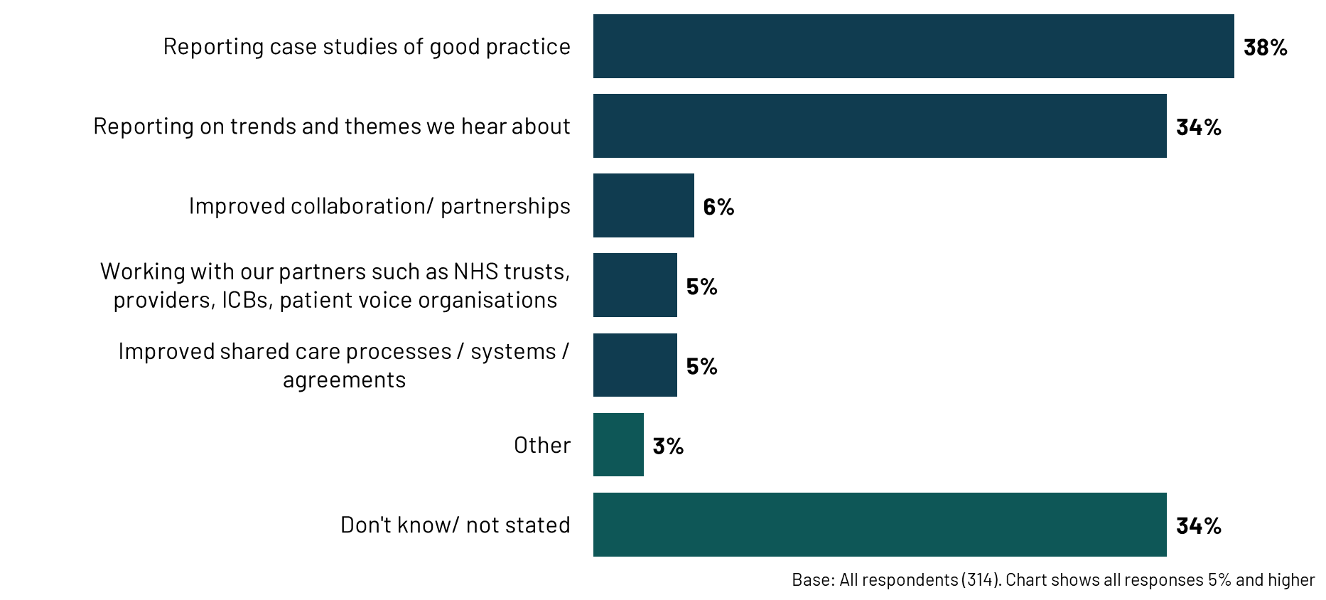
Sharing best practice: Nearly two in five participants (38%) believe that reporting case studies of good practice would be helpful. In the qualitative interviews, participants also suggested that CQC could have a role in developing and disseminating best practice. The types of things they would like to see included:
- What does a good community mental health team look like in terms of skill mix, patient care, safety and outcomes?
- Approaches to patient-centred care, such as shared decision-making tools and resources.
- Examples of innovation.
- Templates and flowcharts to support applicability to local settings.
“I think take examples of best practice and help other organisations to learn from. So I think we are really fortunate in that we've got a very forward thinking mental health trust that seems to genuinely want to improve. I think it is about taking those examples of what can be done and spreading best practice.” GP, Primary Care
However, a small number of participants questioned whether it was CQC’s role to share best practice, noting that this would represent a shift from its current approach and risk duplicating existing sources of best practice.
Around a third (34%) said reporting on trends and themes identified by CQC would be helpful. While this was not discussed in the qualitative interviews, there were areas in which participants felt CQC could exert its influence:
- Encouraging the employment of mental health pharmacists.
- Recognising limited GP specialism in mental health and appreciating the risks of primary care’s role in managing mental health medicine as a result.
Provision of guidance and setting minimum standards: In the qualitative interviews, participants also called for clearer guidance on a range of issues, including:
- Managing and reviewing complex medicine regimens, for example mandating annual psychotropic medicines reviews.
- Clarifying roles and responsibilities within shared care agreements, such as standards on the roles of specialists, GPs and pharmacists in the optimisation of psychotropic medicines.
- Supporting disadvantaged patients.
“It sometimes feels that because there isn't any guidelines or recommendations anywhere of the need to have…pharmacy input or specific targets around medicines, then there's not much to really push organisations to do something about it.” Pharmacist, Mental Health Service
Working with partners and improving shared care: 6% say improved collaboration and partnership should be a focus for CQC. One in twenty (5%) feel that working with partners, such as NHS trusts, providers, ICBs, and patient voice organisations, would be beneficial. The same proportion (5%) say that improving shared care processes/ systems/ agreements should be a focus. This was not raised explicitly in the qualitative interviews when discussing what participants would like to see from CQC. However, the discussions do provide some insight on what this kind of collaborative work could focus on:
- Supporting and improving collaboration, and communication channels, between providers to support the optimisation of psychotropic medicines.
- Facilitating a "mature conversation" around shared care between stakeholders.
- Addressing the uneven distribution of specialist mental health pharmacists across different trusts and creating a more standardised approach to embedding medicine expertise within community mental health teams.
“I think that the regulatory issue is around the interface between primary and secondary care.” GP, ICB & Primary Care

How CQC can use its regulatory mechanisms
Alliance Manchester Business School and The King’s Fund have developed a framework that describes eight ways in which regulation can affect provider performance. The following table summarises the implications for CQC of this research for each impact mechanism.
Impact mechanism | Description of logic/ causal chain/ process | Implications for CQC
Anticipatory | The regulator sets quality expectations, and providers understand those expectations and seek compliance in advance of any regulatory interaction. | Review CQC inspection guidance documents to ensure findings from this report are consistently considered when CQC inspect Community Mental Health Trusts. For example, how are Community Mental Health Trusts engaging with patients who face greater barriers in accessing support.
Directive | Providers take actions that they have been directed or guided to take by the regulator. This includes enforcement actions and, at the extreme, may involve formal legal repercussions such as prosecution or cancellation of registration. | Use regulation to encourage good practice such as employing mental health pharmacists or ensuring that staff are well informed about the side effects and their management, so they can have meaningful conversations with patients.
Organisational | Regulatory interaction leads to internal organisational developments, reflection and analysis by providers that are not related to specific CQC directions. This leads to changes in areas such as internal team dynamics, leadership, culture, motivation and whistleblowing. | Working with partners (such as RPsych and NICE) to develop guidance on shared care between mental health services and GPs, as one example.
Relational | Results from the nature of relationships between regulatory staff (i.e., inspectors) and regulated providers. Informal, soft, influencing actions have an impact on providers. | Encourage CQC relationship owners to use the findings of this report when engaging with services identified as having challenges in managing psychotic medicines in the community. Encourage relationship owners to promote and explore areas that have been identified as good practice in the report - e.g. are there mechanisms in place to provide proactive outreach to patients who are not adhering to their medicines regimes?
Informational | The regulator collates intelligence and puts information about provider performance into the public domain or shares it with other interested parties who then use it for decision-making (e.g., commissioning, patient choice). | Actively promote of the findings of this report across relevant platforms and audiences.
Stakeholder | Regulatory actions encourage, mandate or influence other stakeholders to take action or to interact with the regulated provider. | Use regulatory actions to drive positive outcomes within a local area, for example, by improving communication during the transfer of care in order to minimise the risks of patient harm.
Lateral | Regulatory interactions stimulate inter-organisational interactions, such as providers working with their peers to share learning and undertake improvement work. | Promoting best practice in supporting people taking psychotropic medicines in the community, including positive approaches, such as pharmacists working across organisations.
Systemic | Aggregated findings/ information from regulation are used to identify systemic or inter-organisational issues, and to influence stakeholders and wider systems other than the regulated providers themselves. | Highlighting common challenges for the sector, such as poor communication between organisations and difficulties in establishing and managing shared care agreements.

- Conclusion and implications
The research identifies several key components of good care in the optimisation of psychotropic medicines. These include strong therapeutic alliances between patients and healthcare professionals, proactive and flexible support models that cater to individual needs, and the integration of specialist pharmacists within community mental health teams. Innovative approaches, such as multi-agency wraparound teams and the use of technology to facilitate communication and monitoring, are also showing promise.
However, achieving consistently good care is hindered by a range of challenges. Workforce shortages and capacity constraints within community mental health teams and general practice limit the ability to provide personalised support and proactive monitoring. A lack of robust systems for monitoring adherence to oral medicines, coupled with patients' concerns about side effects, stigma, and a lack of understanding about their medicine, contribute to non-adherence and disengagement from services. Fragmented communication between healthcare providers, particularly within the context of shared care agreements, creates confusion and frustration for both patients and staff, highlighting the need for improved collaboration and information sharing.
  - Implications
The research has identified some key areas where there is scope for improvement:
- Shared care agreements: GPs expressed a lack of capacity and confidence to effectively manage patients under shared care agreements, while participants in secondary care felt GPs should feel they can take on the management of stable patients. Participants thought that more support from specialists and improved communication between primary and secondary care, alongside robust, standardised protocols for shared care agreements would help to minimise confusion, improve accountability, and ensure consistent care for patients.
- Enhancing patient understanding: Poor patient insight into their mental health condition and the role of medicine in their treatment was identified as a key barrier to engagement and adherence. Supporting healthcare professionals to work with patients to empower them (through motivational interviewing, educational materials, peer support groups, and shared decision-making tools) emerged as an area that could help to address these challenges.
- Improving healthcare professionals’ knowledge, confidence and communication skills: Supporting the development of non-specialists' communication skills, confidence and knowledge around discussing psychotropic medicines, side effects, managing expectations, and addressing patients' concerns was felt to be an important area in need of improvement.
- Utilising specialist mental health pharmacy professionals: Where these were in place, they were thought to work well to support people specifically with their medicines, and as a resource that other healthcare professionals can draw on to have these conversations with those taking psychotropic medicines.
- Fostering integration and joined-up care: There were examples of good collaboration and communication, but these were limited. Participants would like to see the wider adoption and consistent implementation of successful community transformation initiatives. They would also like to see technology being leveraged to improve communication, information sharing, and care coordination across the system. This could include shared electronic records, virtual multidisciplinary team meetings, and digital platforms for patient engagement and monitoring.
The survey and interview participants identified several ways they believe CQC could potentially leverage its regulatory authority to improve the optimisation of psychotropic medicines in community mental health settings. Participants highlighted a desire for CQC to:
- Work with partners – with a view to strengthening guidance and standards: Participants suggested there was a need for clear, practical guidance on managing complex medicine regimens. This includes clarifying roles and responsibilities within shared care agreements and supporting equitable access to medicines optimisation support for disadvantaged patients. There is a role for CQC to share findings from this research with partners – for example, with NICE. These insights will be particularly valuable for organisations involved in setting standards and improving practice.
- Promote best practices: There was appetite for CQC to share case studies showcasing successful models of care, innovative approaches, and effective team compositions within community mental health teams.
CQC may also wish to increase its focus on community mental health teams, ensuring that inspections and regulatory activities adequately address the unique challenges of medicines optimisation in these settings, and that its regulation leads to the intended outcomes.
whole system mental health

Appendix

Appendix
  - Questionnaire
RDEC survey – Medicines in Mental Health
SECTION A: Introduction
Thank you for your help with this research.

This survey is being conducted by Ipsos. We are an independent research company. The Care Quality Commission (CQC) has asked us to conduct research on how people are supported to take their medicines for mental health (psychotropic medicines), safely and effectively in the community. CQC also wishes to expand the evidence base on what good care looks like in relation to this.

All the information you provide will be treated in the strictest confidence and only Ipsos will know who said what, unless you tell us something that makes us concerned that you or someone else is at serious risk of harm, in which case we might need to pass this on to somebody else. Ipsos is bound by the Data Protection Act 2018, the UK General Data Protection Regulation 2018 and the Market Research Society Code of Conduct. We will provide anonymised and aggregated findings, and it will not be possible to identify who took part or which organisation they are from when reading the report.

You can access the privacy notice, which outlines further information about how we will use the data from the survey, here.

You can choose to exit the survey at any point and are under no obligation to respond. If you exit the survey before completing it, we may use the information you have provided up until the point you exit.

The survey is designed to be completed by the wide range of individuals who are involved in supporting people in the community with their psychotropic medicines. You might be part of a community mental health team in an NHS trust, a GP or prescriber in a primary care service or integrated care team, or working as an advocate for people in a charity or support organisation – we’re really interested in hearing from you all.

CQC is keen to hear from as many people as possible, so please forward the survey on to other people within your organisation that it is relevant to. This link can be completed by multiple people.

If you have any queries about the survey, please email UK-PA-CMHMedicines@ipsos.com.
If you agree to take part, please click on next.

The research asks you about the management of people taking psychotropic medications. Psychotropic medicines work in the brain. They affect behaviour, mood, consciousness, thoughts or perception. They are used to treat a range of mental health conditions.
Some questions will ask you about what you do in your organisation, and others will ask you about your local area or locality. By local area we’d like you to think about the geographical area within which you usually work. For example, not just the organisation that you work in, but about other organisations in your local area and the services and support they offer.

Section B: Demographics
QA. If you would like to be able to complete this survey in more than one go, please provide your email address
By providing your email address, we will be able to email you a unique link to your response. This link will allow you to return to your response, in the event that you do not want to complete the survey in one go or if you exit this form before you have formally submitted your response.
If you do not want to receive a unique link to your response, you do not need to provide your email address. Email addresses will not be shared with CQC.
What type of organisation do you work for? Please tick all that apply
- Integrated Care Board (ICB)
- Primary care service (such as GP service, Primary Care Network)
- Mental Health charity
- Healthwatch
- NHS mental health service
- Other, please specify
Do you have a patient facing role?
- Yes
- No
What is your professional background? Please tick all that apply
- Medical practitioner/doctor
- Nursing
- Pharmacy
- Other healthcare professional
- Social care professional
- Non-healthcare professional
- Other, please specify
Which NHS England Area are you located in?
- South East
- South West
- London
- East of England
- Midlands
- North West
- North East and Yorkshire
We’re now going to begin the main survey questions, please do not write identifiable personal information about you or anyone else in your responses

SECTION C: Patient experience
Q1 In your experience, what are the three biggest concerns people have about taking their psychotropic medicine? Please select up to 3 options only.
- Side effects
- Lack of effectiveness
- Perceived stigma
- Dependency
- Requirements for administration of medicine (e.g. frequency, route)
- Requirements for additional monitoring
- Prescription cost to the patient
- Impact on physical health
- Lack of involvement in decision making
- Medicines supply issues
- Other – please specify
- Not relevant to my role/organisation
- No concerns
- Don’t know
Q2 Where people are non-adherent with psychotropic medicines, what are their reasons for this? Please select all that apply.
- Forgetting doses
- Side effects
- Lack of understanding about what the medicine is for and how long to take it
- Impact on physical health
- Fear of dependency
- Perceived stigma
- Prescription cost to the person
- Interference with day to day activities
- Medicines supply issues (shortages)
- Difficulties accessing medicines (i.e. having to travel to pick up or receive a dose)
- Barriers in communication between people and providers
- Belief that the medicine is not effective, or needed
- Cultural or religious beliefs around medicines
- Complexity of medicines regime (i.e. multiple medicines and complex dosing schedules)
- Other – please specify
- Not relevant to my role/organisation
- Don’t know
Q3 And in your experience, what are the three main reasons people are non-adherent with psychotropic medicines? Please select up to 3 options only.
- Forgetting doses
- Side effects
- Lack of understanding about what the medicine is for and how long to take it
- Impact on physical health
- Fear of dependency
- Perceived stigma
- Prescription cost to the person
- Interference with day to day activities
- Medicines supply issues (shortages)
- Difficulties accessing medicines (i.e. having to travel to pick up or receive a dose)
- Barriers in communication between people and providers
- Belief that the medicine is not effective, or needed
- Cultural or religious beliefs around medicines
- Complexity of medicines regime (i.e. multiple medicines and complex dosing schedules)
- Other – please specify
- Don’t know
Q4 In your local area, what is most effective, if anything, when supporting people to be involved in decisions about their care and treatment with psychotropic medicines?
Please include support available at the point of prescribing and during ongoing treatment.
Please select all that apply.
- Medication review
- Providing accessible information
- Encouraging people to draw on support from charities, peers, support groups etc.
- Providing continuity in the care team
- Support from mental health specialist teams
- Including people in Multidisciplinary team discussions
- Digital solutions, please specify
- Other, please specify
- Nothing
- Don’t know
Q5 In your local area, what is most effective, if anything, when reviewing and monitoring people who are taking psychotropic medicines? Please select all that apply.
- Regular medication reviews
- Therapeutic drug monitoring
- Side effect monitoring and management
- Clear communication and documentation across the healthcare professionals involved
- Personalised crisis plans
- Access to records and results
- Having shared care arrangements in place
- Drawing on support from charities, peers, support groups etc.
- Supporting and educating family members and carers about the condition, medicines and potential risks
- Regular risk assessments
- Multidisciplinary team approach
- Technology/ digital tools, please specify
- Other, please specify
- Nothing
- Don’t know
SECTION D: Support for people taking psychotropic medicines
Q6 In your experience, what support, if any, is most effective in helping people take their psychotropic medicines in the community as prescribed? Please select all that apply.
- Education materials for people taking medicines (i.e. written, videos, audio)
- Support groups
- One to one consultations
- Medication review clinics (including choice of medicines and how they are taken)
- Specialist clinics (e.g. side effect clinics, adherence clinics)
- Technology for people – e.g. apps/reminders
- Technology for staff - please specify
- “Reminder” service to prompt people about appointments
- Support from mental health pharmacy professional (from a local mental health service)
- Support from a GP based pharmacy professional
- Support from a community pharmacy professional
- Medicines compliance aids
- Support for people to order and receive their medicines
- Education/support for carers who help people with their medicines and/or physical health
- Other – please specify
- Nothing
- Not relevant for my role/organisation
- Don’t know
Q7 What, if any, types of support to help people take their psychotropic medicines in the community as prescribed, are not available in your local area, that you would like to be made available? Please select all that apply.
- Education materials for people taking medicines (i.e. written, videos, audio)
- Support groups
- One to one consultations
- Medication review clinics (including choice of medicines and how they are taken)
- Specialist clinics (e.g. side effect clinics, adherence clinics)
- Technology for people – e.g. apps/reminders
- Technology for staff - please specify
- “Reminder” service to prompt people about appointments
- Support from mental health pharmacy professional (from a local mental health service)
- Support from a GP based pharmacy professional
- Support from a community pharmacy professional
- Medicines compliance aids
- Support for people to order and receive their medicines
- Education/support for carers who help people with their medicines and/or physical health
- Other – please specify
- Nothing
- Not relevant for my role/organisation
- Don’t know
Q8 In your experience, what support, if any, is most effective in supporting people on psychotropic medicines with their physical health? Please select all that apply.
- Access to social prescriber
- Access to health checks
- Signposting to support for healthy lifestyle changes
- Access to physical health nurse
- Access to specialist mental health pharmacy support
- Medication reviews
- Specialist clinics (e.g. side effect clinics, adherence clinics)
- Support groups
- Education/support for carers who help people with their medicines and/or physical health
- Other, please specify
- Nothing
- Not relevant to my role/organisation
- Don’t know
Q9 What, if any, types of support to help people on psychotropic medicines with their physical health, are not available in your local area, that you would like to be made available? Please select all that apply.
- Access to social prescriber
- Access to health checks
- Signposting to support for healthy lifestyle changes
- Access to physical health nurse
- Access to specialist mental health pharmacy support
- Medication reviews
- Specialist clinics (e.g. side effect clinics, adherence clinics)
- Support groups
- Education/support for carers who help people with their medicines and/or physical health
- Other, please specify
- Nothing
- Not relevant to my role/organisation
- Don’t know
Q10 Some people disengage with mental health services and treatment in the community. Please provide one example of what is working well in your organisation or local area to support people to continue to engage.
Where possible please specify:
- The support that is being offered
- Who offers this support
- Who support is provided to
- Any views you have on how well this is working
Please do not write identifiable personal information about you or anyone else in your responses.
- OPEN TEXT BOX
- I cannot think of any examples of what is working well
- Prefer not to say

Q11 What support, if any, do healthcare professionals in your local area need to help people continue to engage with mental health services and treatment in the community? Please select all that apply.
- Training and development
- Improved information sharing and joined up working between organisations
- Improved staff skill mix (having the right number of professionals with the right range of skills locally)
- Improved staff workload capacity
- Improved policies and procedures
- Improved understanding of other services or organisations available in the area
- Other, please specify
- No support is needed
- Don’t know
Q12 What population groups in your local area, if any, face barriers to accessing support when taking psychotropic medicines?
Please think about barriers to accessing support to take medicines as prescribed and support with physical health.
Please select all that apply.
- People from ethnic minority backgrounds
- People with a learning disability
- Autistic or neurodivergent people
- People with multiple long-term health conditions
- People who don’t speak English as their first language
- People with sensory impairment
- Inclusion health groups, such as coastal communities (where there may be small areas of high deprivation hidden amongst relative affluence)
- LGBTQIA people
- People experiencing homelessness
- People with caring responsibilities
- Other groups that share protected characteristics as defined by the Equality Act 2010
- Other groups (please describe)
- No particular population groups face barriers
- Don’t know
Q13 Thinking about the barriers specific population groups face accessing support, please provide one example showing how these are being addressed in your local area.
Where possible please specify:
- The population group
- The barriers they face
- How the barriers are being addressed
- Any views you have on how well this is working
Please do not write identifiable personal information about you or anyone else in your responses.
- OPEN TEXT BOX
- I cannot think of any examples of how these are being addressed
- Prefer not to say

SECTION E: Challenges and risks
Q14 In your experience, what are the three main challenges your service faces when supporting people taking psychotropic medicines? Please select up to 3 options only.
- Lack of physical health monitoring or follow up
- Ineffective medication reviews
- Poor communication across services
- Delayed or inability to access care due to lack of services offered or waiting lists
- Delayed or inability to access care due to clinicians’ referrals being rejected
- Practical challenges with accessing care (such as service opening times or locations)
- Challenges with shared care arrangements
- Lack of patient engagement
- Lack of time
- Team skill mix
- Lack of training and/or professional support
- Digital systems
- Escalating concerns
- Other – please specify
- We don’t face any challenges
- Not relevant to my role
- Don’t know
Q15 To which health and social care providers, if any, does your organisation provide training, advice and support around psychotropic medicines? Please select all that apply.
- Acute trusts
- Community trusts
- Independent mental health providers
- GPs
- Pharmacies
- Care homes (adult social care)
- Homecare (domiciliary) care agencies (adult social care)
- Other (please specify)
- None
- Only provide support within own organisation
- Don’t know
Q16 How could communication about people’s care and treatment between different health and social care providers (including during transfer of care) be improved? Please select all that apply.
- Shared electronic records or IT systems
- Regular multidisciplinary team meetings
- Care coordinators
- Joint care planning/ joint working
- Training on communication skills
- Access to specialist advisory services
- Other, please specify
- I don’t think this needs to be improved
- None of the above
- Don’t know

Q17 In your local area, how effective, if at all, is the implementation of shared care agreements in relation to psychotropic medicines?
- Very effective
- Fairly effective
- Not very effective
- Not at all effective
- Not relevant to my role.
- My area does not use shared care agreements
- Don’t know
Q18 Please provide an example of what works well in relation to the implementation of shared care agreements for psychotropic medicines, in your local area. Where relevant please include experiences of monitoring physical health.
Please do not write identifiable personal information about you or anyone else in your responses.
- OPEN TEXT BOX
- I do not have anything to say at this question
- Prefer not to say

Please provide an example of what doesn’t work well in relation to the implementation of shared care agreements for psychotropic medicines, in your local area. Where relevant please include experiences of monitoring physical health.
Please do not write identifiable personal information about you or anyone else in your responses.
- OPEN TEXT BOX
- I do not have anything to say at this question
- I don’t know

SECTION G: Regulation and improvement
Q19 What, if anything, could CQC do to help your organisation improve how you support people who are taking psychotropic medicines in community settings? Please select all that apply.
- Reporting on trends and themes we hear about
- Reporting case studies of good practice
- Offering guidance (Please specify what would be helpful)
- Working with our partners such as NHS trusts, providers, ICBs, patient voice organisations. (Please specify what would be helpful)
- Other (please specify)
- Don’t know

Q20 Is there anything else you would like to tell us about?
Note: This could include examples of good practice or improvement projects in your organisation, or local area such as between providers and/or other organisations. It could also cover any additional concerns not already raised in this survey, or ideas for future improvements or people’s needs.

Please do not write identifiable personal information about you or anyone else in your responses
- OPEN TEXT BOX
- I do not have anything to say at this question
- I don’t know

Ipsos will be conducting some follow up interviews in the next few months as part of this research study. Your input is really important to help CQC better understand best practice in supporting people who take psychotropic medicines. Would you be happy for Ipsos to invite you to take part in further research on this topic conducted on behalf of CQC, within the next 12 months? You would be under no obligation to take part.
- Yes
- No

Thank you for confirming you are happy to be recontacted for further research on this topic conducted on behalf of CQC. Please enter your email address and phone number below.

Thank you for taking part in this survey. Please click ‘Submit’ to submit your response.

  - Discussion Guide
Discussion guide for CQC Mental Health Medicines Research
This guide is designed to be used for qualitative interviews with individuals involved in the management of psychotropic medicines in the community.
The aims of these interviews are to explore early findings from the survey in more depth. The interviews will be gaining more insight into:
- Supporting patients to engage with psychotropic medicines.
- Communication and collaboration in the local area, specifically in relation to the transfer of care, and shared care arrangements.
- Health inequalities in relation to supporting people with their psychotropic medicines.
- Throughout, identifying challenges, support needs, areas of innovation, good practice, and how CQC can support the management of psychotropic medicines in the community.
Interviews will be held to a total of 15 with: GPs (at least 3), Pharmacy Professionals (at least 3), Mental Health Nurses & Medics (at least 3), ICS Representatives (at least 1), Patient Voice Organisations (at least 1).

Purpose of this discussion guide:
Throughout the qualitative interviews, it is important to probe on why participants hold the views they do. Given their very nature, qualitative interviews are exploratory – it is unlikely that all of these questions will be asked; the discussion guide is designed to be an ‘aide memoir’ for the interviewer. Not all questions in the guide will be covered with every participant – what questions are asked will depend on participants’ knowledge and experiences.

This document should provide an understanding of the aims of the discussion, structure of the interview and the proposed line of questioning. Answers provided by participants will be thoroughly probed to ensure a full explanation is given and understanding secured.

Further information for interviewers:
The interview is designed to explore what is in place in the participant’s local area. By this we mean the geographical area within which they usually work. For example, not just the organisation, but other organisations in the local area and the services and support they offer.
For Patient Voice Organisations – ‘local area’ may not be relevant so please ask questions more generally about support that is in place in different areas.
Please familiarise yourself with the profiling information available for the provider you interview before you start the interview (role and whether a patient facing role or not / organisation/ region). Please also familiarise yourself with relevant survey answers for the participant – these have been indicated throughout the guide.

Interviews will last up to 60 minutes and be conducted over MS Teams, or by phone if this is preferred.
Introduction (5 minutes)
Thank participant for taking part and completing the survey and introduce self and Ipsos.

Purpose of the research: The aim of this research is to explore how people are supported to take their medicines for mental health (psychotropic medicines), safely and effectively in the community. The research is being conducted on behalf of CQC, who are interested in expanding the evidence base on what good care looks like in relation to this.

Confidentiality: We are interviewing 15 people who took part in the survey, and the aggregated findings will be reported back to CQC, without your name or the name of your organisation attached. Only Ipsos will know that you have taken part and what you said. You will not be named in any reporting. Interview transcripts/ notes will only be used for analysis purposes, and not be shared with CQC or anyone outside of Ipsos.

Interview length: Up to 60 minutes depending on what they have to say and the time they have available.

Permission to record: For analysis purposes. Ensure consent to participate is audio recorded. Remind participant that all recordings will be stored on a secure server, and destroyed within 3 months of the project close.

Section 1: Individual and local context (5 minutes)
Could you describe your role and involvement in supporting people taking psychotropic medicines in the community?
- Explore whether it’s a central part of their role, or a smaller part of a wider role
- Length of time working in this area/ previous experience of providing support
- Patient facing?

I’d like to understand a bit more about your local context, and what is in place to support people in the community with taking psychotropic medicines:
- IF PATIENT FACING: First of all, could you describe the team you work in. What are the team’s responsibilities for supporting people with taking psychotropic medicines? What is the configuration of this team (e.g. size/ type of professionals/ skill mix)?
- What services are involved supporting people who take psychotropic medicine, in the community (in your local area)?
Section 2: Patient engagement & adherence (12 minutes)
For these questions, interviewers to check (throughout) whether views are a result of their own experience/ what they hear directly from people using services, or whether this is what they understand generally (e.g. from others).

Can you briefly summarise what factors contribute to people disengaging from mental health services?
- What creates negative experiences for people accessing services?
- How easy or difficult is it to overcome this? Why?

And (if different), briefly what factors contribute to people struggling to adhere to their medication regimens? (Refer to answer given in PENONADHERE/ ADHERETOP3)
- How are services not meeting the needs of patients in relation to adherence to medication regimens? Why is this?
- How easy or difficult is it to overcome this? Why?

What is the process locally to monitoring and reviewing a person’s medication?
- What works well? What works less well?

In the survey you told us about some different approaches to supporting patients to stay engaged with mental health services and adhere to treatment plans for their psychotropic medication. I’d like to focus on that a bit more…

How are people supported to stay engaged with mental health services and adhere to their treatment plans in your local area? (Refer to answer given in SUPPDISENGAGE)
- Probe around each:
  - engagement more generally – and what happens when someone disengages with services
  - adhering to treatment
- FOR EACH MENTIONED:
  - What support is available at this stage, in your local area? From what services/ individuals? What is the format of this support?
  - Probe around: reviews, charities, digital support for healthcare professionals/ people, different professionals/ individuals involved
  - What works well? Why? What works less well? Why?

Are there any (other) innovative approaches you've seen or implemented to improve engagement and adherence?
- Confirm if relevant – is this offered in your local area or not (i.e. they have just heard about it)?
- Please tell me more about this: what is it? In what way is it innovative? How effective is this approach and why? What are the challenges and why?

How could engagement and adherence be improved in your area?
- Clarify whether this is for engagement of adherence

What creates positive experiences and good outcomes for people accessing mental health services?
- What do you consider good practice? E.g. are there key principles to maintain? Are there key services that must be involved? Are there key touchpoints with people?
- To what extent are you able to achieve best practice in your area? Why/ why not?

IF TIME:
Do you collect any patient feedback on mental health services in your area?
- Gather details e.g. on format/ regularity/ focus
- How do you use this feedback in your organisation/ in the local system?

What training and support do healthcare professionals receive to support people taking psychotropic medicines?
- Gather details on format/ regularity/ focus
- How could training and support be improved?

Section 3: Communication, collaboration & shared care (8 minutes)
How well is communication and collaboration between different health and care providers involved in a person's care concerning psychotropic medicines, working in your area?
- What formats/ forums are available? Who is involved and how?
- What works well?
- What are the barriers? What challenges does this cause you/ your team/ people taking psychotropic medicines?

Do you/ do services use shared care agreements in your local area?

How are shared care agreements implemented in your local area?

From your perspective, what are the benefits and drawbacks of using shared care agreements for people prescribed psychotropic medications? (Refer to SCAMONREV and follow-up questions)
- What works well when using shared care agreements?
- What are the main challenges when using shared care agreements?

How could the use of shared care agreements be improved in your local area?

More generally, what measures could be taken to improve communication between health and care providers in your area, to aid the management of psychotropic medicines?
- Specially, during transitions of care?
- E.g. improve clarity of roles and responsibilities/ communication/ training and development

Can you share any examples of successful collaborative initiatives that have had a positive impact on patient care?
- What were they/ when were they implemented/ who did they involve/ how effective were they/ why did they work well or poorly/ how could they have been improved?

Section 4: Addressing Health Inequalities (8 minutes)
IF POPULATION FACING BARRIERS MENTIONED IN SURVEY: In the survey you mentioned that (INSERT POPULATIONS FROM POPBARRIERS) face particular barriers in accessing support for managing psychotropic medications. Can you tell me a bit more about this…
- What specific barriers do they face? How does this differ across groups?
- How are services not meeting the needs of this group?
- How are these barriers being addressed (if at all)? (refer to answer to BARRIERSADDR)
- To what extent is this working well or not? Why?

IF NO POPULATION FACING BARRIERS MENTIONED IN SURVEY: You mentioned in the survey that you were not aware of any populations facing particular barriers to accessing support. Could you elaborate on this: why is this?
- Have you carried out any specific work/ initiatives to address any barriers? What were they/ for whom?
- Are there any groups that may face challenges, even if that hasn’t occurred in your area yet? Is your organisation doing any work to mitigate this?

What improvements would you like to see in your local area to:
- Address any barriers that may restrict equitable access?
- Improve experience/ support for specific populations?

Section 5: Future outlook & recommendations (8 minutes)
Are there any other challenges your service/ your area faces when supporting people taking psychotropic medicines, that we haven’t covered so far? Please tell me more.

What key changes or improvements would you like to see in your local area, regarding the management of psychotropic medicines in the community?

What support or resources would help services to better assist patients who are taking psychotropic medicines? (Refer to answer to SUPPHELPENGAGE)
- FOR EACH: can you tell me a bit more about what would be helpful? Who in your area would benefit from this?

How could CQC help your organisation/ area improve the management of psychotropic medicines locally through their regulatory role?
- Refer to CQCHELP and probe on: reporting on trends/ themes; case studies of good practice; guidance; working with partners
- Please tell me a little more about what you would value: e.g. what topics, what format?

Closing (3 minutes)
Is there anything else you'd like to add or emphasise regarding this topic?

Thank you for your time and contribution to this important discussion.

Next steps for the research: we’ll be writing a report for CQC, shared in April. CQC may publish aspects of the report – e.g. the executive summary.

Our standards and accreditations
Ipsos’ standards and accreditations provide our clients with the peace of mind that they can always depend on us to deliver reliable, sustainable findings. Our focus on quality and continuous improvement means we have embedded a “right first time” approach throughout our organisation.
 | ISO 20252  This is the international specific standard for market, opinion and social research, including insights and data analytics. Ipsos UK was the first company in the world to gain this accreditation.

Market Research Society (MRS) Company Partnership
By being an MRS Company Partner, Ipsos UK endorse and support the core MRS brand values of professionalism, research excellence and business effectiveness, and commit to comply with the MRS Code of Conduct throughout the organisation & we were the first company to sign our organisation up to the requirements & self-regulation of the MRS Code; more than 350 companies have followed our lead.
 | ISO 9001  International general company standard with a focus on continual improvement through quality management systems. In 1994 we became one of the early adopters of the ISO 9001 business standard.
 | ISO 27001  International standard for information security designed to ensure the selection of adequate and proportionate security controls. Ipsos UK was the first research company in the UK to be awarded this in August 2008.
 | The UK General Data Protection Regulation (UK GDPR)  and the UK Data Protection Act 2018 (DPA)  Ipsos UK is required to comply with the UK General Data Protection Regulation (GDPR) and the UK Data Protection Act (DPA). These cover the processing of personal data and the protection of privacy.
 | HMG Cyber Essentials  Cyber Essentials defines a set of controls which, when properly implemented, provide organisations with basic protection from the most prevalent forms of threat coming from the internet. This is a government-backed, key deliverable of the UK’s National Cyber Security Programme. Ipsos UK was assessed and validated for certification in 2016.
 | Fair Data  Ipsos UK is signed up as a “Fair Data” company by agreeing to adhere to twelve core principles. The principles support and complement other standards such as ISOs, and the requirements of data protection legislation.

For more information
3 Thomas More Square
London
E1W 1YW
t: +44 (0)20 3059 5000
www.ipsos.com/en-uk
http://twitter.com/IpsosUK
About Ipsos Public Affairs
Ipsos Public Affairs works closely with national governments, local public services and the not-for-profit sector. Its c.200 research staff focus on public service and policy issues. Each has expertise in a particular part of the public sector, ensuring we have a detailed understanding of specific sectors and policy challenges. Combined with our methods and communications expertise, this helps ensure that our research makes a difference for decision makers and communities.

The state of health care and adult social care in England 2023/24 - Care Quality Commission
Special review of mental health services at Nottinghamshire Healthcare NHS Foundation Trust - Care Quality Commission
Partial responses were included in the analysis if participants answered key questions relevant to the research objectives.
Percentages in the charts may not total 100% due to rounding, or in cases where participants were able to select multiple responses.
Participants in NHS mental health services are also more likely to say these three areas are effective. Survey participants working in mental health services are predominantly pharmacists so it is likely that the alignment in these two groups is because they are the same participants. Side effect monitoring and management: 72% pharmacists and 73% in NHS mental health services vs. 57% overall. Clear communication and documentation: 72% pharmacists and 68% in NHS mental health services vs. 61% overall. Supporting and educating family members and carers: 61% pharmacists and 61% in NHS mental health services vs. 49% overall.
https://www.nhs.uk/using-the-nhs/about-the-nhs/friends-and-family-test-fft/
community-mental-health-framework-for-adults-and-older-adults.pdf
https://www.hee.nhs.uk/our-work/learning-disability/current-projects/oliver-mcgowan-mandatory-training-learning-disability-autism
https://www.kingsfund.org.uk/insight-and-analysis/reports/impact-cqc-provider-performance

