
PUBLIC BOARD MEETING

Date: | 24 September 2025 | Agenda item: 5.4  Paper number: CM/09/25/54
Title of paper: | Performance, Risk and Finance Report (Quarter 1 and July 2025)
Purpose of paper: | For assurance
Executive sponsor: | Chris Usher (Executive Director of Finance and Corporate Services)
Presenter(s) or lead person: | Chris Usher (Executive Director of Finance and Corporate Services)
Summary:
This item enables the Board to fulfil its duties in relation to holding the Executive Team to account for performance of the organisation; ensuring robust and effective systems of risk management; and ensuring financial probity and the efficient and effective use of resources, it includes the following:
- Performance monthly balance scorecard covering Quarter 1 (to June 2025) and July 2025.
- Risk update.
- Finance update covering Quarter 1 and July 2025.

Recommendations:
- The Board is asked to note the performance to date and seek clarification as required of Executive Team members.
- The Board is asked to note the Risk update and seek clarification as required of Executive Team members.
- The Board is asked to note the Finance update and seek clarification as required of Executive Team members.

- Performance:

The following outlines our performance against our key measures for Q1 and July 2025:

Immediate Actions Measures (Slides 3 and 4):
- Assessments – At the end of June 2025, 1,435 assessments had been completed, with 443 completed in April, 452 completed in May and 540 completed in June. July saw an increase of 541 assessments, resulting in 1,976 assessments being completed so far this financial year. This exceeded monthly targets towards a trajectory of 9,000 assessments by September 2026.
- Registration – At the end of June 2025, 3,956 (33.1%) of registration applications in the system were over 10 weeks old. Registration applications in the system over 10 weeks old remained at 33.1% in July and 5,546 applications were received which is an increase on the volumes received monthly throughout Q1. Targeted actions are in place to improve registration processes, including a Rapid Improvement Event to improve the application journey for Domiciliary Care Agencies, given the high volumes from this sector.
- Information of Concern – This area is below expectation. However, there has been a focus on clearing historical backlogs as well as the competing priorities of colleagues delivering assessments. Delivery is being monitored closely and detailed below:
  - Priority 1 referral: Q1 saw an improvement in Priority 1 Information of Concern cases with referrals sent within 2 days by NCSC and this sat at 97.4% in June against a target of 95%. However, there was a decline in July to 89.5%.
  - Priority 1 action: Q1 saw Priority 1 Information of Concern cases having an action taken by operational colleagues within one day of referral at 78.2% against a target of 95%. This increased to 81.5% in July.
  - Priority 2 cases having an action recorded within 10 days sat at 89.1% in Q1, falling to 86.1% in July.
  - Priority 3 cases having an action recorded within 10 days sat at 81.6% in Q1, increasing to 83.2% in July.

Regulatory Effectiveness (slide 5)
- FOIs – At the end of June, 95.4% of FOIs were answered to standard against a target of 95%. July saw a slight decline in the % of FOIs answered to standard, sitting at 94.7%, falling just shy of the target of 95%.
- Subject Access Requests (SARs) - At the end of June, 91.5% of SARs were answered to standard against a target of 95%. July resulted in an increase to SARs being answers to standard and met KPI at 95.2%.
- MNSI – 98% of Maternity and Newborn Safety Investigations had contact with Trusts within two days against a target of 80% in June 2025. This increased to 99% in July. 100% of families were contacted within five days in June and 98% in July. 43% of investigations were completed within six months against a target of 60% and this increased to 44% in July. Work is underway to deliver improvements in this area.
- NCSC Call Lines – All NCSC call lines met their targets at the end of Q1. Sitting at 95.0% for Safeguarding lines, 90.6% for Registration lines, 93.1% for Mental Health lines and 84.2% for General Enquiries. All NCSC call lines continued to improve and meet their targets at the end of July. Sitting at 95.1% for Safeguarding lines, 91.3% for Registration lines, 94.1% for Mental Health lines and 85.1% for General Enquiries.
- Local Authority Assessments – By the end of June 2025 97 Local Authority Assessment site visits had taken place, with 67 having been completed in the last financial year. 45 Local Authority Assessment reports were published by the end of June. July saw six Local Authority Assessment site visits taking place, bringing the number to 103 at this point in the financial year. 53 Local Authority Assessment reports were published by the end of July.

Business Processes (Slide 6 and 7)
- CQC Business Critical Systems – At the end of June 2025, the availability of CQC Business Critical Systems reached 99.9%. This increased to 100% at the end of July.
- Customer Satisfaction – There was an 83.4% customer satisfaction with CQC’s website and give feedback on care service in June. This increased to 83.8 at the end of July.
- National Operations - At the end of Q1 CQC had completed 70 Ionising Radiation Medical Exposure Regulations (IR(ME)R) regulatory activities, 21 regulatory activities relating to Children's services, 23 regulatory and non-regulatory activity relating to Health and Justice, 7 non-regulatory activities relating to Safehouses, 9 non-regulatory activities relating to Defence and 180 regulatory activities relating to Medicines Optimisation.
- Mental Health Act – 2,181 Mental Health Act complaints had a follow up action in June and this increased to 2,351 in July. 100% of Section 61 reports were scrutinised within 14 days in both June and July. 64% of Second Opinion Appointed Doctors were appointed within timeframe against a target of 70%. In June CQC undertook five Independent Care and Treatment Reviews (ICETRs) But this increased to seven in July which exceeded the target of six per month.

Culture and People (slide 8)
- Staff turnover – The volume of staff turnover in June 2025 was sitting at 7.9% in June and 8.0% in July against a target of less than 10%.
- Staff Vacancies - Staff vacancies sat at 7.5% against a target of less than 5% in June and 7.1% in July. The three highest areas for vacancies within the organisation are Regulatory Leadership, Corporate Services and Technology, Data and Insight.
- Sickness – Staff sickness sat at 4.2% against a target of less than 5% at the end of June 2025 and 4.1% at the end of July.
- Staff from an ethnic minority background – At the end of Q1, 18.4% of staff were from an ethnic minority background.
- Staff with a disability – At the end of Q1, 15.4% of staff in CQC were disabled.

- Risk

As part of our risk improvement plan to develop our approach and processes to risk management, our revised Risk Management Policy and Framework were implemented in July 2025. This has included agreeing new ownership and oversight levels of risk across CQC and establishment of a Risk Committee of ET, the committee held its first meeting on 4 September and will provide future review, management and scrutiny of the Corporate Risk Register on behalf of ET.

The following structure chart illustrates the ownership, oversight and escalation and delegation process for CQC risk:

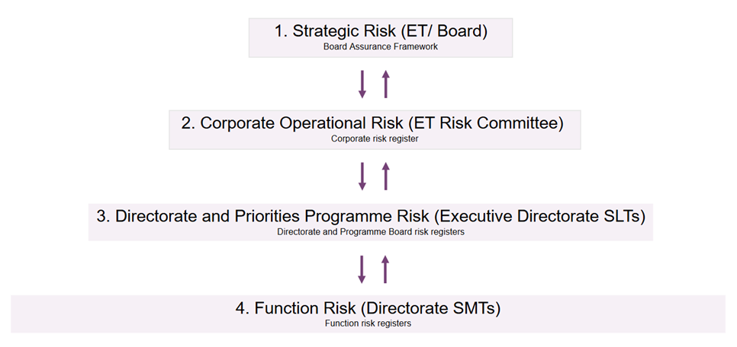

Risks will escalate through the different levels of management supporting a top-down and bottom-up approach to risk identification and management. Escalation will be based on discussions by the relevant ownership group. Each group as part of the monthly review of risks will consider the risk assessment in relation to risk appetite and tolerance thresholds and agree additional responses for risks where needed. As part of this review, groups will agree any risks that are required for escalation for additional oversight or support.

The new Corporate Risk Register includes the live, high level operational risks that require immediate oversight and action. This will typically include risks that are escalating from directorates as outside of tolerance. Following review with risk leads, the Corporate Risk Register currently contains 17 risks, 14 are outside of tolerance, 2 outside of appetite and 1 within appetite.

A summary of the risks is attached as an Annex to the Balanced Scorecard and risks with a score above 20 are highlighted below:

- Op2 - Productivity/ number of assessments – We are on track to meet target of 9,000 assessments by September 2026. Sector alignment is critical to support the management of performance and targets. Further work is to be undertaken by Chief Inspectors to understand all issues impacting on sector performance.
- P5 - Staff wellbeing and morale following changes to ways of working –.Our recent EDI pulse survey showed signs of improvement, and we have recently launched our new commitments, values and behaviours in the CQC Way, however there is still more to do to ensure that this is embedded and we can evidence this risk reducing.
- P1 - Structures and leadership – Executive Leadership Team is now complete. Operations and Regulatory Leadership now have confirmation of director alignment and are developing plans for implementation. Following discussion at Risk Committee it is the intention to split this risk, with one risk focussing on the structures (people in post) and the other around capability and the quality of leadership linked to the values and behaviours in the CQC Way.
- Reg3 - Meeting stakeholder expectations to improve activity – We are engaging stakeholders in change and actively seeking feedback. Stakeholder sentiment to be evaluated and reviewed again in November.

- Finance

At the end of June 2025 (Q1), there is a £0.6m deficit on net revenue expenditure. The first full forecast against budget for the financial year anticipates a £1.2m surplus outturn by the end of the financial year, mirroring our year-to-date position with underspends against depreciation (£2.8m due to sizeable impairment of the Regulatory Platform asset), and non-pay offsetting an overspend against pay budgets.

The year-to-date deficit trend has continued at a similar level into Period 4 (£0.5m deficit at the end of July 2025), and outturn forecast has reduced to a £0.2m surplus, driven by the estimated impact of the pay award agreed for 2025-26 over and above that initially budgeted. Within this, CQC is forecast to be 0.1% (£0.3m) overspent against fee-funded activities, and to realise underspends against both funded activities and non-cash allocations. We are currently expecting to manage within our total revenue Grant in Aid allocation, despite several pressures we are attempting to mitigate and absorb including Mental Health Act Reform and MNSI pay pressures.

Business planning conversations continue internally to understand the financial impact across financial years of our Foundational Improvements work, and externally with DHSC to understand funding implications into 2026-27.

Minimal capital expenditure has been incurred to date against budget although laptop refresh and CRM capital expenditure is backloaded into 2025-26. We continue to forecast to annual budget subject to an assessment of expenditure classification as we unpick the detail of our Technology delivery plan. It is unlikely we will incur this level of capital expenditure budgeted however, and we continue to work to explore opportunities to bring forward spend e.g. laptop replacement. We may want to consider ‘handing back’ a proportion of our allocation to DHSC once we have completed our due diligence.

