
PUBLIC BOARD MEETING

Date of Meeting: | 26th March 2025 | Agenda item: 3.5  Paper number: CM/03/25/35
Title of Paper: | Mandatory Learning Update
Purpose of Paper: | To Note
Executive Sponsor: | Jackie Jackson
Accountable Director: | Jackie Jackson
Presenter(s) or Lead person: | Jackie Jackson/ Darrin Cutting
Summary:
Following the paper submitted in June 2024 to People and Culture Committee and feedback in September 2024 from the board, this paper provides an update on the latest mandatory learning completion data from 1st April 2024 to 5th March 2025 and ongoing actions being taken to improve completions with regards to the drive to highlight to all colleagues the importance of mandatory training.

It outlines the outcome of the review of the legislative drivers and the findings in association with the mandatory learning modules, as well as the modules that are in development and ready for launch within the next financial year to provide the organisation with an even more robust suite of modules.
Recommendations:
- The Board is asked to note and/or endorse an action underway.

Year to date completions
Corporate Mandatory Learning by Directorate from 1st April 2024 – 5th March 2025

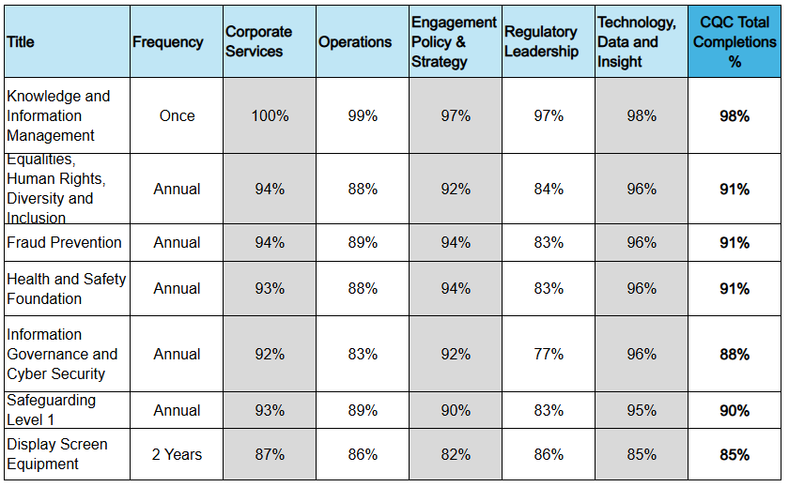

This table presents completion rates for corporate mandatory training courses across different departments. Key highlights:
- Knowledge and Information Management has the highest completion rates, with most departments achieving near or full compliance (97%-100%), and with an organisational average of 98%.
- Technology, Data, and Insight consistently shows high completion rates across all courses (95%-98%).
- Equality, Diversity & Inclusion, Fraud Prevention, Health and Safety Foundation and Safeguarding show a high compliance average ( 90-91%).
- Display Screen Equipment training (every 2 years) has slightly lower overall completion rates compared to annual courses.(Averaging 85%)

This data suggests strong compliance in most teams but highlights pockets of focus needed to hit the target completion rates.

Manager Only Corporate Mandatory Learning completions from 1st April to 5th March 2025

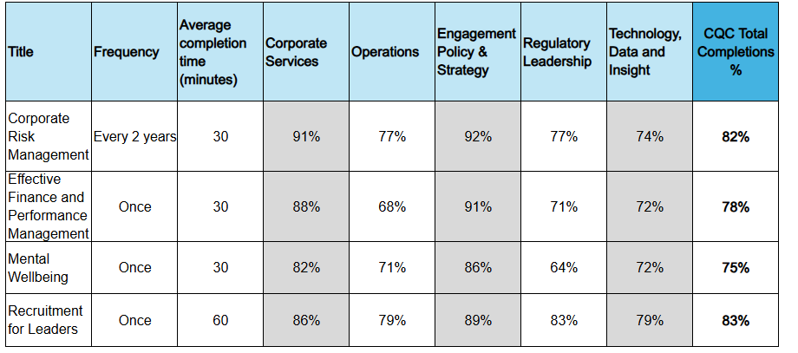
The table provides data on four manager mandatory training courses, detailing their frequency, completion time, and completion percentages across various departments. Key highlights:
- Recruitment for Leaders has the longest duration (60 minutes) and currently has the highest overall completion rates. (Averaging 83%)
- Corporate Risk Management has the second highest overall completion rates and is the only course repeated every two years. (Averaging 82%)
- Mental Wellbeing has the lowest and a notably low completion rate in Regulatory Leadership (64%).
- Engagement, Policy & Strategy has the highest completion rates across most courses (86%-92%), suggesting strong engagement in leadership and policy-related training.

This data highlights variances in training completion rates across different departments, with some areas (e.g., Health Watch England) needing greater engagement.

Immediate action over the next month to drive even stronger completions within this financial year:
- Academy Learning Consultants and Strategic Business Partners will share more frequent updates from the People Hub with SLTs and have targeted discussion when attending SLT meetings with the data added to their SLT packs
- Internal Engagement will include reminders in the all-staff bulletin throughout March
- Support is requested of ET in highlighting the importance of mandatory learning, with the benefits to the organisation and include consequences of non-compliance.

To continue; in order to drive future improvements in completion rates, the following strategies will be adopted:
- Regular Reporting and Awareness: A monthly Power BI league table is shared with Academy Learning Consultants and Strategic People Business Partners for distribution across directorates, ensuring ongoing awareness. As completion deadlines approach, the People Analytics team increases circulation to weekly updates.
- Manager Access to Completion Data: Line managers receive regular updates through the People Hub, which provides direct PowerBi access to their team’s mandatory learning completion data via People Analytics.
- Enhanced Communication and Engagement: Internal communications have been strengthened to emphasise the importance and impact of mandatory learning. Key sponsors for each programme actively highlight the organisational benefits, reinforcing the relevance of each module.
- Structured Completion Deadlines:
  - An initial deadline of 30th November 2024 was set to encourage early completions. Due to the impact of recovery work, this was extended to 31st December 2024.
  - From April 2025, modules will be launched in quarterly clusters, giving colleagues a 12-week window for completion, as agreed by the People and Culture Committee. This will mark the first full year of applying this structured approach.
- Sanctions for Non-Completion: Individuals who fail to complete all mandatory learning will be ineligible for any funded learning opportunities.
- Policy Compliance and Quality Assurance: Following a quality assurance review by the Assurance and Risk team, it has been confirmed that the current mandatory learning aligns with legislative requirements. Ongoing engagement will ensure that any necessary updates to maintain compliance are implemented as needed.
- Following feedback from the board that more work was required to provide a robust set of mandatory modules, the following are either ready or in development for launch:
- Bullying, harassment and discrimination – final stage development
- Anti-racism – We have commissioned an external provider and roll out will start in 2025
- Freedom to Speak-up – Ready to launch as mandatory
- Business Continuity – Ready to launch as mandatory aligned to the new People Finder App.
- Mental Wellbeing for Managers – In development with an external provider, roll out will start in 2025

Governance:
Give the names of any committee, board or other group that has already considered this matter - People & Culture Committee 5 March 2025

Strategy:
Outline how your recommendation aligns with our strategy, business plan and associated KPIs.

Mandatory learning links directly to CQC Strategy in respect to our core purpose and the mitigation of serious risk
Finance:There are no financial considerations for this paper.
Risk:
There remains a significant risk that the organisation may be prosecuted where we do not meet our legal obligation this risk is considered as low currently with a reasonable expectation that we reach at least 90-95 completion rate on our required learning for this year
People:
Outline any considerations for our workforce, including equality, diversity and inclusion.

