

fcommuniCare quality commission

2023 Community mental health survey

Statistical release

NHS Patient Survey Programme

Independent analysis for England published: April 2024
Contents

Summary of findings 3
Positive experiences 3
Key areas for improvement 4
How experience varies for different groups 5

1. Introduction 6

2. The Community mental health survey 8
The importance of collecting data on the experiences of people who use NHS mental health services. 8

3. Mental health policy 10
3.1 Age related mental health support 10
3.2 Integrated care systems and transformation 12
3.3 Equality between physical and mental health services 13
3.4 Accessing care and treatment 13
3.5 Early intervention 14
3.6 Crisis care 15
3.7 Funding 16
3.8 Staffing 17

4. Results from the national survey 19
4.1 Support while waiting 20
4.2 Mental health team 22
4.3 Planning care 24
4.4 Involvement in care 25
4.5 Medication 26
4.6 NHS talking therapies 28
4.7 Crisis care support 29
4.8 Crisis care access 30
4.9 Support with other areas of life 31
4.10 Support in accessing care 36
4.11 Respect, dignity and compassion 37
4.12 Overall experience 38
4.13 Feedback 39

5. Results for the individual assessment service groups (ASG) 40
5.1 Child and adolescent mental health services (CAMHS) 40
5.2 Older People Mental Health Services (OPMHS) 48

6. Subgroup analysis summary: how experience varies for different groups of respondents 53
Questions included in the subgroup analysis 54

Appendix A: Survey methodology 64
Questionnaire design 64
Comparability with previous years 64
Survey methods 64
Sampling 65
Analysis 66

Appendix B: Other sources of information related to survey results 67
Statistics on the use of mental health services 67
Mental Health Five Year Forward View dashboard 67
Staffing 67
Waiting times 67
Children and young people 68

Appendix C: Main users of the survey data 69
Care Quality Commission (CQC) 69
NHS trusts and commissioners 69
NHS England 69
Department of Health and Social Care 69

Appendix D: Further information and feedback 71
Further information 71
Further questions and feedback 71
National Statistics status 71

References 73

Summary of findings
The 2023 Community mental health survey received feedback from 14,770 people who received treatment for a mental health condition between 1 April and 31 May 2023. For the first time, participants of the 2023 survey were offered the choice of responding online or via a paper-based questionnaire.

With support from key stakeholders, CQC took the opportunity to review and update the methodology, eligibility and questions used in the survey. This included lowering the eligibility age to now include 16 and 17-year-olds. The sample period and duration also changed from September to November, to the months of April and May. As a result of the changes, it is not possible to compare this year's results with data collected in previous years.

This report shows that people’s experiences of NHS community mental health services are poor, with less than half of all respondents (39%) saying they were ‘definitely’ given the help they needed the last time they saw someone. In addition, half of all respondents (50%) were not always given enough time to discuss their needs and treatment.

Overall experiences of waiting to receive care are especially poor, with almost half (44%) reporting that their mental health got worse while they waited. In addition, almost half (42%) of respondents reporting that they were not offered support between their assessment with the NHS mental health team and their first appointment for treatment, while 4 in 10 (40%) thought they waited too long.

For the first time, the survey was able to identify respondents using Child and Adolescent Mental Health Services (CAMHS). Results for people using CAMHS indicate especially poor levels of treatment and care across most areas, including ‘waiting for care’, experiences of the ‘mental health team’ and ‘involvement in care’. For instance, only 1 in 4 people (25%) said they were ‘definitely’ given the help they needed when they saw someone from mental health services, and 6 in 10 (60%) said their mental health deteriorated while waiting for care.

Survey results were analysed to show how experiences varied for different groups of people who use services. For example, findings show that disabled service users were more likely to report negative experiences for 14 of the 20 questions analysed. Detailed subgroup analysis findings are shown in section 6.

Positive experiences
There are few areas where most people reported good experiences.

Privacy of care settings
One positive area is the privacy of the settings for the delivery of NHS talking therapies as part of a respondent’s wider package of care. Nationally, 74% said ‘yes, definitely’, when asked if they had enough privacy to talk comfortably.

Medication review
Overall, 77% of all respondents said their NHS mental health team asked them how they were getting on with their medications in the last 12 months. When medication was discussed 97% had discussed, either ‘definitely’ or ‘to some extent', the purpose of the medication, and 93% had some discussion around its benefits. However, side effects and what would happen if they stopped taking their medication was not so frequently discussed.

Key areas for improvement
The 2023 survey identified that poor experiences are occurring across several areas of NHS mental health services. These poor experiences seem to be particularly felt by Disabled users of services where there was a clear contrast between the experiences of those who did not report a disability.

Quality of Care
Less than half of all respondents (39%) said they were ‘definitely’ given the help they needed the last time they saw someone from mental health services. In addition, half of all respondents (50%) said they were ‘definitely’ given enough time to discuss their needs and treatment.

Crisis care
One in 5 people (22%) said they would not know who to contact out of hours if they were in a mental health crisis. Twenty-one per cent reported they had to wait too long to get through. Over a quarter of all respondents (26%) said they did not get the help they needed when they did make contact.

Support while waiting
Overall, 42% of people said they did not receive support with their mental health between their assessment with the NHS mental health team and their first appointment for treatment. This increases to 70% for people who waited more than 6 months for treatment. Further to this, less than half of all respondents (48%) who were offered support said that the support was ‘completely’ appropriate for their needs, with 44% reporting that their mental health deteriorated while they waited.

Planning and involvement in care
Less than a third of respondents (30%) said they ‘definitely’ felt in control of their care. Over a third (37%) of respondents reported that they did not have a care plan and 44% had not had a review of their care plan in the last 12 months. Additionally, 1 in 5 (22%) said they did not decide what care or treatment they would receive together with their NHS mental health team, and less than half (42%) said their mental health team ‘definitely’ supported them to make decisions about their care.

In addition, more than half (59%) of respondents were not asked if they required support to access their care. Of those that were, almost a third (31%) reported that the support did not meet their needs.

Support with other areas of life
NHS mental health services should signpost people to support, if needed, towards areas of their life that promote good mental health. Results indicate that limited support is being provided. For help finding support with Cost of Living, 78% have not received support. Similarly, 70% have not been signposted to support for finding and/or keeping work.

Child and adolescent mental health services (CAMHS)
In addition to the findings discussed above, survey results for people using CAMHS (16+) indicated low levels of satisfaction in the planning of and involvement in their care. Thirty-three per cent of CAMHS respondents did not feel in control of their care. Forty per cent said they did not have a care plan and 47% have not had a review meeting in the last 12 months to discuss how their care is working. Additionally, 27% had not made decisions about their care and treatment with their mental health team.

Older peoples’ mental health services (OPMHS)
Survey respondents using OPMHS generally reported positive experiences of interacting with their mental health team. Eighty-five per cent reported they were always treated with care and compassion and 86% were always treated with dignity and respect.

Poorer experiences were reported for questions around topics including ‘support in accessing care’ and 'planning and involvement in care’. For example, 49% were not asked if they needed support in accessing their care and treatment. Less than half (46%) ‘definitely’ made decisions with their mental health team about what care and treatment they would receive.

How experience varies for different groups
Analysis found there were disparities in the experiences of different demographic groups of people receiving care and treatment from NHS community mental health services. Most notably, respondents with a disability reported worse than average experiences for 14 of the 20 questions analysed. These questions covered areas of care such as being treated with care and compassion, being given the help they needed from services, and being supported to make decisions about their care and treatment. Conversely, people who were not disabled reported better than average experiences in these same areas of care.

Other groups more likely to report worse experiences across multiple questions were people aged 16-35, people with autism or autism spectrum condition, and people who access services over the telephone. In contrast, groups who reported better than average experiences across multiple questions included people aged 66 and over, people who access care face to face, and people who have been using services for 5 years and less.

1. Introduction
Mental health affects how an individual thinks, feels, and acts. Good mental health is essential at every stage of life, from childhood and adolescence through to adulthood to enable people to function productively while coping with the normal stresses of life. However, it is estimated that mental ill-health affects around 1 in 4 people and is more common, long-lasting and impactful than other health conditions., Some mental health conditions, such as anxiety and depression, are common in the UK population, whereas others, such as bipolar disorder, are less common. Experiences of mental health conditions vary significantly in both severity and condition length. As a result, while some people can self-manage their condition, others may need support from healthcare professionals.,

Community mental health services play a vital role in providing mental health care for individuals with mental ill-health. The NHS Long Term Plan and NHS Mental Health Implementation Plan 2019/20 – 2023/24 set out a plan for the NHS to develop new and integrated models of primary and community mental health care to give people greater choice and control over their care. This community support should include access to psychological therapies, improved physical health care, employment support, personalised and trauma informed care, medicines management, and support for self-harm.

Providing wider support, including access to physical health checks, aims to address some of the inequalities people with mental health conditions experience. For example, it has been estimated that those with severe mental illness die on average 15-20 years earlier than the general population and may experience multi-morbidity; the presence of two, or more, physical health conditions. Treating both mental and physical health side by side could also improve parity between them. The NHS Long Term Plan and the NHS mandate for 2022/23 states the requirement for the NHS to treat mental health with the same urgency as physical health. This is reinforced by the commitment that by 2023/24, 390,00 physical health checks should have been delivered each year.

People of all ages experience mental ill health. While the NHS Long Term Plan identifies that mental health support should be based on need rather than age, it acknowledges that staff with expertise in caring for individuals within specific age groups should be readily available. Currently, mental health services are subdivided into child and adolescent mental health service (CAMHS), adult mental health services (AMHS), and older peoples’ mental health services (OPMHS).

Rates of mental poor health are increasing in young adults. In 2022, 22% of young people aged 17 to 24 years had a probable mental disorder. Mental health difficulties experienced as an adult have often developed in childhood or young adulthood, with three quarters of all lifetime cases established by 24 years of age. Consequently, the Mental health and wellbeing plan discussion paper highlights the benefits of early intervention.

Older adult mental health care is expected to commence when a person is over 65 years old. A study of older adults aged 65-84 years identified that 1 in 3 had experienced a mental disorder within the past year and nearly 1 in 4 currently had a mental disorder. The NHS Long Term Plan and NHS mental health implementation plan 2019/20 – 2023/24 set out that the NHS would ensure consistent access to mental health care for older adults. However, there are inequalities in accessing some services, such as talking therapies.

2. The Community mental health survey
Established in 2004, the Community mental health survey asks people who use NHS community mental health services in England about their experiences of care. In 2023, the Community mental health survey underwent a large-scale redevelopment, revising both methodology and questionnaire design.
Utilising the push-to-web methodology adopted across the wider NHS Patient Survey Programme, the questionnaire is now available to be completed online for the first time, as well as in a paper format. In addition, 23 new questions were added, 19 were removed, and 14 were amended. As a result of these changes, no historical comparisons are available for 2023.

For the 2023 survey:

- Fifty-three providers of NHS mental health services participated. This includes combined mental health and social care trusts, foundation trusts and community healthcare social enterprises that provide NHS mental health services.
- For the first time this year, 16-and 17-year-olds were eligible to participate if they were receiving specialist care or treatment for a mental health condition between 1 April and 31 May 2023.
- Fieldwork took place between August and December 2023.
- In total 14,770 people responded, a response rate of 20%.
- Responses were received from 11,163 adult mental health service (AMHS) users and from 873 child and adolescent mental health service (CAMHS) users. Survey responses were also received from 2,734 older peoples’ mental health service (OPMHS) users.

Basic demographic information was collected from everyone who took part in the survey. This anonymised data is available in the ‘About you’ section in the Open data published on CQC’s website. The demographic data indicates a balanced respondent profile in terms of age, though there was a lower representation of respondents over 81 years old. Females represented 61% of all respondents and when considering ethnic group most respondents were White (87%).

The importance of collecting data on the experiences of people who use NHS mental health services.
The NHS outcomes framework (Domain 4) recognises the importance of delivering high-quality services to encourage positive patient experiences. With this in mind, the NHS Constitution commits the NHS to collecting feedback from patients, noting that information collected should be used for service improvement.

This reflects the emphasis placed on patient involvement in the Health and Social Care Act 2012, which states that commissioners of services must encourage and enable people who use services, and their carers, to make decisions about their care and treatment.

Care Quality Commission (CQC) has placed people and communities at the centre of its strategy for the changing world of health and social care, stating that regulation will be driven by people’s experiences of care and focusing on what is important to them as they access and navigate services. As part of CQC's single assessment framework, people's experiences of services are a key evidence category which is used to inform the rating of health and social care services.

Mental health policy
This section explores policy and contextual issues relevant to NHS community mental health services in England. For the first time, the Community mental health survey also captures the experiences of people aged 16 and 17. The discussion below will include a review of policy specific to this age group.

In recent years, government mental health policy has centred on reforming mental health services. Reducing pressures on inpatient care has been identified as a key priority, with policymakers highlighting the potential for community services to play an integral role in achieving this.,,, The NHS Long Term Plan is the current landmark national policy that provides structure for NHS service reform. Published in 2019, it builds on the commitments set out in the Five Year Forward View for Mental Health and presents core priorities for the NHS over a period of 10 years.

Key priorities related to mental health services from the NHS Long Term Plan and the NHS Mental Health Implementation Plan 2019/20 – 2023/24 include aims to provide a more integrated model of primary and community mental health care that will result in more accessible and effective services. The plan also discusses encouraging large-scale behaviour change and understanding the root cause of mental ill-health, to proactively tackle health inequalities.

The importance of the NHS adopting a prevention-first approach to mental health care delivery and provision was set out in the government green paper Prevention is better than cure. The paper argues that international studies have shown investment in prevention can have significant long-term financial return. Furthermore, the NHS Confederation proposed that the return on investment is highest for interventions that improve and enhance mental health, and argued there are significant opportunities to fund greater preventive health care.

3.1 Age related mental health support
NHS mental health services are currently sub-divided into the following age-based categories:

- Child and Adolescent Mental Health Services – for people aged up to 25 years
- Adult Mental Health Services – for people aged 18-65 years
- Older Peoples’ Mental Health Services – for people aged 65 years and older.
However, the NHS Long Term Plan identifies that mental health support should be based on need rather than age.

Good mental health is important for children and young adults so they can attend school, participate in their communities, and enjoy time with their family. However, rates of mental ill-health are increasing and in 2022, 22% of young people aged 17 to 24 years had a probable mental disorder.

Mental health difficulties experienced as an adult have often developed in childhood or young adulthood. Half are established by the age of 14, with three quarters established by 24 years of age.10 Appropriate early intervention enables children and young people experiencing difficulties to enhance their mental health and maximise their prospects for a healthy and happy life. 7, ,

The NHS provides mental health support for children and young people experiencing poor mental health, or difficult feelings or experiences. This is delivered through child and adolescent mental health services (CAMHS), until the individual reaches 25. However, people can start transitioning to adult mental health services (AMHS) from the age of 16, depending on where they live and their specific needs. There are local NHS CAMHS services across the UK, with teams made up of nurses, therapists, psychologists, child and adolescent psychiatrists, support workers, and social workers, as well as other professionals offering a range of therapies.

The NHS Long Term Plan aims to embed support for children and young people in schools and colleges. New NHS-funded mental health support teams working in educational settings should be rolled out to between one-fifth and a quarter of the country by the end of 2023. Further support may involve the use of digital interventions that may moderate the need for specialist child and adolescent mental health services.

Disparity is reported between the support that is offered through CAMHS around the country, with the Health and Social Care Committee 2021 report reiterating that it is essential support does not remain a ‘postcode lottery’. The Children’s Commission March 2023 annual report observed that waiting times for treatment could vary between 13-80 days across the country. NHS monthly data shows that the number of children and young people undergoing treatment or waiting to start care has reached new records, with 496,897 open referrals to children and young people’s mental health services in November 2023.

Between the ages of 16-25 years, young adults will transition from children and young people services to AMHS. Despite NICE guidance indicating the transition should be prepared for by school year 9 (aged 13 to 14 years), or immediately after, adults can feel inadequately or inconsistently supported resulting in disrupted care or disengagement from the service.

Older adult mental health care is expected to commence when a person is over 65 years old. Around 1 in 3 older adults (aged 65 to 84) who participated in an international study (which included UK participants) reported having experienced a mental disorder in the previous year, and nearly 1 in 4 reported having one at present.

The NHS long term plan and NHS mental health implementation plan 2019/20 – 2023/24 set out that the NHS will ensure consistent access to mental health care for older adults with functional needs (such as depression, anxiety and severe mental illnesses). However, there are inequalities in accessing some services. For example, the NHS Long Term Plan highlights that local areas will be expected to plan to meet the needs of their population to address access inequalities in NHS talking therapies for older people. While the number of individuals undertaking talking therapies is lower in older adults compared to adults, the numbers are increasing.

Access to services can be related to a range of factors. Some older adults may experience technological challenges with online delivery, though many welcome and embrace this method of delivery. Furthermore, older people, can sometimes normalise anxiety and mild depressive symptoms alongside a decline in physical health and so may be reluctant to seek support.

3.2 Integrated care systems and transformation
The health and care system is made up of thousands of different bodies and organisations within primary and specialist care, physical and mental health services, and health with social care. Drawing together these separate bodies into integrated care systems (ICSs) is considered central to the delivery of the NHS Long Term Plan. Through shared leadership and action, local bodies and organisations can focus on better outcomes and reducing health inequalities within their locality.

There are 42 ICSs in England. Each ICS has 2 statutory elements: an integrated care partnership (ICP) and an integrated care board (ICB). These statutory arrangements build on the partnerships already in place locally.

Historically, according to the Royal College of Psychiatrists, mental health services have not been sufficiently prioritised in local health planning, with many challenges being faced in isolation, and disconnected from wider health and social care systems. Radical change in the design of community mental health care has been proposed. This involves:
- moving away from isolated, hard-to-reach services
- integrating local community mental health services aligned to primary care networks
- working collaboratively within ICSs.

The programme to transform the way mental health care and support is delivered is called the Community mental health framework for adults and older adults. The framework aims to be delivered by following the NHS Mental Health Implementation Plan 2019/20 – 2023/24. The national programme has been co-designed with people who use services and carers. It emphasises equality of access and culturally appropriate care, particularly for people from communities traditionally underserved. Other changes include the discontinuation of the Care Programme Approach and a focus on population-based early interventions and prevention.

From April 2021, all systems began receiving Service Development Funding (SDF) for community mental health transformation. By 2023/24 all areas should have been covered by transformed services, with 370,000 people being supported through these new, primary care-based, services. Transformation is occurring through a phased approach across the country, with a ‘roadmap’ developed by the national team to support local implementation of the key elements of the transformation. In 2022/23, 34% of Primary Care Networks (PCNs) in England were reported as providing access through fully transformed models of care. A further 285 (23%) had met 3 of the 5 transformation criteria, 178 (15%) had met 1 or 2 of the criteria, and 358 (28%) were not yet meeting any criteria.

3.3 Equality between physical and mental health services
People with severe mental illnesses are at higher risk of poor physical health. For example, it has been estimated that those with severe mental illness die on average 15-20 years earlier than the general population. In response, several key policies have been developed to address the health gap between people with mental ill health and the wider population. In 2012, parity of esteem between mental and physical health was enshrined into law through the Health and Social Care Act 2012. It has been a focus of both the Five Year Forward View for Mental Health (published in 2016) and the NHS Long Term Plan (published in 2019). Recently, the NHS mandate for 2022/23 re-stated the requirement for the NHS to treat mental health with the same urgency as physical health.

Mental and physical health are closely linked. The long-term plan highlights that individuals with severe mental illnesses are at substantially higher risk of obesity, asthma, diabetes, chronic obstructive pulmonary disease (COPD), and cardiovascular disease. NHS England aims to improve physical health care for people with severe mental illness, including early intervention, to avoid the development of preventable diseases. The long-term plan stated that by 2023/24, the NHS would ensure that at least 390,000 people living with severe mental health problems would have their physical health needs met.

NHS England figures show that 279,935 out of 535,075 people on GP severe mental illness (SMI) registers received all 6 elements of the health checks in the 12 months to the end of September 2023. The most common checks were on smoking status (408,407 people), blood pressure (405,125 people), and BMI weight (394,987 people). The least common was the blood lipid check (375,773 people).

People are living longer with multiple, complex, long-term conditions and need their mental and physical health care needs aligned rather than delivered in a fragmented, disconnected way. The creation of ICSs aims to encourage communication and collaboration between services. This offers an opportunity for mental and physical health to be treated effectively side-by-side.

3.4 Accessing care and treatment
Being able to access mental health support is critical for wellbeing. A House of Commons Committee report published July 2023 approximated the number of people on the waiting list for community-based NHS mental health services to be 1.2 million people., However, not all groups access mental health support equally, and seeking help can be challenging for those who are unwell. Inequality may be based on age, ethnicity, gender, sexual orientation, or disability, and can be felt in terms of prejudice, stigma, or in financial terms.

Different groups have different rates of mental ill-health, sometimes depending on the inequalities they experience as a group.52 The 2020 Advancing mental health equalities strategy described how different groups also access services differently, with underrepresentation in some services and overrepresentation in others.51 For example, older people are underrepresented in talking therapies, and black-British men are overrepresented in mental health secure care.

COVID-19 highlighted the need to prevent and manage ill health in groups that experience health inequalities, as defined in the NHS Long Term Plan. In response to the pandemic, NHS England and Improvement (NHSE&I) issued guidance listing 8 actions to address health inequalities which was later refined to 5 key priority areas. More recently, in October 2023, the Patient and carer race equality framework (PCREF) was launched. This mandatory anti-racism framework should be embedded within all mental health trusts, including community providers, to reduce racial inequalities within their services including barriers to access that ethnically and culturally diverse groups still face.

NHSE&I guidance also aims to mitigate digital exclusion and stresses that providers offer face-to-face care to those individuals who cannot use remote services. While the move to remote care during the COVID-19 pandemic helped to maintain a connection between services and service users, remote services still occurring post-pandemic have been met with a mixed response. People using services and providers have reported the advantages of delivering mental health services remotely as convenience and faster access to care., However, others reported issues including poor access to technology, lack of technological experience, stable internet connection, and potentially a lack of privacy and confidentiality.

The National Institute for Health and Care Research (NIHR) Mental Health Policy Research Unit has raised concerns that while policymakers are focused on the advantages of remote care, the disadvantages may be understated. This could result in patients being seen as uncooperative if they refuse to receive care remotely. However, NHS guidance indicates people who use services should have a choice and control in how they receive services.

These issues could lead to inequality of access for certain groups. Due to a lack of data on variations in patients’ access, The National Audit Office’s 2023 report ‘Progress in improving mental health services in England’ states that it is not yet clear what impact NHS England’s initiatives have had on reducing inequalities in patients’ experiences and outcomes.

3.5 Early intervention
The Mental health and wellbeing plan discussion paper highlights that delayed help can lead to mental health problems escalating. However, early intervention has been found to produce better long-term outcomes.

The Five Year Forward View for Mental Health and NHS Mental Health
Implementation Plan 2019/20 – 2023/24 set out waiting time standards for 3 services. These include early intervention in psychosis (EIP), and children and young people’s eating disorder services. Waiting times vary between these services. For EIP, the standard expects 60% of people with a first episode of psychosis to start treatment within 2 weeks of referral. Children and young people referred for assessment or treatment for an eating disorder should receive treatment within 1 week for urgent cases and 4 weeks for every other case. For all other mental health services, in line with physical care, for consultant led services the NHS commits to treatment within 18 weeks.

Community Mental Health Framework outlined the development and testing of new 4-week waiting time standard for accessing community mental health services. Help may involve:
- immediate advice, support, or a brief intervention
- help to access another more appropriate service
- the start of a longer-term intervention or agreement about a patient care plan
- the start of a specialist assessment.

A public consultation on the proposals took place in 2021, with NHS England’s formal response published in early 2022. The NHS has stated it is working with the government and stakeholders to set out how these ambitions can be achieved as quickly as possible. The July 2023 House of Commons Committee report ‘Progress in improving NHS mental health services’ highlights that the Department of Health and Social Care and NHS England have not yet committed to rolling out waiting times standards to all mental health services.

The COVID-19 pandemic put additional pressure on NHS mental health services. A UK Parliament Post Note, dated July 2021, stated that the number of people contacting the NHS seeking help for mental health problems was at a record high. This has likely contributed to the increased waiting times observed in 2021-22 after the declining numbers in previous years. This would imply that early intervention will continue to present a challenge in future years.

3.6 Crisis care
Alongside hospital-based treatments, community-based mental health services provide vital care to people experiencing a mental health crisis. The signs of a mental health crisis can vary from person to person but can include experiences of extreme anxiety and suicidal feelings.

Improving access to mental health crisis care and decreasing waiting times for crisis services are commitments made in the Five Year Forward View Implementation Plan and the NHS Long Term Plan.

In 2019, a clinically lead review of NHS access standards proposed new guidelines for expert assessments. Following on from this, in 2021, NHS England proposed the following standards.

- People referred from an emergency department should be seen face-to-face within 1 hour, by a mental health liaison service or children and young people’s equivalent service.
- For a ‘very urgent’ referral to a community-based mental health crisis service, a patient should be seen within 4 hours from referral, for all age groups.
- For an ‘urgent’ referral to a community-based mental health crisis service, a patient should be seen within 24 hours from referral, across all ages.

As with early intervention waiting time standards, the Department for Health and Social Care and NHS England have yet to commit to rolling out these standards for crisis care services.

In addition, a government press release in June 2022 outlined plans for increased capital funding to improve mental health support for those in crisis. It states that £150 million will be invested over the next 3 years to bolster NHS urgent and emergency mental health services.

The funding includes £7 million for specialised mental health ambulances across England to reduce the use of general ambulance callouts for those experiencing a mental health crisis, as well as preventing the inappropriate use of police vehicles to take people to hospital. Funding will also support local communities to invest in alternatives to hospital admission for people experiencing a mental health crisis, such as ‘crisis houses’ run by the voluntary sector, which will ensure people can access the treatment they need in their community. This builds on investment in crisis care services through the NHS Long Term Plan, which aims for 100% coverage of 24/7 age-appropriate care, through NHS 111, by the end of 2023/24. Progress has been made towards this ambition, with:

- almost all Crisis Resolution and Home Treatment (CRHT) teams now operating 24/7 and open to self-referral
- 24/7 crisis lines set up nationally
- expansion of alternative models of community crisis
- 24/7 liaison in 92% of general hospitals

3.7 Funding
Since the NHS was established, healthcare spending has increased nearly every year to meet increasing demand. However, the funding growth rate varies and, in the decade before the COVID-19 pandemic, rates fell below the long-term average. The British Medical Association states that between 2009/10 and 2021/22, the cumulative underspend (difference between actual funding and funding calculated on historic growth rates) reached £322 billion.

Most local mental health funding is not ring-fenced, so each local NHS area must determine its own mental health budget from its overall funding allocation. Consequently, neither the Government nor NHS England determines the levels of funding given to mental health services in local areas. The NHS Long Term Plan and NHS Mental Health Implementation Plan 2019/20 – 2023/24 included a new ring-fenced investment fund worth at least £2.3 billion a year by 2023/24 for mental health services. In addition, in March 2021, the government launched the mental health recovery plan which diverted £500 million into mental health services to respond to the impact of the pandemic. The plan allocated the £500 million to specific services, including:
- children and young people support (£79m)
- support for 18 to 25 year olds transitioning to adult services (£13m)
- integrated community support for adults and older adults with severe mental illness (£58m)
- memory assessment services and recovery of the dementia diagnosis rate (£17m)
- talking therapy funding (£38m)
- suicide prevention and reduction (£1m)
- action to tackle critical ‘backlogs’ (£170m).

3.8 Staffing
The aim of increasing staffing numbers in the NHS has been a key component of several national plans since 2016. In 2019, the NHS Long Term Plan and the NHSE Mental Health Implementation Plan outlined the additional workforce required which includes a further 470 consultant posts in psychiatry by March 2024, as part of a planned increase of 27,460 posts in the mental health workforce.

The Department of Health and Social Care reported that the number of mental health nurses working in NHS trusts had increased by over 1,000 compared to the past year, with almost 40,000 full-time equivalent mental health nurses employed in NHS trusts and commissioning bodies in England.

Despite the increase in staffing numbers, services remain under pressure. Around 1 in 6 full-time equivalent doctor roles in NHS mental health services in England were vacant as at June 2023, and approximately 1 in 5 mental health nursing posts were vacant in the first 3 months of 2023/24. NHS Confederation has described how there is a demand-supply gap in mental healthcare which has left mental health services in “persistent crisis mode”.

Following on from the NHS Mental Health Implementation Plan (2019-2024), the 2023 NHS Long Term Workforce Plan has been produced. The plan sets out commitments to grow the number and proportion of NHS staff working in mental health, primary care, and community care by 73% by 2036/37. It also aims to increase training places for mental health nursing by 93% to more than 11,000 places by 2031/32. To support this ambition, by 2028/29 the plan states it will increase training places by 38% for mental health nursing.

The Royal College of Psychiatrists campaigns to grow the mental health workforce to deliver better services for its users. Its briefing on the 2023 NHS Long-Term Workforce Plan acknowledged the progress previous plans had made but observed targets related to the psychiatric workforce were unmet, revealing an uneven workforce growth across specialities. It outlined concerns about the lack of detail about how to address under-resourced specialties, including psychiatry, within the 2023 NHS Long-Term Workforce Plan.

The government has reiterated its view that ensuring an adequate and skilled workforce is key to transforming mental health services while acknowledging the increasing demand and the subsequent need for growth. This has increased pressure on the workforce, increased staff workloads and burnout rates, and negatively impacted morale. The 2023 NHS Long-Term Workforce Plan attempts to address these challenges by focussing on 3 themes; train, retain, and reform; thereby increasing not only recruitment but also retention.

Results from the national survey
This section presents the national findings from the 2023 Community mental health survey, which asks people about their experiences of using NHS community mental health services in England. For 2023, the survey has undergone a large-scale redevelopment. The redevelopment of the questionnaire ensures that its contents continue to be in line with policy and practice and enables trusts to use the new questions for improvement. As a result of the redevelopment, no historical comparisons are available with the 2023 data. As the results from this survey are not comparable to previous years, the trend charts which featured in the 2022 survey report will not be used.

This section also includes the results of a ‘subgroup analysis’, which considers the experiences of different groups of people, according to demographic, health, and care characteristics. These characteristics are:

- age
- sex
- gender same as sex
- ethnicity
- religion
- sexual orientation
- mode of contact
- index of multiple deprivation decile (IMD)
- length of contact
- long-term conditions
- disability
- ‘proxy response’ (whether the questionnaire was completed entirely by, or with the support of, someone other than the person who used the services)
- Assessment Service Group (ASG)

Findings are grouped by the following themes:

- Support while waiting
- Mental health team
- Planning care
- Involvement in care
- Medication
- NHS talking therapies
- Crisis care support
- Crisis care access
- Support with other areas of life
- Support in accessing care
- Respect, dignity and compassion
- Overall experience
- Feedback

Please note: Responses to questions such as “don't know/can’t remember” are not shown and are excluded from percentage calculations. Other non-specific response options are also excluded, such as where the respondent does not require the experience/service e.g., “I do not need support for this”. Additionally, the respondent numbers shown below the charts are weighted values.

4.1 Support while waiting
The NICE quality statement 5: Access to services highlights the importance of ensuring people have access to high-quality mental health services when they need them. The Mental health and wellbeing plan discussion paper stresses that delayed help can lead to mental health problems escalating, while early intervention can produce better long-term outcomes. Support while waiting may involve immediate advice, support, or a brief intervention, help to access another more appropriate service, the start of a longer-term intervention or agreement about a patient care plan, or the start of a specialist assessment.

Forty-four per cent of respondents waiting for their first appointment for treatment, after an assessment with the NHS mental health team, reported their mental health had got worse. While waiting 42% of respondents were not offered support with their mental health.

Figure 1: While waiting, between your assessment with the NHS mental health team and your first appointment for treatment, were you offered support with your mental health? (Q6)
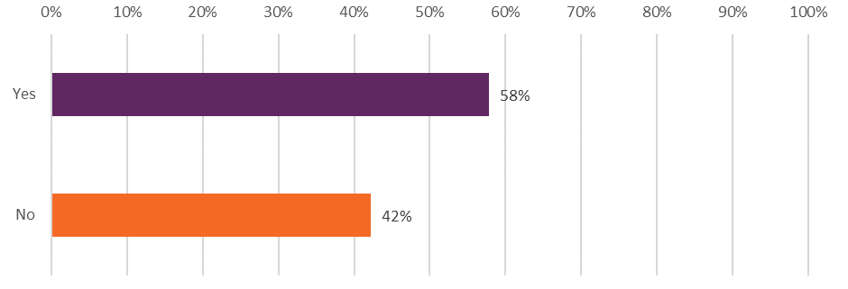
Answered by those who have been in contact with the NHS mental health services for the past 2 years. Respondents who stated that they didn't know / couldn't remember have been excluded. (2023, Respondents: 4757)
When question 6 (While waiting…were you offered support with your mental health) was considered against question 3 (How long did you wait between your assessment with the NHS mental health team and your first appointment for treatment?) results show that 70% of respondents who waited more than 6 months were not offered support. Comparatively, of those who said they waited less than 2 weeks between their assessment and first appointment for treatment, 82% were offered support.

Figure 2: Indicates how support offered (‘yes’) for mental health while waiting (Q6) varies depending on how long the respondent was waiting (Q3)
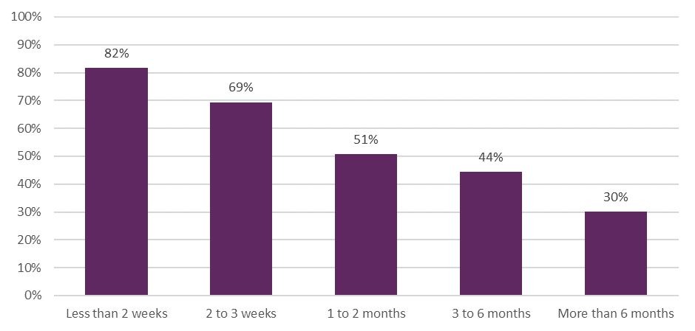
Cross-tabulation between Q6 and Q3. Answered by those who have been in contact with the NHS mental health services for the past 2 years. Respondents who stated that they didn't know / couldn't remember have been excluded. (2023, Respondents: <2 weeks 1,046; 2-3 weeks 776; 1-2 months 883; 3-6 months 745; >6 months 654)

Appropriate support
Respondents who said they were offered support while they waited for treatment were asked whether they felt the support they were offered was appropriate for their mental health needs. Forty-eight per cent responded ‘yes, completely’ and 43% answered ‘to some extent’. Nine per cent felt the support offered was not appropriate for their mental health needs.

Figure 3: Was the support offered appropriate for your mental health needs? (Q7)
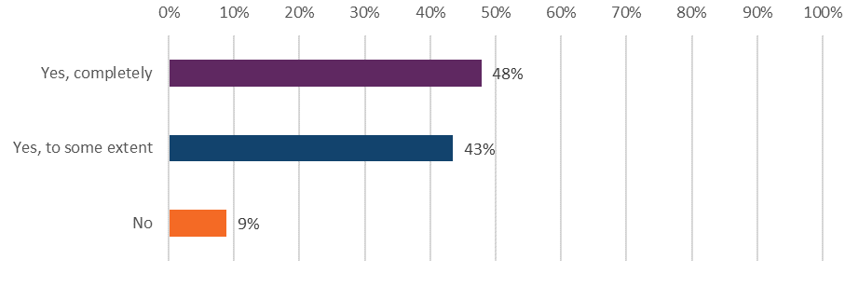
Answered by those who have been in contact with the NHS mental health services for the past 2 years. Respondents who stated that they didn't know / couldn't remember or that they did not need any support have been excluded. (2023, Respondents: 2,594)
When question 7 (Was the support offered appropriate for your mental health needs?) was considered against question 3 (How long did you wait between your assessment with the NHS mental health team and your first appointment for treatment?) results show that people who waited more than 6 months had the highest percentage of respondents who felt the support offered was not appropriate for their needs (27%).

4.2 Mental health team
Positive, respectful interactions between people delivering and people using mental health services are beneficial to overall outcomes of care. Furthermore, people are more likely to feel supported and receive successful treatment when they are aware of who is in charge of their care. The NHS England position statement on the Care Programme Approach emphasises the importance of the service user knowing who is in their multidisciplinary team (MDT). Building a relationship with the team should allow people who use services to share experiences of their care, their mental health, and other areas of their life. This will require appointments being of sufficient duration despite increasing demand on the service.

In the survey, respondents were asked if they were given enough time to discuss their needs and treatment during their appointments. Fifty per cent of people responded ‘yes, definitely’, while 34% answered ‘to some extent’. Sixteen per cent of all respondents said they were not given enough time to discuss their needs and treatment.

Figure 4: Were you given enough time to discuss your needs and treatment? (Q8)
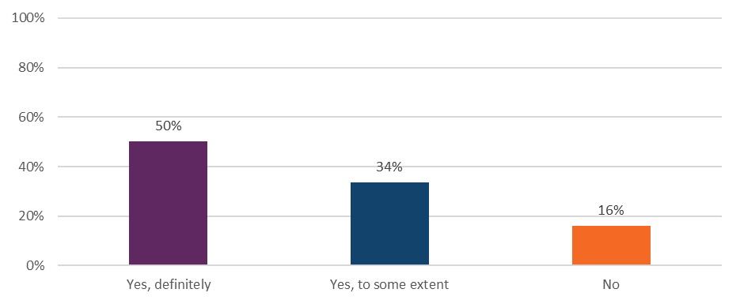
Answered by all. Respondents who stated that they didn't know / couldn't remember have been excluded. (2023, Respondents: 13,998)

Sub-group analysis of specific demographic groups identified that some groups were more likely to report a poorer experience about the time they were given to discuss their needs and treatment. These included those aged 16 to 50, people with a disability, and those who accessed services via the telephone were more likely to report a poorer experience.

When asked if respondents got the help they needed from their mental health team, 39% answered, ‘yes, definitely’. In contrast, 22% of respondents reported they did not get the help they needed.

Figure 5: Did you get the help you needed? (Q9)
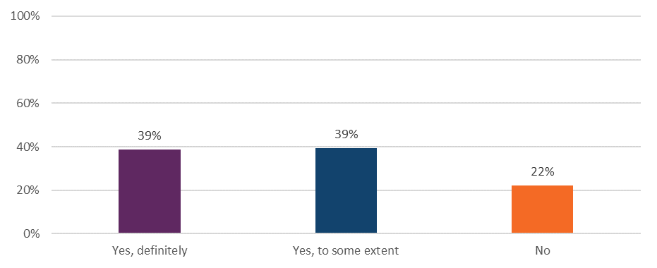
Answered by all. Respondents who stated that they didn't know / couldn't remember have been excluded. (2023, Respondents: 14,200)

Using sub-group analysis, several groups were identified as reporting above the average that they were given enough time to explain their needs and treatments and get the help they needed. These included older people (66+), people who accessed services face to face and people who were not disabled. In contrast people aged 16-50 years old, people who accessed services via the telephone, and people with a disability reported worse than average experiences.

Some patients report frustration at having to repeat their medical history when information is not shared between medical teams. Therefore, respondents were asked if they had to repeat their mental health history to their NHS mental health team. Results show 36% of respondents answered ‘yes, often’, while 24% said they did not have to repeat their mental health history.

Figure 6: Did you have to repeat your mental health history to your NHS mental health team? (Q11)
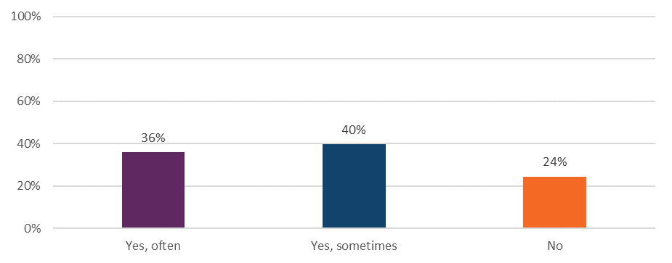
Answered by all. Respondents who stated that they didn't know / couldn't remember have been excluded. (2023, Respondents: 13,579)
Groups that were more likely to report having to repeat their mental health history were people aged 16 to 50 and Disabled people. This contrasts with the experience of those aged 66 and over and those who are not disabled, who were more likely to have a positive experience.

Respondents were also asked if their NHS mental health team asked how areas of their life impacted on their mental health. Less than half of all respondents (46%) said ‘yes, definitely’ the team did consider how areas of their life impacted their mental health.

Figure 7: Did your NHS mental health team consider how areas of your life impact your mental health? (Q10)
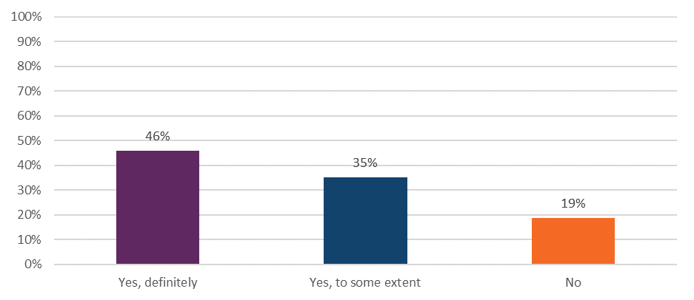
Answered by all. Respondents who stated that they didn't know / couldn't remember have been excluded. (2023, Respondents: 13,705)

Younger respondents (16-35) were less likely to report that the NHS mental health team considered how other areas of their life impacted on their mental health. The length of contact with the team also impacted on the result. Those who had been in contact for less than 1 year up to 5 years were more likely to report they had been asked about the impact. This contrasts with those in contact for more than 10 years who were less likely to have been asked.

4.3 Planning care
The Community mental health framework for adults and older adults aims to deliver high-quality co-produced, personalised care and support planning for people with mental ill health living in the community. In line with NICE quality statement 2, the aim should be to adopt a model which promotes active participation in treatment decisions and supports self-management. Consequently, a care plan, which contains elements including crisis contact detail and personal goals, should be developed in collaboration with the service user and regularly reviewed.

Findings from the survey show that 37% of respondents did not have a care plan in place. Those who have face to face contact and have been in contact with the team for 1 to 10 years, were more likely to report that they had a care plan.

As the collaborative approach to development of a care plan also extends to its review, people using services should be involved in any reviews and revisions. These should take place on flexible timescales but should be reviewed at least every 12 months.

Survey respondents were asked if they had a care review meeting with their NHS mental health team, to discuss how their care was working, in the last 12 months. Overall results show that 44% of respondents have not had this meeting.

4.4 Involvement in care
For people who use NHS mental health services, positive experiences are linked to better health outcomes. At service level, good experiences can lead to lower costs of care and improved organisational reputation. It is, therefore, important that people who use services are given an opportunity to contribute to the system that has been set up to protect and care for them.

People have the right to be involved in discussions and make informed decisions about their care, as described in NICE's information on making decisions about your care. Shared decision making should occur between health professionals and people who use services to ensure a range of treatment options and care are discussed, along with the risks and benefits of these.

Within their support team people using services should have a key worker who can form a therapeutic alliance with them, and whom they trust and connect with. These key workers can support people to express their care and treatment decisions.

To understand involvement of people using services in decision-making, respondents were asked, ‘Have you and your NHS mental health team decided together what care and treatment you will receive?’. Less than half (39%) of all respondents said they had ‘definitely’ made decisions together with their mental health team, while 22% reported they had not made decisions together.

Groups which were more likely to report a poorer experience include 16- to 50-year-olds, Disabled people, those with autism or autism spectrum condition, and those who receive care over the telephone.

In terms of feeling supported to make decisions about their care, national results show that 42% of respondents felt they were ‘definitely’ supported to make decisions about their care and treatment.

Figure 8: Has your NHS mental health team supported you to make decisions about your care and treatment? Support includes sharing information on risks and benefits of your care and treatment. (Q17)
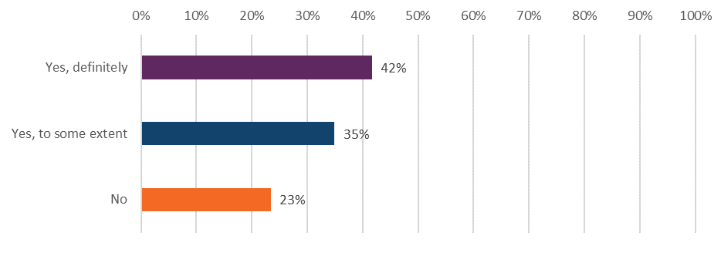
Answered by all. Respondents who stated that they didn't know / couldn't remember have been excluded. (2023, Respondents:13,629).

Furthermore, when asked whether they felt in control of their care, less than a third (30%) of respondents felt they were ‘definitely’ in control of their care, while a further 41% said they felt in control ‘to some extent’.

Figure 9: Do you feel in control of your care? (Q18)
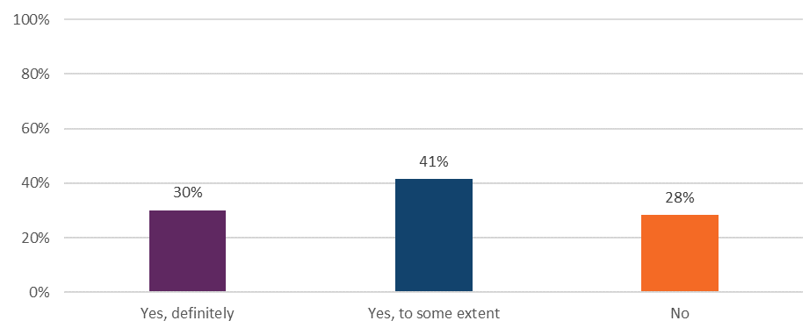
Answered by all. Respondents who stated that they didn't want to be in control of their care, their care has now ended, or they didn't know / couldn't remember have been excluded. (2023, Respondents: 12,408)

For these questions that asked about ‘involvement in care’ there were several groups that consistently reported a poorer experience. These include people aged 16 to 50, those receiving support via the telephone, and people with a disability. All were less likely to feel in control of their care; less likely to have been involved with their mental health team in deciding what care and treatment they would receive; and feel less supported by the team to make these decisions.

4.5 Medication
Non-adherence to treatment can occur frequently for people with mental ill health. The reasons for this are multifaceted and may include an individual’s perception of illness and medicines, adverse side effects, and some demographic characteristics such as homelessness.

Research has identified that people who do not consistently take their regular medication are more likely to use multiple health services, leading to higher treatment costs., As well as prolonged hospitalisation, suicide rates for people with bipolar disorder increase when medicines are not regularly taken, as do relapse rates for people with schizophrenia.

To help professionals understand an individual’s motivations for taking, or not taking medicines, as well as to increase overall compliance, guidance produced by NICE recommends that people who use services are included in decisions about prescribed medicines. Furthermore, people should have any possible side effects of their medication explained to them. This knowledge can result in side effects feeling more manageable and less worrying which in turn helps prevent people stopping their medication and becoming unwell again.

Respondents who indicated they were receiving medication for their mental health needs (84% of all respondents) were asked a series of questions, focusing on discussions about their medicines. When asked if the purpose of their medication had been discussed with them, 62% responded ‘yes, definitely’. In addition, 55% also responded that they had ‘definitely’ had the benefits of their medication explained to them.

When asked about the side effects of their medication being explained, and what would happen if they stopped taking their medication, there was an increase in respondents answering ‘no’. Thirty per cent had not had the side effects of their medication explained to them and 36% had not discussed what would happen if they stopped taking their medication.

Figure 10: Have any of the following been discussed with you about your medication…(Q21_1 to Q21_4)
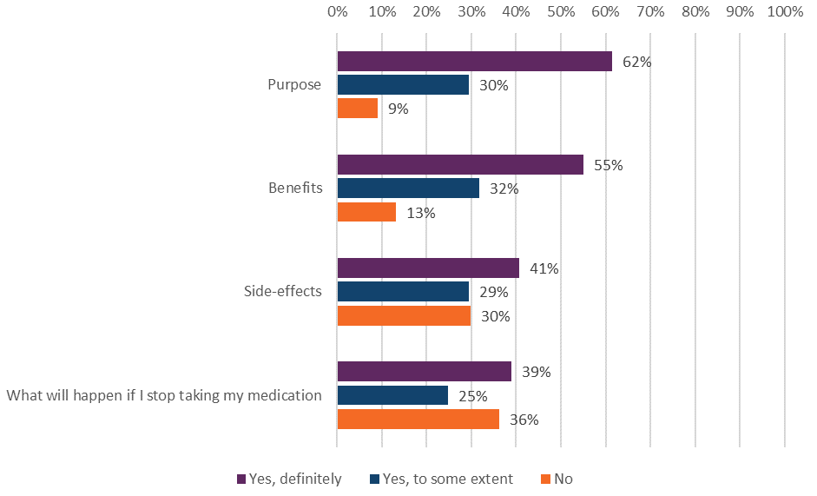
Answered by those who have been receiving medication for their mental health needs in the last 12 months. Respondents who stated that they didn't know have been excluded. (2023, Respondents: Purpose 11,821; Benefits 11,528; Side-effects 11,384; What will happen if I stop taking my medication 10,860)

The survey also asked respondents if, in the last 12 months, their NHS mental health team asked them how they are getting on with their medication. Overall results show 77% of respondents had been asked how they were getting on with their medication, while almost a quarter (23%) had not.

Figure 11: In the last 12 months, has your NHS mental health team asked you how you are getting on with your medication? (Q22)
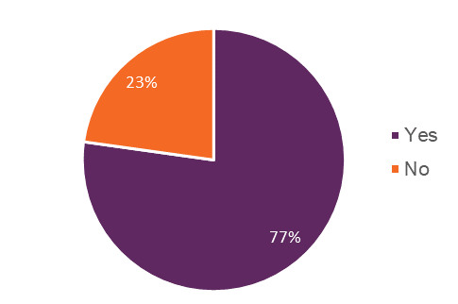
Answered by those who have been receiving medication for their mental health needs in the last 12 months. Respondents who stated that they didn't know / not sure have been excluded. (2023, Respondents: 11,093)

4.6 NHS talking therapies
Some mental health conditions, such as anxiety and depression, can be treated using NHS talking therapies, or psychological therapies. These are treatments that involve people talking to an accredited practitioner about their thoughts, feelings and behaviours.

There are a number of different types of talking therapy, but they all aim to provide people with a safe space to:
- understand themselves better.
- make sense of complicated feelings and unhelpful patterns or find ways to live with them.
- talk to a professional without judgement.

Talking therapies may be delivered either in-person or remotely. When in-person they can occur within a confidential consulting room, or when appropriate, in an outside setting. However, whether the delivery is face-to-face or remote, the privacy of the space is important so people can talk freely.

There are several referral pathways including self-referral, community referral, and primary referral. This survey asked about those who had secondary care referral from their existing mental health service. Of all respondents, 61% received NHS talking therapies in the last 12 months as part of a wider package of care.

The survey asked if, during the last time they received NHS talking therapies, respondents had enough privacy to talk comfortably. In response, 74% said ‘yes, definitely’, while 6% answered ‘no’.

Figure 12: Thinking about the last time you received NHS talking therapies, did you have enough privacy to talk comfortably? (Q25)
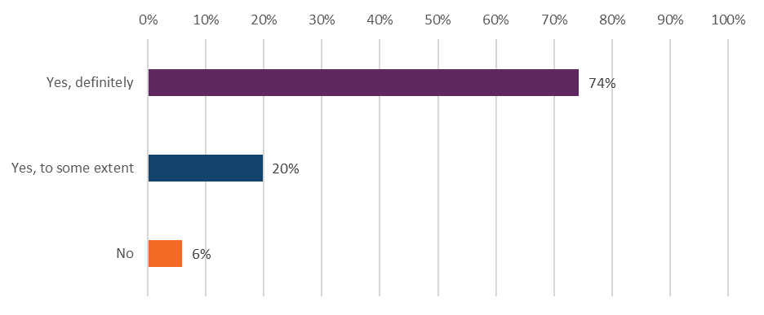
Answered by those who have received any NHS talking therapies in the last 12 months for their mental health needs. Respondents who stated that they didn't know / could not remember have been excluded. (2023, Respondents: 5,960).

4.7 Crisis care support
A mental health crisis is when a person requires urgent help for their mental health and may be at immediate risk of self-harm. They may be feeling suicidal, experiencing extreme anxiety, or going through mania or paranoia. When people are in mental health crisis, they need support that is compassionate and meets their needs.

Respondents were asked a series of questions to understand their experience of crisis care support. Of those respondents that contacted the crisis team, less than half (41%) answered that they had ‘definitely’ received the help they needed, while a quarter (26%) answered ‘no’, they did not receive the help they needed.

Figure 13: Thinking about the last time you contacted this person or team, did you get the help you needed? (Q28)
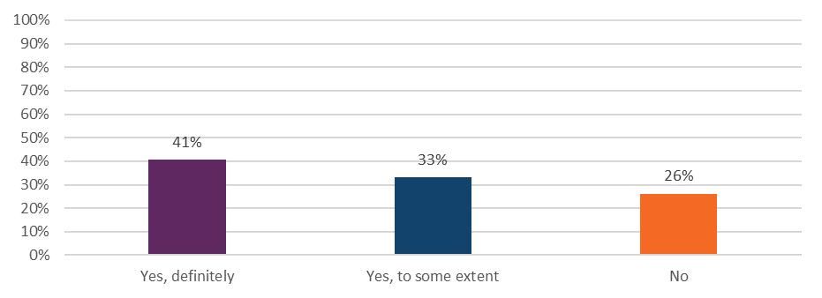Answered by those who would know who to contact out of office hours within the NHS if they had a crisis. Respondents who stated that they didn't know / couldn't remember have been excluded. (2023, Respondents: 4,384)

The survey also asked respondents if the NHS mental health team gave their family or carer support whilst they were in crisis. Thirty-one per cent of respondents said their family or carer was ‘definitely’ given support, whereas almost half (46%) said they were not.

Figure 14: Did the NHS mental health team give your family or carer support whilst you were in crisis? (Q30)
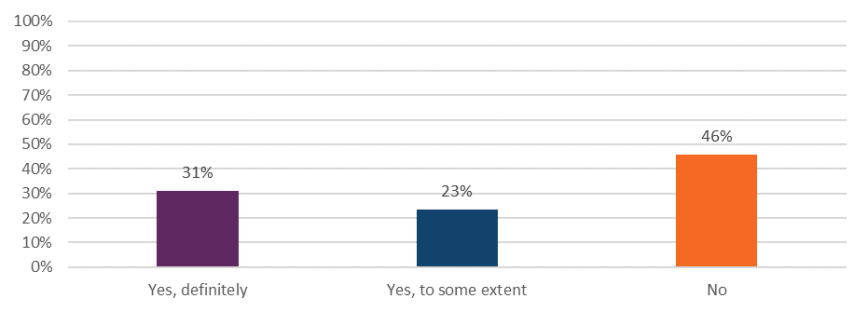Answered by those who would know who to contact out of office hours within the NHS if they had a crisis. Respondents who stated that they didn't know / couldn't remember, this was not applicable, or their family / carer did not want support have been excluded. (2023, Respondents: 3,435)

4.8 Crisis care access
When people are in mental health crisis, they need timely help and access to support. The establishment of the Crisis Care Concordat, and investment through the NHS Long Term Plan to expand and improve mental health services, means that more people who require care and support can access this in an appropriate setting and from the right professional. However, the 2023 policy paper National Partnership Agreement: Right Care, Right Person (RCRP) acknowledges this is not yet universally the case.

The NHS provides urgent mental health helplines for people of all ages which offer 24-hour advice and support from a mental health professional who will help to decide on the best course of care. Additionally, a person’s care plan should include details of who to contact in a crisis, which will often be the local crisis team.

Respondents were asked if they would know who to contact out of office hours within the NHS if they had a crisis. Seventy-eight per cent of respondents knew who to contact in a crisis, and 45% have contacted this person/team.

Figure 15: Would you know who to contact out of office hours within the NHS if you had a crisis? This should be a person or a team within NHS mental health services. (Q26)
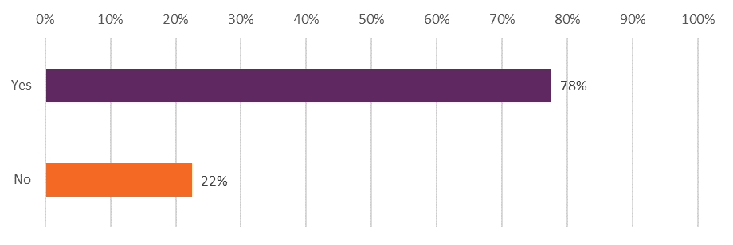
Answered by all. Respondents who stated that they were not sure have been excluded. (2023, Respondents: 12,907)

In 2021 NHS England proposed new mental health access standards. These aimed to ensure that patients requiring urgent care would be seen by community mental health crisis teams within 24 hours of referral, with the most urgent getting help within 4 hours. However, the July 2023 House of Commons Committee report – ‘Progress in improving NHS mental health services’, highlights that there is no commitment yet to rolling out waiting times standards to all mental health services.

As people in mental health crisis need timely help and support, respondents were asked about the length of time it took them to get through to their crisis contact or team. Around a third of all respondents (35%) reported getting through ‘straight away’, while 1 in 5 (21%) felt they ‘had to wait too long’.

Figure 16: Thinking about the last time you contacted this person or team, how do you feel about the length of time it took you to get through to them? (Q29)
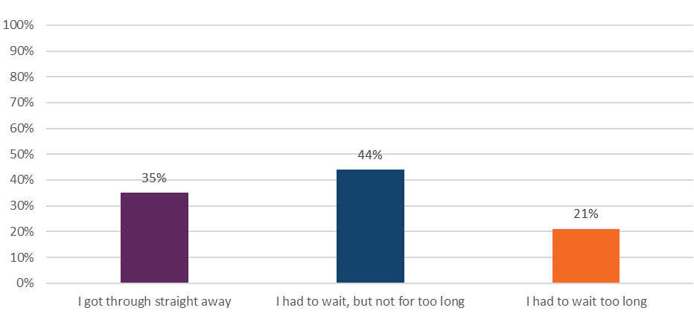Answered by those who would know who to contact out of office hours within the NHS if they had a crisis. Respondents who stated that they didn't know / couldn't remember have been excluded. (2023, Respondents: 4,191)

4.9 Support with other areas of life
Mental ill health does not occur in isolation. It can be influenced by, and influence, many aspects of a person’s life. These can include housing, financial support, employment, and physical health.,

Survey respondents were asked several questions about the support provided to them in accessing help for their broader needs. This year the survey also included questions around the ‘cost of living’ and social engagement. Those who already had active support or felt they did not require support with their needs were excluded from results. The percentage of total respondents who did not need support ranged from 15% to 35% across the individual questions.

Physical health needs
Mental and physical health are inextricably linked. The NHS long-term plan highlights that people with severe mental illnesses are at substantially higher risk of obesity, asthma, diabetes, chronic obstructive pulmonary disease (COPD), and cardiovascular disease. It has been estimated that those with severe mental illness die on average 15-20 years earlier than the general population. Recently, the NHS mandate for 2022/23 re-stated the requirement for the NHS to treat mental health with the same urgency as physical health.

Respondents were asked if, in the last 12 months, their NHS mental health team had supported them with their physical health needs. Overall, responses show that 40% have not received support but would have liked it, while 31% had ‘definitely’ received this support.

Figure 17: In the last 12 months, has your NHS mental health team supported you with your physical health needs (this might be an injury, a disability, or a condition such as diabetes, epilepsy, etc)? (Q31)
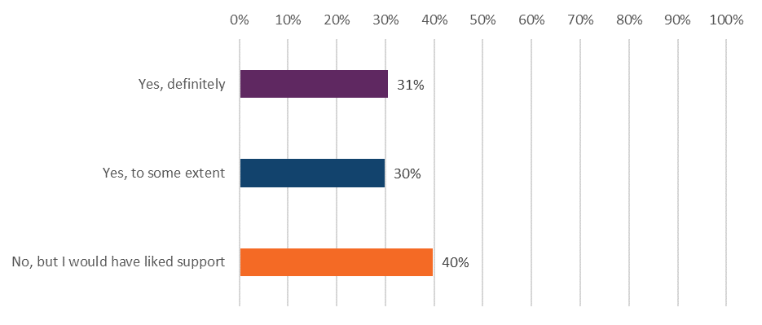
Answered by all. Respondents who stated that they had support and did not need this (18.9%), didn't need support and did not have physical needs have been excluded (14.7%). (2023, Respondents: 8,061). Note: Because of rounding, percentages do not sum to 100%.

Groups which were more likely to report that they had ‘definitely’ received support with their physical needs include those from CAMHS, those who are not disabled and people who access services face to face. Conversely, those that were more likely to have had a poorer experience were those who accessed services via the telephone, Disabled people, and people who use adult mental health services.

Social activities
Social isolation and loneliness are detrimental to health, with weak social networks and lack of social support associated with higher health risks. Social prescribing is an approach that connects people to activities, groups, and services in their community to meet the practical, social and emotional needs that affect their health and wellbeing. The NHS Long Term Plan committed to building the infrastructure for social prescribing. The goal was that at least 900,000 people would be referred to social prescribing by 2023/24.99

To understand the support people using receive in tackling social isolation and loneliness, the survey asked respondents whether their NHS mental health team gave them any help or advice with finding support for joining a group or taking part in an activity. Overall, responses show that 44% have not received help or advice in finding this support.

Figure 18: In the last 12 months, did your NHS mental health team give you any help or advice with finding support for joining a group or taking part in an activity (e.g. art, sport etc.) (Q32_1)
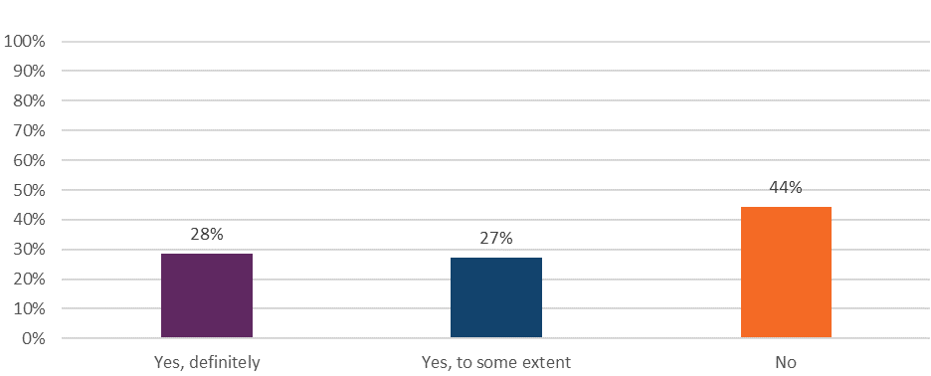
Answered by all. Respondents who stated that they did not need support have been excluded (15.3%). (2023, Respondents: 11,873)

Financial advice, benefits, and employment
Stability in both employment and general finances are important elements of maintaining good mental health. In 2017, Thriving at work: a review of mental health and employers found that 300,000 people with a long-term mental health condition lose their jobs each year, which is a much higher proportion than those with physical health conditions. The Five Year Forward View for Mental Health notes that people with mental health conditions are often over-represented in low-paying, high-turnover, temporary roles. This suggests higher levels of financial instability for people in this group.

Respondents were asked if in the last 12 months, their NHS mental health team gave them any help or advice with finding support for finding or keeping work. Responses show that 70% have not received support.

Figure 19: In the last 12 months, did your NHS mental health team give you any help or advice with finding support for finding or keeping work? (Q32_2)
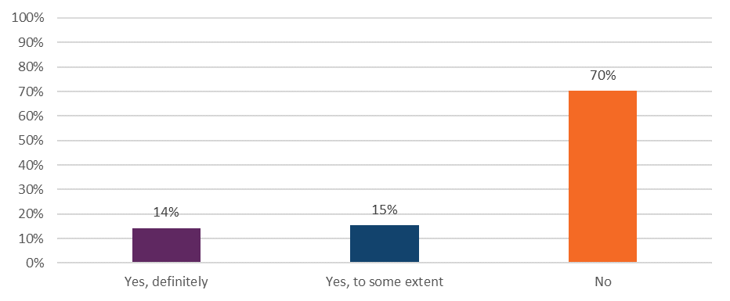Answered by all. Respondents who stated that they did not need support have been excluded (35%). (2023, Respondents: 8,364)

The government provides support through a disability cost of living payment if the claimant is in receipt of one of the named payments/allowances. However, a survey conducted by Mind in 2017 showed how challenging the benefits system can be for people with mental health problems.

Respondents were also asked if in the last 12 months, their NHS mental health team gave them any help or advice with finding support for financial advice or benefits. Overall responses show that 67% have not received help or advice in finding support for financial advice or benefits.

Figure 20: In the last 12 months, did your NHS mental health team give you any help or advice with finding support for financial advice or benefits? (Q32_3)
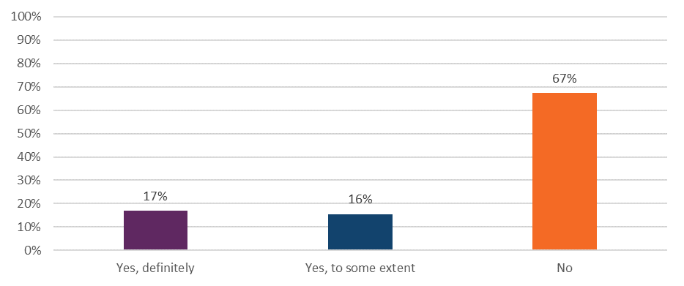Answered by all. Respondents who stated that they did not need support have been excluded (26.5%). (2023, Respondents: 9,779)

Cost of living
Poor mental health can make earning and managing money harder, leading to financial instability. This is an increasing concern for many people when considering the rising cost of living and the impact this has on household finances, as well as the removal of support networks as local community services close, which can make mental health problems worse. People are washing clothes less, struggling to pay bills, or not putting the heating on. In, NHS England’s report, Mental Health of Children and Young People in England 2022, among 17 to 22 year olds with a probable mental disorder, 14.8% reported living in a household that had experienced not being able to buy enough food or using a food bank in the past year. This compared with 2.1% of young people unlikely to have a mental disorder. Furthermore, a survey carried out by the Money and Mental Health Policy Institute found that nearly 1 in 5 respondents reported missing appointments from being unable to meet the travel costs.102

The rising cost of living, and the effect this may have on household finances and a person’s social network, can have an impact on mental health problems. Respondents were asked whether in the last 12 months, their NHS mental health team gave them any help or advice with finding support for the cost of living. Overall findings show 78% of respondents indicated ‘no’ they were not offered any help or advice in finding support with the cost of living.

Figure 21: In the last 12 months, did your NHS mental health team give you any help or advice with finding support for cost of living? (Q32_4)
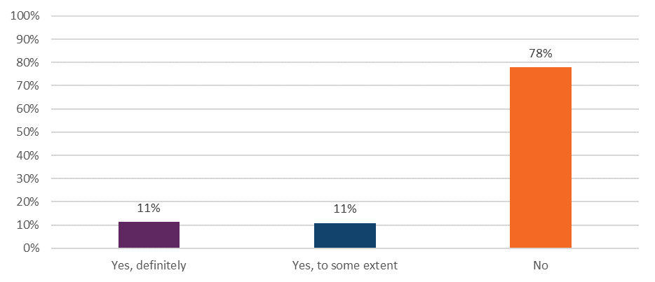Answered by all. Respondents who stated that they did not need support have been excluded (27.4%). (2023, Respondents: 9,556)

Involving family or friends
Having the support of families and carers, including relatives, friends and non-professional advocates, can be invaluable in making a person feel empowered to deal with their mental health condition. NICE guidance encourages the involvement of family and carers of people using services, should the person receiving care want this. A discussion with the person using mental health services should occur at regular intervals to take account of any changes in circumstances, and should not happen only once.

Respondents were asked if NHS mental health services involved a member of their family or someone else close to them as much as they would like. Overall, 45% responded ‘yes, definitely’, while 8% felt they had been involved too much.

Figure 22: Have NHS mental health services involved a member of your family or someone else close to you as much as you would like? (Q33)

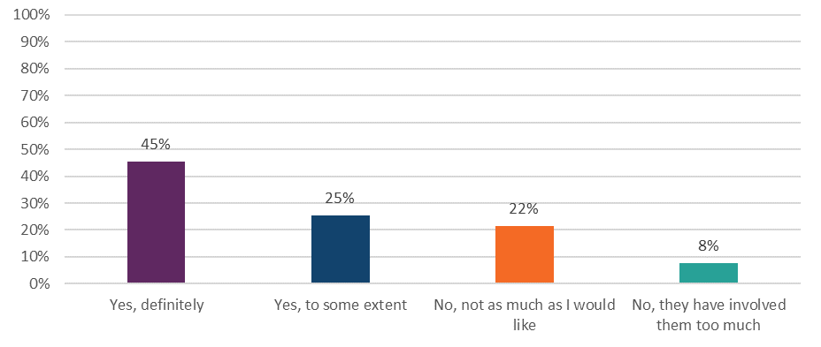Answered by all. Respondents who stated that this was not applicable to them have been excluded. (2023, Respondents: 10,183)
Support with other areas of life varied between groups. This is notable for participants with a disability who were less likely to report they had ‘definitely’ been given support with joining a social group, finding or keeping work or having the involvement of family or others as much as they would like. Groups more likely to respond positively to receiving support for financial advice and benefits include males, those who access services face to face, and people with dementia.

4.10 Support in accessing care
Ensuring everyone can access services fairly is a key priority for the NHS. Equality of access is enshrined within the Public Sector Equality Duty set out in the Equality Act 2010 which applies to all public bodies and all those that carry out public functions. To achieve equity, people need to be given appropriate access to information, services, and support. This could include:

- support accessing the building where treatment is delivered such as provision of lifts, ramps, or signage
- language support in the form or translation, or interpreters
- the format of materials or documents (easy read, braille, large print)
- support accessing online appointments.
Respondents were asked if their NHS mental health team asked if they needed support to access their care and treatment. Overall, more than half of all respondents (59%) were not asked if they required support to access their care and treatment.

Groups who were more likely to have been asked if they needed support in accessing their care and treatment, included those who access services face to face or via video conferencing and those who have been in contact with the mental health team for 5 years or less.

Respondents who did require support and had received this support, were asked if the support met their needs. Around a third (31%) responded ‘no’.

Figure 23: Do you feel the support provided meets your needs? (Q37)
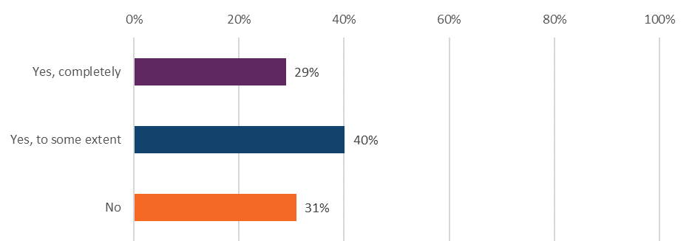
Answered by those who needed support to access their care and treatment. Respondents who stated that they didn't receive any support and didn't know / couldn't remember have been excluded. (2023, Respondents: 3,132)

4.11 Respect, dignity and compassion
Showing respect, dignity and compassion is essential for developing positive relationships between those providing mental health services and those receiving care and treatment. People should expect to be treated with compassion, dignity and respect as a basic human right, as highlighted in the NHS Constitution. Furthermore, the NICE quality statement 1: Empathy, dignity and respect, acknowledges all 3 as important components of positive experiences. Unfortunately, stigma, or perceived stigma, connected to mental ill health can act as a barrier for people who need specialist help, both within and outside of the healthcare system.

Respondents were asked if their NHS mental health team treated them with care and compassion. Overall results show 65% of respondents answered ‘yes, always’, while 9% felt they were not treated with care and compassion.

Subgroup analysis indicated several groups were less likely to report that they were treated with care and compassion. These include people aged 16 to 50, those whose mode of contact is the telephone, and respondents who have been in contact for more than 10 years or are no longer in contact with their mental health team. Groups that were more likely to report they were treated with care and compassion include those from the Christian and Muslim faiths and people aged 51 and over.

Figure 24: Did your NHS mental health team treat you with care and compassion?
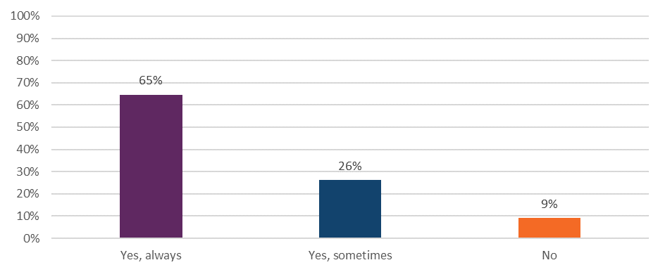Answered by all. Respondents who stated that they didn't know / couldn't remember have been excluded. (2023, Respondents: 14,236)

Respondents were also asked if they were treated with respect and dignity. Similarly, 65% of respondents reported they were ‘always’ treated with respect and dignity.

Groups that were less likely to give the most positive responses include people aged 16 to 50, Disabled respondents, those of Sikh faith, and people who accessed services via the telephone. In contrast those who were likely to answer more positively were people aged 66 and above, respondents who are not disabled, people from the Christian and Muslim faiths, and those who access services face to face.

Figure 25: Overall, in the last 12 months, did you feel that you were treated with respect and dignity by NHS mental health services?

Answered by all. (2023, Respondents: 14,318)

4.12 Overall experience
The common principles and values of the NHS, as set out in the NHS Constitution, includes the commitments to place people who use services at the heart of everything the NHS does, and provide quality care that is focused on patient experience.

Respondents were asked to rate their experience of using NHS mental health services on a scale of 0 to 10, with zero indicating very poor experiences and 10 indicating very good experiences. Overall, 34% of respondents gave a score of 9 or 10.

Figure 26: Overall, in the last 12 months, how was your experience of using the NHS mental health services. (Q38)
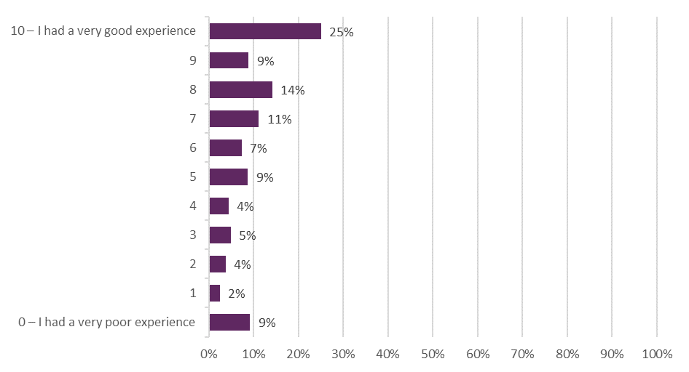
Answered by all. (2023, Respondents: 14,254)

4.13 Feedback
Principle 4 of the NHS Constitution places people who use services at the heart of everything the NHS does. Patient experience is also embedded in the values outlined within the constitution where they encourage and welcome feedback from patients, families, carers, staff and the public. CQC data supports NHS England to track how it is doing on user experience and understand where inequality is present and the impact that policy initiatives are having on patients.

In the last 12 months, 73% of respondents were not asked by NHS mental health services to give their views on the quality of their care.

Subgroups that were less likely to have been asked include those who access services via the telephone and people who are White. Those more likely to have been asked were people who access service face to face.

Figure 27: Aside from this questionnaire, in the last 12 months, have you been asked by NHS mental health services to give your views on the quality of your care? (Q40)
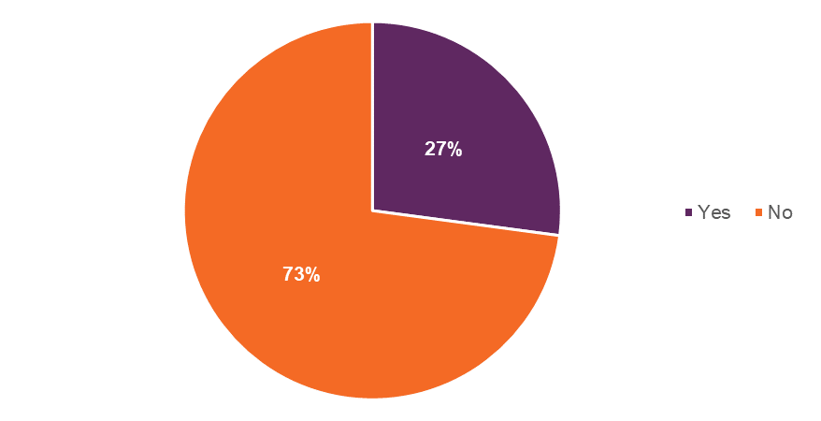
Answered by all. Respondents who answered that they were not sure have been excluded. (2023, Respondents: 12,102)

Results for individual assessment service groups (ASG)
In this section the findings from the survey for the individual assessment service groups (ASG) are presented. Specifically, child and adolescent mental health services (CAMHS), and older peoples’ mental health services (OPMHS). Adult mental health services (AMHS) are not addressed separately as the results largely reflect the national findings. The results display findings from CAMHS and OPMHS that reflect the experience of those who responded to the survey.

These results are presented separately to the national results due to the low response rates, particularly for the CAMHS data. Consequently, comparisons will not be drawn between the groups or against the national results. However, these results provide new insight this year into the experience of mental health services from the perspective of different service groups.

5.1 Child and adolescent mental health services (CAMHS)
Good mental health is important for children and young adults so they can attend school, participate in their communities, and enjoy time with their family. However, rates of mental ill-health are increasing and in 2022, 22% of young people aged 17 to 24 years had a probable mental disorder.

Children and young people access NHS mental health support via child and adolescent mental health services (CAMHS). Support within this service is provided until the individual reaches 25, however, people can start transitioning to adult mental health services (AMHS) from the age of 16.

For the first time, the community mental health survey included the views of 16-and 17-year-olds who were receiving specialist care or treatment for a mental health condition between 1 April and 31 May 2023. In line with the national findings, CAHMS user experiences are discussed across a range of themes.

Support while waiting
Mental health difficulties experienced as an adult have often developed in childhood or young adulthood. Half are established by the age of 14, with three quarters established by 24 years of age.10 Appropriate early intervention enables children and young people experiencing difficulties to enhance their mental health and maximise their prospects for a healthy and happy life. 7, ,

To understand aspects of early intervention respondents were asked if they were offered support while waiting between their assessment with the NHS mental health team and their first appointment for treatment. Sixty per cent said they were not offered support while waiting.

Figure 28: While waiting, between your assessment with the NHS mental health team and your first appointment for treatment, were you offered support with your mental health? (Q6)
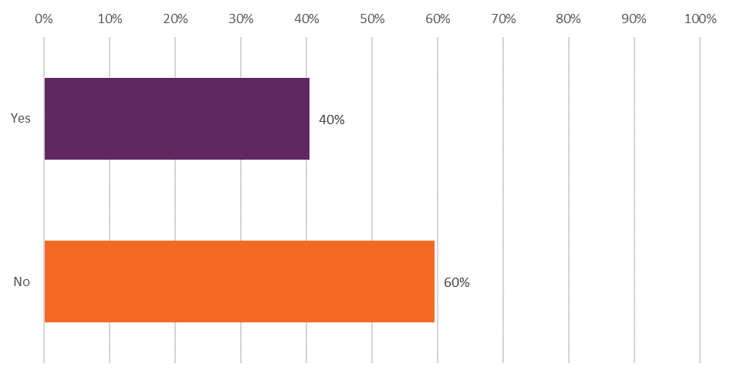
Answered by those who have been in contact with the NHS mental health services for the past 2 years. Respondents who stated that they didn't know / couldn't remember have been excluded. (2023, Respondents: 484)

Respondents who said they were offered support while they waited for treatment were asked whether they felt the support they were offered was appropriate for their mental health needs. Thirty-six per cent of people who answered the survey using CAMHS said the support offered was ‘completely’ appropriate for their needs.

Mental health team
Working with CAMHS involves talking about difficult thoughts and memories. Therefore, it is important for young people to feel comfortable with their team. Building a relationship with the mental health team should allow people to share experiences of their care, their mental health, and other areas of their life. This will require appointments being of sufficient duration despite the increasing demand on the service along with a coordinated approach to support.

To understand the respondent’s experiences of their mental health team respondents were firstly asked if they were given enough time to discuss their needs and treatment during their appointments. Less than half (39%) of CAMHS users said they were ‘definitely’ given enough time to discuss their needs and treatment.

Figure 29 Were you given enough time to discuss your needs and treatment? (Q8)

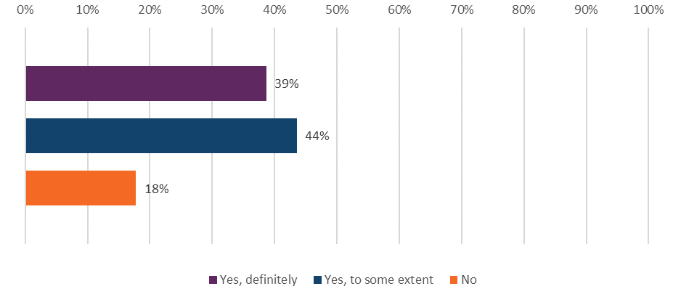
Answered by all. Respondents who stated that they didn't know / couldn't remember have been excluded. (2023, Respondents: 1,211)

Respondents were then asked if they got the help they needed from their mental health team. One in 4 people (25%) reported they ‘definitely’ got the help they needed from their mental health team, while almost a third (30%) reported they did not.

Figure 30: Did you get the help you needed? (Q9)

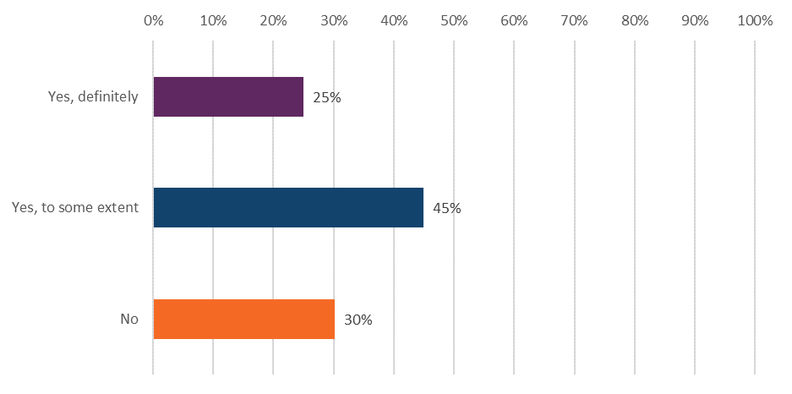
Answered by all. Respondents who stated that they didn't know / couldn't remember have been excluded. (2023, Respondents: 1,240)

Repeating medical history can be frustrating and time consuming for some users of services. Therefore, respondents were asked if they had to repeat their mental health history to their NHS mental health team. Results show 41% of CAMHS users who answered the survey had to repeat their mental health history ‘often’.

Figure 31: Did you have to repeat your mental health history to your NHS mental health team? (Q11)
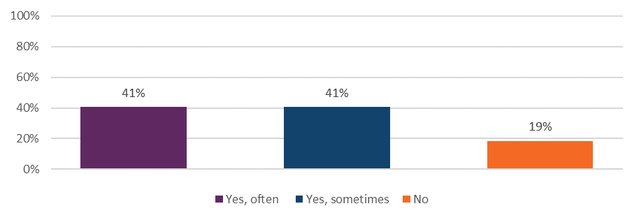
Answered by all. Respondents who stated that they didn't know / couldn't remember have been excluded. 2023, Respondents: 1,173)

Planning and involvement in care
There should be active participation with users of services in treatment decisions which supports self-management. To understand people’s involvement in decision-making, respondents were asked if they had a care plan. Survey results for CAMHS respondents show that 2 in 5 (40%) do not have a care plan.

Respondents were also asked ‘Have you and your NHS mental health team decided together what care and treatment you will receive?’. Thirty per cent felt they ‘definitely’ made decisions together with their mental health team, while 27% reported they had not made decisions together.

In terms of feeling supported to make decisions about their care, results show that around a third (36%) of CAMHS users felt they were ‘definitely’ supported to make decisions about their care and treatment.

Furthermore, when asked whether they felt in control of their care, a third (33%) did not feel in control of their care.

Figure 32: Do you feel in control of your care? (Q18)
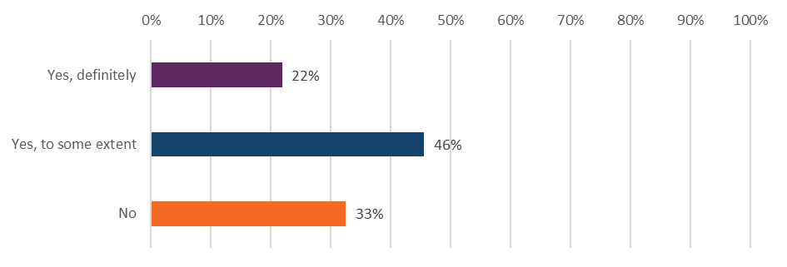
Answered by all. Respondents who stated that they didn't want to be in control of their care, their care has now ended, or they didn't know / couldn't remember have been excluded. (2023, Respondents: 969)

Medication
The survey asked CAMHS respondents if, in the last 12 months, their NHS mental health team asked them how they are getting on with their medication. Results show 86% of CAMHS users indicated they had been asked how they were getting on with their medications in the last 12 months.

Figure 33: In the last 12 months, has your NHS mental health team asked you how you are getting on with your medication? (Q22)
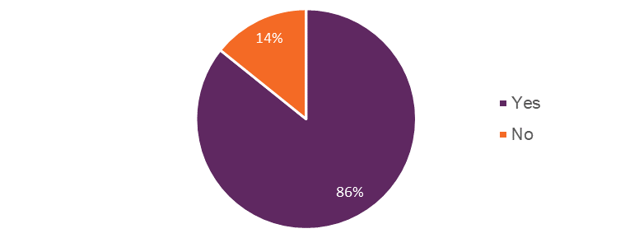
Answered by those who have been receiving medication for their mental health needs in the last 12 months. Respondents who stated that they didn't know / not sure have been excluded. (2023, Respondents: 683)

Over a series of 4 questions people were then asked what aspects of their medication had been discussed with them. The purpose of their medication had ‘definitely’ been discussed with 71% of respondents. The benefits of their medication had ‘definitely’ been discussed with 61% of respondents. When asked if the side effects of their medication had been explained, the percentage of respondents who had ‘definitely’ discussed this reduced to 53%. Lastly when asked if they had discussed what would happen if they stopped taking their medication 39% responded ‘no’ they had not had this discussion.

Figure 34: Have any of the following been discussed with you about your medication? (Q21)
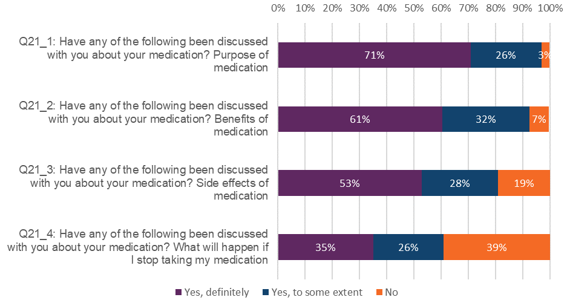
Answered by those who have been receiving medication for their mental health needs in the last 12 months. Respondents who stated that they didn't know have been excluded. (2023, Respondents: Q21_1, 775; Q21_2, 761; Q21_3, 761; Q21_4, 740)

NHS talking therapies
Where CAMHS respondents had received any NHS talking therapies in the last 12 months for their mental health needs the survey asked how they felt about the length of time they waited between their assessment with the NHS mental health team and their first talking therapies appointment? Fifty-eight percent answered that the waiting time was too long.

The survey asked if, during the last time they received NHS talking therapies, respondents had enough privacy to talk comfortably. In response, 67% of those using CAMHS said ‘yes, definitely’.

Crisis care – access and support
Respondents were asked if they would know who to contact out of office hours within the NHS if they had a crisis. For those using CAHMS, the survey results indicate nearly 2 in 5 people (38%) do not know who to contact in a crisis. This is reinforced by sub-group analysis that shows CAMHS respondents as a group are less likely to know who to contact in a crisis than the average of all survey respondents.

Respondents were also asked a series of questions to understand their experience of crisis care support. Of those respondents that contacted the crisis team, around a quarter (26%) answered that they had ‘definitely’ received the help they needed.

Figure 35: Thinking about the last time you contacted this person or team, did you get the help you needed? (Q28)
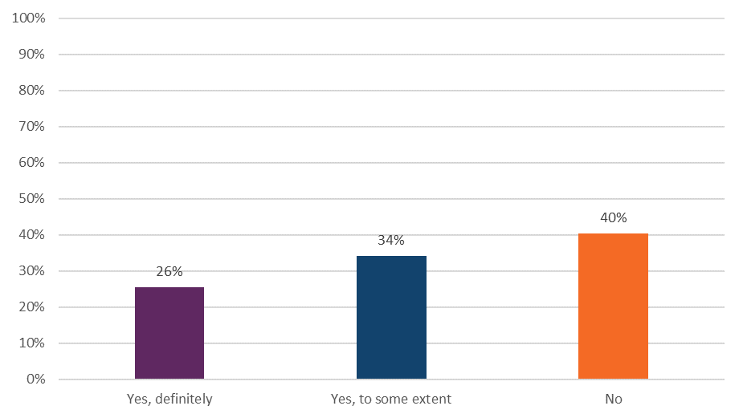
Answered by those who would know who to contact out of office hours within the NHS if they had a crisis. Respondents who stated that they didn't know / couldn't remember have been excluded. (2023, Respondents: 279)

Support with other areas of life
Mental ill health does not occur in isolation. It can be influenced by, and influence, many aspects of a person’s life. Therefore, the survey respondents were asked several questions about the support provided to them in accessing help for their broader needs. Those who already had active support or felt they did not require support with their needs were excluded from results.

Respondents were also asked if in the last 12 months, their NHS mental health team gave them any help or advice with finding support for financial advice or benefits. Eighty-five per cent for all CAMHS respondents have not received help or advice in finding support for financial advice or benefits.

The rising cost of living, and the effect this may have on household finances and a person’s social network, can have an impact on mental health problems. Therefore, respondents were asked whether in the last 12 months, their NHS mental health team gave them any help or advice with finding support for the cost of living. Ninety-one per cent of people using CAMHS reported they did not receive help or advice.

Figure 36: In the last 12 months, did your NHS mental health team give you any help or advice with finding support for …
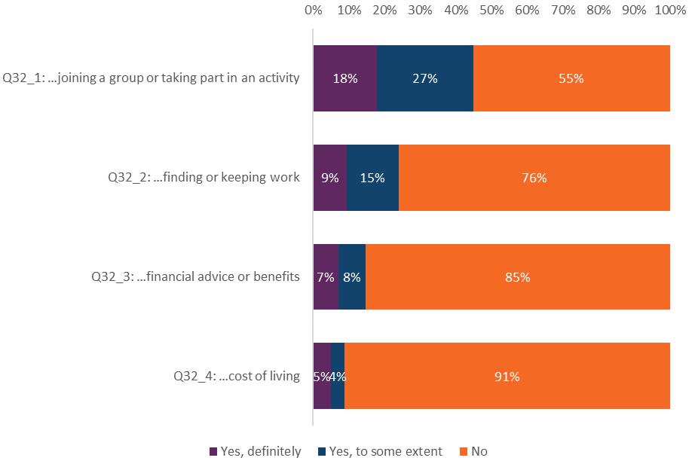
Answered by all. Respondents who stated that they did not need support have been excluded. (2023, Respondents: Q32_1, 1,032; Q32_2, 803; Q32_3, 760; Q32_4, 739)

Support in accessing care
Respondents were asked if their NHS mental health team asked if they needed support to access their care and treatment. Sixty-five per cent of CAMHS users were not asked if they required support to access their care and treatment.

Figure 37: Has your NHS mental health team asked if you need support to access your care and treatment? (Q34)
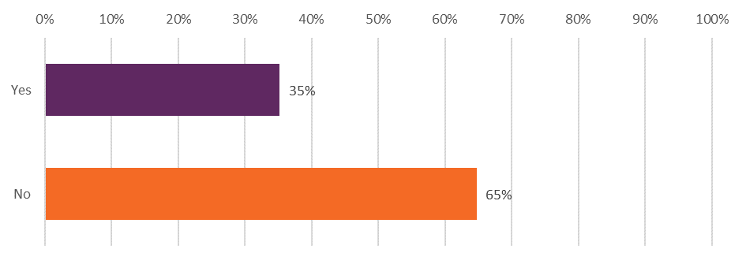
Answered by all. Respondents who stated that they didn't know / couldn't remember have been excluded. (2023, Respondents: 929)

Respondents who had received support were asked whether the support provided met their needs. In response, 41% of CAMHS users said the support provided did not meet their needs.

Figure 38: Do you feel the support provided meets your needs? (Q37)
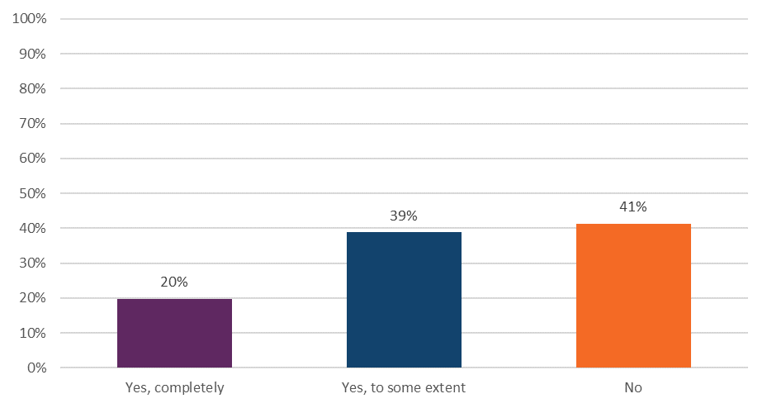
Answered by those who needed support to access their care and treatment. Respondents who stated that they didn't receive any support and didn't know / couldn't remember have been excluded. (2023, Respondents: 198)

Respect, dignity and compassion
Respondents were asked if their NHS mental health team treated them with care and compassion. Over half (56%) of CAMHS users reported that they were ‘always’ treated with care and compassion. Similarly, 55% of respondents reported they were ‘always’ treated with respect and dignity.

Overall experience
Respondents were asked to rate their experience of using NHS mental health services on a scale of 0 to 10, with zero indicating a very poor experience and 10 indicating they had a very good experience. Of those using CAMHS services, 1 in 5 people (19%) assigned a score of 9 or 10 to their experience.

Figure 39: Overall, in the last 12 months, how was your experience of using the NHS mental health services? (Q38)
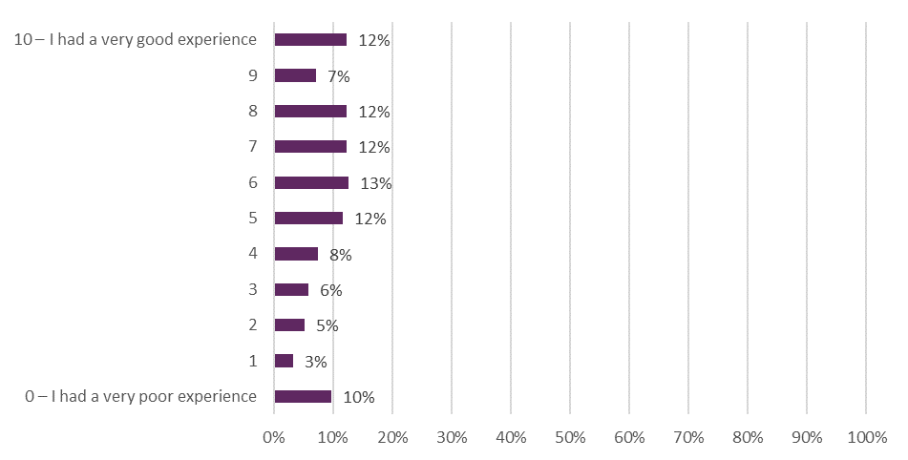
Answered by all. (2023, Respondents: 1,254)

5.2 Older People Mental Health Services (OPMHS)
It is expected that older peoples’ mental health services will begin for those who are 65 years of age or older. Through integrated models of primary and community mental health care, older adults should have greater choice and control over their care. Furthermore, as part of the transformation of community mental health care, OPMH staff will be expected to work closely with ‘physical health’ support.

In line with the national findings, and the section on the CAHMS user experiences, OPMHS are discussed across the same range of themes.

Support while waiting
Respondents who said they were offered support while they waited for treatment were asked whether they felt the support they were offered was appropriate for their mental health needs. Just over half (54%) of people using older peoples’ mental health services said the support offered was ‘completely’ appropriate for their needs.

Mental health team
Those who use services should be able to talk about their experiences of care, mental health, and other aspects of their lives by developing a relationship with their mental health team. This will require appointments being of sufficient duration despite increasing demand on the service.

In the survey, respondents were asked if they were given enough time to discuss their needs and treatment during their appointments. Sixty-six per cent of people using older people’s mental health services said they were ‘definitely’ given enough time to discuss their needs and treatment.

Planning and involvement in care
To understand involvement of people using services in decision-making, respondents were asked, ‘Have you and your NHS mental health team decided together what care and treatment you will receive?’. Less than half (46%) of people using older people’s mental health services felt they ‘definitely’ made decisions together with their mental health team, while 17% had not made decisions together.

Figure 40: Have you and your NHS mental health team decided together what care and treatment you will receive? (Q14)
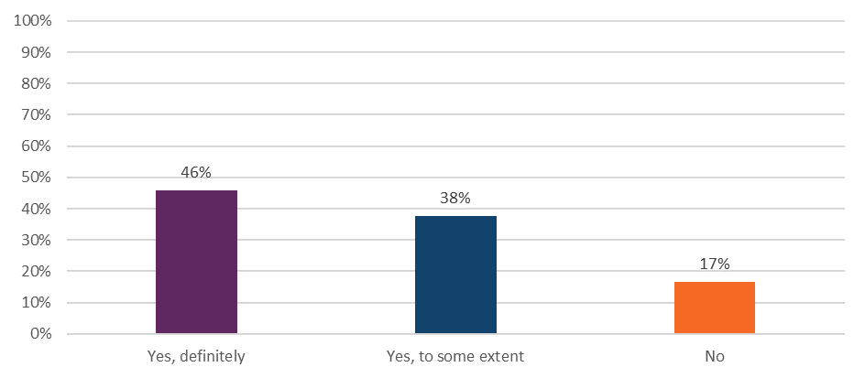
Answered by all. Respondents who stated that they didn't know / couldn't remember have been excluded. (2023, Respondents: 2,099)

Medication
When asked in the last 12 months if their NHS mental health team has asked how they are getting on with their medication, 83% of people using OPMHS answered ‘yes’.

A series of questions then sought to better understand the discussions about their medication. Results show that 67% of respondents had ‘definitely’ talked about the purpose of their medication with their mental health professional. Similarly, the benefits of a person’s medication was ‘definitely’ discussed with 62% of respondents. Topics discussed less frequently were the side effects of medication, with a quarter (26%) of respondents reporting this had not been discussed with them. In addition, 32% of respondents had not discussed what will happen if they stop taking their medication.

Figure 41: Have any of the following been discussed with you about your medication?... (Q21_1 to Q21_4)
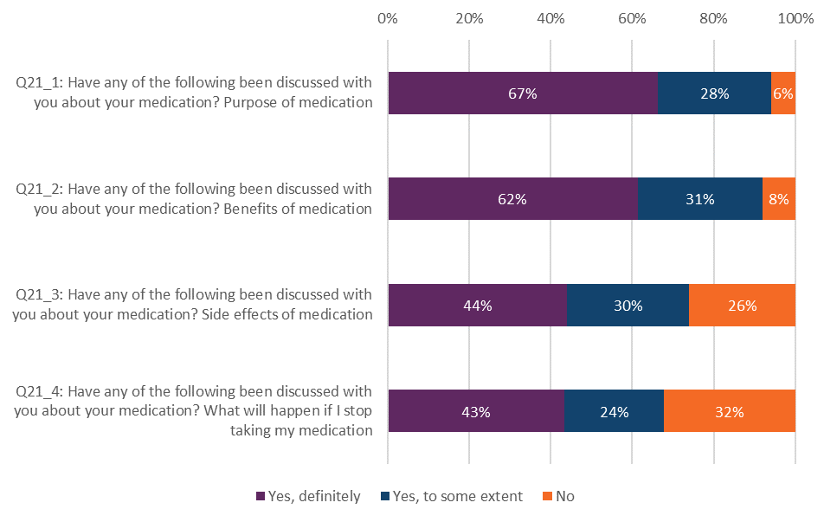
Answered by those who have been receiving medication for their mental health needs in the last 12 months. Respondents who stated that they didn't know have been excluded. (2023, Respondents: Q21_1, 1781; Q21_2, 1683; Q21_3, 1616; Q21_4, 1474)

NHS talking therapies
When respondents had received any NHS talking therapies in the last 12 months for their mental health needs the survey asked how they felt about the length of time they waited between their assessment with the NHS mental health team and their first talking therapies appointment? Sixty-eight per cent answered that the waiting time was appropriate.

The survey then asked if, during the last time they received NHS talking therapies, respondents had enough privacy to talk comfortably. In response, 84% of those using older adult services ‘definitely’ felt they had enough privacy.

Crisis care support and access
Respondents were asked ‘Would you know who to contact out of office hours within the NHS if you had a crisis?’ Seventy-one per cent of respondents’ answers ‘yes’, they knew who to contact. Additionally, 60% of respondents that contacted crisis services ‘definitely’ got the help they needed.

Support with other areas of life
People’s mental health is influenced by many aspects of their lives, including their housing, financial support, employment and physical health.,

Survey respondents were asked several questions about the support provided to them in accessing help for their broader needs. Those who already had active support or felt they did not require support with their needs were excluded from results.

Firstly, respondents were asked if, in the last 12 months, their NHS mental health team had supported them with their physical health needs. Results from those accessing older people’s mental health services showed less than half (42%) of people had ‘definitely’ received support with their physical health needs.

Respondents were then asked if in the last 12 months, their NHS mental health team gave them any help or advice with finding support for finding or keeping work. Finding work is increasingly relevant for older people in part due to the rising pension age and the cost-of-living crisis. In 2023 there were 446,601 people above the age of 70 still in work which was a rise of 61% compared to 2012. Survey responses show that 90% of those using the older people’s mental health services had not been given any help or advice with finding support for finding or keeping work.

Figure 42: In the last 12 months, did your NHS mental health team give you any help or advice with finding support for… (Q32_1 to Q32_4)
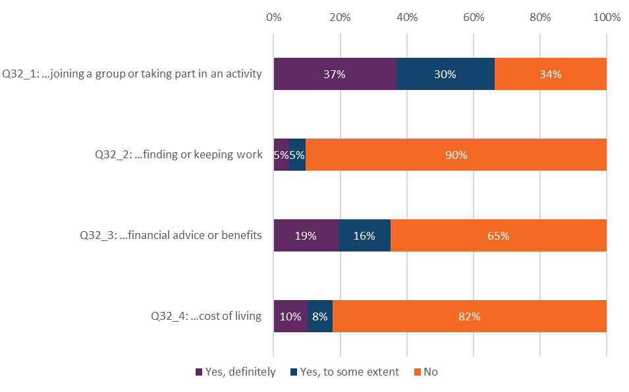
Answered by all. Respondents who stated that they did not need support have been excluded. (2023, Respondents: Q32_1, 1,630; Q32_2, 628; Q32_3, 1,111; Q32_4,993)

Support in accessing care
Respondents were asked if their NHS mental health team asked if they needed support to access their care and treatment. In response, 49% of people using older people’s mental health services were not asked if they required support to access their care and treatment. Of those who were asked and did require support, 18% said the support did not meet their needs.

Respect, dignity and compassion
Respondents were asked if their NHS mental health team treated them with care and compassion. Eighty-five per cent of those using older adult mental health services reported they were ‘always’ treated with care and compassion. Furthermore, 86% of people using older people’s mental health services reported they were ‘always’ treated with respect and dignity.

Overall experience
Respondents were asked to rate their experience of using NHS mental health services on a scale of 0 to 10, with zero indicating very poor experiences and 10 indicating very good experiences. Around half (49%) of people using older people’s mental health services gave an overall score of 9 or 10.

Subgroup analysis summary: how experience varies for different groups of respondents
Both the NHS Constitution and the Equality Act 2010 require providers of healthcare services to equally consider the needs, experiences, outcomes and aspirations of people with protected characteristics under equalities law.

This section shows the results of a ‘subgroup analysis’, which considers the experiences of different groups of people. Looking at the questions asked within the survey, the analysis models the average probability of different groups of people using community mental health services selecting the most positive answers to questions or sets of questions according to demographic, health, and care characteristics.

These characteristics are:

- Age
- Sex
- Ethnicity
- Gender same as sex
- Religion
- Sexual orientation
- Mode of contact
- Index of multiple deprivation decile (IMD)
- Length of contact
- Disability
- ‘Proxy response’ (whether the questionnaire was completed entirely by, or with the support of, someone other than the person who used the services).
- Assessment Service Group (ASG)
- Long-term conditions.

Please refer to the subgroup report on the Community mental health survey 2023 page for more information about the questions used, as well as the charts.

In this report, subgroup differences are considered reportable where a demographic or care characteristic overall (for example, age) is significantly associated with experience and where the mean response for the specific subgroup (for example, people aged 18 to 35) is significantly different from the overall mean. For further technical information on the subgroup analysis please see the Quality and methodology report.

Questions included in the subgroup analysis

Q8: Were you given enough time to discuss your needs and treatment?
Q9: Did you get the help you needed?
Q10: Did your NHS mental health team consider how areas of your life impact your mental health?
Q11: Did you have to repeat your mental health history to your NHS mental health team?
Q12: Did your NHS mental health team treat you with care and compassion?
Q13: Do you have a care plan? This is a plan for any care and treatment you may receive.
Q14: Have you and your NHS mental health team decided together what care and treatment you will receive?
Q16: In the last 12 months, have you had a care review meeting with your NHS mental health team to discuss how your care is working?
Q17: Has your NHS mental health team supported you to make decisions about your care and treatment?
Q18: Do you feel in control of your care?
Q26: Would you know who to contact out of office hours within the NHS if you had a crisis?
Q31: In the last 12 months, has your NHS mental health team supported you with your physical health needs?
Q32_1: In the last 12 months, did your NHS mental health team give you any help or advice with finding support for…Joining a group or taking part in an activity (e.g. art, sport etc)?
Q32_2: In the last 12 months, did your NHS mental health team give you any help or advice with finding support for…Finding or keeping work?
Q32_3: In the last 12 months, did your NHS mental health team give you any help or advice with finding support for…Financial advice or benefits?
Q32_4: In the last 12 months, did your NHS mental health team give you any help or advice with finding support for…Cost of living?
Q33: Have NHS mental health services involved a member of your family or someone else close to you as much as you would like?
Q34: Has your NHS mental health team asked if you need support to access your care and treatment?
Q39: Overall, in the last 12 months, did you feel that you were treated with respect and dignity by NHS mental health services?
Q40: Aside from this questionnaire, in the last 12 months, have you been asked by NHS mental health services to give your views on the quality of your care?
Table 1: The following tables show the experiences of different groups of people answering specific questions from the survey. Findings significantly above (B) or significantly below (W) average are shown for each subgroup category under each question.

W | Significantly worse than average experience
B | Significantly better than average experience

 | Q8: Were you given enough time to discuss your needs and treatment? | Q9: Did you get the help you needed? | Q10: Did your NHS mental health team consider how areas of your life impact your mental health? | Q11: Did you have to repeat your mental health history to your NHS mental health team? | Q12: Did your NHS mental health team treat you with care and compassion? | Q13: Do you have a care plan? This is a plan for any care and treatment you may receive. | Q14: Have you and your NHS mental health team decided together what care and treatment you will receive? | Q16: … have you had a care review meeting … to discuss how your care is working? | Q17: Has your NHS mental health team supported you to make decisions about your care and treatment? | Q18: Do you feel in control of your care? | Q26: Would you know who to contact out of office hours within the NHS if you had a crisis? | Q31: In the last 12 months, has your NHS mental health team supported you with your physical health needs? | Q32_1: … any help or advice with finding support for...Joining a group or taking part in an activity | Q32_2… any help or advice with finding support for...Finding or keeping work | Q32_3: …any help or advice with finding support for...Financial advice or benefits | Q32_4: … any help or advice with finding support for...Cost of living | Q33: Have NHS MHS involved a member of your family or someone else close to you as much as you would like? | Q34: Has your NHS mental health team asked if you need support to access your care and treatment? | Q39: Overall, …, did you feel that you were treated with respect and dignity by NHS mental health services? | Q40: … in the last 12 months, have you been asked by NHS MHS to give your views on the quality of your care?
Age
16-35 | W | W | W | W | W |  | W |  | W | W |  |  |  |  |  |  |  |  | W
36-50 | W | W |  | W | W |  | W |  |  |  |  |  |  |  |  |  |  |  | W
51-65 |  |  |  |  | B
66-80 | B | B |  | B | B |  | B |  | B |  |  |  |  |  |  |  |  |  | B
81+ | B | B |  | B | B |  |  |  |  | B |  |  |  |  |  |  |  |  | B
Sex
Male |  |  |  |  | B |  |  |  |  |  |  |  |  |  | B |  |  | B | B
Female
Prefer not to say (sex) |  |  |  |  | W |  |  |  |  |  |  |  |  |  |  |  |  | W
Ethnicity
White |  |  |  |  |  |  |  |  |  |  |  |  |  |  | W |  |  |  |  | W
Multiple ethnic groups
Asian or Asian British
Black or Black British
Arab or other ethnic group
Not known (ethnicity)
Gender same as sex
Same gender as registered at birth
Not the same gender as registered at birth
I would prefer not to say
Religion
No religion
Buddhist
Christian |  |  |  |  | B |  | B |  |  |  |  |  |  |  |  |  |  |  | B
Hindu
Jewish |  |  |  |  |  |  | W
Muslim | B | B |  |  | B |  | B | B |  |  |  |  |  |  |  |  |  |  | B
Sikh |  |  |  |  |  |  |  |  |  |  |  |  |  |  |  |  |  |  | W
Other (religion)
I would prefer not to say
Sexual orientation
Heterosexual / straight | B |  | B |  | B |  |  | B | B |  |  |  |  |  |  |  |  |  | B
Gay / lesbian
Bisexual
Other (sexual orientation)
I would prefer not to say | W |  | W |  |  |  |  | W
Mode of contact
Face to face (i.e. in person) | B | B | B |  | B | B | B | B | B | B |  | B | B |  | B |  | B | B | B | B
Video conferencing |  |  | B |  | B |  |  |  |  |  |  |  |  |  |  |  |  |  | B
Telephone | W |  | W |  | W |  | W | W | W | W |  | W |  |  |  |  |  | W | W | W
Multiple modes of contact used | W |  |  |  |  |  | W
Unsure
IMD decile
1st Decile
2nd Decile
3rd Decile
4th Decile
5th Decile
6th Decile
7th Decile
8th Decile
9th Decile
10th Decile
Length of contact
Less than 1 year | B | B | B |  | B |  | B |  | B | B |  |  | B |  |  |  |  | B | B
1 to 2 years | B | B | B |  | B | B | B | B | B |  | B |  | B |  |  |  |  | B | B
3 to 5 years | B |  | B |  |  | B | B | B | B |  | B |  |  |  |  |  |  | B
6 to 10 years |  |  |  |  |  | B |  | B
More than 10 years |  |  | W | B | W | B |  | B |  |  | B
I am no longer in contact with NHS MHS | W |  | W |  | W | W | W | W | W |  | W |  | W |  |  |  |  | W | W
Don’t know / can’t remember |  | W | W |  |  | W | W | W |  |  | W |  | W |  |  |  |  |  | W
Disability
Disabled | W | W | W | W | W |  | W | W | W | W |  | W | W | W |  |  | W |  | W
Not disabled | B | B | B | B | B |  | B | B | B | B |  | B | B | B |  |  | B |  | B
Proxy response
Service user |  |  |  |  |  | W |  | W |  |  |  |  |  |  |  |  | W | W | W
Friend or relative |  |  |  |  |  |  |  |  |  | W |  | W |  |  | W |  | B |  |  | W
Both service user and friend / relative |  |  |  |  |  | W |  |  |  | W |  |  |  |  |  |  |  | W |  | W
Service user & help of a health professional |  |  |  |  |  | B |  |  |  | B |  | B |  |  | B |  |  | B |  | B
Assessment Service Group (ASG)
CAMHS |  |  |  |  |  |  |  |  |  |  | W | B |  |  |  |  | B
Adult Mental Health Services |  |  |  |  |  |  |  |  |  |  | B | W |  |  |  |  | W
Older People Mental Health Services |  |  |  |  |  |  |  |  |  |  | B
Long-term conditions
Autism or autism spectrum condition | W | W |  |  | W |  | W |  |  |  |  |  |  |  |  | W |  |  | W
Breathing problem, such as asthma
Blindness or partial sight
Cancer in the last 5 years
No dementia or Alzheimer’s disease |  |  |  |  |  |  |  |  |  | B | B |  |  |  | W
Dementia or Alzheimer’s disease |  |  |  |  |  |  |  |  |  | W | W |  |  |  | B
Deafness or hearing loss
Diabetes
Heart problem, such as angina
Joint problem, such as arthritis |  |  |  |  |  |  |  |  |  |  |  |  |  |  |  |  | W
Kidney or liver disease
Learning disability
Mental health condition |  |  |  | W |  | B |  |  |  |  | B
Neurological condition | W |  |  |  |  |  | W
Physical Mobility
No stroke (affects your day-to-day life)
Stroke (affects your day-to-day life)
Another long-term condition | W | W |  |  | W |  |  |  | W | W |  | W |  | W |  | W | W |  | W

Appendix A: Survey methodology
This appendix covers aspects of survey methodology including questionnaire design, sampling, fieldwork and analysis. For more detailed information and for information on data limitations, please see the Quality and methodology report.

Questionnaire design
Before each survey, questions are reviewed to ensure the questionnaire is up-to-date and reflects current policy and practice. This development work makes sure that questions have the most utility for people who use services and to other stakeholders who use the survey data in their work. More information on how survey stakeholders use the data is provided in Appendix C.

Wherever possible, questions remain the same over time to measure change. However, the change from a paper-based to mixed-mode data collection methodology for the 2023 Community mental health survey necessitated a break in trends. The 2023 questionnaire was fully reviewed with large-scale changes made. Full details of this change are available in the Survey development report for the 2023 survey.

Comparability with previous years
Results from the 2023 survey are not comparable with those from previous survey years due to the change in mode of data collection and significant changes made to the questionnaire and sampling.

The change in mode of data collection did not affect the response rate, the response rate for the 2023 survey stayed the same compared to the previous year (21%).

Survey methods
The 2023 Community mental health survey used both an online and a postal questionnaire for survey data collection. All relevant survey materials were redeveloped for the 2023 survey based on learning from social research best practice to reflect the mixed-mode approach.

Patients were sent 2 letters containing a URL for the online survey, and 2 SMS reminders with a personalised URL that took them directly into the online survey without a login required, to encourage online completion. SMS reminders were sent at different times of day to reach different groups. The first SMS should be sent between 9am and 10am, 7 days after the initial contact. The second SMS should be sent between 4pm and 5pm, 7 days after the second contact. All participants received a postal questionnaire alongside their third letter.

Fieldwork for the survey (the time during which questionnaires were sent out and returned) took place between 18 August 2023 to 1 December 2023. For the Community mental health survey 2023, the fieldwork period was shortened from 18 to 15 weeks.

The 2023 survey offered several accessible formats of the questionnaire to ensure it followed best practice for survey accessibility. The online survey was translated into 9 non-English languages and British Sign Language. Additionally, participants were able to change font size, background colour of the online survey and it was tested to ensure screen reader compatibility. A paper Braille, large-print and easy read questionnaire were available on request.

Accessibility formats | Number of requests received
Non-English online completes | 59
BSL online completes | 0
Braille requests | 0
Large print requests | 8
Easy read requests | 6
Easy Read completes | 5
% of Easy Read completed | 83%
Phone calls | 1874
Emails | 436
Telephone assisted completes | 191
Telephone calls requiring translator | 8

Sampling
The sample for this survey was a random sample of minimum 1,250 people using services who:
- are aged 16 years and above; and
- were seen by someone face-to-face at the trust or via video conference or telephone call between 1 April and 31 May 2023 (the sample period); and
- had at least one other contact (face-to-face, video conference, phone or email) either before, during or after the sampling period.

For the 2023 survey, trusts could submit boosted samples for the first time. All trusts must submit a sample of 1,250 service users as a minimum, however trusts could choose to boost their sample to include additional records.

Certain groups of people using services were excluded before the trusts drew their sample, including:

- people under the age of 16 years old at the time of drawing the sample.
- people known to have died.
- people known to be current inpatients at the time of drawing the sample.
- people users that do not have a known UK address.
- people removed if there was insufficient name or address information for the questionnaire to have a reasonable chance of being delivered.
- people who have asked that their details are not used for any purpose other than their clinical care, including requests made following sight of survey pre-publicity. However, as stated above, services users who have opted out specifically through the National Data Opt-Out Programme are still eligible.
- Any duplicates, or any alias names where the person’s real name is already included in the list.

No trusts were excluded from analysis because of sampling errors.

The sample size was enough to allow analysis of results at individual trust level. Full details of the sampling are available in the sampling instructions for the survey.

Analysis

Data cleaning
‘Data cleaning’ refers to all editing processes carried out on survey data once the survey has been completed and the data has been entered and collated. This is done to ensure data quality and make sure that it is comparable across trusts. For further information please see the data cleaning guidance document.

Weighting
The data presented in this report has been weighted with 2 weights:

- ‘Trust weight’ aims to weight responses from each trust to ensure each trust has an equal influence on England results. As some trusts have a higher response rate than others, they have a larger share of respondents in the total respondent’s population for England.
- ‘Population weight’, ensures responses for each individual are weighted to make sure it is representative of the trust’s own population (based on the initial eligible sample). This involves weighting based on variables that are related to how people respond. These are age group and sex.

Both sets of weights are then multiplied together to produce a single combined weight for the data tables that underpin the analysis.

This weighting has been applied to all questions except for demographic questions, as it is more appropriate to present the real percentages of respondents to describe the profile.

Rounding
The percentages shown in the results are rounded to the nearest whole number, so the values given for any question will not always add up to 100%.

Appendix B: Other sources of information related to survey results
This section summarises other sources of data related to mental health services in England. Please note that, because they do not measure experience of those using services, they are not directly comparable with the findings presented in this report.

Statistics on the use of mental health services
The Mental Health Services Data Set (MHSDS) contains record-level data about the care of children, young people and adults who are in contact with mental health, learning disability or autism spectrum disorder services.

The latest data (November 2023) shows:
- at the end of November 2023, 1.85 million people were in contact/had an open referral with mental health services. This is higher than the figure for June 2022, which saw 1.61 million people in contact with services.
- 2.68 million contacts were made during November 2023. The data does not indicate if these contacts were attended or not or how these contacts took place (for example, face-to-face or telephone).
- 573,065 adults with a serious mental illness accessed community mental health services.

Mental Health Five Year Forward View dashboard
This dashboard is intended to help monitor progress against the delivery of the Five Year Forward View for Mental Health and is published quarterly. At the time of publication, it was last updated in November 2023. Please see the NHS England website for more information about the Five Year Forward View for Mental Health dashboard.

Staffing
Statistics on staffing numbers are provided in NHS Digital’s statistical release on NHS Workforce Statistics. Please note this data covers all trust types, such as acute and community trusts, as well as mental health providers. For more information on NHS Workforce statistics, please visit the NHS Digital website.

Waiting times
NHS England currently publishes access and waiting time metrics for 3 mental health pathways:
- NHS Talking Therapies, for anxiety and depression
- Children and young people (CYP) with an eating disorder (ED)
- Early intervention in psychosis (EIP).

For more information about access and waiting time standards, please visit the NHS England website.

Children and young people
Mental health of Children and Young People in England in 2023 - wave 4 follow up to the 2017 survey.

The latest report presents findings from the fourth (wave 4) in a series of follow up reports to the 2017 Mental Health of Children and Young People (MHCYP) survey, conducted in 2023. The sample includes 2,370 of the children and young people who took part in the MHCYP 2017 survey.

The survey investigates the mental health of children and young people aged 8 to 25 years living in England in 2023, as well as their household circumstances, and their experiences of education and services and of life in their families and communities.

Appendix C: Main users of the survey data
This appendix lists known users of data from the Community mental health survey and how they use the data.

Care Quality Commission (CQC)
CQC will use results from the survey to build an understanding of the risk and quality of services and those who organise care across an area. Where survey findings provide evidence of a change to the level of risk or quality in a service, provider or system, CQC will use the results alongside other sources of people’s experience data to inform targeted assessment activities.

NHS trusts and commissioners
Trusts, and those who commission services, use the results to identify and make the changes they need to improve the experience of people who use their services.

NHS England
NHS England is a key user of data from the NHS Patient Survey Programme. Listening to patients’ experiences of their care plays a crucial part in delivering services that are safe, effective and continuously improving. Data from the survey programme is important for NHS England to understand patients’ experiences of the services they are receiving from NHS mental health, acute and community settings.
Patient experience is a cross-cutting theme throughout the NHS Long Term Plan. CQC data supports NHS England to track how it is doing on user experience, and understand where inequality is present and the impact that policy initiatives are having on patients.
NHS services have suffered a heavy burden from the COVID-19 pandemic, with the 2022/23 NHS Priorities and Operational Planning Guidance outlining a continuing path to reduce backlogs and meet new care demands. CQC data supports NHS England and Improvement to understand how they do this in an equitable way.
For more information about NHS England, please visit their website.

Department of Health and Social Care
The government measures progress on improving people’s experiences through Domain 4 of the NHS Outcomes Framework ‘ensuring people have a positive experience of care’. The Framework sets out the outcomes and corresponding indicators that the Department of Health and Social Care uses to hold NHS England to account for improvements in health outcomes.
The NHS Outcomes Framework survey indicators are based on the standardised, scored trust level data from the survey (similar to that included in CQC’s benchmark reports), rather than the England level percentage of respondent’s data that is contained in this report.
More information is available via NHS Digital.

Appendix D: Further information and feedback

Further information
This report, together with the trust level results, is available on CQC’s website. You can also find a ‘technical document’ there, which describes the methodology for analysing trust level results, and a ‘quality and methodology’ document, which provides information about the survey development and methodology.

All survey reports, instructions and documents created as part of the survey can be found on the NHS Surveys website. These include full details of the methodology for the survey, questionnaires, letters sent to people who use services, instructions on how to carry out the survey, and the survey development report.

There is more information on the NHS Patient Survey Programme, including results from other surveys and a programme of current and forthcoming surveys, on the NHS Surveys website.

Further questions and feedback
This report was produced by CQC’s Research Team and reflects the findings of the 2023 Community mental health survey. The guidance on our website should help answer any questions you have about the programme. However, should you wish to contact the team directly with questions, please do so using the details below.

We welcome all feedback on the survey findings and the approach we have used to report the results, particularly from people using services and their representatives, and those providing services.

If you have any views, comments or suggestions on how we can improve this publication, please contact Tamatha Webster, Principal Researcher, at Patient.Survey@cqc.org.uk.

We will review your information and use it, as appropriate, to improve the statistics that we publish across the NHS Patient Survey Programme.

If you would like to be involved in consultations or receive updates on the NHS Patient Survey Programme, please subscribe to our newsletter.

National Statistics status
National Statistics status means that the statistics in this document meet the highest standards of trustworthiness, quality and public value.

All official statistics should comply with all aspects of the Code of Practice for Official Statistics. They are awarded National Statistics status following an assessment by the Authority’s regulatory arm. The Authority considers whether the statistics meet the highest standards of Code compliance, including the value they add to public decisions and debate.

References

Response rates for the results included in this section range from 907 to 1,240.
Response rates for the results included in this section range from 993 to 2,216.
For more information on the demographic groups analysed see: Subgroup analysis summary.
Worse experiences: 16-35 years olds 45% of questions; people with autism or autism spectrum condition 55% of questions; access services over the telephone 30% of questions.
In 2009 community mental health survey was replaced with the mental health inpatient survey.
All providers of NHS Community mental health services are invited and take part.
Based on 546 CAMHS respondents for this question.
Assessment service groups are used within CQC regulation to focus inspection activity on specific areas of services delivered by a trust.
Low response rate reduces confidence in generalising results to the wider population. For sub-group analysis, a larger response rate may result in narrower confidence intervals which tend to give more precise estimates of effects.
There were 187 responses for this question.
Low response rate for this question, 279 respondents.
Low response rate to this question – 198 respondents.
509 respondents to this question (Q37)
Mind. 2024. How Common are mental health problems. Available at: How common are mental health problems? - Mind
Public Health England. 2019. Health profile for England: 2019, Chapter 3 – trends in morbidity and risk factors, figure 4. Available at: https://www.gov.uk/government/publications/health-profile-for-england-2019
Mind. 2020. Mental health facts and statistics. Avaiable at: https://www.mind.org.uk/information-support/types-of-mental-health-problems/statistics-and-facts-about-mental-health/how-common-are-mental-health-problems/
Mental Health Foundation. 2020. Self-management of mental ill health. Available at: https://www.mentalhealth.org.uk/a-to-z/s/self-management-mental-ill-health
Evans, T.S., Berkman, N., Brown, C., Gaynes, B. and Weber, R.P. 2016. Disparities within serious mental illness. Available: Background - Disparities Within Serious Mental Illness - NCBI Bookshelf (nih.gov)
NHS England. 2024. Community mental health services. Available at: https://www.england.nhs.uk/mental-health/adults/cmhs/
Department of Health and Social Care. 2011. No health without mental health. Available at: https://assets.publishing.service.gov.uk/government/uploads/system/uploads/attachment_data/file/213761/dh_124058.pdf
NHS.UK. NHS Long Term Plan. Available at: https://www.longtermplan.nhs.uk/
NHS Digital. 2022. Mental Health of Children and Young People in England 2022 - wave 3 follow up to the 2017. Available at: https://digital.nhs.uk/data-and-information/publications/statistical/mental-health-of-children-and-young-people-in-england/2022-follow-up-to-the-2017-survey
Kessler, R., Berglund, P., Demler, O., Jin, R., Merikangas, K., & Walters, E. 2005 Lifetime prevalence and age of-onset distributions of DSM-IV disorders in the National Comorbidity Survey Replication. Archives of General Psychiatry. 62 (6), 593–602. Available at: https://doi.org/10.1001/archpsyc.62.6.593
Public Health England. 2019. Guidance - 7. Living well in older years. Available at: https://www.gov.uk/government/publications/better-mental-health-jsna-toolkit/7-living-well-in-older-years
Andreas, S., Schulz, H., Volkert, J., Dehoust, M., Sehner, S., Suling, A., Ausín, B., Canuto, A., Crawford, M., Da Ronch, C. and Grassi, L. 2017. Prevalence of mental disorders in elderly people: the European MentDis_ICF65+ study. The British Journal of Psychiatry, 210(2), pp.125-131.
NHS England. 2021. Advancing mental health equalities in NHS Talking Therapies for anxiety and depression services. Available at: https://www.england.nhs.uk/mental-health/adults/nhs-talking-therapies/advancing-mental-health-equalities/
Department of Health and Social Care. 2016. NHS outcomes framework: at-a-glance. Available at: https://assets.publishing.service.gov.uk/Government/uploads/system/uploads/attachment_data/file/513157/NHSOF_at_a_glance.pdf
Department of Health and Social Care. 2012. NHS Constitution for England (Updated in 2015). Available at: www.gov.uk/Government/publications/the-nhs-constitution-for-england
Department of Health of Social Care. 2012. Health and Social Care Act 2012: fact sheets. Available at: www.gov.uk/Government/publications/health-and-social-care-act-2012-fact-sheets
Care Quality Commission. 2021. New CQC strategy champions regulation driven by people’s experiences of care. Available at: https://www.cqc.org.uk/news/releases/new-cqc-strategy-champions-regulation-driven-peoples-experiences-care
NHS England. 2016. The five year forward view for mental health. Available at: https://www.england.nhs.uk/wp-content/uploads/2016/02/Mental-Health-Taskforce-FYFV-final.pdf
NHS England. 2016. Implementing the five year forward view for mental health. Available at: https://www.england.nhs.uk/wp-content/uploads/2016/07/fyfv-mh.pdf
UK Parliament. 2021. Mental Health Policy in England. Available at: https://commonslibrary.parliament.uk/research-briefings/cbp-7547/
Care Quality Commission. 2022. Written evidence submitted by the Care Quality Commission (CQC) (MHB0011). Available at: https://committees.parliament.uk/writtenevidence/111375/pdf/
Department of Health and Social Care. 2018. Prevention is better than cure - our vision to help you live well for longer. Available at: https://assets.publishing.service.gov.uk/government/uploads/system/uploads/attachment_data/file/753688/Prevention_is_better_than_cure_5-11.pdf
NHS Confederation. 2021. Now or Never: A systemic investment review of mental health care in England. Available at: https://www.nhsconfed.org/sites/default/files/2021-07/Centre-for-Mental-Health-Now-or-Never.PDF.pdf
Children’s Commissioner, 2023. Children’s Mental Health Services 2021-22. Available at: Childrens-Mental-Health-Services-2021-2022-2.pdf (childrenscommissioner.gov.uk)
Newlove-Delgado, T., Marcheselli, F., Williams, T., Mandalia, D., Davis, J., McManus, S., Savic, M., Treloar, W. & Ford, T. 2022. Mental Health of Children and Young People in England, 2022 - wave 3 follow up to the 2017 survey. NHS Digital.
Uhlhaas, P.J., Davey, C.G., Mehta, U.M., Shah, J., Torous, J., Allen, N.B., Avenevoli, S., Bella-Awusah, T., Chanen, A., Chen, E.Y. and Correll, C.U., 2023. Towards a youth mental health paradigm: a perspective and roadmap. Molecular Psychiatry, 28(8), pp.3171-3181.
Department of Health and Social Care and Department for Education. 2017 Transforming Children and Young People’s Mental Health Provision: a Green Paper Cmnd.9523. Available at: Transforming_children_and_young_people_s_mental_health_provision.pdf (publishing.service.gov.uk)
Royal College of Psychiatrists. 2022. Delivering better outcomes for children and young adults – new service models and better transitions across mental health. Available at: https://www.rcpsych.ac.uk/docs/default-source/improving-care/better-mh-policy/position-statements/ps03_22.pdf?sfvrsn=23c278e0_8
Young Minds. 2023. Guide to CAMHS. Available at: https://www.youngminds.org.uk/young-person/your-guide-to-support/guide-to-camhs/#WhatisCAMHSWhatisCYPMHS
British Medical Journal. 2016. Supporting young people in their transition to adults’ services: summary of NICE guidance. Available: https://www.bmj.com/content/353/bmj.i2225
Andreas, S., Schulz, H., Volkert, J., Dehoust, M., Sehner, S., Suling, A., Ausín, B., Canuto, A., Crawford, M., Da Ronch, C. and Grassi, L. 2017. Prevalence of mental disorders in elderly people: the European MentDis_ICF65+ study. The British Journal of Psychiatry, 210(2), pp.125-131.
The Department of Health and Social Care. 2022. The government’s response to the Health and Social Care Committee’s expert panel evaluation: the government’s progress against its policy commitment in the area of mental health services in England. Available at: https://www.gov.uk/government/publications/hsccs-expert-panel-mental-health-evaluation-government-response/the-governments-response-to-the-health-and-social-care-committees-expert-panel-evaluation-the-governments-progress-against-its-policy-commitment-i#workforce-1
Pacini, A., Stickland, A., and Kupeli, N. 2022. Connecting in place: older adults’ experience of online mindfulness therapy during the COVID-19 pandemic. Available at: https://academic.oup.com/ageing/article/51/12/afac270/6881503
Frost, R., Nair, P., Aw, S., Gould, R.L., Kharicha, K., Buszewicz, M. and Walters, K. 2020. Supporting frail older people with depression and anxiety: a qualitative study. Aging & mental health, 24(12), pp.1977-1984.
NHS England. 2023. What are integrated care systems? Available at: https://www.england.nhs.uk/integratedcare/what-is-integrated-care/
The Kings Fund. 2022. Integrated care systems: how will they work under the Health and Care Act? Available at: https://www.kingsfund.org.uk/audio-video/integrated-care-systems-health-and-care-act
Royal College of Psychiatrists. 2019. Improving mental health services in systems of integrated and accountable care: emerging lessons and priorities. Available at: https://www.rcpsych.ac.uk/docs/default-source/improving-care/better-mh-policy/policy/rcpsych---improving-mental-health-services-in-systems-of-integrated-and-accountable-care-final.pdf?sfvrsn=21848a8d_2
NHS England., 2019. The Community Mental Health Framework for Adults and Older Adults. Available: https://www.england.nhs.uk/wp-content/uploads/2019/09/community-mental-health-framework-for-adults-and-older-adults.pdf
NHS England. 2022. Care Programme Approach: position statement. Available at: NHS England » Care Programme Approach: position statement
NHS England. 2022. Community mental health services. Available at: NHS England » Community mental health services
NHS England. 2023. NHS England Board meeting. Available: https://www.england.nhs.uk/wp-content/uploads/2023/02/board-2-feb-23-item-6-cmh-role-of-vcse-v2.pdf
NHS England. 2023. RightCare physical health and severe mental illness scenario. Available at: https://www.england.nhs.uk/long-read/rightcare-physical-health-and-severe-mental-illness-scenario/#:~:text=People%20with%20severe%20mental%20illness,earlier%20than%20the%20general%20population.
Department of Health and Social Care. 2011. No health without mental health. Available at: https://assets.publishing.service.gov.uk/government/uploads/system/uploads/attachment_data/file/213761/dh_124058.pdf
UK Government. 2022 to 2023 mandate to NHS England. 2022. Available at: The government's 2022 to 2023 mandate to NHS England (publishing.service.gov.uk)
NHS England. 2023. Statistical Press Notice - Physical Health Checks for People with Severe Mental Illness – November 2023. Available at: https://www.england.nhs.uk/statistics/wp-content/uploads/sites/2/2023/11/Physical-Health-Checks-SMI-Statistical-Press-Notice-2023-24-Q2.pdf
The King’s Fund. 2022. Integrated care systems explained - Making sense of systems, places and neighbourhoods. Available at: https://www.kingsfund.org.uk/insight-and-analysis/long-reads/integrated-care-systems-explained
House of Commons Committee. 2023. Progress in improving NHS mental health services – Report Summary. Available at: https://publications.parliament.uk/pa/cm5803/cmselect/cmpubacc/1000/summary.html#:~:text=Report%20%5BPDF%20306KB%5D-,Summary,for%20community%20mental%20health%20services.
National Audit Office. 2023. Progress in improving mental health services in England. Available at: https://www.nao.org.uk/wp-content/uploads/2023/02/Progress-in-improving-mental-health-services-CS.pdf
NHS England. 2020. Advancing mental health equalities strategy September 2020 - Publications approval reference: 001559. Available at: https://www.england.nhs.uk/wp-content/uploads/2020/10/00159-advancing-mental-health-equalities-strategy.pdf
NHS England. 2023. Breaking down barriers and fighting mental health inequalities 15 May 2023 [Blog] Professor Tim Kendall. Available at: https://www.england.nhs.uk/blog/breaking-down-barriers-and-fighting-mental-health-inequalities/
NHS England. 2024. Patient and carer race equality framework. Available at: https://www.england.nhs.uk/mental-health/advancing-mental-health-equalities/pcref/
Liberati, E., Richards, N., Parker, J., Willars, J., Scott, D., Boydell, N., Pinfold, V., Martin, G., Dixon-Woods, M. and Jones, P. 2021. Remote care for mental health: qualitative study with service users, carers and staff during the COVID-19 pandemic. BMJ open, 11(4). Available at: https://bmjopen.bmj.com/content/bmjopen/11/4/e049210.full.pdf
Mind. 2021. Trying to connect: The importance of choice in remote mental health services. Available at: https://www.mind.org.uk/media/7592/mind-20582-trying-to-connect-report-low-res.pdf
Appleton, R., Williams, J., Vera San Juan, N., Needle, J.J., Schlief, M., Jordan, H., Sheridan Rains, L., Goulding, L., Badhan, M., Roxburgh, E. and Barnett, P. 2021. Implementation, adoption, and perceptions of telemental health during the COVID-19 pandemic: systematic review. Journal of medical Internet research, 23(12), p.e31746. Available at: https://www.jmir.org/2021/12/e31746/
Appleton, R., Williams, J., Vera San Juan, N., Needle, J.J., Schlief, M., Jordan, H., Sheridan Rains, L., Goulding, L., Badhan, M., Roxburgh, E. and Barnett, P. 2021. Implementation, adoption, and perceptions of telemental health during the COVID-19 pandemic: systematic review. Journal of medical Internet research, 23(12), p.e31746. Available at: https://www.jmir.org/2021/12/e31746/authors
University College London. 2021. Significant barriers in shift to remote mental health services during pandemic. Available at: https://www.ucl.ac.uk/news/2021/dec/significant-barriers-shift-remote-mental-health-services-during-pandemic
NHS England. 2024. NHS Choice Framework - what choices are available to you in your NHS care. Available at: https://www.gov.uk/government/publications/the-nhs-choice-framework/the-nhs-choice-framework-what-choices-are-available-to-me-in-the-nhs
Department of Health and Social Care. 2023. Mental health and wellbeing plan: discussion paper. Available at: https://www.gov.uk/government/calls-for-evidence/mental-health-and-wellbeing-plan-discussion-paper-and-call-for-evidence/mental-health-and-wellbeing-plan-discussion-paper
NHS England. 2020. Community Mental Health Services. Available at: https://www.england.nhs.uk/mental-health/adults/cmhs/
NHS England. 2022. Widespread support for proposed NHS mental health access standards for patients. Available at: https://www.england.nhs.uk/2022/02/widespread-support-for-proposed-nhs-mental-health-access-standards-for-patients/
NHS England. 2022. Support for proposed NHS mental health access standards. Available at: NHS England » Widespread support for proposed NHS mental health access standards for patients
The King’s Fund. 2021. The Road to Renewal: Five priorities for health and care. Available at: https://www.kingsfund.org.uk/publications/covid-19-road-renewal-health-and-care
Mind. 2021. Crisis services and planning. Available at: https://www.mind.org.uk/information-support/guides-to-support-and-services/crisis-services/
NHS England. 2021. NHS England proposes new mental health access standards. Available at: https://www.england.nhs.uk/2021/07/nhs-england-proposes-new-mental-health-access-standards/
GOV.UK. 2022. Better mental health support for people in crisis. Available at: https://www.gov.uk/Government/news/better-mental-health-support-for-people-in-crisis
House of Commons. 2023. Research Briefing - Mental health policy and services in England. Available at: https://commonslibrary.parliament.uk/research-briefings/cbp-7547/#:~:text=Most%20local%20mental%20health%20funding%20is%20not%20ring-fenced%2C,goes%20to%20mental%20health%20services%20in%20local%20areas.
House of Commons. 2023. Mental health statistics: prevalence, services and funding in England [Research Briefing 13 March 2023]. Available at: https://commonslibrary.parliament.uk/research-briefings/sn06988/#:~:text=In%202022%2F23%2C%20local%20CCGs%20plan%20to%20spend%20%C2%A313.29,health%20services%2C%20for%20a%20total%20of%20%C2%A315.55%20billion.
GOV.UK. 2021. Mental health recovery plan backed by £500 million. Available at: https://www.gov.uk/government/news/mental-health-recovery-plan-backed-by-500-million
The Department of Health and Social Care. 2023. How we are supporting mental health services in England. June 2023 [Blog]. Available at: https://healthmedia.blog.gov.uk/2023/06/09/how-we-are-supporting-mental-health-services-in-england/
Nursing Times. 2022. England’s CNO says 50,000 more NHS nurses ‘no longer enough’. Available: https://www.nursingtimes.net/news/workforce/englands-cno-says-50000-more-nhs-nurses-no-longer-enough-22-03-2022/
NHS Digital. 2024. NHS Vacancy Statistics England, April 2015 - June 2023, Experimental Statistics. Available at: https://digital.nhs.uk/data-and-information/publications/statistical/nhs-vacancies-survey/april-2015---june-2023-experimental-statistics
NHS Confederation. 2023. Maximising the potential of digital in mental health - The challenges, benefits and opportunities of digital mental health and how it can improve mental healthcare and population mental health. Available at: https://www.nhsconfed.org/publications/maximising-potential-digital-mental-health
The Department of Health and Social Care. 2022. The government’s response to the Health and Social Care Committee’s expert panel evaluation: the government’s progress against its policy commitment in the area of mental health services in England. Available at: https://www.gov.uk/government/publications/hsccs-expert-panel-mental-health-evaluation-government-response/the-governments-response-to-the-health-and-social-care-committees-expert-panel-evaluation-the-governments-progress-against-its-policy-commitment-i#workforce-1
NHS England. 2020. Community Mental Health Services. Available at: https://www.england.nhs.uk/mental-health/adults/cmhs/
NHS England. 2022. Widespread support for proposed NHS mental health access standards for patients. Available at: https://www.england.nhs.uk/2022/02/widespread-support-for-proposed-nhs-mental-health-access-standards-for-patients/
Junghan U, Leese M, Priebe S and Slade M. 2007. Staff and patient perspectives on unmet need and therapeutic alliance in community mental health services. Available at: http://bjp.rcpsych.org/content/191/6/543
Citizens Advice. 2018. Citizens Advice mental health insights: people’s experience of care coordination. Available at: https://www.citizensadvice.org.uk/Global/CitizensAdvice/Public%20services%20publications/PUBLIC%20FINAL%202%20-%20mental%20health%20care%20coordination%20(3).pdf
Health watch Surrey. 2015. If I’ve told you once....People’s views on record sharing between the health and care professionals involved in their care in Surrey. Avaiable at: https://www.healthwatchsurrey.co.uk/wp-content/uploads/2017/06/If-Ive-told-you-once-Peoples-views-on-record-sharing-between-health-and-social-care-professionals-FULL-REPORT.pdf
NICE. 2019. Service user experience in adult mental health services. Available at: https://www.nice.org.uk/guidance/qs14/chapter/quality-statement-6-joint-care-planning
NHS England. 2022. Care Programme Approach – NHS England position statement. Available at: https://www.england.nhs.uk/wp-content/uploads/2021/07/B0526-care-programme-approach-position-statement-v2.pdf
NHS England. 2013. Domain 4: Ensuring that people have a positive experience of care. Available at: https://www.england.nhs.uk/wp-content/uploads/2013/11/pat-expe.pdf
Sokol M. 2020. Person-centred regulation. Patient experience and patient/public involvement in public health services. Spring 2020. Page 3. Available at: http://pexlib.net/?213312
NHS England. 2022. Care Programme Approach - NHS England position statement. Available at: https://www.england.nhs.uk/wp-content/uploads/2021/07/B0526-care-programme-approach-position-statement-v2.pdf
Gonzalez, J., Williams, J.W., Noël, P.H. and Lee, S. 2005. Adherence to mental health treatment in a primary care clinic. The journal of the American board of family practice, 18(2), pp.87-96. Available at: https://www.jabfm.org/content/jabfp/18/2/87.full.pdf
El-Mallakh, P. Findlay, J. 2015. Strategies to improve medication adherence in patients with schizophrenia: the role of support services. Available at: https://www.ncbi.nlm.nih.gov/pmc/articles/PMC4404876/
Schafer KM, Gionfriddo MR and Boehm DH. 2003. Shared decision making and medication therapy management with the use of an interactive template. Available at: https://www.ncbi.nlm.nih.gov/pubmed/27000167
Svarstad B, Shireman T and Sweeney JK. 2001. Using Drug Claims Data to Assess the Relationship of Medication Adherence With Hospitalization and Costs. Available at: https://ps.psychiatryonline.org/doi/abs/10.1176/appi.ps.52.6.805
White D, Wright M, Baber B and Barrera A. 2017. A pilot study evaluating the effectiveness of a medicines education group in a mental health inpatient setting: A UK perspective. Available at: http://mhc.cpnp.org/doi/full/10.9740/mhc.2017.05.116
NICE. 2009. Medicines adherence: involving patients in decisions about prescribed medicines and supporting adherence. Available at: https://www.nice.org.uk/guidance/cg76
NHS Derbyshire Healthcare. 2024. Side Effects. Available at: https://www.derbyshirehealthcareft.nhs.uk/getting-help/understanding-your-medication/side-effects
Mind. 2021. Talking therapy and counselling. Available at: https://www.mind.org.uk/information-support/drugs-and-treatments/talking-therapy-and-counselling/types-of-talking-therapy/
National Collaborating Centre for Mental Health. 2023. The Improving Access to Psychological Therapies Manual. Available at: https://www.england.nhs.uk/wp-content/uploads/2018/06/the-nhs-talking-therapies-manual-v6.pdf
Mind. 2024. Crisis services and planning. Available at: https://www.mind.org.uk/information-support/guides-to-support-and-services/crisis-services/
Mind. 2022. The link between money and mental health. Available at: https://www.mind.org.uk/information-support/tips-for-everyday-living/money-and-mental-health/the-link-between-money-and-mental-health/
McDaid S and Kousoulis A. 2020. Tackling social inequalities to reduce mental health problems: How everyone can flourish equally. Available at: https://www.mentalhealth.org.uk/explore-mental-health/publications/tackling-social-inequalities-reduce-mental-health-problems
Department of Health and Social Care. 2011. No health without mental health. Available at: https://assets.publishing.service.gov.uk/government/uploads/system/uploads/attachment_data/file/213761/dh_124058.pdf
UK Government. 2022 to 2023 mandate to NHS England. 2022. Available at: The government's 2022 to 2023 mandate to NHS England (publishing.service.gov.uk)
Office for Health Improvements & Disparities. 2022. Community-centred practice: applying All Our Health. Available at: https://www.gov.uk/government/publications/community-centred-practice-applying-all-our-health/community-centred-practice-applying-all-our-health
NHS England. 2024. Social Prescribing - What is social prescribing? Available at: https://www.england.nhs.uk/personalisedcare/social-prescribing/
Stevenson D and Farmer P. 2017. Thriving at work: The Stevenson / Farmer review of mental health and employers. Available at: https://assets.publishing.service.gov.uk/Government/uploads/system/uploads/atta chment_data/file/658145/thriving-at-work-stevenson-farmer-review.pdf
Mind. 2017. People with mental health problems made more unwell by benefits system. Available at: https://www.mind.org.uk/news-campaigns/news/people-with-mental-health-problems-made-more-unwell-by-benefits-system/
Money and Mental Health Policy Institute. 2022. Cost of living crisis: What’s the mental health impact? Available at: https://www.moneyandmentalhealth.org/cost-of-living-crisis-and-mental-health/
Mind. 2024. Our work on the cost of living crisis. Available at: https://www.mind.org.uk/news-campaigns/campaigns/benefits/cost-of-living-crisis/
NICE. 2011. Service user experience in adult mental health: Improving the experience of care for people using adult NHS mental health services. Available at: https://www.nice.org.uk/guidance/cg136/chapter/1-Guidance
Office for Health Improvement & Disparities. 2022. Health disparities and health inequalities: applying All Our Health. Available at: https://www.gov.uk/government/publications/health-disparities-and-health-inequalities-applying-all-our-health/health-disparities-and-health-inequalities-applying-all-our-health
Knaak, S. Mantler, E. Szeto, A. 2017. Mental illness-related stigma in healthcare: barriers to access and care and evidence-based solutions. Healthcare management forum (HMF). Volume 30. Issue 2. Pages 111-116. Available at: https://journals.sagepub.com/doi/full/10.1177/0840470416679413
Children’s Commissioner, 2023. Children’s Mental Health Services 2021-22. Available at: Childrens-Mental-Health-Services-2021-2022-2.pdf (childrenscommissioner.gov.uk)
Newlove-Delgado, T., Marcheselli, F., Williams, T., Mandalia, D., Davis, J., McManus, S., Savic, M., Treloar, W. & Ford, T. 2022. Mental Health of Children and Young People in England, 2022 - wave 3 follow up to the 2017 survey. NHS Digital.
Uhlhaas, P.J., Davey, C.G., Mehta, U.M., Shah, J., Torous, J., Allen, N.B., Avenevoli, S., Bella-Awusah, T., Chanen, A., Chen, E.Y. and Correll, C.U., 2023. Towards a youth mental health paradigm: a perspective and roadmap. Molecular Psychiatry, 28(8), pp.3171-3181.
Department of Health and Social Care and Department for Education. 2017 Transforming Children and Young People’s Mental Health Provision: a Green Paper Cmnd.9523. Available at: Transforming_children_and_young_people_s_mental_health_provision.pdf (publishing.service.gov.uk)
Childline. 2024. Child and adolescent mental health services (CAMHS). Available at: https://www.childline.org.uk/info-advice/your-feelings/mental-health/child-adolescent-mental-health-services/
NICE. 2019. Quality statement 2: Decision making. Available at: https://www.nice.org.uk/guidance/qs14/chapter/Quality-statement-2-Decision-making
NHS England. 2024. Older peoples’ mental health. Available at: https://www.england.nhs.uk/mental-health/adults/older-people/
Mind. 2022. The link between money and mental health. Available at: https://www.mind.org.uk/information-support/tips-for-everyday-living/money-and-mental-health/the-link-between-money-and-mental-health/
McDaid S and Kousoulis A. 2020. Tackling social inequalities to reduce mental health problems: How everyone can flourish equally. Available at: https://www.mentalhealth.org.uk/explore-mental-health/publications/tackling-social-inequalities-reduce-mental-health-problems
The Guardian. 2023. British workers increasingly likely to work into their 70s, research suggests. Available at: https://www.theguardian.com/society/2023/apr/30/british-workers-work-into-70s-cost-of-living

