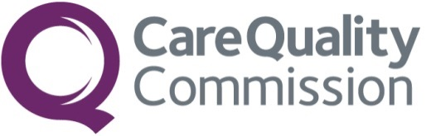
BOARD MEETING

Date: 29 November 2023 | Public Board | Agenda item: 3.1  Paper number: CM/11/23/31
Title of paper: | Annual Health and Safety Report
Purpose of paper: | For Note/assurance
Executive sponsor: | Kate Terroni, Deputy Chief Executive
Presenter(s) or lead person: | Max Hood, Head of Workplace, Facilities and Safety
Summary:
The annual report contains information around the work of the Health and Safety team and the safety performance from April 2022 to March 2023.

We continue to work with Trade Union colleagues with quarterly meetings to discuss emerging issues. Key risks for this reporting period include homeworking and increased sedentary work, for which the Health and Safety Team and Organisation Development colleagues will be drafting guidance, this also includes verbal abuse, threats and intimidation. A corporate stress risk assessment has been developed which has been shared with Operations colleagues, and health and safety colleagues are part of a project team for out of hours inspections which is progressing a structured process and guidance for operational colleagues and managers.

CQC (Care Quality Commission) remains a relatively low risk, low incident organisation from a health and safety perspective. However, the threats and verbal abuse, display screen assessment related risks and work-related stress remain a concern. Measures to mitigate and reduce these risks are in place and reviewed regularly and a good working relationship exists with trade union colleagues and other groups.
Recommendations:
Board is asked to note the report for assurance purposes.

Governance:
ET (Executive Team) and the National Health, Safety and Wellbeing Committee has reviewed this report.

Finance:
No financial considerations.

People:
People Directorate and TU (Trade Unions) colleagues are part of the Health, Safety and Well-being Committee.

Health and Safety overview 2022-2023

- Home Working

During the pandemic, office-based colleagues were given the opportunity to apply to contractually work at home. We now have 95% of the workforce homeworking on a contractual basis. This has increased the number of on-line meetings and is likely to have caused a more inactive workstyle. In turn this has affected colleagues’ health and safety and the amount of support they require. There has been a marked increase in requests for additional workstation equipment which includes rise and fall desks, specialist chairs, specialist keyboards and other peripherals such as ergonomic mice. The Health and Safety team are working with colleagues in Organisational Development on developing good working etiquette and guidance for how best to work; ensuring work areas support safe working, taking breaks from the screen, moving around. There is also a well-being component to this, and work is being developed in the People Directorate to look at organisational culture, how we work and how we connect, to help address this.

- COVID

During the reporting period weekly PCR tests ceased and from mid-2022 the LFD (lateral flow device) testing for inspectors was paused. As a result, the Inspection COVID risk assessment was reviewed and has now become now the Infection Prevention & Control (IPC) risk assessment and is a requirement for all inspections. Personal protective equipment is no longer mandatory but is available should it be required.

- Health and Safety Incident Reporting System

The contract for CQC’s health and safety incident reporting system with Datix ended earlier in 2023. Incident reporting is now submitted through our time recording system, Cygnum. The process remains the same with managers identifying any actions being taken as a result of the incident and all submissions being scrutinised by the Health and Safety team.

- Display Screen Equipment and Driving Training

The contract for the provision of online display screen equipment and driving training and assessment was retendered in 2022/23. Awaken/BeOnline continue to provide this service for CQC. The Health and Safety team continues to follow up on non-completion of assessments and any incidents that have raised concerns. Managers receive monthly summaries of the outcomes from this system, for their team members. Data on completion rates is reviewed quarterly and the Health, Safety and Well-being Committee so that Trade Union colleagues have visibility and can support completion.

- Out of Hours Inspections

The team has been working with colleagues in Operations and People on the out of hours inspection programme. This is to ensure we have safe working practices, risk assessments, management and regulatory support. Time recording and how out of hours work is identified and any contractual changes is also part of this. This work is now nearing completion.

- Corporate Stress Risk Assessment

A work-related stress information gathering exercise was carried out in February 2023 in Operations. A corporate stress risk assessment was completed, and discussions held with the Health Safety and Wellbeing Committee and Trade Union colleagues, to discuss the assessment and determine any further controls. The assessment has been completed and is in the process of being disseminated to Director and Deputy Directors, to complete any additional actions and to distribute to their team managers and colleagues.

- Stress Risk Assessment Statistics

For the period 2022-2023 there were 154 stress risk assessments completed. The seven indicators covered within a stress risk assessment are set out below. It should be noted that figures below include data from 2019 onwards to provide a longer-term view of this important issue. The second row is the number of responses to each indicator. This tells us that the main indicator of stress is ‘other reasons’ such as medical or personal issues. The secondary contributory factor is demands, which includes whether work demands are reasonable; receiving instructions from one source; deadlines being achievable; neglecting tasks to meet deadlines; not taking sufficient breaks; pressure to work long hours and working intensively. Respondees can list multiple stressors and ‘Other reasons’ was rarely a lone indicator.

Table showing total number of stress risk assessments from 2019 to date:

Stressor: | Work demands | Ability to control workload | Support available | Work relationships | Role | Change | Other
Total returns | 265 | 164 | 172 | 194 | 152 | 191 | 290

- Incident Statistics – See Appendix 1 Graph 1

There was a total of 188 incidents from April 2022 to March 2023. The majority of incidents were threats, harassment or intimidation, followed by verbal abuse. Most of these occurred within our Contact Centre, with some instances occurring in Operations. Individuals were supported by their line manager and the Health and Safety team, where appropriate. The Health and Safety team have a personal safety register in place whereby persistent abusers are listed and they are sent a letter notifying them that they are on this register, along with the reasons for this. Colleagues within Organisation Development and Operations are looking at further initiatives to support colleagues, such as Listening Lounges, Trim Training and Able Futures access.

Our Contact Centre has a process in place to deal with individuals who are persistent in their verbal abuse or intimidation, either placing them on email only contact, or only being able to leave a message via answerphone. Contact Centre colleagues have a system whereby a flag is placed on the regulatory platform next to the name of any individual or provider that has a separate process in place. This notifies call handlers that they need to carry out further checks before speaking to individuals.

- Training Statistics – Display Screen Equipment (DSE) – See Appendix 1 Graph 2

Completion of DSE training and assessment is a mandatory requirement every two years. From April 2022 to March 2023, 917 colleagues had completed their DSE training and assessment. 84 colleagues had not started,1 colleague failed, which was followed up by the Health and Safety team, and 15 colleagues were in progress of completing the training and assessment. There were 15 colleagues who were under review, which means they needed further support with their workstation set-up. The Health and Safety team continue to work with individuals to provide additional support and equipment. The team also regularly review completion rates and follow this up with individuals who have not yet completed the training.

- Driving Safely – See Appendix 1 Graph 3

The driving for work training and assessment is a requirement for all colleague who drive for work purposes and completion is required every two years. From April 2022 to March 2023, 255 colleagues had completed the training and assessment; 14 colleagues had not started, 6 were in progress and 1 failed, this was followed up by the Health and Safety team. Those who have been allocated the training but not completed it, receive regular reminders that this is outstanding.

Appendices

Annual health and safety incidents by type – Graph 1

Display screen equipment, training and assessment – Graph 2

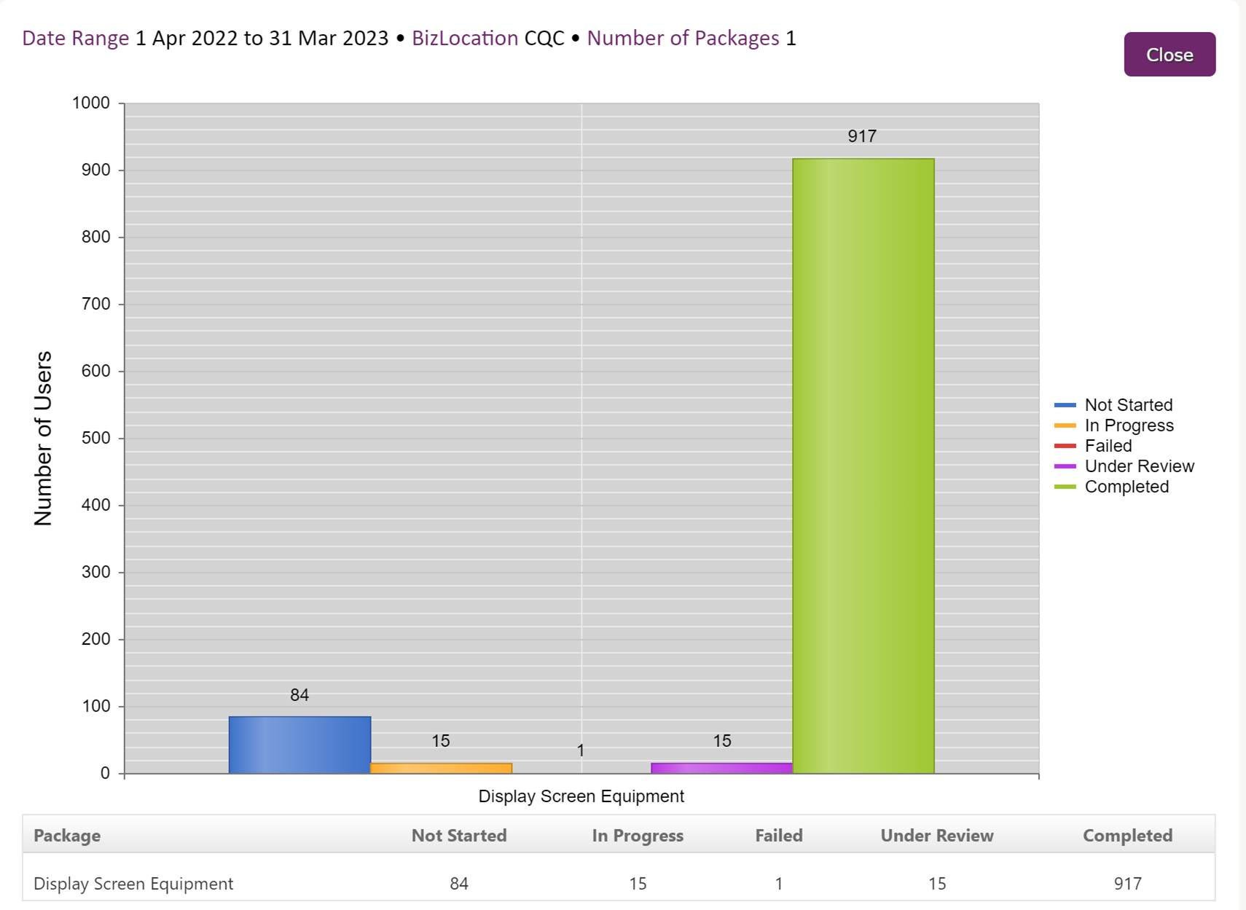

Driving Safely training – Graph 3



