

Care quality commission logos

2021 Maternity Survey

Statistical release: Appendix H

Published: February 2022
Interpreting the graphs
This appendix provides the graphs underlying the subgroup analysis, the results for which are provided in the statistical release available on the CQC website.

The graphs in this section highlight significantly better than average experiences in green. Significantly worse than average experiences are highlighted in orange.

Worse than average experience
Average experience
Better than average experience

Respect for patient-centred values, preferences, and expressed needs (Questions D6 and C23)
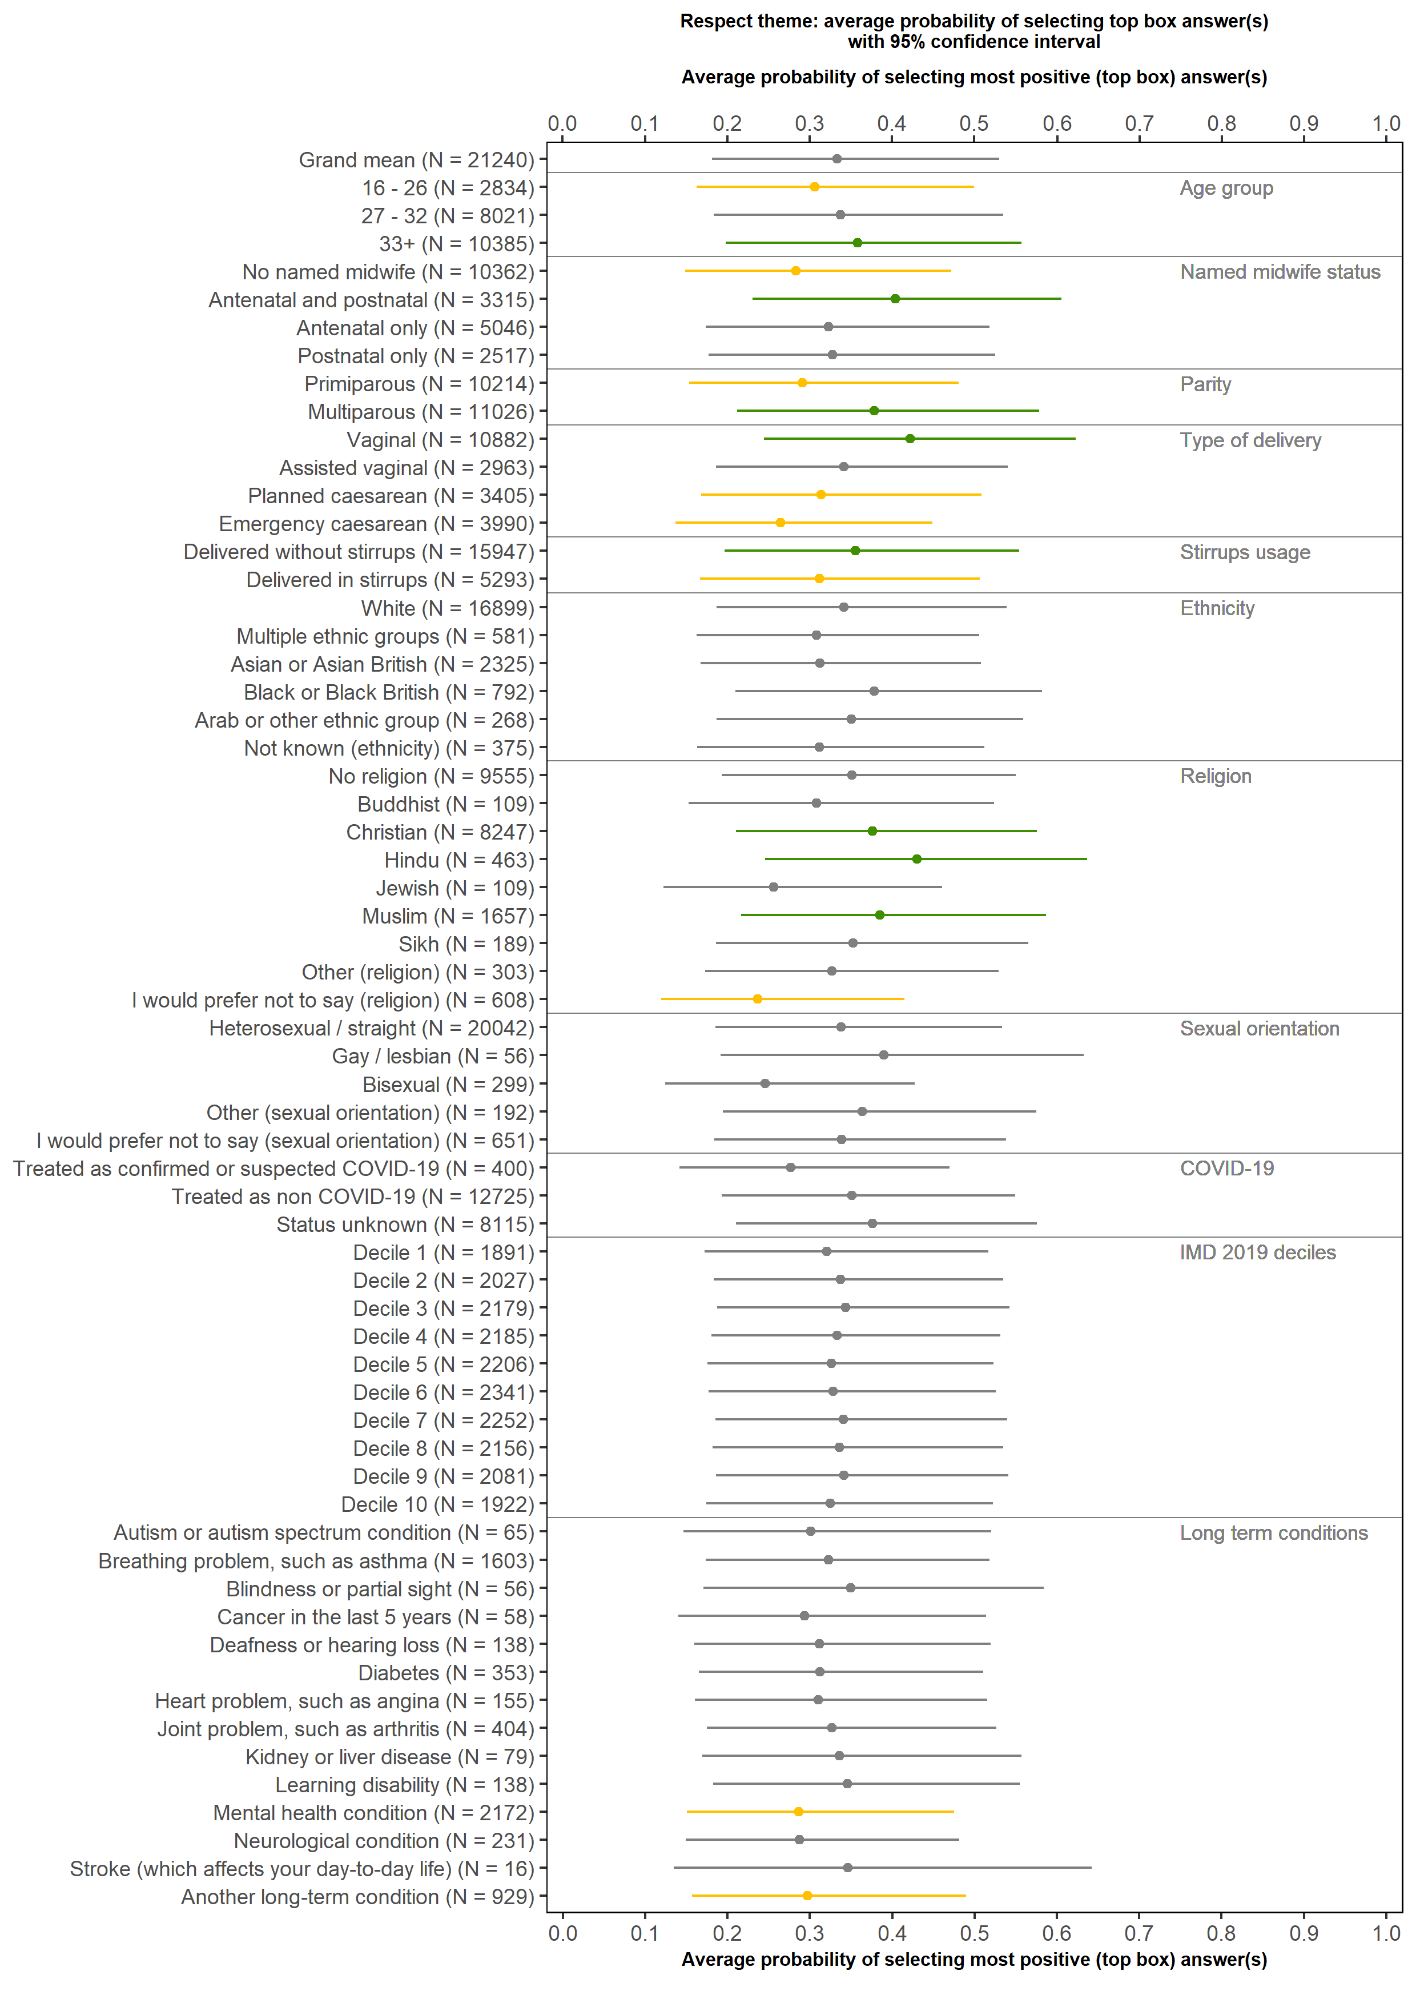
Feeding support
(Questions E2 and E3)

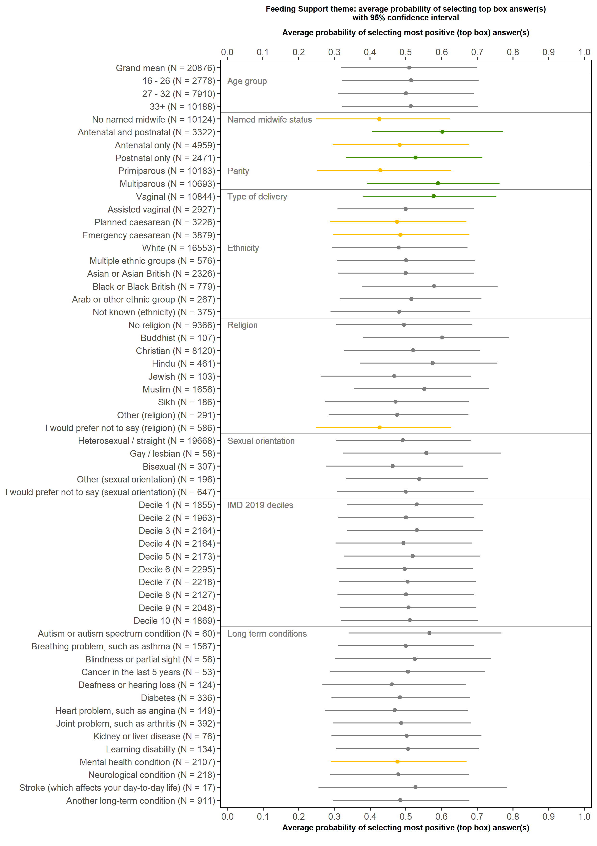

Experience of induction
(Questions C9 and C10)

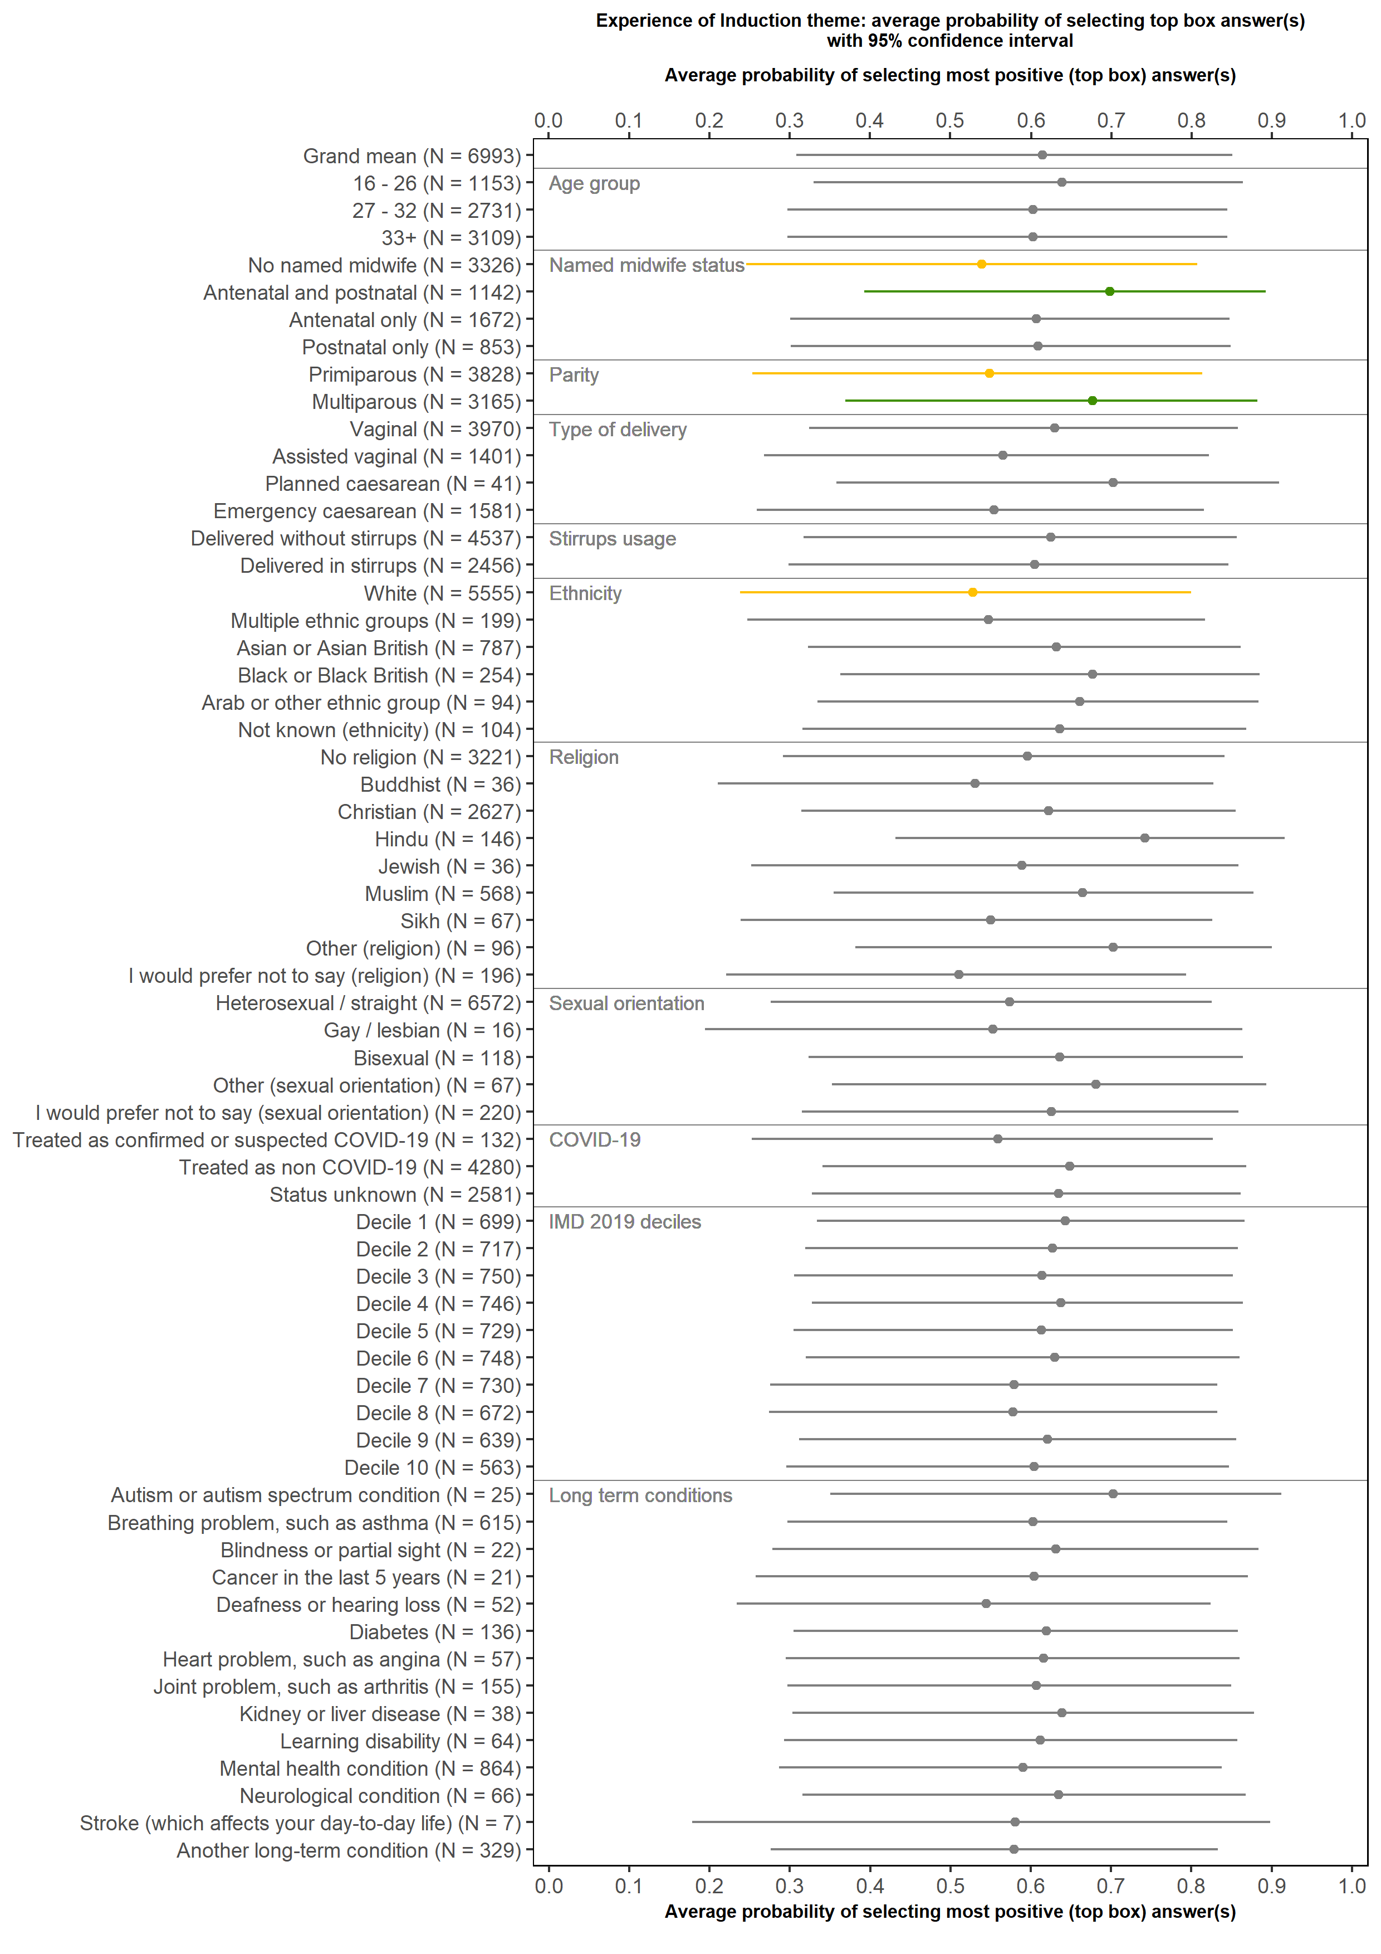

Mental Health (Antenatal)
(Questions B10 and B120

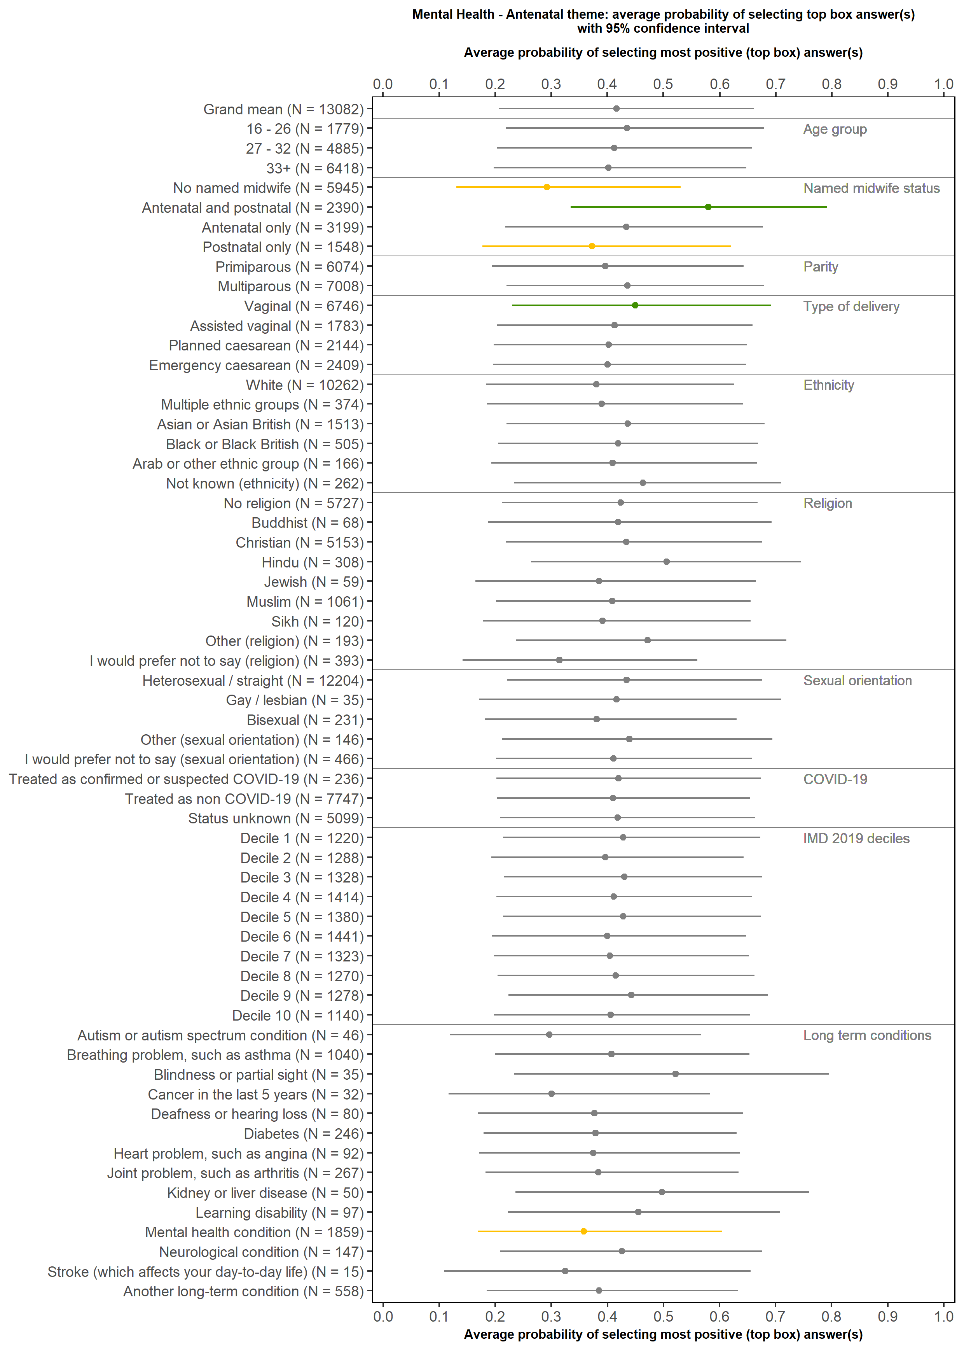

Mental health (Postnatal)
(Questions F12, F13, F14)

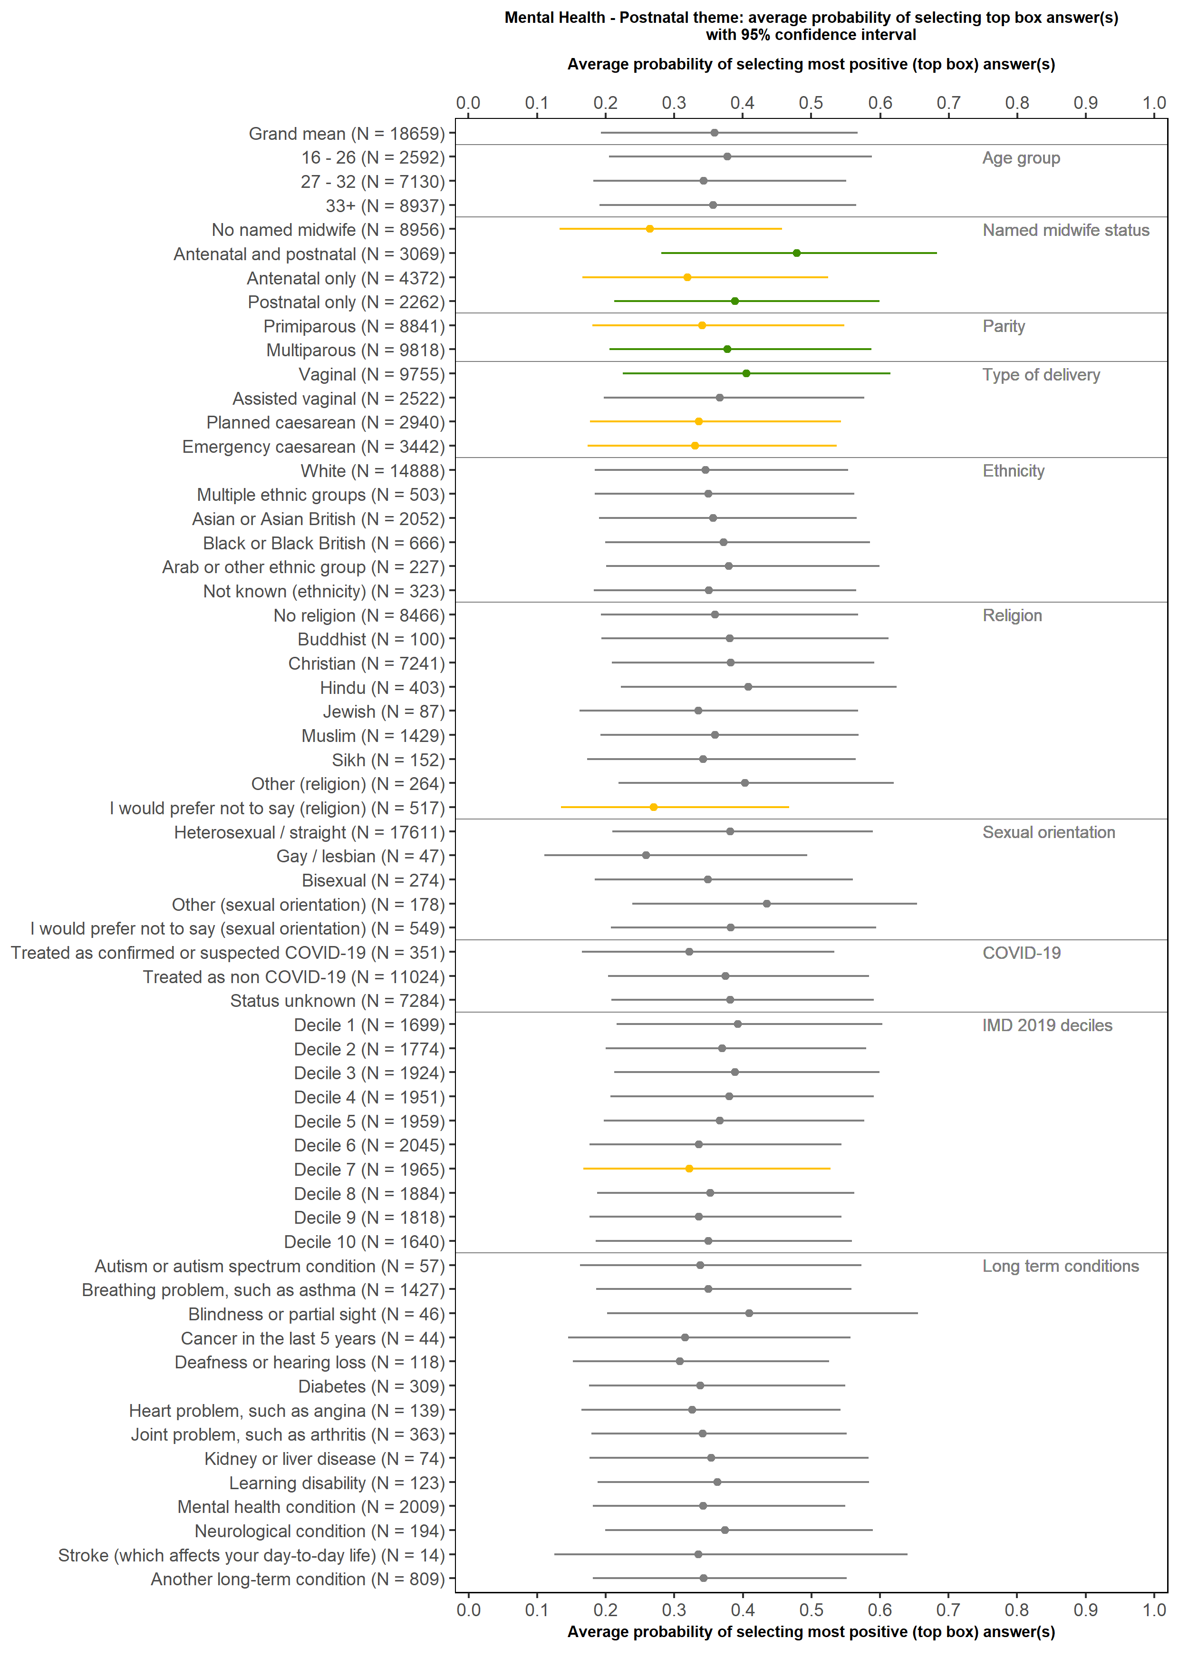

Information and communication in hospital
(Questions C1, C25, D5)

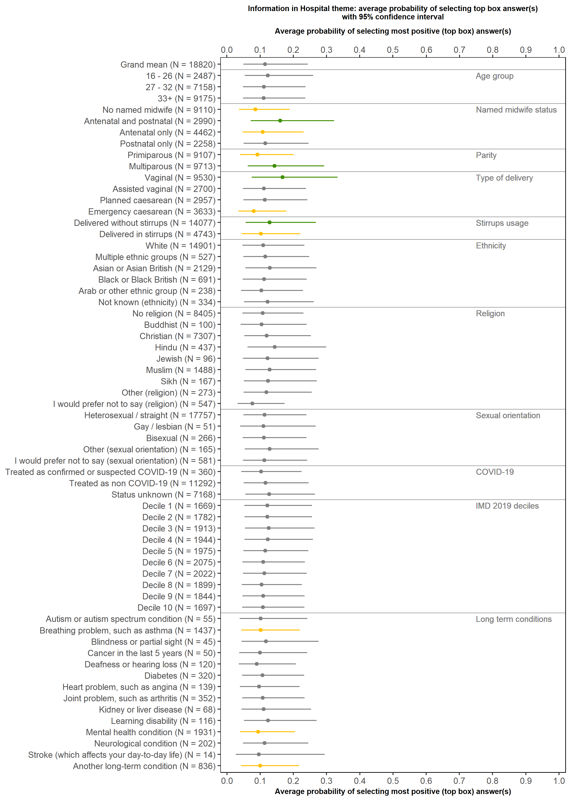

Availability of staff
(Questions C20 and D4)

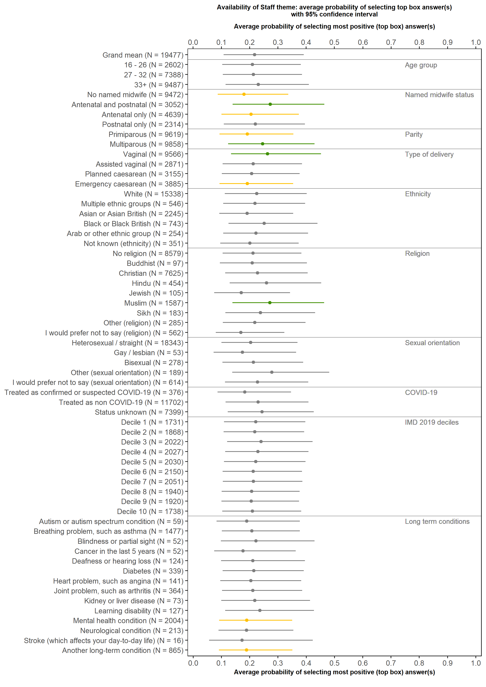

C19: If you raised a concern during labour and birth, did you feel that it was taken seriously?

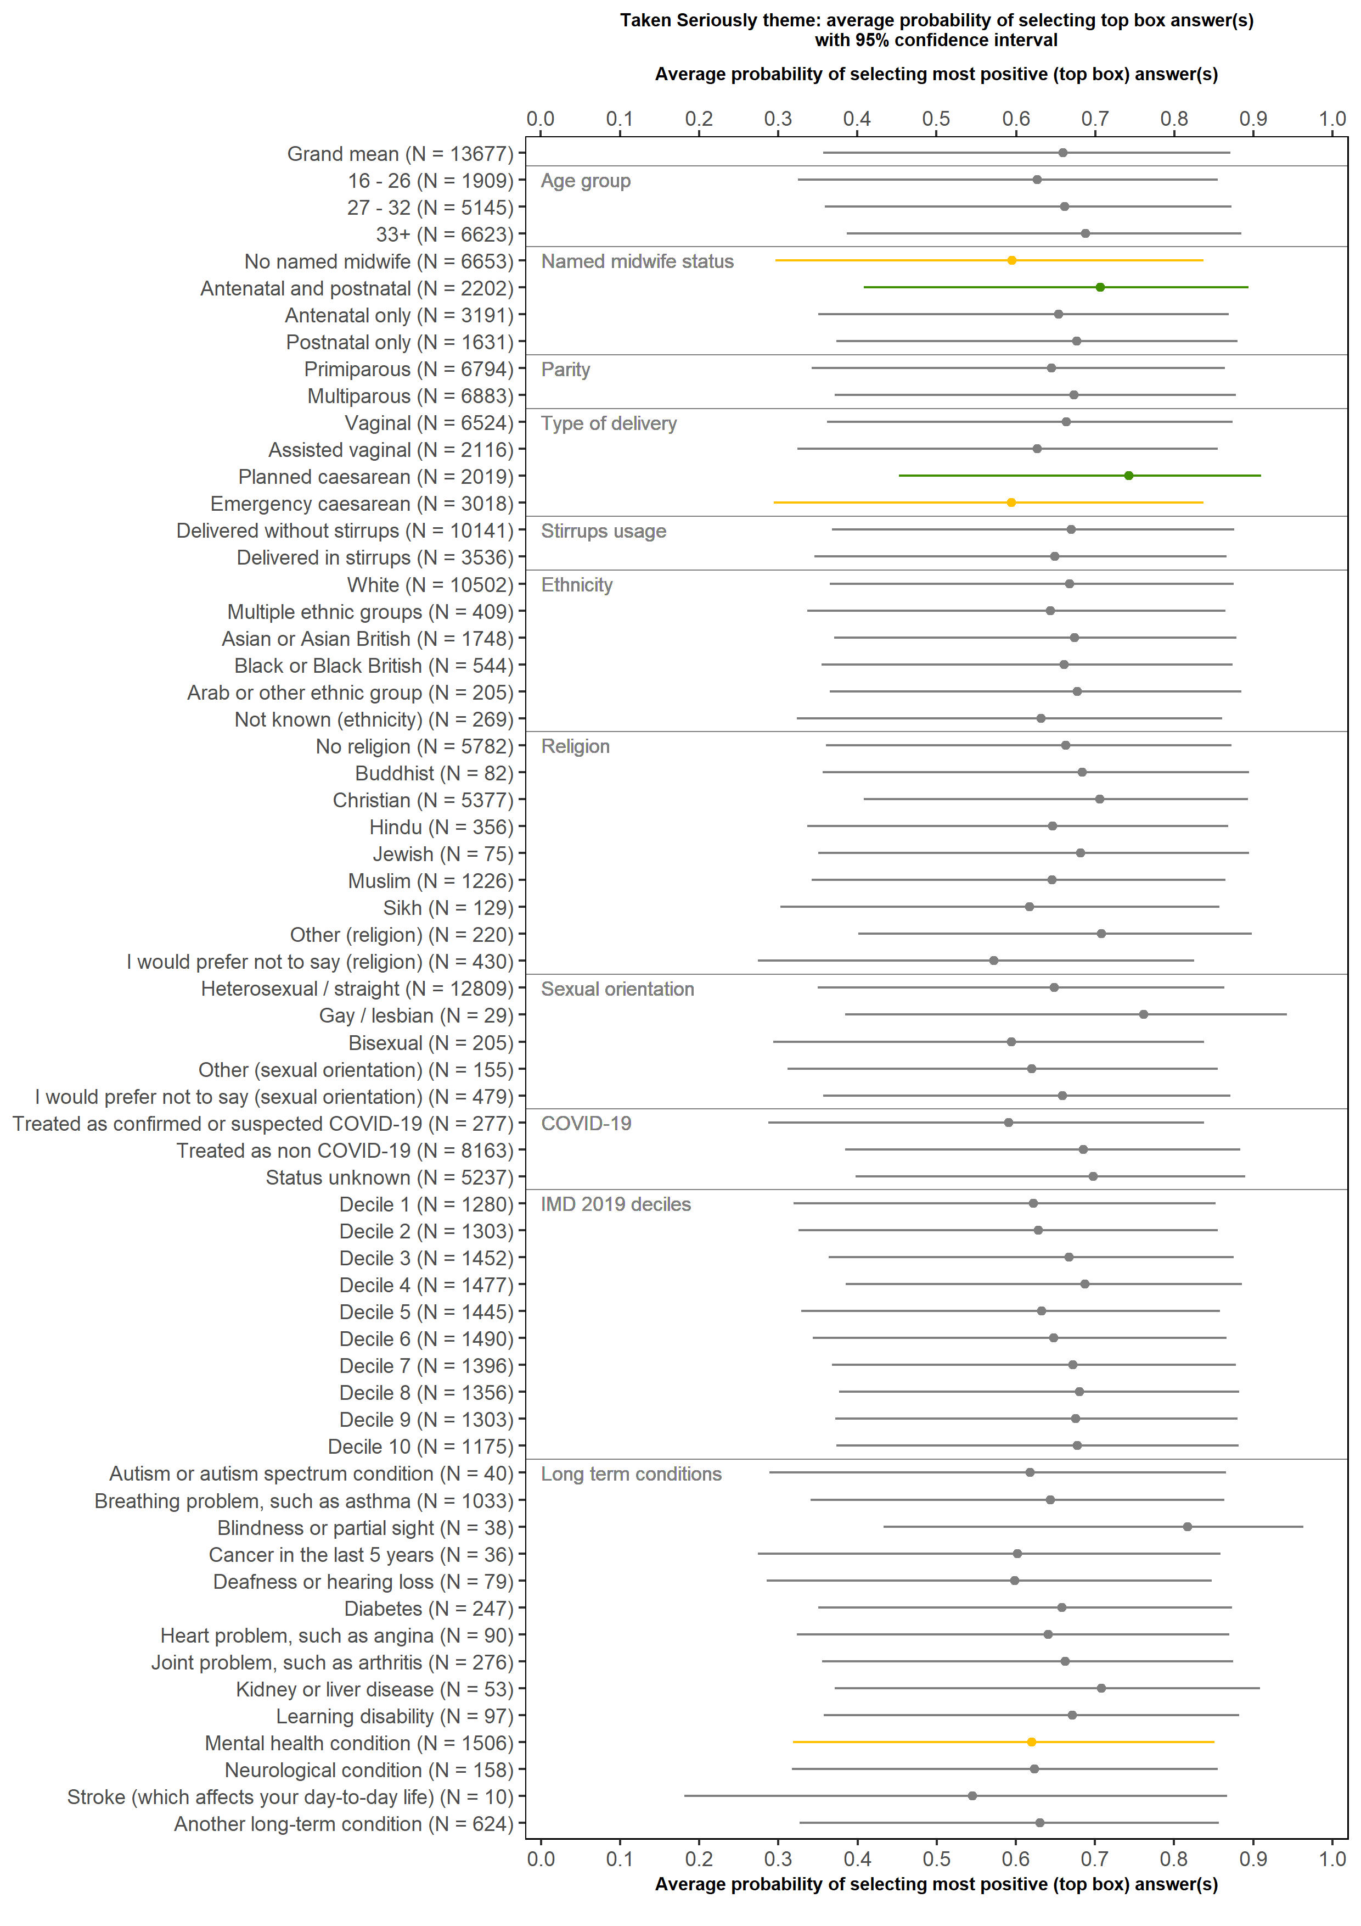
C22: Thinking about your care during labour and birth, were you involved in decisions about your care?

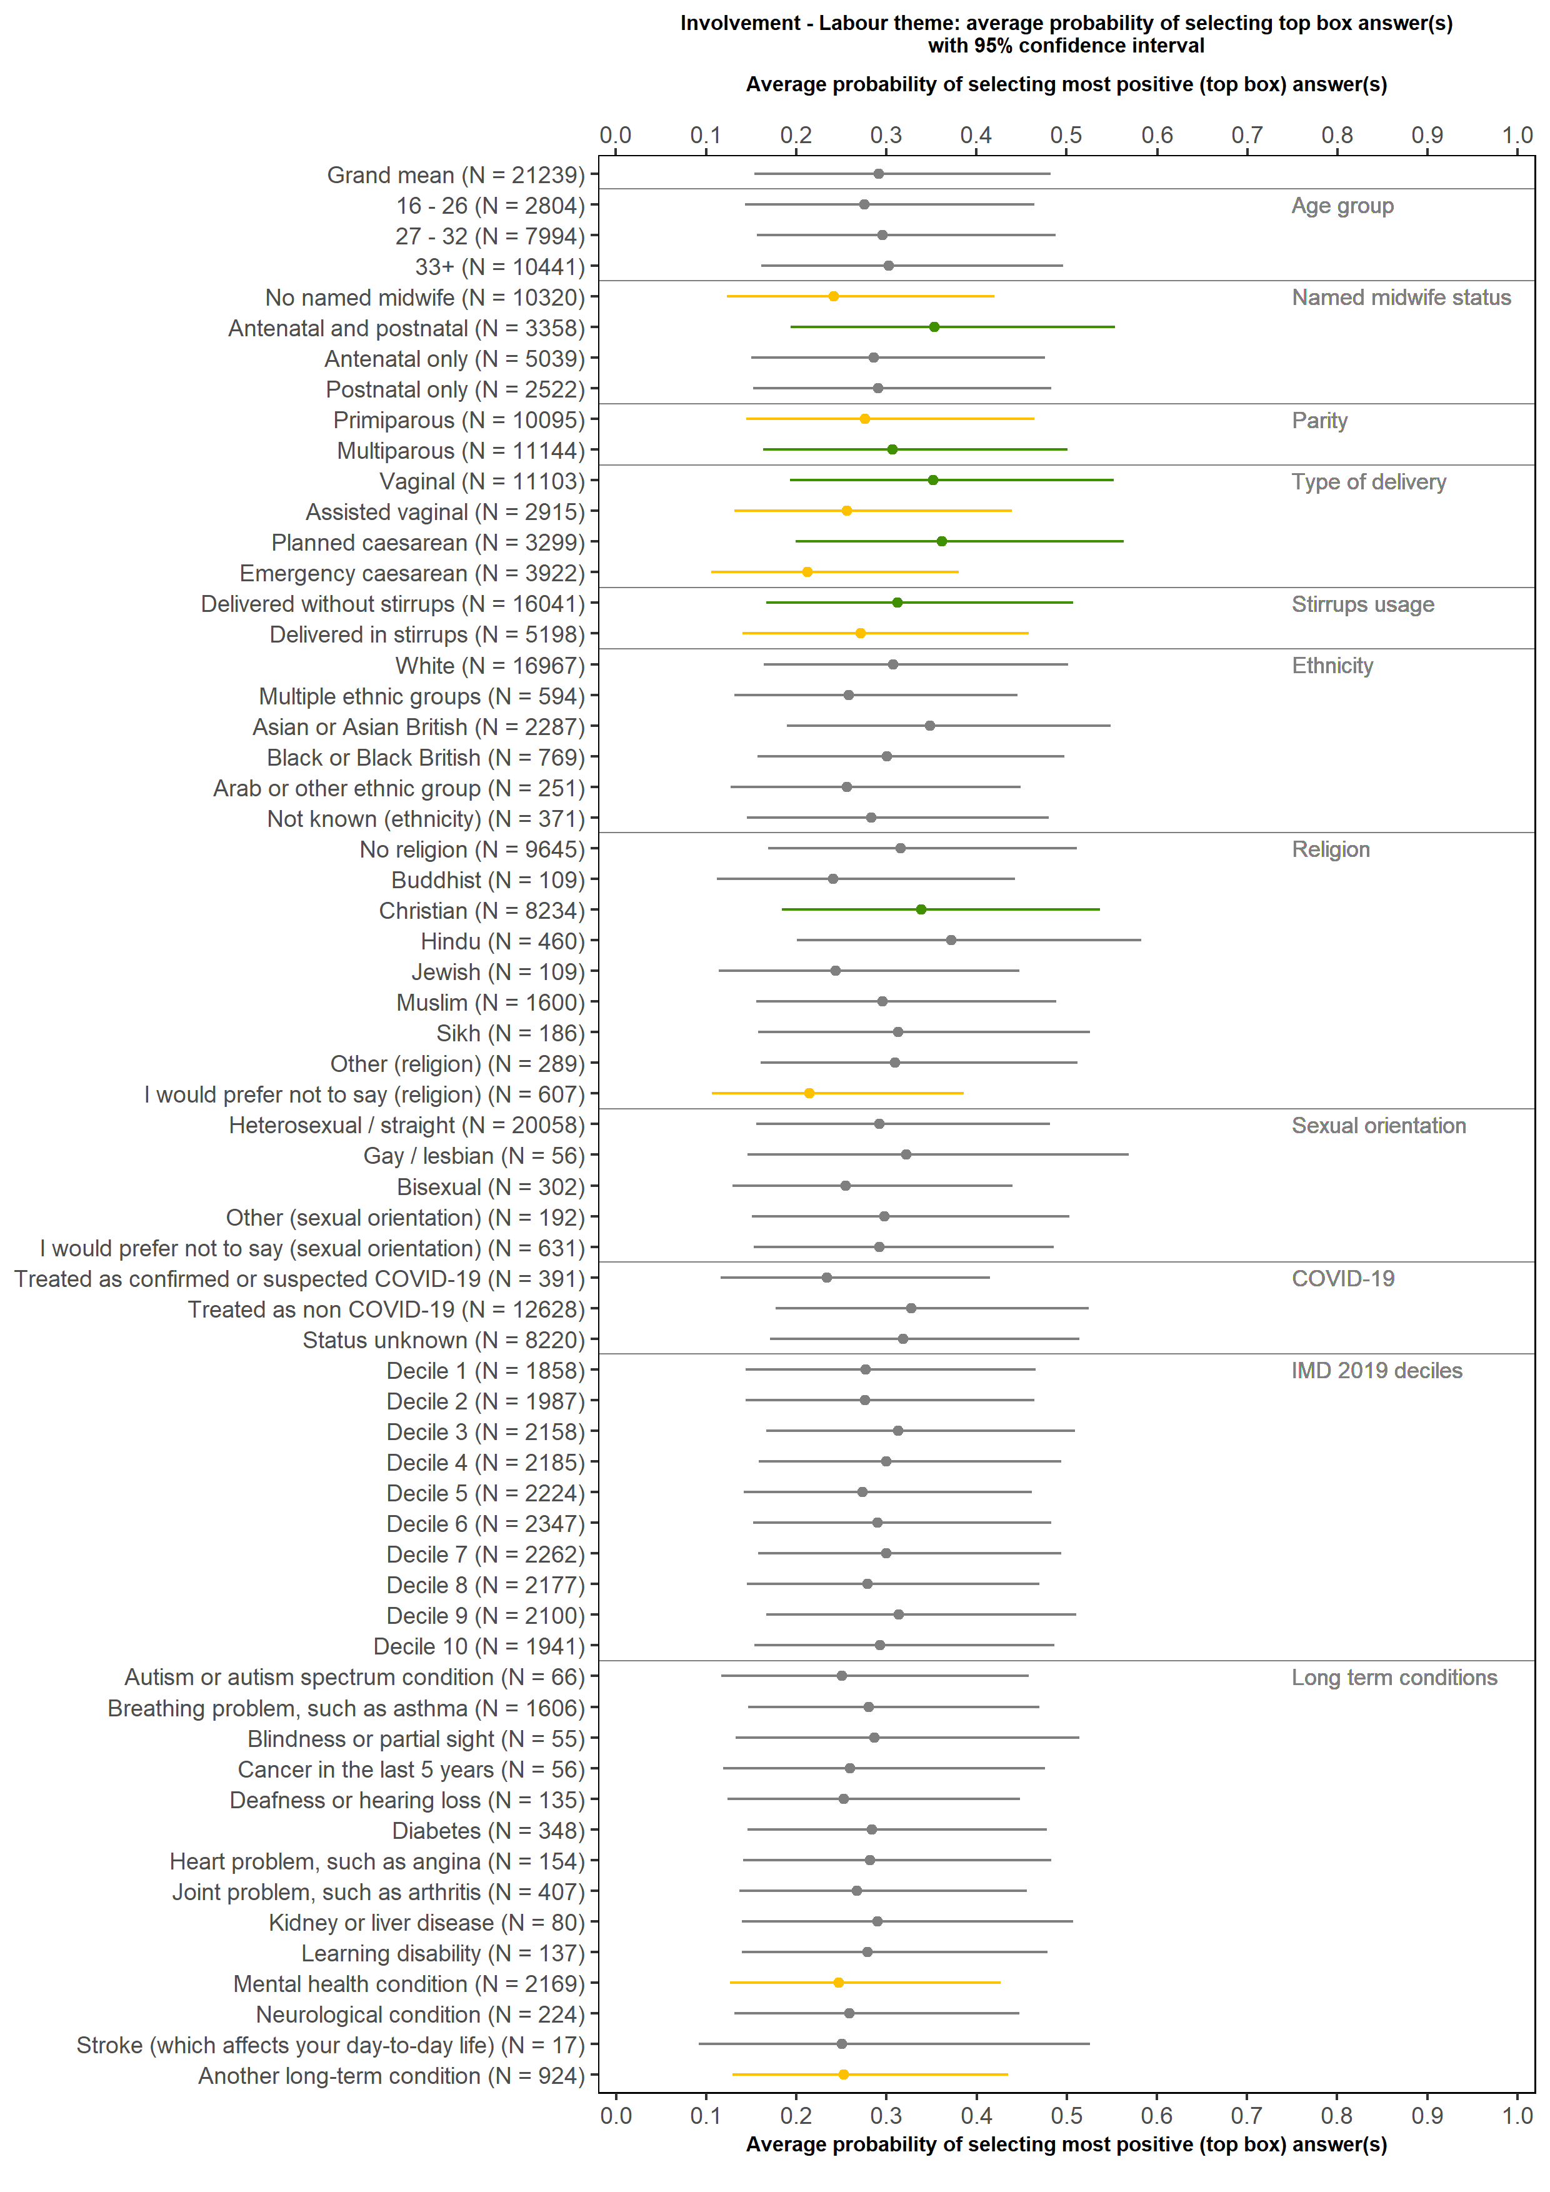
B15: Thinking about your antenatal care, were you involved in decisions about your care?

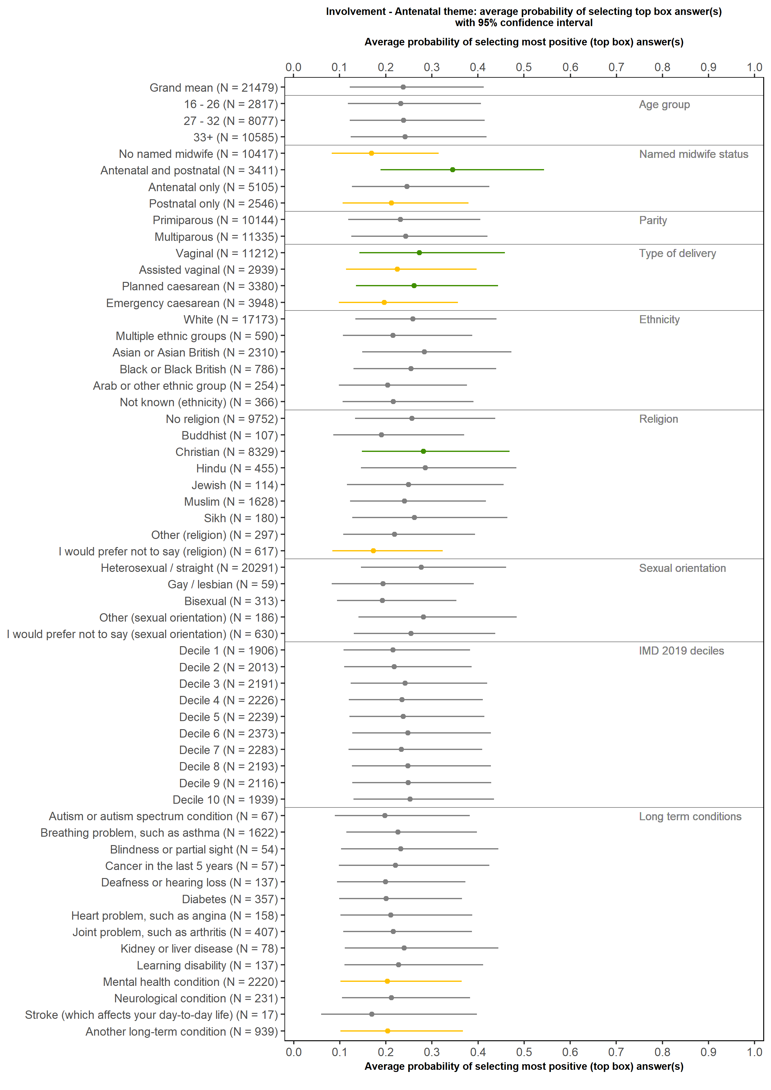
C24: Did you have confidence and trust in the staff caring for you during your labour and birth?

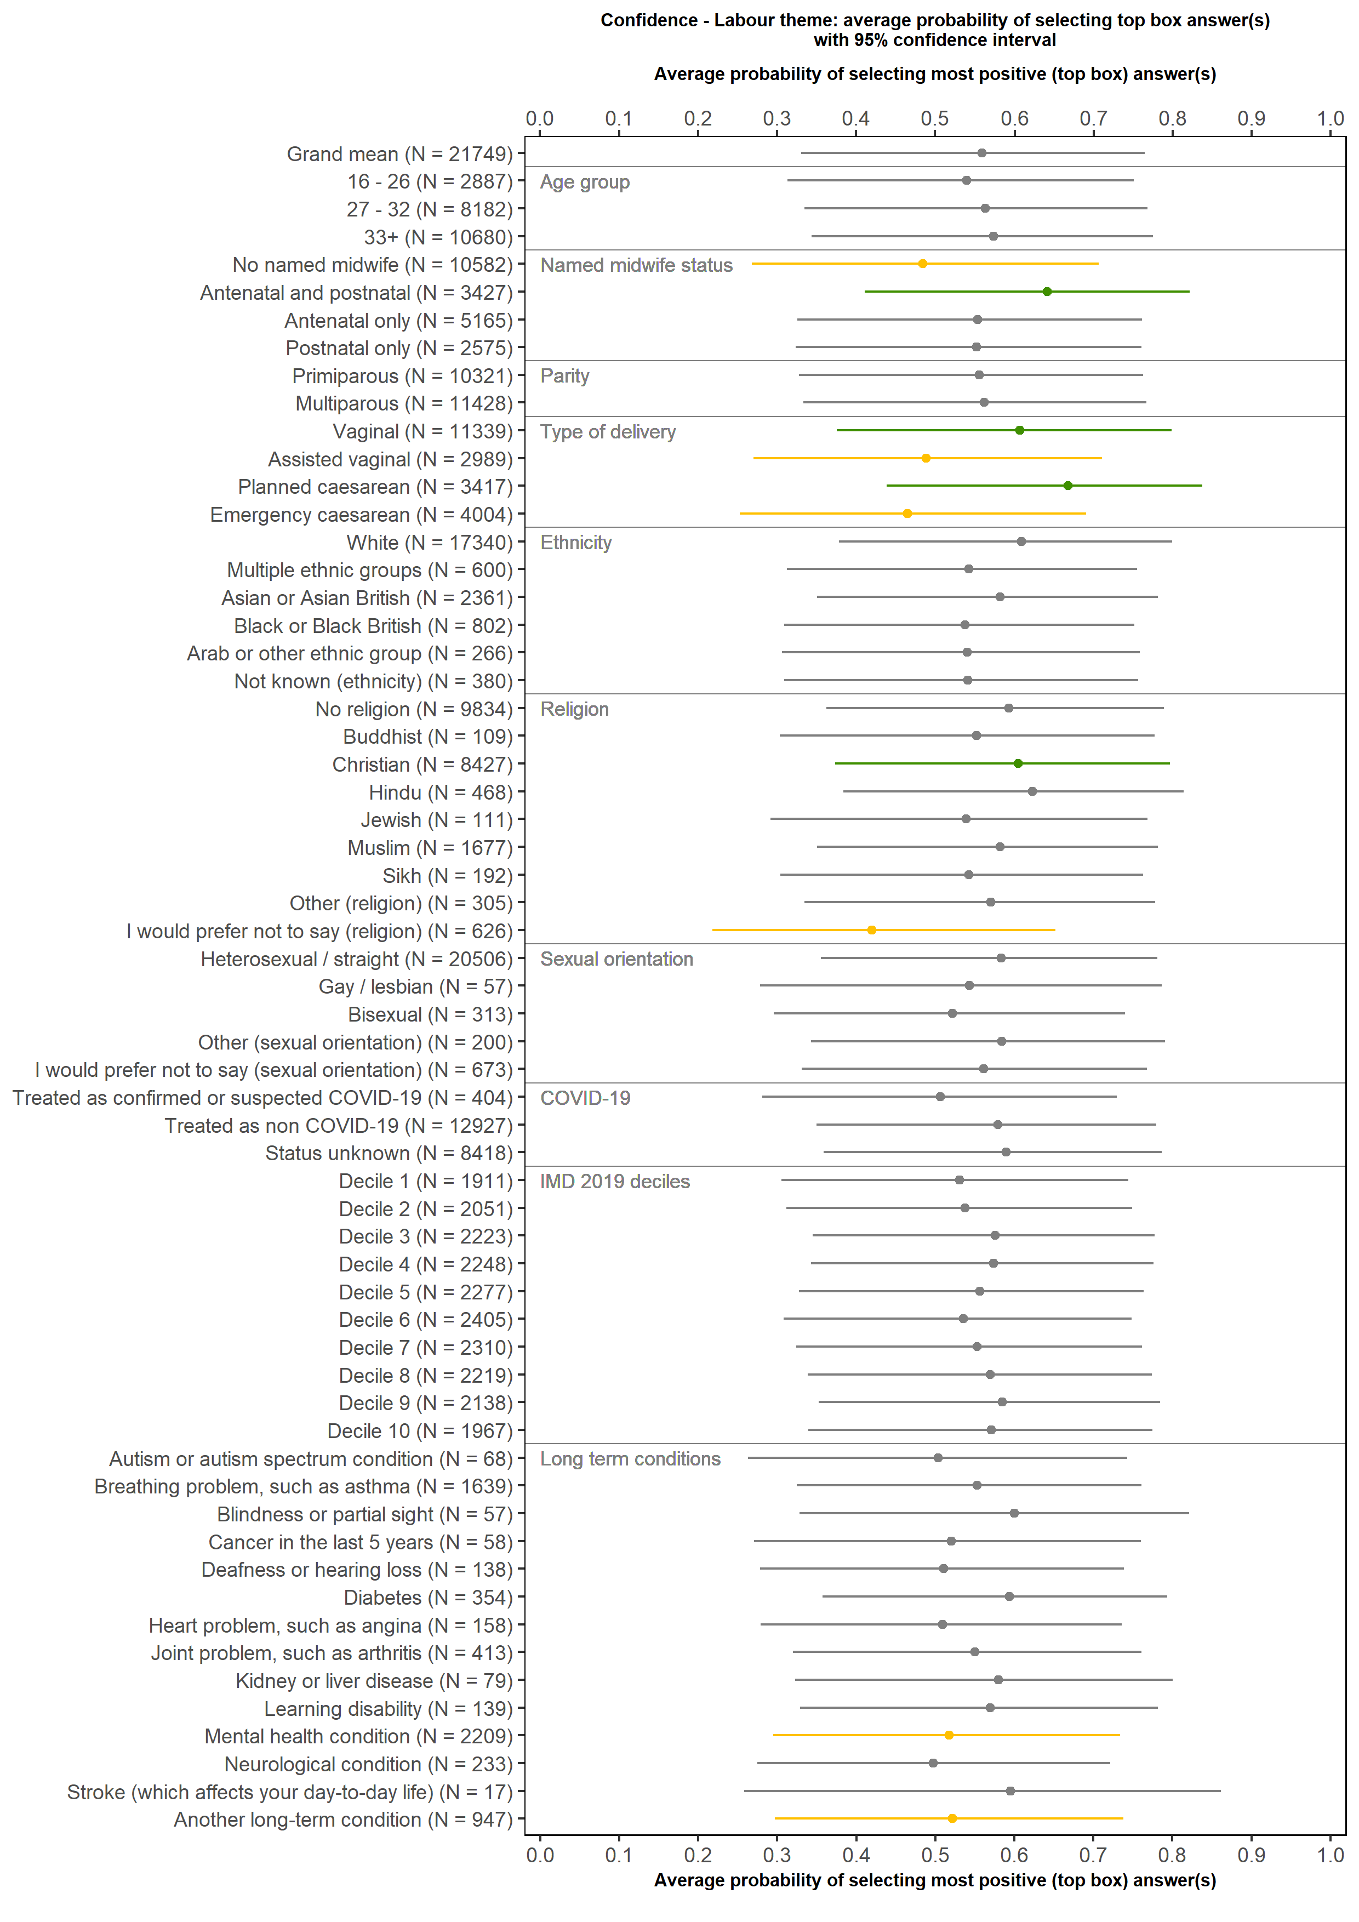

F10: Did you have confidence and trust in the midwife or midwifery team you saw or spoke to after going home?

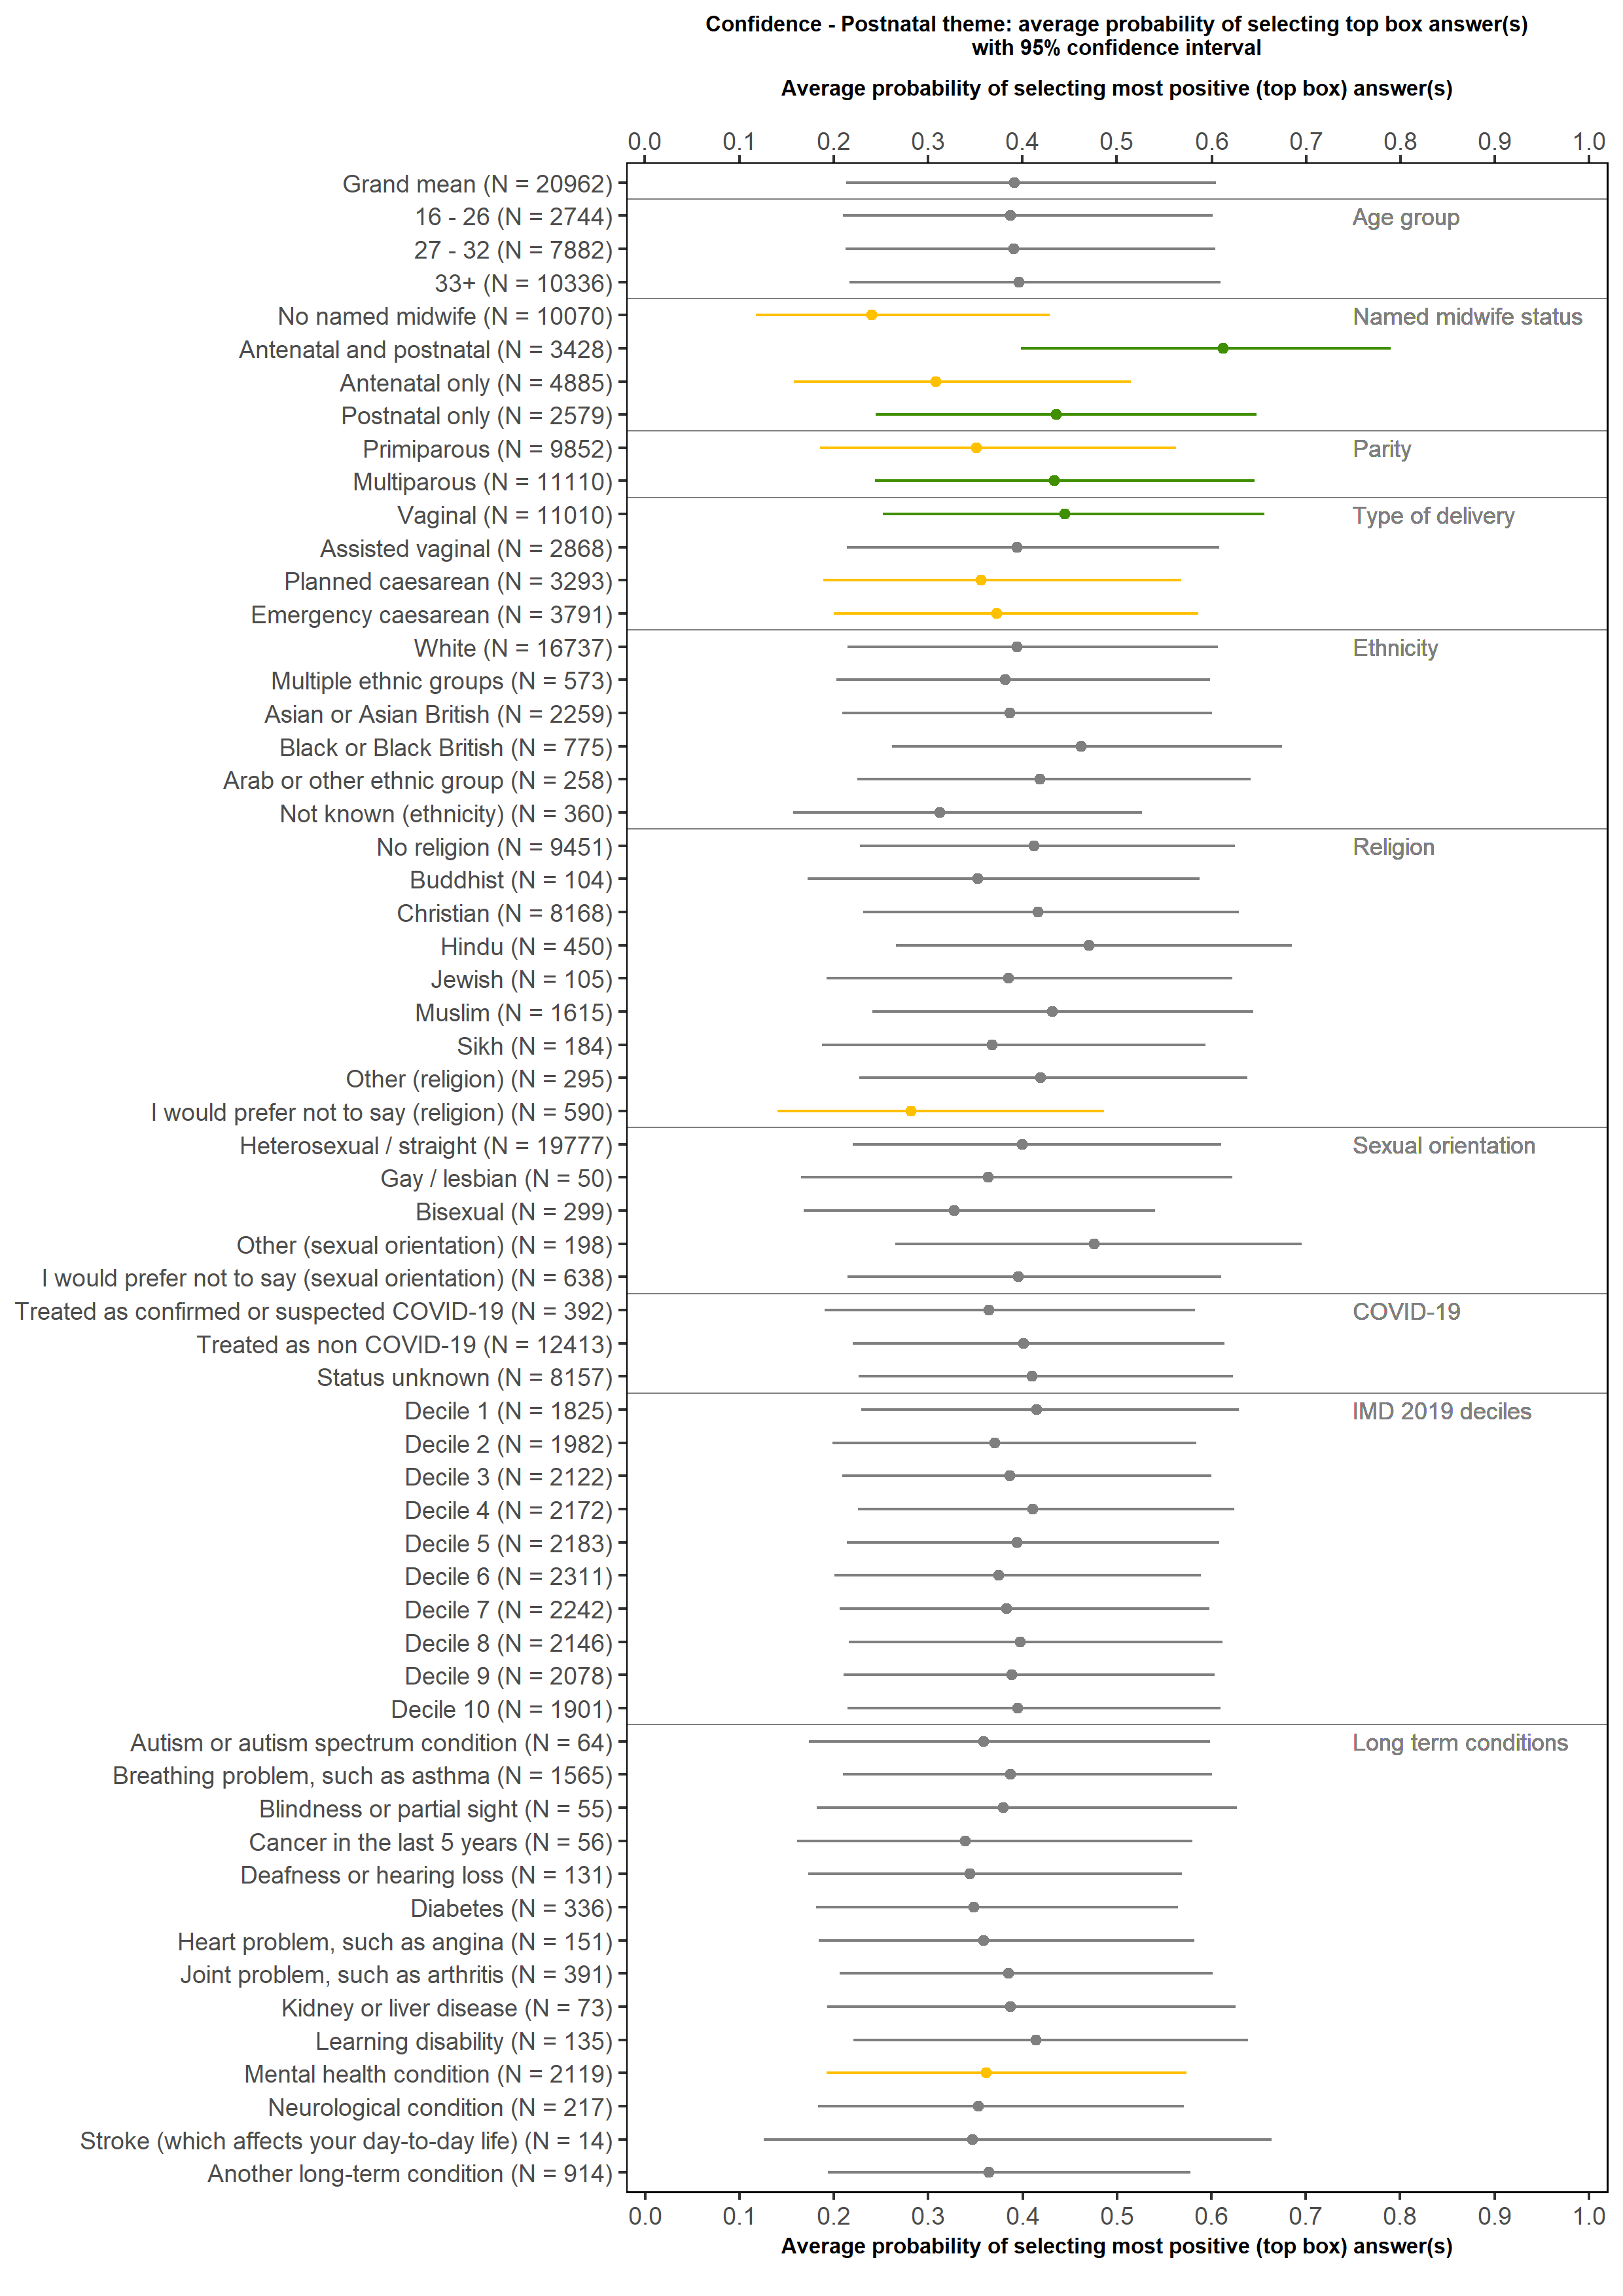

B4: At the start of your care in pregnancy, did you feel that you were given enough information about any coronavirus restrictions and any implications for your maternity care?

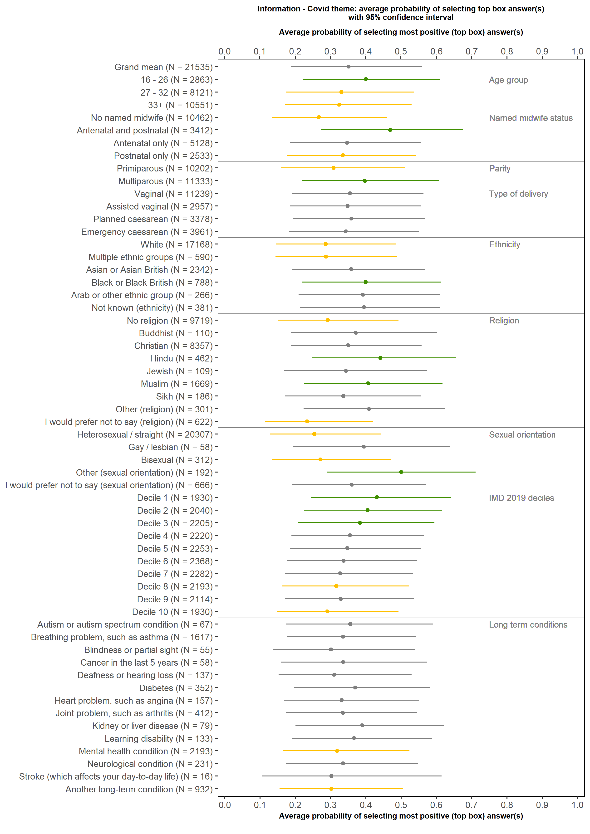
C18: Were you (and / or your partner or a companion) left alone by midwives or doctors at a time when it worried you?



