

Care quality commission logos

2022 Community mental health survey

Statistical release

NHS Patient Survey Programme

Independent analysis for England published: October 2022
Contents
Summary of findings 2
Introduction 5
The community mental health survey 6
Mental health policy 8
Results from the survey 14
1. Access 16
2. Your health and social care workers 17
3. Organising your care 19
4. Planning and reviewing care 21
5. Crisis care 22
6. Medicines 24
7. NHS talking therapies 25
8. Support and wellbeing 27
9. Responsive care 31
10. Overall 31
Subgroup analysis summary: how experience varies for different groups of respondents 32
Appendix A: Survey methodology 39
Appendix B: Other sources of information related to survey results 42
Appendix C: Comparisons with other surveys 44
Appendix D: Main users of the survey data 45
Appendix E: Further information and feedback 47
Appendix F: Care cluster codes 49
References 51

Summary of findings
The 2022 community mental health survey received feedback from 13,418 people who received treatment for a mental health condition between September and November 2021.

This report shows that people’s experiences of mental health services provided in the community remain poor. Many of the areas with the poorest historical results, are still the poorest in 2022.

Most notably, access to care, crisis care, involvement in care and support and wellbeing are key areas which have been highlighted as being poor over a number of years. Trend analysis was carried out on 13 evaluative questions, including questions within these key areas, on data from the last five years (2018 to 2022). Of these 13 questions, eight reported their lowest result, with seven showing a statistically significant downward trend across these years.

Communication is also an area with poor results in 2022. Four in ten people (40%) have not had a care review meeting in the last 12 months, almost a third of respondents (31%) have not been told who is in charge of their care; and less than half (48%) thought the person they saw was aware of their treatment history.

Survey results were analysed to show how experience varied between different groups of people who use services. Consistent with 2021 results, findings this year showed that people who received their care via telephone, younger people (aged 18 to 35) and those with more challenging and severe non-psychotic disorders were less likely to report positive experiences. In addition, people with autism or autism spectrum conditions reported worse than average experiences. Conversely, people who have been in touch with services for less than one year also reported better experiences, as did heterosexual people.

Positive results
There are few results, or areas of care, where the majority of people reported good experiences. However, some areas show signs of improvement.

Organising care
‘Organising care’ continued to be an area where people were more positive. Although 31% of people had not been told who was in charge of organising their care, 96% of those who had, said that they knew how to contact this person. Sixty-three per cent of respondents said they ‘definitely’ got the help they needed the last time they contacted this person, while 88% said that this person organised their care ‘quite well’ or ‘very well’.

Key areas for improvement
The following areas have been highlighted for improvement, with many, such as access to care, crisis care, involvement in care and support and wellbeing, being highlighted as areas for improvement over a number of years. Access to care in particular, has seen significant decline since 2014, with a decrease of 11 percentage points in the number of people stating they were ‘definitely’ given enough time to discuss their needs and treatment. Similarly, there has been a decrease of eight percentage points in the number of people feeling that they have ‘definitely’ seen NHS mental health services enough for their needs.

Communication
Forty per cent of people did not have a care review meeting with someone from community mental health services in the last 12 months to discuss how their care is working. Under half (48%) of people reported that the person they saw was ‘completely’ aware of their treatment history. Almost a third of people (31%) had not been told who is in charge of their care. This is a statistically significant increase since 2021.

Accessing care
Only 40% of people had ‘definitely’ seen services enough for their needs. Two in five people (45%) were not always given enough time to discuss their needs. Two in five people (44%) thought the waiting time for their NHS talking therapies was too long.

Crisis care
Over a quarter of people (28%) would not know who to contact out of office hours in the NHS if they had a crisis. This is a statistically significant increase since 2021. Almost a quarter of people either did not get the help they needed (22%) or could not contact them (2%). Less than half (47%) reported that they ‘definitely’ got the help they needed. Nineteen per cent of people felt they had to wait too long to get through to a crisis worker or team.

Support and wellbeing
Two out of five people (40%) did not receive support for their physical health needs. Just over half of people did not receive help or advice in finding support for their finances or benefits (51%) or in finding/keeping work (50%). These results were all statistically significant increases since 2021. Further to this, only half (50%) of people reported that the person they saw ‘definitely’ understood how their mental health affected other areas of their lives.

Involvement
Forty-four per cent of respondents said they ‘definitely’ agreed what care they would receive with someone from NHS community mental health services. Around half (55%) of people were involved as much as they wanted to be in deciding what care they would receive. Similarly, 51% were involved as much as they wanted to be in deciding which NHS talking therapies to use.

Medicines
A quarter of people (25%) said that the possible side effects of their medicines had never been discussed with them. Results showed a statistically significant increase in ‘no’ responses since 2021 when asked ‘Has the purpose of your medicines ever been discussed with you?’ (7% responded ‘no’). Further to this, 25% of people answered ‘no’ when asked if an NHS mental health worker had checked in with them about how they are getting on with their medicines in the last 12 months. This is also a statistically significant deterioration since 2021.

How experience varies for different groups of people
Analysis found there were disparities in the experiences of different groups of people when receiving care and treatment from NHS community mental services. For example, younger people (18 to 35 year olds) reported worse than average experiences across multiple areas of care. Out of the 18 themes analysed, younger people reported worse than average experiences in 12 areas including overall experience, organisation of care and access to care. In comparison, people in the 66-88 age group reported better experiences in 12 areas.

In line with previous survey years, findings showed that people with challenging and chaotic non-psychotic disorders reported worse than average experiences of care across multiple areas. In contrast, those with a diagnosis of first episode psychosis consistently reported better than average experiences. People who expected their mental health condition to last longer than 12 months also reported worse than average experiences across multiple themes.

When looking at how experiences of care varied by method of contact (telephone, video call, face-to-face or multiple methods), findings showed that people who received care via telephone reported worse than average experiences. This was found across seven of the 18 themes analysed. People who received care face-to-face or via video call reported better than average experiences across multiple themes.

Introduction
Mental ill-health affects around one in four people in any given year and is more common, long-lasting and impactful than other health conditions., They range from common conditions such as depression and anxiety, to rarer conditions such as schizophrenia and bipolar disorder. Experiences of mental health conditions vary significantly. For instance, while some people can self-manage their condition, others may need support from healthcare professionals.

Some people experience mental health conditions in addition to one, or more, physical health conditions. The Department of Health and Social Care (DHSC) expects the proportion of people aged over 65, with four or more diseases, to double by 2035, with a third of these people having at least one mental health condition.

People who present with complex or serious mental health conditions have traditionally been supported by community mental health teams (CMHTs). A CMHT can include community psychiatric nurses, psychiatrists, psychologists, occupational therapists and social workers. As part of the commitments set out in the Long Term Plan, the NHS is investing almost £1 billion per year extra in the expansion and transformation of community mental health services in England. This aims to broaden the types of support available to people within new and integrated models of primary and community mental health care.

At the outset of the COVID-19 pandemic, services adapted to social distancing measures at pace, delivering remote care using telephone and digital methods. Restrictions have since been lifted; however services have continued to be delivered in this way, with people who use services now being offered a choice in how they receive care.

Service reform has been central to the government’s ambitions for NHS mental health services for a number of years. Publications include:
- the Next Steps on the Five Year Forward View (2017)
- the NHS Long Term Plan (2019)
- the NHS Mental Health Implementation Plan 2019/20 – 2023/24 (2019)
- the Green paper ‘Prevention is better than cure’ (2018).,,

However, targets and budgets associated with these plans were created before the pandemic. They do not account for increased levels of demand on community-based mental health care, services and providers. As the Mental Health Policy Group notes, fewer than four in 10 people who need support are benefiting from mental health services. In their recent manifesto for the new Prime Minister, the Mental Health Policy Group argues for urgent rollout of proven prevention programmes to address disparities.

The community mental health survey
The community mental health survey has been conducted almost every year since 2004 and asks people who use NHS community mental health services in England about their experiences. For the 2022 survey:

- Fifty-three providers of NHS mental health services participated. This includes combined mental health and social care trusts, foundation trusts and community healthcare social enterprises that provide NHS mental health services.
- Those aged 18 and over were eligible to take part if they were receiving specialist care or treatment for a mental health condition between 1 September 2021 and 30 November 2021.
- Fieldwork took place between February 2022 and June 2022.
- We received responses from 13,418 people, a response rate of 21%. The 2021 survey received responses from 17,322 people, a response rate of 26%.

The survey collected basic demographic information from everyone who took part, and this anonymised data is available in the ‘About you’ section in the Open data published on CQC’s website. Although we saw some minor changes to the respondent profile in 2021, the basic demographic characteristics of respondents in 2022 were similar to the 2019 and 2020 surveys for gender, age and ethnicity.

Questions remain unchanged over time, where possible, to monitor change in the experiences of people who use services. However, questions are amended, added or removed to reflect changes in relevant policy or survey best practice. We also seek guidance from an external advisory group to make sure the questions remain relevant.

Many services adopted remote methods of care due to challenges faced during the pandemic. In response, sampling criteria for the 2021 survey was adapted to include telephone or video interaction, as well as face-to-face. As services are still offering remote care, the sampling criteria remained unchanged for 2022.

The importance of collecting data on the experiences of people who use NHS mental health services
The NHS outcomes framework (Domain 4) recognises the importance of delivering high-quality services to encourage positive patient experiences. With this in mind, the NHS Constitution commits the NHS to collecting feedback from patients, noting that information collected should be used for service improvement.

This reflects the emphasis placed on patient involvement in the Health and Social Care Act 2012, which states that commissioners of services must encourage and enable people who use services, and their carers, to make decisions about their care and treatment.

The Care Quality Commission (CQC) has placed people and communities at the centre of its new strategy, stating that regulation will be driven by people’s experiences of care and focusing on what is important to them as they access and navigate services. CQC intends to develop more methods of collecting information on the experiences of people using services, making it easier to provide feedback.

Mental health policy
This section discusses policy and contextual issues relevant to NHS community mental health services in England. It also covers the shift in mode of service delivery as a result of the COVID-19 pandemic, which resulted in many services being delivered remotely via telephone or video call.

Over the last decade, government mental health policy has had a focus on reform of mental health services. Within the proposed reforms, the potential for community services to reduce pressures on inpatient care has been identified as a priority.,, The NHS Long Term Plan, published in 2019, is the current landmark national policy that provides structure for NHS service reform. It builds on the commitments set out in the Five Year Forward View for Mental Health and presents key priorities for the NHS over a period of 10 years.

Key priorities related to mental health services from the NHS Long Term Plan include a commitment to improve access to mental health crisis services and deliver expansion and transformation of community mental health services, with 370,000 people with severe mental health problems to be supported through new integrated primary and community mental health services. The plan also discusses encouraging large-scale behaviour change and understanding the root cause of mental ill-health, to proactively tackle health inequalities.

The government green paper Prevention is better than cure advises the NHS to adopt a prevention-first approach to mental health care delivery and provision. In their review of investment in mental health care in England, NHS Confederation proposed that the return on investment is highest for interventions that improve and enhance mental health, and argued there are significant opportunities to fund greater preventive health care.

Integrated care systems
The health and care system is made up of thousands of different bodies and organisations. The disadvantages of fragmented systems were recognised in the NHS Long Term Plan, which called for all local areas to become integrated care systems (ICSs), addressing the health needs of a particular locality.
ICSs are partnerships that bring health and care organisations together locally to develop shared plans for their contribution to improving health and wellbeing outcomes, and reducing health inequalities, in their area. Integrated care is about giving people the support they need, in the right place and at the right time, joined up across the NHS, local councils, the voluntary and community sector, and other partners.
On 1 July 2022, 42 ICSs were legally established, each with two statutory elements: an integrated care partnership (ICP) and an integrated care board (ICB). These statutory arrangements build on the partnerships already in place locally.
Historically, according to the Royal College of Psychiatrists, mental health services have not been sufficiently prioritised in local health planning, with many challenges being faced in isolation, disconnected from wider health and social care systems. To address these issues, the Community Mental Health Transformation Programme has been piloted. During 2019/20 and 20/21, 12 Earlier Implementer sites were funded to test and share learning on implementing the vision set out in the Community Mental Health Framework (CMHF). Since April 2021, all systems are receiving funding to transform and expand community mental health services in line with the CMHF. By 2023/24 all areas should be covered by transformed services, with 370,000 people being supported through these new, primary care based, services. The programme has been co-designed with people who use services and carers nationally and emphasises equality of access and culturally appropriate care, particularly for people from communities traditionally underserved. Other changes include the discontinuation of the Care Programme Approach and a focus on population-based early interventions and prevention.

Equality between physical and mental health services
People with severe mental illness die on average 15-20 years earlier than the general population. In response, a number of national policies have committed to closing the health gap between people with mental ill-health and the population as a whole. Parity of esteem between mental and physical health was enshrined into law in 2012, through the Health and Social Care Act 2012. It has been a focus of both the Five Year Forward View for Mental Health (published in 2016) and the NHS Long Term Plan (published in 2019). Most recently, the NHS mandate for 2022/23 re-stated the requirement for the NHS to treat mental health with the same urgency as physical health.

Currently, NHS treatments for mental and physical illness are delivered to the same person using two separate systems, resulting in people finding their needs are addressed in a disconnected way. The creation of ICSs aims to encourage communication and collaboration between services. This offers an opportunity for mental and physical health to be treated side-by-side.

Further to this, the NHS Long Term Plan commits to providing physical health checks to:
- 280,000 people with severe mental illness by 2020/21
- 390,000 people with severe mental illness by 2023/24.

In response, NHS England set a standard that requires 60% of people on a GP severe mental illness (SMI) register to have a comprehensive physical health check, in any setting, at least once a year. Figures from NHS England show that 227,076 of 522,000 people (44%) on GP SMI registers were in receipt of all six elements of the health checks in the 12 months to the end of Q1 2022/23 (April to June 2022). This is an increase of 17 percentage points, compared with figures at the end of Q1 2021/22.

In December 2021, the Health and Social Care Committee published its evaluation of the government’s progress against its policy commitments in the area of NHS mental health services in England. Its evaluation of delivery against the commitment to provide annual physical health checks was considered to be lacking, because only approximately half of the target numbers had been achieved as of Q1 2021/22.

Care and treatment
In response to the pandemic and subsequent national lockdown, many face-to-face services were moved to remote services. Although social distancing restrictions have now been lifted, remote services are still offered across most services.

While the move to remote care helped to maintain a connection between services and patients during a national crisis, there has been a mixed response to receiving remote care. Services and patients have reported the advantages of delivering mental health services remotely as convenience and faster access to care., However, other reported issues include poor access to technology or stable internet connection, and a potential lack of privacy and confidentiality.

The mixed response to remote care from patients demonstrates the value of personal choice in the mode of care received. This is echoed by the National Institute for Health and Care Excellence (NICE). NICE’s quality standard for mental health currently consists of quality statements that assist mental health professionals in the delivery of care that supports shared decision-making and care planning.

However, the National Institute for Health and Care Research (NIHR) Mental Health Policy Research Unit has raised concerns that while policymakers are focused on the advantages of remote care, the disadvantages may be minimised. This could result in patients being seen as uncooperative if they refuse to receive care remotely.

Early intervention
It is noted in the report No Health Without Mental Health that delayed access to treatment can result in lower levels of social functioning and experiences of poor physical health, among other outcomes. In contrast, earlier intervention has been found to produce better long-term outcomes.

In 2016, a national access and waiting time standard for Early Intervention in Psychosis (EIP) services was introduced. The standard expects 50% of people with a first episode of psychosis to start treatment with a NICE-recommended package of care within two weeks of referral. This figure is expected to increase to 60% by the end of 2023/24. This standard is still a priority and is discussed in the NHS Long Term Plan and the NHS Mental Health Implementation Plan 2019/20 – 2023/24.

The NHS has committed to developing and testing new waiting times standards for mental health, including a new four week waiting time standard for accessing community mental health services. A public consultation on the proposals took place in 2021, with NHS England’s formal response published in early 2022. The NHS has stated it is working with the government and stakeholders to set out how these ambitions can be achieved as quickly as possible. Draft guidance to systems on how to measure community waiting times was shared with systems in September 2022.

It is widely acknowledged that the COVID-19 pandemic put additional pressure on NHS mental health services. A UK Parliament Post Note, dated July 2021, stated that the number of people contacting the NHS seeking help for mental health problems was at a record high. More recently, in May 2022, NHS Confederation published its analysis of the rise in mental health demand. It found that the additional demand for care since the pandemic is putting tremendous pressure on mental health services, and is increasing waiting times, especially for those needing more routine care. This would imply that early intervention will become more difficult in the coming years.

Crisis care
Community-based mental health services provide vital care to people experiencing a mental health crisis, alongside hospital-based treatment. The signs of a mental health crisis can vary from person to person but can include experiences of extreme anxiety and suicidal feelings.

Improving access to mental health crisis care and decreasing waiting times for crisis services are commitments made in the Five Year Forward View Implementation Plan and the NHS Long Term Plan.

Following a clinically-led review and trials of NHS access standards specific to crisis services, three new waiting time standards directly related to mental health crisis have been developed:

- People referred from an emergency department should be seen face-to-face in one hour, by a mental health liaison service.
- For a ‘very urgent’ referral to a community-based mental health crisis service, a patient should be seen within four hours from referral, for all age groups.
- For an ‘urgent’ referral to a community-based mental health crisis service, a patient should be seen within 24 hours from referral, across all ages.

In addition, a government press release in June 2022 outlined plans for increased capital funding to improve mental health support for those in crisis. It states that £150 million will be invested over the next three years to bolster NHS urgent and emergency mental health services.

The funding includes £7 million for specialised mental health ambulances across England to reduce the use of general ambulance callouts for those experiencing a mental health crisis, as well as preventing the inappropriate use of police vehicles to take people to hospital. Funding will also support local communities to invest in alternatives to hospital admission for people experiencing a mental health crisis, such as ‘crisis houses’ run by the voluntary sector, which will ensure people can access the treatment they need in their community. This builds on investment in crisis care services through the NHS Long Term Plan, which will ensure that aims for 100% coverage of 24/7 age-appropriate care, via NHS 111, by the end of 2023/24. Progress has been made towards this ambition, with almost all Crisis Resolution and Home Treatment teams now operating 24/7 and open to self-referral; 24/7 crisis lines set up nationally; expansion of alternative models of community crisis; and 24/7 liaison in 92% of general hospitals.

Funding
In 2018, as part of the NHS Long Term Plan, the Department for Health and Social Care announced that NHS funding would increase by 3.4% in real terms, each year for five years. Overall, this will increase funding by £20.5 billion by 2023/24. Of this funding, almost £1 billion will be earmarked for community mental health services for adults and older people with severe mental illness., In addition, in March 2021, the government launched the mental health recovery plan which diverted £500 million to services in response to pressures faced as a result of the pandemic.

The Royal College of Psychiatrists raised concerns in 2020 about a ‘tsunami’ of mental health illness as a direct result of the pandemic. This was supported by analysis from NHS Confederation, which found that additional demand since the pandemic had put increased pressure on mental health services, increasing waiting lists to 1.5 million as of August 2022., Since then, pressures on services have been compounded by the increased cost of living in the UK, with mental health charities and organisations collaborating to compose an open letter asking for urgent intervention to avoid a nationwide mental health crisis.

In response to increased demand on services, the Centre for Mental Health raised concerns that current NHS Long Term Plan funding will not go far enough. Mind added that this money “should be seen as a down payment for additional investment, which will inevitably be needed”.

Staffing
In 2019, The King’s Fund stated that, to meet the commitments set out in the NHS Long Term Plan, there would need to be a further 27,460 new posts, in addition to the 21,000 identified in the 2017 workforce plan.

In the Five Year Forward View, there was a clear emphasis on reducing the demand for acute mental health services by strengthening community mental health provision.

In its evaluation of the government’s progress against its mental health policy commitments in England, published in December 2021, the Health and Social Care Committee’s expert panel evaluated the progress on the government’s commitment to grow the mental health workforce. It found that, although overall the mental health workforce has increased by 17,778 full-time equivalent (FTE) staff since 2016, recruitment to key staffing groups, such as mental health nurses and consultant psychiatrists, was not in line with targets. The panel also commented that funding is insufficient to retain and upskill existing staff.

Results from the survey
This section presents findings from the 2022 community mental health survey, which asks people about their experiences of using NHS community mental health services in England.

Where trend data is available, results for evaluative questions are displayed using line graphs. Where we have data for three or four years, a simple line graph is used to show comparisons between each year.
Where we have data for a minimum of five years (2018 to 2022), trend analysis using a ‘Generalised Linear Model’ has been conducted to determine if there has been an upward or downward trend. This analysis is carried out on the most recent five data points only, using the most positive (‘top box‘) response to identify significant change over time.
The rationale for using only the five most recent time periods within this analysis is twofold. First, the most recent years of data are considered to be most applicable to understanding people’s recent experiences of community mental health services. In order to analyse any trend, multiple years of data is required and using the five most recent data points is seen as a suitable compromise between having enough data for the trend analysis to be applicable, and not going so far back as for the data to be no longer representative.
Secondly, to allow for the optimum detection of changes in long-term trends, limiting the trend analysis to the five most recent years avoids a scenario where any decline or improvement in the early years has become “baked in” to the results. With nine years of data available for the Community Mental Health Survey, it could take many years of improvement /decline before an overall trend was detected if we included each time point in the analysis
This is illustrated with a hypothetical example in figure 1, where the line of best fit continues to show a decline even though new data points indicate an upward trajectory.
Figure 1: Line of best fit example with later upward trajectory
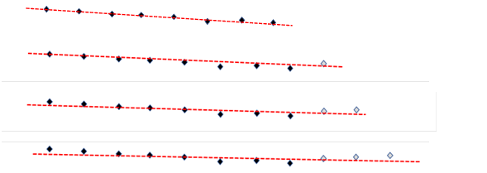

The following example shows a trend analysis graph that has data for nine consecutive years. Analysis carried out on the most recent five years (2018 to 2022) shows a trend of decline since 2018.

Example of trend analysis graph.

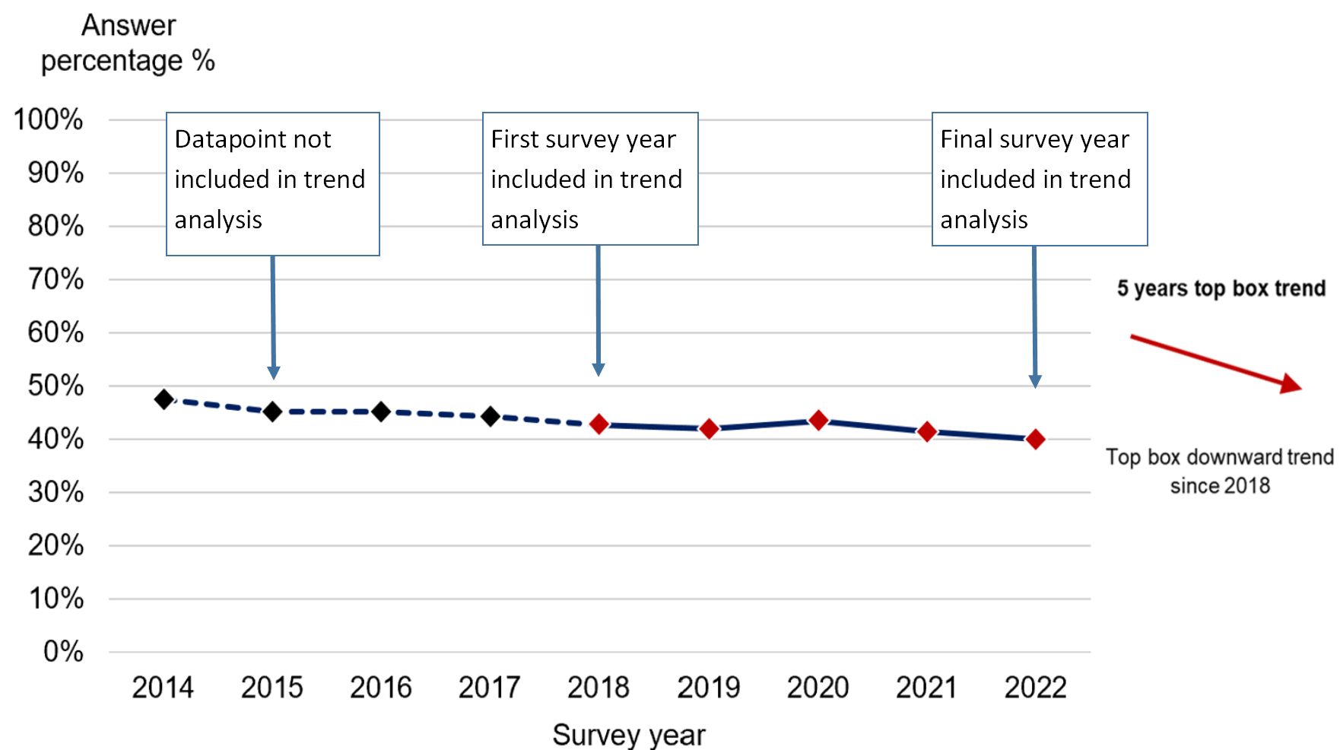
The arrow next to the graph above clearly states whether there is a trend and if that trend is upward or downward. For all trend analysis included within this report a significant finding is classed as a p value <0.05.

All charts are available in the open data source files on CQC's website.

In this section, we have included the results of a ‘subgroup analysis’, which considers the experiences of different groups of people, according to demographic, health and care characteristics. These characteristics are:

- age
- sex
- gender
- religion
- sexual orientation
- ethnicity
- Care Programme Approach status
- diagnosis (care cluster codes)
- mode of contact
- index of multiple deprivation decile
- length of contact
- long-term conditions
- ‘proxy response’ (whether the questionnaire was completed entirely by, or with the support of, someone other than the person who used the services).

Findings are grouped by the following themes:

- Access
- Your health and social care workers
- Organising your care
- Planning and reviewing care
- Crisis care
- Medicines
- NHS talking therapies
- Support and wellbeing
- Responsive care
- Overall experience.

Please note, responses to questions such as “don't know/can’t remember” are not shown and are excluded from percentage calculations. Other non-specific response options are also excluded, such as where the respondent does not require the experience/service e.g., not needing financial support.
- Access
As highlighted in NICE quality statement 5: Access to services, it is important to make sure people have access to high-quality mental health services when they need it. Receiving early access to services is also vitally important and this is reflected in the decision to introduce new waiting time standards to mental health services. Current access standards state that 60% of people presenting with a first episode of psychosis should start treatment with a NICE recommended package of care within two weeks of referral. However, as detailed above, the NHS is working to develop a new waiting time standard for accessing community mental health services. The new waiting time standard will state that adults and older adults should start to receive help within four weeks from referral. This may involve the start of therapeutic intervention or social intervention, or agreement about a patient care plan.

In 2021, CQC’s The state of health care and adult social care in England 2020/21 discussed challenges faced by people unable to access specialist mental health care, primarily caused by a lack of capacity in community mental health services.

Respondents were asked ‘In the last 12 months, do you feel you have seen NHS mental health services often enough for your needs?’ Forty per cent of all respondents reported feeling they had ‘definitely’ seen NHS mental health services enough for their needs in the last 12 months. This is a statistically significant decline over a five year period, and is the lowest positive result since 2014 (47%). Thirty per cent said they did not see services enough.

Q3. In the last 12 months, do you feel you have seen NHS mental health services often enough for your needs? (This includes contact in person, via video call and telephone). (Answer: ‘Yes, definitely’)

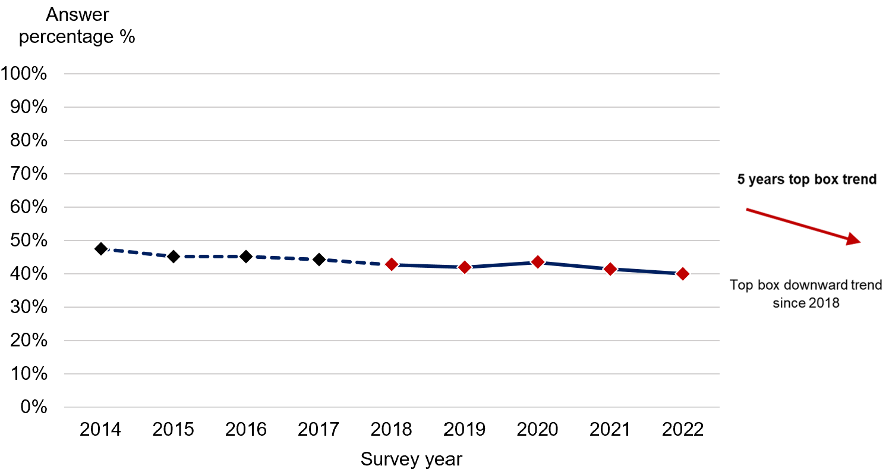

Answered by all.
Respondents who stated that they didn't know or couldn’t remember have been excluded.
Total number of respondents: 2014 (13,061), 2015 (11,072), 2016 (12,587), 2017 (11,474), 2018 (12,179), 2019 ( 11,883), 2020 (16,738), 2021 (16,479), 2022 (12,828)

People aged 65 and younger were less likely to say they had enough access to services to meet their needs than those aged 66 years and over. People accessing care using telephone-based modes also reported worse experiences with accessing services, as did those presenting with severe and more challenging non-psychotic disorders.
- Your health and social care workers
Positive interactions between people delivering, and people using, mental health services are beneficial to overall outcomes of care. Consequently, respectful relationships that allow both parties to communicate equally are important.

NICE quality statement 3: Involvement to improve services highlights the importance of delivering care and treatment that involves the person using the service in decision-making processes. NICE also urges service providers to support people in the self-management of their care.

With this in mind, all respondents were asked if they were given enough time to discuss their needs and treatment. Fifty-five per cent of people responded ‘yes, definitely’, a significant decrease from 58% in 2018, and lower still than 65% in 2014. Sixteen percent felt they did not have enough time.

Q7: Were you given enough time to discuss your needs and treatment? (Answer: ‘Yes, definitely’)

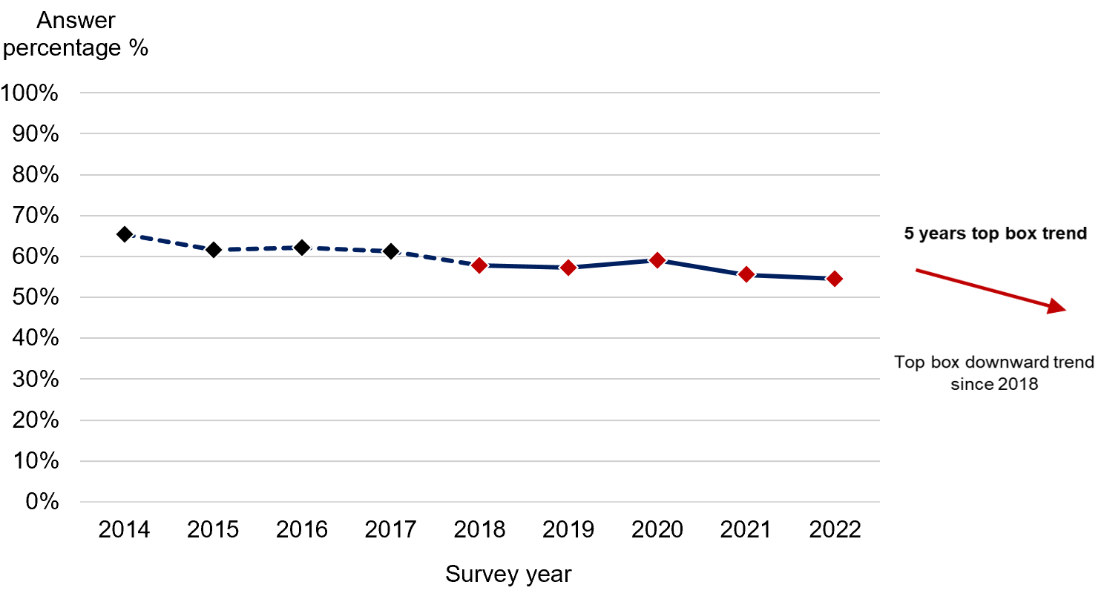
Answered by all.
Respondents who stated that they didn't know / couldn't remember have been excluded.
Total number of respondents: 2014 (13,085), 2015 (10,925), 2016 (12,507), 2017 (11,454), 2018 (12,149), 2019 ( 11,860), 2020 (16,738), 2021 (16,064), 2022 (12,549)

People receiving care via telephone, people in younger age groups (18 to 35 and 36 to 50) and people with more challenging non-psychotic disorders were less likely to report they were given enough time to discuss their needs and treatment.

When asked if the person, or people, they saw understood how their mental health needs affected other areas of their lives, 50% of respondents selected ‘yes, definitely’. This is a significant drop from 52% in 2018 and a larger decline from 57% in 2014. Eighteen per cent of respondents did not think the impact of their mental health needs on other areas of their life were considered (which is a significant increase when compared with 2021).

Q8: Did the person or people you saw understand how your mental health needs affect other areas of your life? (This includes contact in person, via video call and telephone). (Answer: ‘Yes, definitely’)

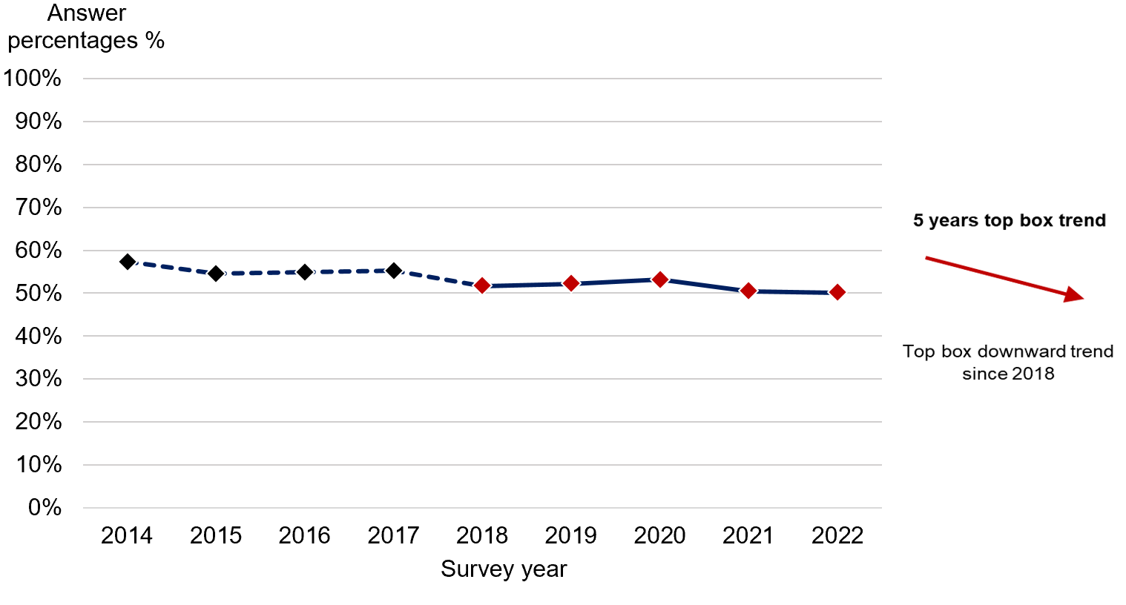
Answered by all.
Respondents who stated that they didn't know / couldn't remember have been excluded.
Total number of respondents: 2014 (12,777), 2015 (10,799), 2016 (12,312), 2017 (11,102), 2018 (11,937), 2019 (11,738), 2020 (16,508), 2021 (15,919), 2022 (12,433).

People were also asked if the person they saw appeared to be aware of their treatment history. Less than half (48%) of all respondents reported that the person they saw appeared to be aware of their treatment history. This is a statistically significant decrease of two percentage points when compared with the 2021 results.
- Organising your care
People are more likely to feel supported and receive successful treatment when they are aware of who is in charge of their care. According to the Royal College of Psychiatrists, a care coordinator should build good relationships with the people with whom they are working. This includes discussing care plans with them and making sure the plans are clear about the help people will receive.

Continuous and consistent care from the same team will encourage a relationship of familiarity with the person receiving care. As a result, people are likely to feel more empowered to successfully manage their mental health and the impact it has on other areas of their life. NICE quality statement 4: Contacts for ongoing care advises that people who use community mental health services are supported by staff from the same multidisciplinary team.

All respondents were asked if they have been told who is in charge of organising their care and services, to help gain an understanding of these relationships. Findings show that just over a third of respondents (31%) had not been told who is in charge of organising their care. Sixty-nine per cent reported that they had been told, which is a statistically significant decline since 2018, continuing a decline from 77% in 2014. The sharpest fall was in the last year (72-69%).

Q10: Have you been told who is in charge of organising your care and services? (This person can be anyone providing your care, and may be called a “care coordinator” or “lead professional”). (Answer: ‘Yes’)

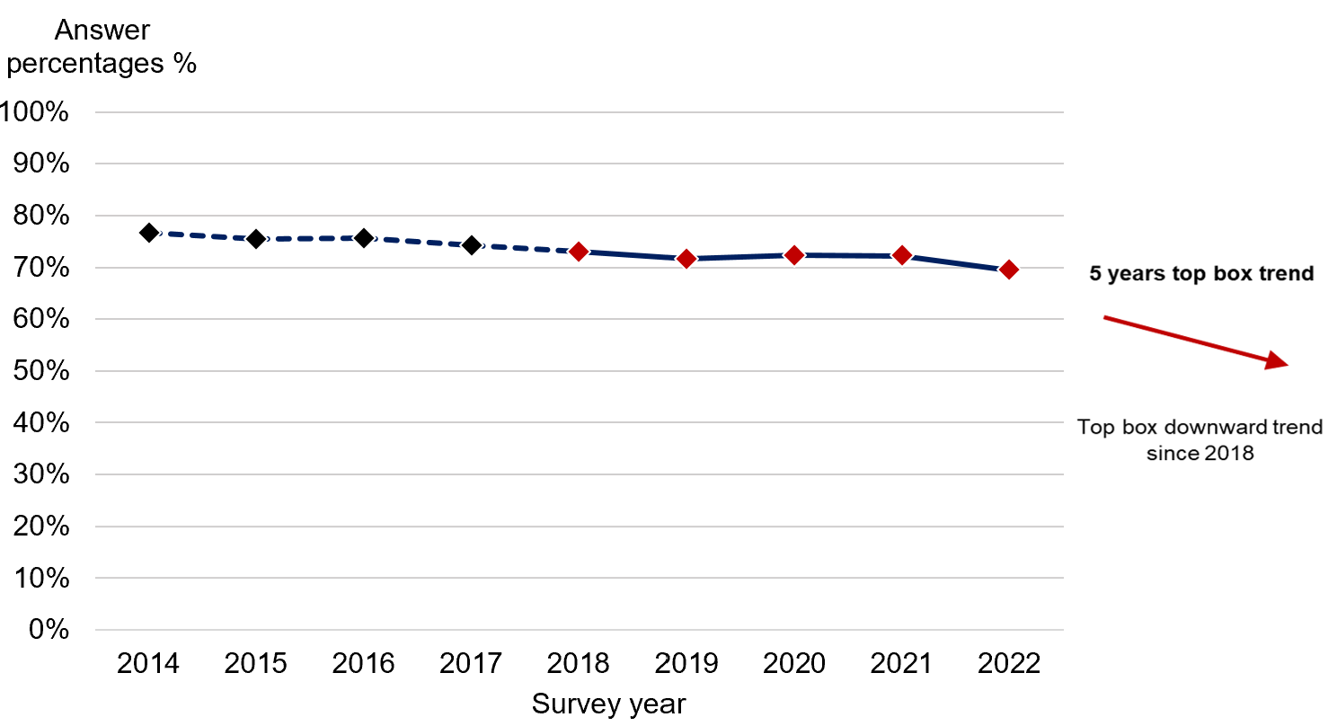

Answered by all.
Respondents who stated that they weren’t sure have been excluded.
Total number of respondents: 2014 (11,314), 2015 (9,589), 2016 (10,838), 2017 (9,863), 2018 (10,358), 2019 ( 9,982), 2020 (13,978), 2021 (13,849), 2022 (10,934).

Additional questions were asked to those who had been told who is in charge of organising their care and services, but where this person was not a GP. Ninety-six per cent of people, when asked if they knew how to contact this person if they had a concern about their care, responded ‘yes’. When asked how well this person organised the care and services they need, 57% responded ‘very well’ and a further 31% responded ‘quite well’. In addition, when asked if they got the help they needed last time they contacted this person, 63% responded ‘yes, definitely’ and 26% responded ‘yes, to some extent’. Eleven per cent of people either did not get the help they needed (9%) or could not contact this person (2%).

- Planning and reviewing care
For people who use services, positive experiences are linked to better health outcomes. At service level, good experiences can lead to lower costs of care and improved organisational reputation. It is, therefore, important that people who use services are given an opportunity to contribute to the system that has been set up to protect and care for them.

As highlighted in NICE quality statement 6: Joint care planning, actively involving people in the creation of their own care plan can better demonstrate the support available to help them live an independent life, achieving their desired outcomes and goals. This is echoed in guidance on care planning produced by the Department for Health and Social Care. The guidance emphasises that working collaboratively to create a care plan ensures care and support are tailored to an individual’s needs, thereby increasing the likelihood of successful recovery.

People who had collaboratively planned their care, were asked if they were involved as much as they wanted to be in making these decisions. Around half (55%) stated that they had ‘definitely’ been involved as much as they wanted to be, 35% answered ‘yes, to some extent’ and 10% answered ‘no, but I wanted to be’.
In addition, people were also asked whether decisions on what care they will receive took into account needs in other areas of their life. Half (50%) answered ‘yes, definitely’, 37% answered ‘yes, to some extent’ and 13% answered ‘no’.
The benefits of collaborative care planning also extend to reviewing care. The NHS recommends that care plans should be reviewed within a few months of creation, followed by annual reviews thereafter. Mind, the mental health charity, acknowledges the importance of regular care plan reviews, stating that they are vital to:
- monitor progress and respond effectively to a person’s changing needs,
- consider how the care plan is meeting specific needs and allowing an individual to achieve personal outcomes
- establish future service requirements.

To establish if care plans are reviewed annually as advised, participants who had been with NHS community mental health services for longer than 12 months were asked if they had a care review meeting with someone from NHS mental health services to discuss how their care was working. Forty per cent of people reported that they had not had a care review meeting in the last 12 months.

When care reviews took place during the previous 12 months, 63% of respondents felt decisions were ‘definitely’ made jointly - a statistically significant increase of two percentage points since 2021. Eight per cent did not think decisions were made together.
- Crisis care
Defined as a mental health emergency that presents an immediate threat to a person’s emotional or physical wellbeing, some people experience mental health crises as part of their ongoing mental health conditions.

A national agreement between different services and agencies involved in providing care and support to people in crisis, the Crisis Care Concordat identifies four main areas that organisations should focus on when providing care and treatment during a mental health crisis:

- access to support before a person reaches crisis point
- urgent and emergency access to crisis care
- the quality of care and treatment when a person is in crisis
- recovery and staying well.

To establish if people were able to access crisis care, people were asked if they would know who to contact within the NHS, out of office hours, if they had a crisis. More than a quarter of people (28%) said they would not know who to contact. This is a significant increase of two percentage points when compared with 2021. The remaining 72% said they did know who to contact.

Those who indicated that they would know who to contact within the NHS, out of office hours, if they had a crisis, were asked if they received the help they needed the last time they tried to contact this person or team. Almost a quarter of respondents did not get the help they needed (22%) or could not make contact with this person or team (2%). Less than half (47%) said they ‘definitely’ received the help they needed.

Q21: Thinking about the last time you contacted this person or team, did you get the help you needed?

Answered by those who would know the person or a team within NHS mental health services to contact out of office hours if they had a crisis. Respondents who didn't know / couldn't remember or those who have not tried contacting a person or team have been excluded.
Total number of respondents: 2022 (6,249).
When asked how they felt about the length of time it took to get through to this person or team, 37% of people reported that they got through straight away, while one in five people (19%) felt they had to wait too long.
When considering the experiences of different groups of people receiving crisis care, younger people (aged 18 to 35 and 36 to 50) reported worse than average experiences, while those in the older age groups (66 to 80 and those over 80 years old) reported better than average experiences. In addition, people with moderate to severe non-psychotic and non-psychotic chaotic and challenging disorders reported worse than average experiences.

- Medicines
Adherence to treatment is often low for people with mental ill-health. Reasons for this are multifaceted but can include an individual’s perception of illness and medicines. Intolerable side effects and some demographic characteristics such as homelessness can also impact adherence.

Research has found that people who should use medicines regularly but do not, are more likely to use multiple health services, leading to higher treatment costs., As well as prolonged hospitalisation, suicide rates for people with bipolar disorder increase when medicines are not regularly taken, as do relapse rates for people with schizophrenia.

To help professionals understand an individual’s motivations for taking, or not taking medicines, as well as to increase overall compliance, guidance produced by NICE recommends that people who use services are included in decisions about prescribed medicines.

Most respondents (80%) said they received medication in the previous 12 months. These people were then asked if the purpose of their medicines had ever been discussed with them. Almost two-thirds (62%) of people responded ‘yes, definitely’. Seven per cent of people responded ‘no’, which is a significant increase of one percentage point when compared with the results in 2021.

Furthermore, when asked if the possible side effects of their medicines had ever been discussed with them, 44% of people responded ‘yes, definitely’. However, a quarter of respondents (25%) had not had the possible side effects of their medicines discussed with them.

Respondents who had been receiving medicines for 12 months or longer were also asked if an NHS mental health worker had checked with them about how they were getting on with their medicines during this period. A quarter of people (25%) had not had their medicines reviewed in the last 12 months. Three quarters (75%) had received a review, but this proportion has dropped to its lowest point since 2014 and seen a statistically significant decline since 2021.

Q27: In the last 12 months, has an NHS mental health worker checked with you about how you are getting on with your medicines? (That is, have your medicines been reviewed?). (Answer: ‘Yes’)

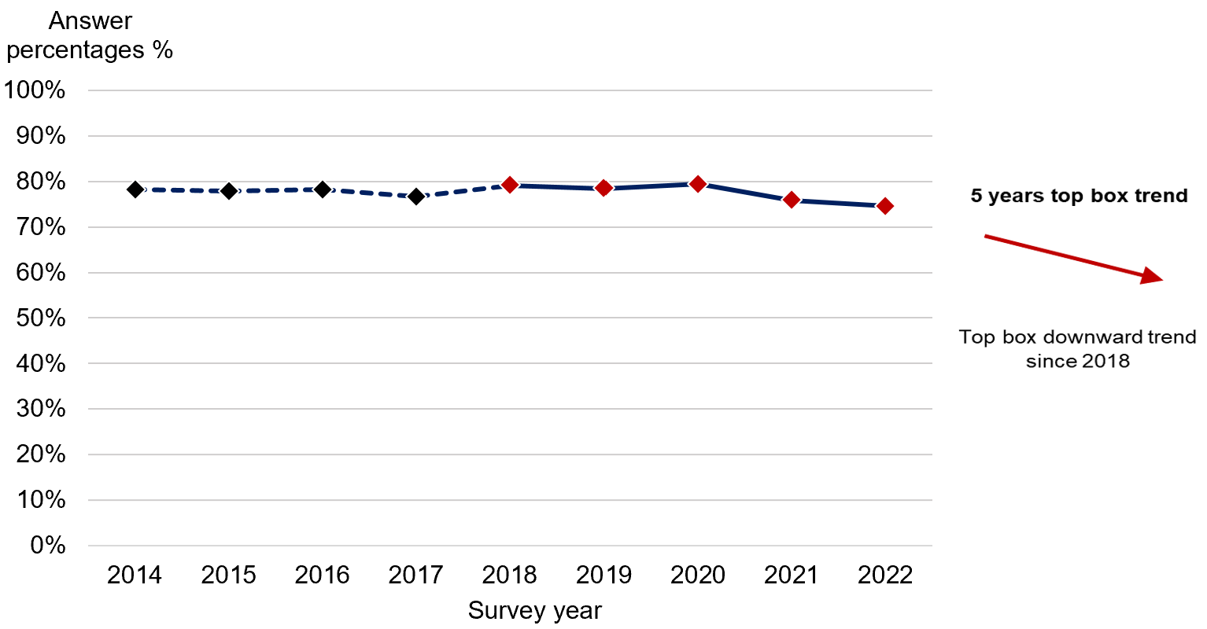

Answered by those who have been receiving any medicines for 12 months or longer for their mental health needs.
Respondents who stated that they didn't know / couldn't remember have been excluded.
Total number of respondents: 2014 (9,052), 2015 (7,575), 2016 (8,522), 2017 (7,812), 2018 (7,987), 2019 (7,859), 2020 (10,909), 2021 (10,716), 2022 (8,144).

- NHS talking therapies
Common mental health conditions, such as stress, anxiety and depression can be treated using NHS talking therapies, or psychological therapies, which are treatments that involve people talking to an accredited practitioner about their thoughts, feelings and behaviours. There are a number of different types of talking therapy, but they all share the aim of providing people with a safe space to:

- understand themselves better
- make sense of complicated feelings and unhelpful patterns, or find ways to live with them
- talk to a professional without judgement.

Therapies vary in duration and intensity, and people are able to access multiple types of talking therapy simultaneously. This results in care that is tailored to specific needs. For example, people with depression can often receive cognitive behavioural therapy (CBT) alongside interpersonal therapy.

Before therapy is delivered, it should be assessed for each individual, considering the level of risk posed and adjusting the intensity and duration accordingly.

Of all respondents, 57% received NHS talking therapies in the last 12 months, as part of a package of care. When asked if talking therapies were explained in a way they could understand, 65% answered ‘yes, completely’, with a further 30% responding ‘yes, to some extent’. Trend analysis carried out on data for this question from 2018 to 2022 has shown a very small, but statistically significant trend of improvement over this period.

Q29: Were these NHS talking therapies explained to you in a way you could understand? (Answer: Yes, completely)
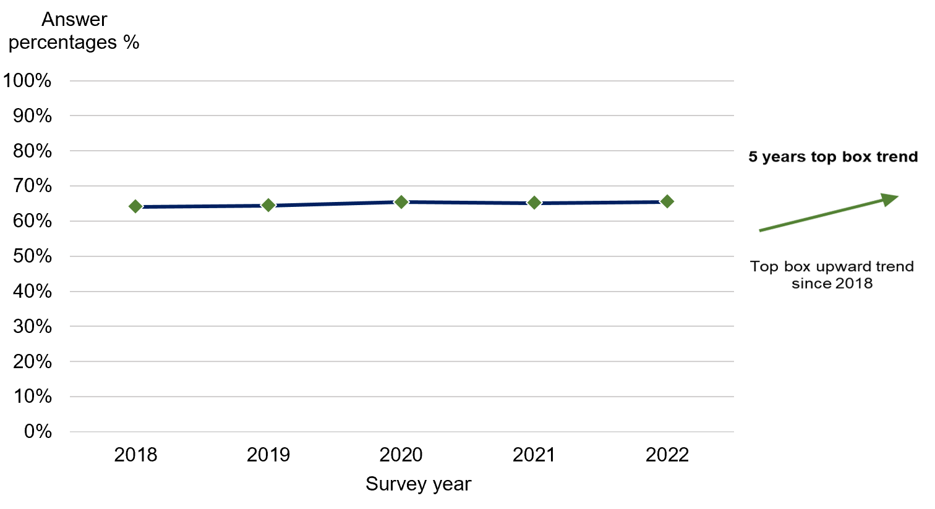
Answered by those who have received any NHS talking therapies in the last 12 months for their mental health needs.
Respondents who stated that no explanation was needed have been excluded.
Total number of respondents: 2018 (4,405), 2019 (4,273), 2020 (6,319), 2022 (4,330)

Similarly, just over half (51%) of respondents who received talking therapies as part of their care plan said they were ‘definitely’ involved as much as they wanted to be in deciding which therapies to use, a statistically significant upward trend when comparing data from 2018 to 2022. However, 15% said they were not involved ‘but wanted to be’, an increase from 13% in 2021.

Q30: Were you involved as much as you wanted to be in deciding what NHS talking therapies to use?

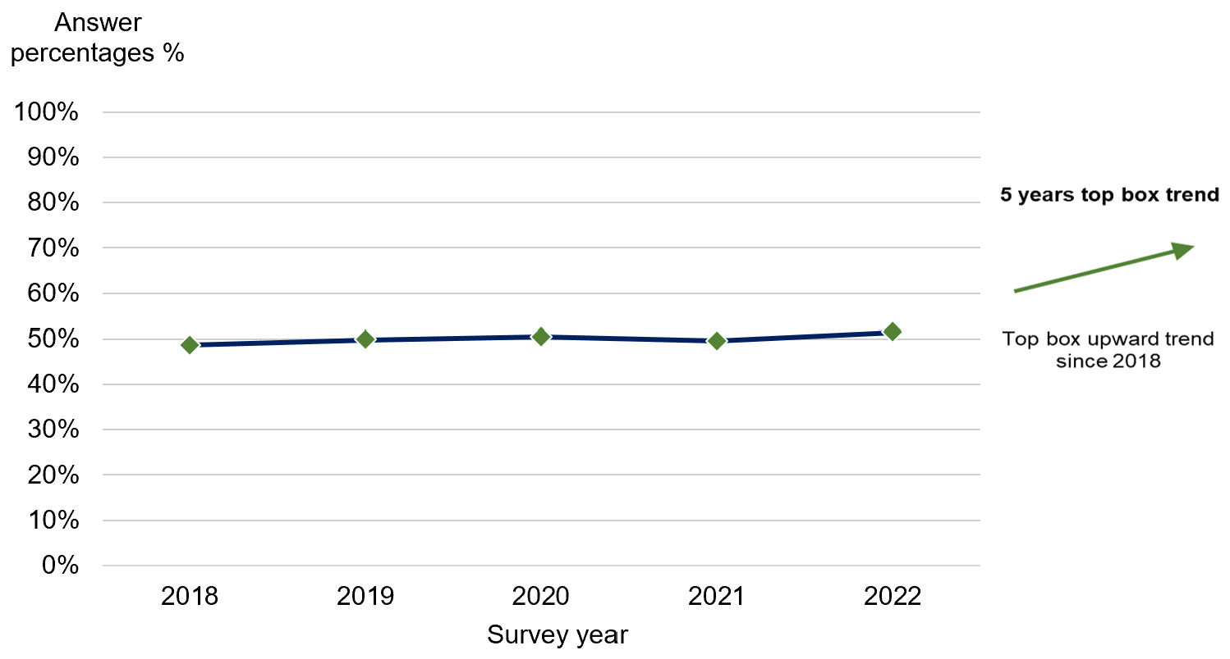
Answered by those who have received any NHS talking therapies in the last 12 months for their mental health needs.
Respondents who stated that they didn't know / couldn't remember or did not want to be involved have been excluded.
Total number of respondents: 2018 (4,227), 2019 (4,119), 2020 (6,084), 2021 (5,228), 2022 (4,122).

As discussed earlier in this report, demand for mental health services has increased in recent years, with increased waiting times being reported. To determine if respondents have experienced the impact of this, they were asked how they felt, overall, about the length of time they waited before receiving NHS talking therapies. Fifty-five per cent of respondents thought the waiting time was appropriate, while 44% reported feeling they waited too long for treatment.
- Support and wellbeing
Often, needs in other areas of a person’s life, such as housing, financial support, employment and physical health, can impact their recovery from a mental health condition.,

Survey respondents were asked several questions about the support provided to them in accessing help for their broader needs. Those who already had active support or felt they did not require support with their needs were excluded from results.

Physical health needs
Multimorbidity, where a person has more than one long-term health condition, has been noted as being one of the biggest challenges facing health services. More than 15 million people in the UK have multiple long-term conditions, with four million of these people also experiencing mental ill-health. It is therefore important to address both mental and physical long-term conditions equally.

As discussed in the Five Year Forward View for Mental Health, the risk of mental ill-health is significantly increased when an individual also experiences physical health problems. The same is true in reverse, as people who experience severe and prolonged mental illness are at risk of dying on average 10 to 25 years earlier than the general population. Two-thirds of these deaths result from avoidable physical illness. For example, the risk of developing diabetes or cardiovascular disease for people with mental ill-health is around double that of those without a mental health condition.

Participants in this survey were asked if they had a physical or mental health condition, disability or illness that has lasted, or are expected to last for more than 12 months. Overwhelmingly, 94% of people responded ‘yes’. The most prevalent physical health conditions reported were:

- 32% reported having joint problems, such as arthritis
- 21% reported having breathing problems, such as asthma
- 17% reported having deafness or hearing loss
- 15% reported having diabetes.

When asked if, in the last 12 months, NHS mental health services provided them with support for their physical health needs, two out of five people (40%) did not receive support but would have liked it. This is a significant increase from 39% in 2021. Three in ten (31%) ‘definitely’ received support.

Financial advice, benefits and employment
Stability in both employment and general finances are important elements of maintaining good mental health.

In 2017, Thriving at work: a review of mental health and employers found that 300,000 people with a long-term mental health condition lose their jobs each year, which is a much higher proportion than those with physical health conditions. The Five Year Forward View for Mental Health notes that people with mental health conditions are often over-represented in low-paying, high-turnover, temporary roles. This suggests higher levels of financial instability for people in this group.

Financial instability is an increasing concern for many individuals when considering the rising cost of living and the impact this has on household finances. A survey carried out by the Money and Mental Health Policy Institute found that many people reported financial uncertainty as having a serious impact on their mental health. Nearly one in five respondents reported missing appointments from being unable to meet the travel costs.

Considering this, respondents were asked if in the last 12 months, they had received help or advice from NHS mental health services with finding support for financial advice or benefits. Just over half of people (51%) did not receive advice but would have liked to. This is a statistically significant increase of three percentage points when compared with the findings in 2021.

A quarter (25%) of respondents said they ‘definitely’ received help and advice with finding support, a significant deterioration from 29% in 2018.

Q34. In the last 12 months, did NHS mental health services give you any help or advice with finding support for financial advice or benefits? (Answer: ‘Yes, definitely’)

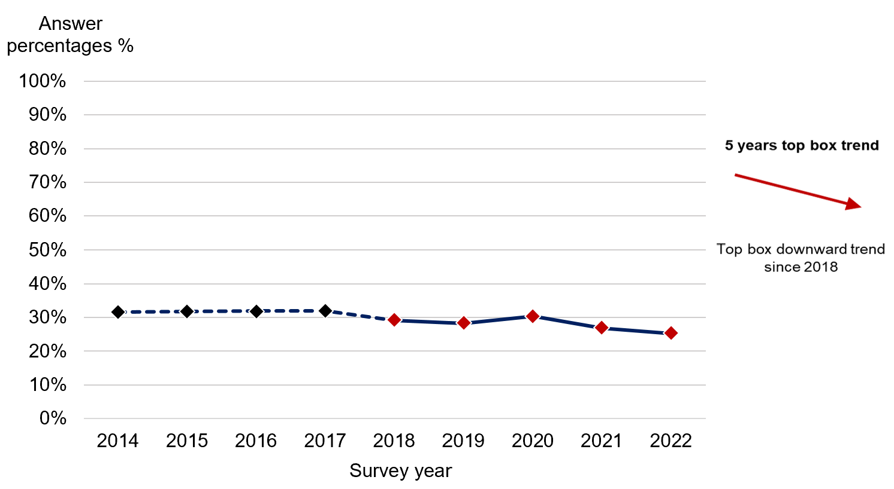

Answered by all.
Respondents who stated that they have support and did not need help / advice to find it, or do not need support for this have been excluded.
Total number of respondents: 2014 (7,315), 2015 (6,294), 2016 (7,028), 2017 (6,420), 2018 (6,897), 2019 (7,049), 2020 (9,680), 2021 (8,808), 2022 (7,233).

Additionally, respondents were asked if, in the last 12 months, NHS mental health services gave them any help or advice with finding support for finding or keeping work (paid or voluntary). A quarter of people (26%) reported that they had ‘definitely’ received help and advice. Half (50%) said they did not receive help or advice with finding support but would have liked it - a statistically significant increase of two percentage points when compared with the results in 2021.

Involving family or friends
The support of friends and family can be crucial in making a person feel empowered to deal with their mental health condition. To reflect this, NICE guidance encourages the involvement of family and carers of people using services, should the person receiving care want this.

All respondents were asked if NHS mental health services involved a member of their family, or someone close to them, as much as they would have liked. Half (51%) said services had ‘definitely’ involved a family member or someone else close to them as much as they would like – a significant downward trend when compared to results from 2018 to 2022. Twenty-one per cent of people said their family member, or person close to them, was not included as much as they would have liked.

Q36. Have NHS mental health services involved a member of your family or someone else close to you as much as you would like? (Answer: ‘Yes, definitely’)

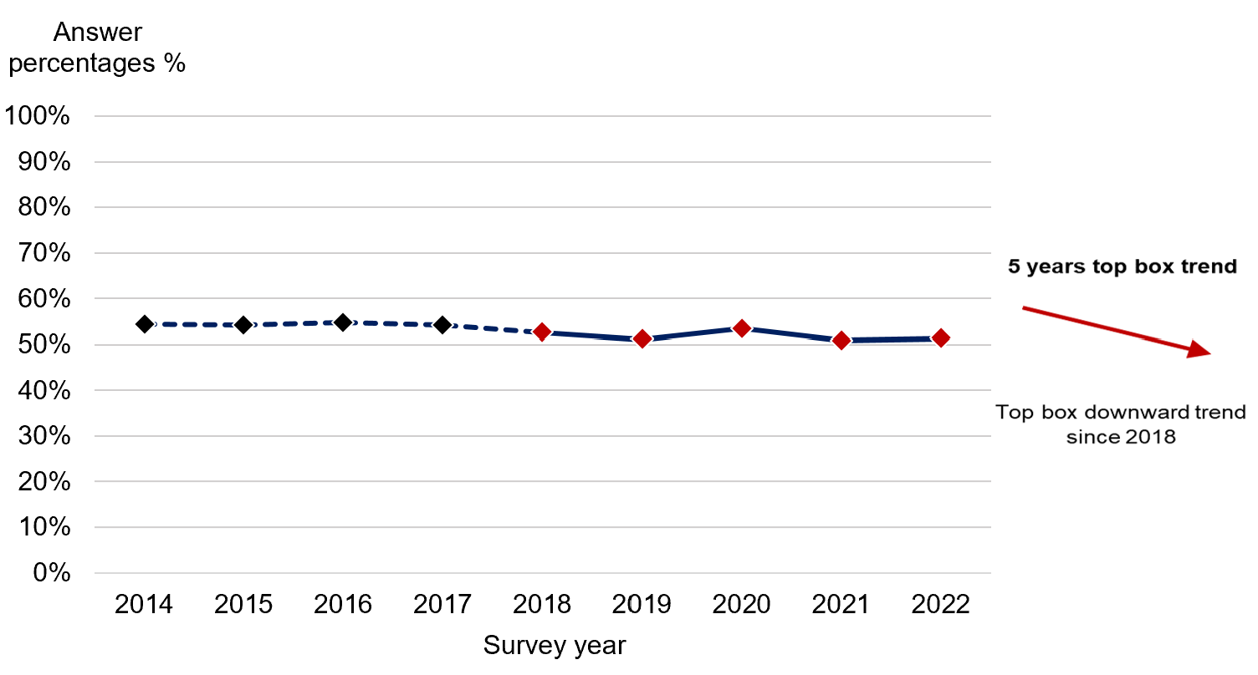
Answered by all.
Respondents who stated that their friends or family did not want to be involved, did not want their friends or family to be involved, or that this does not apply to them have been excluded.
Total number of respondents: 2014 (8,870), 2015 (7,448), 2016 (8,718), 2017 (7,978), 2018 (8,231), 2019 (8,284), 2020 (11,624), 2021 (11,089), 2022 (8,680).

- Responsive care

In response to social distancing measures implemented during the COVID-19 pandemic, many services adopted remote modes of care delivery, such as the use of video and telephone calls. In many trusts, remote options are still available to people who use services, alongside traditional face-to-face care and treatment. When asked how they agreed to receive their care, 78% of respondents reported receiving face-to-face care, 23% selected ‘by video call’ and 51% selected ‘by telephone, which implies that a number of respondents were receiving a hybrid model of care for their mental health needs. However, personal choice in the mode of care received is an important consideration in care planning. This is echoed by the National Institute for Health and Care Excellence (NICE). NICE’s quality standard for mental health currently consists of quality statements that assist mental health professionals in the delivery of care that supports shared decision-making and care planning.

With this in mind, respondents were asked if, in the last 12 months, they and someone from NHS mental health services had agreed how their care would be delivered. Seventy-one per cent of people reported that they had agreed how their care would be delivered. One in five people (18%) had not agreed how their care would be delivered and a further 11% were ‘not sure’. Of those who had agreed how care and treatment would be delivered, 68% said they ‘always’ received care in that way, with further 26% indicating that they ‘sometimes’ received care in the way they’d agreed.

Furthermore, when considering the experiences of different groups of people in relation to agreeing a mode of care and then receiving care in the agreed way, people who received care using solely video calls reported better than average experiences. Those who received telephone-based care and a hybrid model of care reported worse than average experiences.

- Overall
The guiding principles of the NHS, as set out in the NHS Constitution, include commitments to place people who use services at the heart of everything it does, and provide care that is focused on patient experience.

The NHS Constitution pledges that the NHS will encourage feedback from people about their experiences of health and care services, to meet these commitments and drive improvement.

When people were asked if, aside from the community mental health questionnaire, they had been asked by NHS mental health services to give their views on the quality of their care in the last 12 months, most people (80%) had not. The remaining 20% of respondents had been asked to share their views.

Respondents were also asked to rate their overall experience of NHS mental health services, with a score of zero representing a ‘very poor experience’ and a score of 10 representing a ‘very good experience’. Less than a third (29%) of people rated their experience as being very good, scoring it a nine or a 10. Five per cent of people rated their experience as a zero, which is a statistically significant increase when compared with 2021.

Dignity and respect
Respect and dignity are essential to developing positive relationships between those providing mental health services and those receiving care and treatment. However, stigma, or perceived stigma, connected to mental illness can act as a barrier for people who need specialist help, both within and outside of the healthcare system.

People should expect to be treated with empathy, dignity and respect as a basic human right, as highlighted in the NHS Constitution. This is also recognised by NICE quality statement 1: Empathy, dignity and respect, which acknowledges all three as important components of positive experiences.

Respondents were asked if overall, in the last 12 months, they were treated with respect and dignity by NHS mental health services. Sixty-nine per cent of people stated that they were ‘always’ treated with respect and dignity. This is a statistically significant decrease of two percentage points when compared with 2021 and is the lowest score across all nine years in the reporting period. A further 21% said they were ‘sometimes’ treated with respect and dignity, while 10% were not. Again, this shows a statistically significant increase in negative response when compared with 2021 results.

Subgroup analysis summary: how experience varies for different groups of respondents
Both the NHS Constitution and the Equality Act 2010 require providers of healthcare services to equally consider the needs, experiences, outcomes and aspirations of people with protected characteristics under equalities law.

In this section, we have included the results of a ‘subgroup analysis’, which considers the experiences of different groups of people. Using a set of themes based on the NHS Patient Experience Framework, the analysis models the average probability of different groups of people using community mental health services selecting the most positive answers to questions or sets of questions according to demographic, health and care characteristics. These characteristics are:

- sex
- age
- ethnicity
- ‘proxy response’ (whether the questionnaire was completed entirely by, or with the support of, someone other than the person who used the services).
- length of contact
- gender
- religion
- sexual orientation
- Care Programme Approach (CPA) status
- mode of contact
- index of multiple deprivation decile
- long-term conditions
- diagnosis (care cluster codes- see Appendix G: Care cluster codes for the definition of each code.)

The themes (some using composites of individual survey questions) are:
- overall experience (Q37)
- access (Q3)
- care delivery (Q6)
- communication (Q7)
- crisis care (access) (Q22)
- crisis care (care) (Q21)
- information sharing (medicines) (Q24 and Q25)
- informed on care delivery and who to contact (Q4, Q10 and Q20)
- involvement in deciding care (Q16)
- involvement in decisions being made together (Q19)
- involvement of family and friends (Q36)
- organisation of care (Q12 and Q13)
- respect and dignity (Q38)
- respect for person-centred values (Q8 and Q17)
- support and wellbeing (financial) (Q34)
- support and wellbeing (physical) (Q33)
- support and wellbeing (work) (Q35)
- treatment history (Q9).

Please refer to the subgroup report on the Community Mental Health Survey 2022 page for more information about the questions used, as well as the charts.
In this report, subgroup differences are considered reportable where a demographic or care characteristic overall (for example, age) is significantly associated with experience and where the mean response for the specific subgroup (for example, people aged 18 to 35) is significantly different from the overall mean. For further technical information on the subgroup analysis please see the quality and methodology report.
The following tables show the experiences of different groups of people using a set of themes based on the NHS Patient Experience Framework. Findings significantly above (B) or significantly below (W) average are shown for each subgroup category under each question.

W | Significantly worse than average experience
B | Significantly better than average experience

 |  |  |  |  | Overall | Access | Care delivery | Communication | Crisis care (access) | Crisis care (care) | Information sharing (meds) | Informed on care delivery | Involvement in decisions being made together | Involvement in deciding care | Involve. of family & friends | Organisation of care | Respect and Dignity | Support & wellbeing-Financial | Support & wellbeing-Physical | Support & wellbeing-Work | Treatment | Respect- person centred val.
Sex
Male
Female
Intersex
Prefer not to say
Age
18-35 |  |  |  |  | W | W | W | W |  | W |  | W |  | W | W | W | W | W |  |  | W
36-50 |  |  |  |  | W | W | W | W |  | W |  |  | W |  | W | W | W |  |  |  | W
51-65 |  |  |  |  |  | W |  |  |  |  |  |  |  |  | W |  | W
66-80 |  |  |  |  | B | B | B | B |  | B |  | B | B | B | B | B | B |  |  |  | B
>80 |  |  |  |  | B | B | B | B |  | B |  |  |  | B | B | B | B |  |  |  | B
Ethnicity
White
Multiple ethnic groups
Asian or Asian British
Black or Black British
Arab/other ethnic grp
Not known
Proxy response
Service user |  |  |  |  |  |  |  |  |  |  |  |  |  |  | W |  |  |  |  |  |  | W
Friend or relative |  |  |  |  | W | W |  |  |  |  |  |  |  |  |  |  |  |  | W |  |  | W
S.U & friend/relative |  |  |  |  | W | W |  |  |  |  |  |  |  |  |  |  |  |  | W |  |  | W
S.U & health prof. |  |  |  |  | B | B |  |  |  |  |  |  |  |  |  |  |  |  | B |  |  | B
Length of contact
Less than 1 year |  |  |  |  | B | B |  | B | B |  |  | B |  | B | B |  | B | B |  |  | B | B
1 to 5 years |  |  |  |  | B | B |  | B |  |  |  | B |  |  |  |  | B | B |  |  | B
6 to 10 years |  |  |  |  | B |  |  |  |  |  |  | B
More than 10 years |  |  |  |  |  |  | W |  |  | W |  |  |  |  |  |  | W |  |  |  | W | W
No longer in contact |  |  |  |  | W |  |  | W |  |  |  | W
Don’t know |  |  |  |  | W | W |  | W |  |  |  | W |  |  | W |  | W |  |  |  | W
 |  |  |  |  | Overall | Access | Care delivery | Communication | Crisis care (access) | Crisis care (care) | Information sharing (meds) | Informed on care delivery | Involvement in decisions being made together | Involvement in deciding care | Involve. of family & friends | Organisation of care | Respect and Dignity | Support & wellbeing-Financial | Support & wellbeing-Physical | Support & wellbeing-Work | Treatment | Respect- person centred val.
Gender
Same gender as reg. at birth
Not the same as reg. at birth
Prefer not to say
Religion
No religion
Buddhist |  |  |  |  | W | W | W | W | W |  |  | W |  | W | W | W | W | W |  |  | W
Christian |  |  |  |  | W | W | W | W | W |  |  | B | W |  | W | W | W |  |  |  | W
Hindu |  |  |  |  |  | W |  |  |  |  |  |  |  |  | W |  | W
Muslim
Sikh
Other (religion)
Prefer not to say |  |  |  |  | W
Sexual Orientation
Heterosexual/straight |  |  |  |  | B |  |  |  |  |  | B |  |  |  | B |  | B |  |  |  | B | B
Gay/lesbian |  |  |  |  |  |  |  |  |  |  | W
Bisexual
Other (sexual orientation)
Prefer not to say |  |  |  |  | W |  |  |  |  |  |  |  |  |  |  |  | W
CPA status
On CPA |  |  |  |  | B | B |  |  |  |  |  | B |  |  |  |  |  | B | B |  | B
Not on CPA |  |  |  |  | B |  |  |  |  |  |  | W |  |  |  |  |  | W
Unknown (CPA) |  |  |  |  | W | W |  |  |  |  |  | W |  |  |  |  |  | W | W |  | W
Mode of contact
Face to face (in person) |  |  |  |  | B | B |  | B |  |  |  | B |  | B | B |  |  | B | B |  | B
Video conferencing |  |  |  |  | B |  | B |  |  |  |  | B |  |  |  |  | B
Telephone |  |  |  |  | W | W | W | W |  |  |  | W |  |  |  |  | W |  |  |  |  | W
Multiple modes |  |  |  |  | W |  | W |  |  |  |  | W
Unsure (mode of contact) |  |  |  |  | W |  |  | W |  |  |  |  |  |  | B |  | W

 | Overall | Access | Care delivery | Communication | Crisis care (access) | Crisis care (care) | Info. sharing (meds) | Informed- on care delivery | Involvement in decisions | Involve. deciding care | Involve. of family & friends | Organisation of care | Respect and Dignity | Support & wellbeing-Financial | Support & wellbeing-Physical | Support & wellbeing-Work | Treatment | Respect- person centred values
IMD decile
1st decile
2nd decile
3rd decile
4th decile
5th decile
6th decile
7th decile
8th decile
9th decile
10th decile
Long-term cond.
Autism/autism spec. | W |  |  | W |  |  |  | W |  |  |  |  |  |  |  |  | W | W
Breathing problem
Blind/partial sight
Cancer (last 5 years)
No dementia/Alz.
Dementia/Alz.
Deaf/hearing loss |  |  |  |  |  |  |  |  |  |  |  |  |  |  |  | W
Diabetes
Heart problem
Joint problem
Kidney/liver disease
Learning disability
Mental health cond. |  | W | W | W |  |  |  | B |  |  |  |  | W
Neurological cond. |  | W |  |  |  |  |  |  |  |  |  |  | W
Stroke
Another LTC | W | W |  | W |  | W | W |  |  | W | W | W | W | W | W |  | W | W

 | Overall | Access | Care delivery | Communication | Crisis care (access) | Crisis care (care) | Information sharing (meds) | Informed on care delivery | Involvement in decisions being made together | Involvement in deciding care | Involve. of family & friends | Organisation of care | Respect and Dignity | Support & wellbeing-Fin. | Support & wellbeing-Phys | Support & wellbeing-Work | Treatment | Respect- person centred val.
Care cluster
Variance |  |  |  |  |  |  |  |  |  | B
Non-psychotic
Care cluster 1
Care cluster 2
Care cluster 3 |  |  |  |  |  | W
Care cluster 4 |  | W |  |  |  | W
Care cluster 5
Care cluster 6 |  | W |  | W
Care cluster 7 |  | W |  |  |  | W
Care cluster 8 | W | W | W | W |  | W | W |  |  | W |  |  | W
Psychotic
Care cluster 10 | B | B | B | B |  | B | B | B |  | B | B | B | B | B | B | B | B | B
Care cluster 11 | B | B | B | B |  | B |  |  |  |  |  |  | B |  |  |  | B
Care cluster 12 | B | B | B | B
Care cluster 13
Care cluster 14
Care cluster 15
Care cluster 16
Care cluster 17
Cognitive impairment and dementia |  | W
Care cluster 18 |  | W |  |  |  |  |  | W
Care cluster 19 |  |  |  |  |  |  |  | W
Care cluster 20 |  | W
Care cluster 21 |  |  |  |  |  |  |  | W
No cluster assigned | W | W |  | W |  |  |  | W |  |  |  |  |  | W |  |  | W

Appendix A: Survey methodology
Survey method
The community mental health survey used a postal methodology for the 2022 survey.

Sample members received their first survey pack containing a questionnaire, covering letter and a leaflet offering guidance on multi-language and other accessible options, such as braille, easy-read and large print. This was followed by a reminder letter, then a final survey pack containing a questionnaire, reminder letter, freepost envelope and multi-language sheet.

The first reminder was mailed seven working days after the first mailing. The second reminder was mailed two to three weeks later, allowing time to remove those who had since died and those who had opted out from mailings.

People aged 18 and over were eligible to take part in the survey if they received specialist care or treatment for a mental health condition and had been seen by an NHS trust between 1 September 2021 and 30 November 2021. This includes care and treatment delivered in-person, over the telephone and via video call. From their records, trusts drew a random sample of 1,250 people who had been treated by the trust during the sampling period. The sample size is sufficient to allow analysis of results at individual trust level.

All providers of NHS community mental health services were eligible to take part in the survey.

Certain groups of people were excluded from the survey before providers drew their samples, including:
- anyone who was a current mental health inpatient
- anyone seen only once for an assessment
- anyone seen for assessment only through a liaison service
- anyone primarily receiving the following services:
- drug and alcohol
- learning disability
- forensic
- psychological treatments from Improving Access to Psychological Therapies (IAPT)
- chronic fatigue/ Myalgic Encephalomyelitis (ME)
- psychosexual medicine (sexual dysfunction)
- gender identity.

Fieldwork for the survey (the time during which questionnaires were sent out and returned) took place between February 2022 and June 2022.

For more detailed information on the inclusion and exclusion criteria, please see the sampling instructions for the survey.

As shown in the table below, following years of little variation, the respondent age profile for 2021 changed for both the 16 to 35 and the 66+ age groups, with more younger people and fewer older people responding to the survey. However, for 2022, the respondent age profile has returned to pre-2021 proportions, with a 6% increase of people in the 66+ group.

Historical comparisons are still appropriate as responses are adjusted to reflect sample profiles.

Respondent age profile for 2014 to 2021

 | 18-35 | 36-50 | 51-65 | 66+
2014 | 14% | 23% | 25% | 38%
2015 | 14% | 23% | 25% | 39%
2016 | 14% | 22% | 25% | 39%
2017 | 14% | 21% | 25% | 40%
2018 | 15% | 20% | 25% | 39%
2019 | 15% | 19% | 25% | 40%
2020 | 15% | 18% | 26% | 40%
2021 | 18% | 20% | 26% | 36%
2022 | 16% | 17% | 25% | 42%

Further information about the sample profile can be found in the quality and methodology report on CQC’s website.

Questionnaire design
Wherever possible, the questions remain the same over time to measure change. However, questions are amended, added or removed to reflect changes in policy or survey best practice. We also seek guidance from an external advisory group to make sure the questions remain relevant. For this survey iteration, members included representatives from CQC, NHS England, NHS mental health trusts, the mental health charity Mind and people who use mental health services.

For the 2022 survey, five new questions were added, five questions were modified and four questions were removed.

For more detailed information please see the Community mental health 2022 survey development report and the final questionnaire for the 2022 survey.

Analysis methodology
Weighting
The data presented in this report has been weighted with two weights:

1. A ‘trust weight’, which weights responses from each NHS mental health trust to ensure that each trust has an equal influence on the results for England. As some trusts have a higher response rate than others, they have a larger share of respondents in the total respondent’s population for England.

Without weighting, the views of respondents from these trusts would be over-represented in the England-level results. The weighting is therefore designed so that each trust that participated contributes equally to the overall results for England, regardless of differences in response rates.

2. A ‘population weight’, which aims to weight responses for each individual to make sure it is representative of the trust’s own population (based on the initial eligible sample). This involves weighting based on variables that are related to how people respond: age group and sex.

Both sets of weights are then multiplied together to produce a single combined weight for the data tables that underpin the analysis.

This weighting has been applied to all questions except for demographic questions. The demographic questions are presented without weights applied, because it is more appropriate to present the real percentages to describe the profile of respondents, rather than adjust figures.

Rounding
The results present percentage figures rounded to the nearest whole number, so the values given for any question will not always add up to 100%. Please note that rounding up or down may make differences between survey years appear bigger or smaller than they actually are.

Appendix B: Other sources of information related to survey results
This section summarises other sources of data related to mental health services in England. Please note that, because they do not measure experience of those using services, they are not directly comparable with the findings presented in this report.

Statistics on the use of mental health services
The Mental Health Services Data Set (MHSDS) contains record-level data about the care of children, young people and adults who are in contact with mental health, learning disability or autism spectrum disorder services.

The latest data (June 2022) shows:
- At the end of June 2022, 1.61 million people were in contact/had an open referral with mental health services. This is higher than the figure for June 2020, which saw 1.30 million people in contact with services.
- 2.31 million contacts were made during June 2022. The data does not indicate if these contacts were attended or not or how these contacts took place (for example, face-to-face or telephone).
- 505,578 adults with a serious mental illness accessed community mental health services.
- Of all age groups, the 11 to 15 years old group had the most contacts with services (259,263). With regard to the age groups eligible to participate in the community mental health survey, we can see those in the 18 to 24 years old group had the most contacts with 252,631. The number of contacts decreases as age increases.

Mental Health Five Year Forward View dashboard
This dashboard is intended to help monitor progress against the delivery of the Five Year Forward View for Mental Health and is published quarterly. At the time of publication, it was last updated in August 2022. Please see the NHS England website for more information about the Five Year Forward View for Mental Health dashboard.

Staffing
Statistics on staffing numbers are provided in NHS Digital’s statistical release on NHS Workforce Statistics. Please note this data covers all trust types, such as acute and community trusts, as well as mental health providers. For more information on NHS Workforce statistics, please visit the NHS Digital website.

Waiting times
The government has committed to introducing access and waiting time standards for mental health services. For more information about access and waiting time standards, please visit the NHS England website.

Appendix C: Comparisons with other surveys
There are very few surveys related to community mental health services and this is the only survey of community mental health services currently conducted in the UK. Other surveys tend to be diagnostic or establish prevalence of mental health issues, rather than focus on experiences of care received.

Coronavirus: Mental health in the pandemic
The Mental Health Foundation (MHF) is leading an ongoing, UK-wide, long-term survey of how COVID-19 is affecting people’s mental health. All participants are aged 18 or older. Not all participants have pre-existing mental health conditions.
Working in partnership with a number of universities, the MHF has released key findings of the study in different waves, as well as investigated inequalities in the experiences of different people during the pandemic. Data is collected in waves. Wave 1 began in mid-March 2020, before the first national lockdown, with the latest wave being wave 13, which collected data from 9 to 15 November 2021).
A report on the mental health experiences of older people during the pandemic can be found on the Mental Health Foundation website, as can a study on financial inequality during the pandemic.
Information about the long-term COVID-19 study can be found on the Mental Health Foundation website.

Appendix D: Main users of the survey data
This appendix lists known users of data from the Community Mental Health Survey and how they use the data.

Care Quality Commission (CQC)
CQC will use results from the survey to build an understanding of the risk and quality of services and those who organise care across an area. Where survey findings provide evidence of a change to the level of risk or quality in a service, provider or system, CQC will use the results alongside other sources of people’s experience data to inform targeted assessment activities.

NHS trusts and commissioners
Trusts, and those who commission services, use the results to identify and make the changes they need to improve the experience of people who use their services.

NHS England
NHS England are a key user of data from the NHS Patient Survey Programme. Listening to patients’ experiences of their care plays a crucial part in delivering services that are safe, effective and continuously improving. Data from the survey programme is important for NHS England to understand patients’ experiences of the services they are receiving from NHS mental health, acute and community settings.
Patient experience is a cross-cutting theme throughout the NHS Long Term Plan. CQC data supports NHS England to track how it is doing on user experience, and understand where inequality is present and the impact that policy initiatives are having on patients.
NHS services have suffered a heavy burden from the COVID-19 pandemic, with the 2022/23 NHS Priorities and Operational Planning Guidance outlining a continuing path to reduce backlogs and meet new care demands. CQC data supports NHS England and Improvement to understand how they do this in an equitable way.
For more information about NHS England, please visit their website.

Department of Health and Social Care
The government measures progress on improving people’s experiences through Domain 4 of the NHS Outcomes Framework ‘ensuring people have a positive experience of care’. The Framework sets out the outcomes and corresponding indicators that the Department of Health and Social Care uses to hold NHS England to account for improvements in health outcomes.
The NHS Outcomes Framework survey indicators are based on the standardised, scored trust level data from the survey (similar to that included in CQC’s benchmark reports), rather than the England level percentage of respondent’s data that is contained in this report.
For more information, see the following link:
https://digital.nhs.uk/data-and-information/publications/clinical-indicators/nhs-outcomes-framework.

Appendix E: Further information and feedback
Further information
This report, together with the trust level results, is available on CQC’s website. You can also find a ‘technical document’ there, which describes the methodology for analysing trust level results, and a ‘quality and methodology’ document, which provides information about the survey development and methodology.

All survey reports, instructions and documents created as part of the survey can be found on the NHS Surveys website. These include full details of the methodology for the survey, questionnaires, letters sent to people who use services, instructions on how to carry out the survey, and the survey development report.

There is more information on the NHS Patient Survey Programme, including results from other surveys and a programme of current and forthcoming surveys, on the NHS Surveys website.

Further questions and feedback
This report was produced by CQC’s Research Team and reflects the findings of the 2022 community mental health survey. The guidance on our website should help answer any questions you have about the programme. However, should you wish to contact the team directly with questions, please do so using the details below.

We welcome all feedback on the survey findings and the approach we have used to report the results, particularly from people using services and their representatives, and those providing services.

If you have any views, comments or suggestions on how we can improve this publication, please contact Tamatha Webster, Principal Researcher, at Patient.Survey@cqc.org.uk.

We will review your information and use it, as appropriate, to improve the statistics that we publish across the NHS Patient Survey Programme.

If you would like to be involved in consultations or receive updates on the NHS Patient Survey Programme, please subscribe to our newsletter.

National Statistics status
National Statistics status means that the statistics in this document meet the highest standards of trustworthiness, quality and public value.

All official statistics should comply with all aspects of the Code of Practice for Official Statistics. They are awarded National Statistics status following an assessment by the Authority’s regulatory arm. The Authority considers whether the statistics meet the highest standards of Code compliance, including the value they add to public decisions and debate.

Appendix F: Care cluster codes
Care cluster codes enable people using mental health services to see which care and treatments are most likely to meet their needs. Created by clinicians and people who use mental health services, each care cluster considers the level of need and risk that someone has, as well as their diagnosis. There are 20 clusters in total and these fall into one of three main groups:

Non-psychotic (Codes 1 to 8)
This group includes people diagnosed with anxiety, depression, obsessive compulsive disorder, phobic disorders and eating disorders.

Psychotic (Codes 10 to 17)
This group includes people diagnosed with forms of psychosis, such as bipolar disorder and schizophrenia.

Cognitive impairment and dementia (Codes 18 to 21)
This group includes people diagnosed with dementia, including Alzheimer’s disease, and other types of brain injury impacting people’s mental health.

The care cluster codes are as follows:

Non-psychotic
Care Cluster 1: Common Mental Health Problems (Low Severity)
Care Cluster 2: Common Mental Health Problems (Low Severity with Greater Need)
Care Cluster 3: Non-Psychotic (Moderate Severity)
Care Cluster 4: Non-Psychotic (Severe)
Care Cluster 5: Non-Psychotic Disorders (Very Severe)
Care Cluster 6: Non-Psychotic Disorder of Over-Valued Ideas
Care Cluster 7: Enduring Non-Psychotic Disorders (High Disability)
Care Cluster 8: Non-Psychotic Chaotic and Challenging Disorders

Psychotic
Care Cluster 10: First Episode Psychosis
Care Cluster 11: Ongoing Recurrent Psychosis (Low Symptoms)
Care Cluster 12: Ongoing or Recurrent Psychosis (High Disability)
Care Cluster 13: Ongoing or Recurrent Psychosis (High Symptoms and disability)
Care Cluster 14: Psychotic Crisis
Care Cluster 15: Severe Psychotic Depression
Care Cluster 16: Dual Diagnosis
Care Cluster 17: Psychosis and Affective Disorder (Difficult to Engage)

Cognitive impairment and dementia
Care Cluster 18: Cognitive Impairment (Low Need)
Care Cluster 19: Cognitive Impairment or Dementia Complicated (Moderate Need)
Care Cluster 20: Cognitive Impairment or Dementia Complicated (High Need)
Care Cluster 21: Cognitive Impairment or Dementia Complicated (High Physical or Engagement)

Care Cluster 0: Variance is assigned to people who use services who are not adequately described by any of the care clusters mentioned above, but need mental health care.

For more information, visit the NHS mental health clustering guidance booklet.

References

. We report the ‘adjusted’ response rate. This is calculated by subtracting the number of questionnaires returned as undeliverable, or if someone had died, from the total number of questionnaires sent out. The adjusted response rate is then calculated by dividing the number of returned useable questionnaires by the adjusted base.
. For this survey iteration, members included representatives from CQC, NHS England, NHS mental health trusts, the mental health charity Mind, and people who use mental health services.
MIND. How Common are mental health problems. Available at: How common are mental health problems? - Mind
Public Health England. Health profile for England: 2019. Chapter 3 – trends in morbidity and risk factors, figure 4. 2019. Available from: gov.uk
NICE. Common Mental Health Problems. 2019. Available at: https://www.nice.org.uk/guidance/cg123/ifp/chapter/Common-mental-health-problems
Mental Health Foundation. Self-management of mental ill health. 2020. Available at: https://www.mentalhealth.org.uk/a-to-z/s/self-management-mental-ill-health
Department for Health and Social Care. Integration and innovation: working together to improve health and social care for all. 2021. Available at: https://www.gov.uk/Government/publications/working-together-to-improve-health-and-social-care-for-all/integration-and-innovation-working-together-to-improve-health-and-social-care-for-all-html-version
Cheshire and Wirral Partnership NHS Foundation Trust. Adult and Older People's Community Mental Health Teams. 2020. Available at: https://www.cwp.nhs.uk/services-and-locations/services/adult-and-older-peoples-community-mental-health-teams/
NHS England. The NHS Long Term Plan. 2019. Available at: https://www.longtermplan.nhs.uk/
NHS England. 2022 Available at: NHS England » Community mental health services
Royal College of Psychiatrists. COVID-19 support for patients and carers. 2020. Available at: https://www.rcpsych.ac.uk/about-us/responding-to-covid-19/covid-19-and-mental-health
NHS England. Next steps on the NHS Five Year Forward View. 2017. Available at: https://www.england.nhs.uk/publication/next-steps-on-the-nhs-five-year-forward-view/
NHS England. NHS Mental Health Implementation Plan 2019/20 – 2023/24. 2019. Available at: https://www.longtermplan.nhs.uk/publication/nhs-mental-health-implementation-plan-2019-20-2023-24/
HM Government. Prevention is Better than Cure. 2019. Available at: https://assets.publishing.service.gov.uk/Government/uploads/system/uploads/attachment_data/file/753688/Prevention_is_better_than_cure_5-11.pdf
NHS confederation. Manifesto for a new prime minister. 2022. Mental Health Policy Group leadership election manifesto FINAL.pdf (nhsconfed.org)
Department of Health and Social Care. NHS outcomes framework: at-a-glance. 2016. Available at: https://assets.publishing.service.gov.uk/Government/uploads/system/uploads/attachment_data/file/513157/NHSOF_at_a_glance.pdf
Department of Health and Social Care. NHS Constitution for England, 2012 (Updated in 2015) www.gov.uk/Government/publications/the-nhs-constitution-for-england
Department of Health of Social Care. Health and Social Care Act 2012: fact sheets. 2012. Available at: www.gov.uk/Government/publications/health-and-social-care-act-2012-fact-sheets
Care Quality Commission. New CQC strategy champions regulation driven by people’s experiences of care. 2021. Available at: https://www.cqc.org.uk/news/releases/new-cqc-strategy-champions-regulation-driven-peoples-experiences-care
NHS England. The five year forward view for mental health. 2016. Available at: https://www.england.nhs.uk/wp-content/uploads/2016/02/Mental-Health-Taskforce-FYFV-final.pdf
NHS England. Implementing the five year forward view for mental health. 2016. Available at: https://www.england.nhs.uk/wp-content/uploads/2016/07/fyfv-mh.pdf
UK Parliament. Mental Health Policy in England. 2021. Available at: https://commonslibrary.parliament.uk/research-briefings/cbp-7547/
NHS Confederation. Now or Never: A systemic investment review of mental health care in England. 2021. Available at: https://www.nhsconfed.org/sites/default/files/2021-07/Centre-for-Mental-Health-Now-or-Never.PDF.pdf
The Kings Fund. Integrated care systems: how will they work under the Health and Care Act? 2022. Available at: https://www.kingsfund.org.uk/audio-video/integrated-care-systems-health-and-care-act
Royal College of Psychiatrists. Improving mental health services in systems of integrated and accountable care: emerging lessons and priorities. 2019. Available at: https://www.rcpsych.ac.uk/docs/default-source/improving-care/better-mh-policy/policy/rcpsych---improving-mental-health-services-in-systems-of-integrated-and-accountable-care-final.pdf?sfvrsn=21848a8d_2
NHS England. 2022 Available at: NHS England » Community mental health services
NHS England. Care Programme Approach: position statement. 2022. Available at: NHS England » Care Programme Approach: position statement
Department of Health and Social Care. No health without mental health. 2011. Available at: https://assets.publishing.service.gov.uk/government/uploads/system/uploads/attachment_data/file/213761/dh_124058.pdf
UK Government. 2022 to 2023 mandate to NHS England. 2022. The government's 2022 to 2023 mandate to NHS England (publishing.service.gov.uk)
The King’s Fund. Bringing together physical and mental health. A new frontier for integrated care. 2016. Available at: https://www.kingsfund.org.uk/sites/default/files/field/field_publication_file/Bringing-together-Kings-Fund-March-2016_1.pdf
NHS England. Statistical Press Notice. August 2022. Available at: Physical-Health-Checks-SMI-Statistical-Press-Notice-2022-23-Q1.pdf (england.nhs.uk)
The Health and Social Care Committee’s Expert Panel. Evaluation of the Government’s progress against its policy commitments in the area of mental health services in England. 2021. Available at: The Health and Social Care Committee’s Expert Panel: Evaluation of the Government’s progress against its policy commitments in the area of mental health services in England (parliament.uk)
Liberati, E. Et al. Remote care for mental health: qualitative study with service users and staff during the COVID-19 pandemic. 2021. Available at: https://bmjopen.bmj.com/content/bmjopen/11/4/e049210.full.pdf
Mind. Trying to connect: The importance of choice in remote mental health services. 2021. Available at: https://www.mind.org.uk/media/7592/mind-20582-trying-to-connect-report-low-res.pdf
Appleton, et al. Implementation, adoption and perceptions of telemental health during the COVID-19 pandemic: Systemic review. 2021. Available at: https://www.jmir.org/2021/12/e31746/
NICE. Service user experience in adult mental health services. 2019. Available at: https://www.nice.org.uk/guidance/qs14
University College London. Significant barriers in shift to remote mental health services during pandemic. 2021. Available at: https://www.ucl.ac.uk/news/2021/dec/significant-barriers-shift-remote-mental-health-services-during-pandemic
NHS England. Community Mental Health Services. 2020. Available at: https://www.england.nhs.uk/mental-health/adults/cmhs/
NICE. Implementing the early intervention in psychosis access and waiting time standard: Guidance. 2016. Available at: https://www.england.nhs.uk/mentalhealth/wp-content/uploads/sites/29/2016/04/eip-guidance.pdf
NHS. NHS England proposes new mental health access standards. 2021. Available at: https://www.england.nhs.uk/2021/07/nhs-england-proposes-new-mental-health-access-standards/
NHS England. Support for proposed NHS mental health access standards. 2022. NHS England » Widespread support for proposed NHS mental health access standards for patients
The King’s Fund. The Road to Renewal: Five priorities for health and care. 2021. Available at: https://www.kingsfund.org.uk/publications/covid-19-road-renewal-health-and-care
NHS Confederation. Analysis- rise in mental health demand. 2022. https://www.nhsconfed.org/articles/analysis-rise-mental-health-demand
Mind. Crisis services and planning. 2021. Available at: https://www.mind.org.uk/information-support/guides-to-support-and-services/crisis-services/
NHSE. Clinically-led review of NHS access standards: Interim report. 2019. Available at: https://www.england.nhs.uk/wp-content/uploads/2019/03/CRS-Interim-Report.pdf
GOV.UK. Better mental health support for people in crisis. 2022. Available at: https://www.gov.uk/Government/news/better-mental-health-support-for-people-in-crisis
The Kings Fund. Mental health funding in the 2018 Autumn Budget: the devil will be in the detail. 2018. Available at: https://www.kingsfund.org.uk/blog/2018/10/mental-health-funding-2018-autumn-budget
NHSE. Community Mental Health Services. 2020. Available at: https://www.england.nhs.uk/mental-health/adults/cmhs/
GOV.UK. Mental health recovery plan backed by £500 million. 2021. Available at: https://www.gov.uk/government/news/mental-health-recovery-plan-backed-by-500-million
NHS Confederation. Analysis: The rise in mental health demand. 2022. Available at: Analysis: the rise in mental health demand | NHS Confederation
Royal College of Psychiatrists. Psychiatrists see alarming rise in patients needing urgent and emergency care and forecast a 'tsunami' of mental illness. 2020. Available at: https://www.rcpsych.ac.uk/news-and-features/latest-news/detail/2020/05/15/psychiatrists-see-alarming-rise-in-patients-needing-urgent-and-emergency-care
Mental health foundation. An open letter to the current and future Prime Minister on the cost-of-living crisis and our mental health system. 2022. An open letter to the current and future Prime Minister on the cost-of-living crisis and our mental health system | Mental Health Foundation
Centre for Mental Health. Spending review 2020 offers limited hope for nation’s mental health, says Centre for Mental Health. 2020. Available at: https://www.centreformentalhealth.org.uk/news/spending-review-2020-offers-limited-hope-nations-mental-health-says-centre-mental-health
Mind. Mind responds to the UK government’s $500 million mental health recovery plan. 2021. Available at: https://www.mind.org.uk/news-campaigns/news/mind-responds-to-uk-governments-500-million-mental-health-recovery-plan/
The King’s Fund. Securing money to improve mental health care... but no staff to spend it on. 2019. Available at: https://www.kingsfund.org.uk/blog/2019/10/mental-health-staff-shortage
Care Quality Commission. The state of healthcare and adult social care in England 2020/21. 2020. Available at: https://www.cqc.org.uk/sites/default/files/20211021_stateofcare2021_print.pdf
Junghan U, Leese M, Priebe S and Slade M. Staff and patient perspectives on unmet need and therapeutic alliance in community mental health services. 2007. Available at: http://bjp.rcpsych.org/content/191/6/543
NICE. Quality statement 3: Involvement to improve services. 2019. Available at: https://www.nice.org.uk/guidance/qs14/chapter/quality-statement-3-involvement-to-improve-services#quality-statement-3-involvement-to-improve-services
Citizens Advice. Citizens Advice mental health insights: people’s experience of care coordination. 2018. Available at: https://www.citizensadvice.org.uk/Global/CitizensAdvice/Public%20services%20publications/PUBLIC%20FINAL%202%20-%20mental%20health%20care%20coordination%20(3).pdf
Royal College of Psychiatrists. Mental Health Services/Teams in the Community. 2020. Available at: https://www.rcpsych.ac.uk/healthadvice/treatmentsandwellbeing/mentalhealthinthecommunity.aspx
NICE. Quality statement 4: Contacts for ongoing care. 2019. Available at: https://www.nice.org.uk/guidance/qs14/chapter/Quality-statement-4-Contacts-for-ongoing-care
NHS England. Domain 4: Ensuring that people have a positive experience of care, 2013. Available at: https://www.england.nhs.uk/wp-content/uploads/2013/11/pat-expe.pdf
Sokol M. 2020. Person-centred regulation. Patient experience and patient/public involvement in public health services. Spring 2020. Page 3. Available at: http://pexlib.net/?213312
Department of Health and Social Care. Refocusing the Care Programme Approach: Policy and positive practice guidance. 2008. Available at: https://webarchive.nationalarchives.gov.uk/20130105012529/http://www.dh.gov.uk/en/Publicationsandstatistics/Publications/PublicationsPolicyAndGuidance/DH_083647
NHS. Care and support plans. 2019. Available at: https://www.nhs.uk/conditions/social-care-and-support-guide/help-from-social-services-and-charities/care-and-support-plans/
Mind. Health and social care rights. 2018. Available at: https://www.mind.org.uk/information-support/legal-rights/health-and-social-care-rights/care-and-support-planning/#.W-3nttTFLIU
Crisis Care concordat. Available at: https://www.crisiscareconcordat.org.uk/about/
Gonzalez J, Williams JW, Et al. Adherence to Mental Health Treatment in a Primary Care Clinic. 2005. Available at: https://www.jabfm.org/content/jabfp/18/2/87.full.pdf
El-Mallakh, P. Findlay, J. Strategies to improve medication adherence in patients with schizophrenia: the role of support services. 2015. Available at: https://www.ncbi.nlm.nih.gov/pmc/articles/PMC4404876/
Schafer KM, Gionfriddo MR and Boehm DH. Shared decision making and medication therapy management with the use of an interactive template. 2003. Available at: https://www.ncbi.nlm.nih.gov/pubmed/27000167
Svarstad B, Shireman T and Sweeney JK, Using Drug Claims Data to Assess the Relationship of Medication Adherence With Hospitalization and Costs. 2001. Available at: https://ps.psychiatryonline.org/doi/abs/10.1176/appi.ps.52.6.805
White D, Wright M, Baber B and Barrera A. A pilot study evaluating the effectiveness of a medicines education group in a mental health inpatient setting: A UK perspective. 2017. Available at: http://mhc.cpnp.org/doi/full/10.9740/mhc.2017.05.116
NICE. Medicines adherence: involving patients in decisions about prescribed medicines and supporting adherence. 2009. Available at: https://www.nice.org.uk/guidance/cg76
Mind. Talking therapy and counselling. 2021. Available at: https://www.mind.org.uk/information-support/drugs-and-treatments/talking-therapy-and-counselling/types-of-talking-therapy/
Mind. Depression. Available at: https://www.mind.org.uk/information-support/types-of-mental-health-problems/depression/treatments/#.XZ3aiZO6Pcs.
Mind. Money and mental health. 2020. Available at: https://www.mind.org.uk/information-support/tips-for-everyday-living/money-andmental-health/money-and-mental-health/
McDaid S, Kousoulis A. Tackling social inequalities to reduce mental health problems: How everyone can flourish equally. 2020. Available at: https://www.mentalhealth.org.uk/publications/tackling-social-inequalities-reducemental-health-problems
Mental Health Foundation. Fundamental facts about mental health. 2016. Available at: https://www.mentalhealth.org.uk/sites/default/files/fundamental-facts-about-mental-health-2016.pdf
GOV.UK. Severe mental illness (SMI) and physical health inequalities: briefing. 2018. Available at: https://www.gov.uk/Government/publications/severe-mental-illness-smi-physical-health-inequalities/severe-mental-illness-and-physical-health-inequalities-briefing
National Institute for Health Research. Multiple long-term conditions (multimorbidity): making sense of the evidence. 2021. Available at: https://evidence.nihr.ac.uk/collection/making-sense-of-the-evidence-multiple-long-term-conditions-multimorbidity/#_Toc67472451
Stevenson D and Farmer P. Thriving at work: The Stevenson / Farmer review of mental health and employers. 2017. Available at: https://assets.publishing.service.gov.uk/Government/uploads/system/uploads/atta chment_data/file/658145/thriving-at-work-stevenson-farmer-review.pdf
Money and Mental Health Policy Institute. Cost of living crisis: What’s the mental health impact? 2022. Available at: https://www.moneyandmentalhealth.org/cost-of-living-crisis-and-mental-health/
NICE. Service user experience in adult mental health: Improving the experience of care for people using adult NHS mental health services. 2011. Available at: https://www.nice.org.uk/guidance/cg136/chapter/1-Guidance
NICE. Service user experience in adult mental health services. 2019. Available at: https://www.nice.org.uk/guidance/qs14
Knaak, S. Mantler, E. Szeto, A. Mental illness-related stigma in healthcare: barriers to access and care and evidence-based solutions. Healthcare management forum (HMF). Volume 30. Issue 2. Pages 111-116. 2017. Available at: https://journals.sagepub.com/doi/full/10.1177/0840470416679413
NHS Digital. Mental health services monthly statistics final June, provisional July 2020. 2020. Available at: https://digital.nhs.uk/data-and-information/publications/statistical/mental-health-services-monthly-statistics/performance-june-provisional-july-2020

