CQC People Plan 2022-2025

A great employee experience


An introduction from our Chief Executive Ian Trenholm
Our ‘New strategy for a changing world of health and social care’ sets out our ambitions to make a real difference to health and social care across the country, ensuring people in all communities have access to the high quality of care they have a right to expect. The world after the Covid pandemic is a very changed place. The way people’s work has changed, the relationship between home and work has changed and what people see as important at work is different. We have always had an ambition to be a well-regarded employer and to offer a great employee experience. Our previous People Plan created the foundations, and this new plan builds on that, making ourselves fit for the world we now find ourselves in.
Our Transformation Programme is deliberately ambitious, setting out to create new ways of working, introduce new technologies and reorganise the way we work, all supported by new ways of using what we know to create insight. This new plan evolves the way we attract and retain a diverse range of people into our teams, equipping them to do the best work they can by ensuring that they are really well supported, developed and led. The last two years have taught us that the world can change rapidly and it is important we can equip our people and teams to rise to the challenges of the future, some of which we can predict, some of which we cannot. This places particular importance on acquiring new skills, alongside strong supportive leadership. A big feature of our plan is making sure we can attract and retain a diverse group of people that reflects the diversity of the services we regulate.
I want us to create a great employee experience, somewhere people really want to come to work, and this plan sets out the practical steps we will be taking over the next few years to make that a reality.


Director of People, Gill Nicholson
The People Plan remains a central focus for us as we set out our people priorities for the next three years. It’s important to have a clear articulation of what our people offer is, and how it will support our people and the delivery of our organisation’s transformation programme.
We have made some fantastic progress over the past few difficult years against the backdrop of a global pandemic. We have adapted the way we work and support colleagues with connection events bringing together colleagues at times of increased isolation and remote working. We have increased our focus on mental health, working with colleagues with lived experiences and using the Mental Health at Work commitment standards to inform our approach.
During this time, we have held People surveys which showed continued areas of strength within line management, teamwork, and commitment to our purpose and values as well as ongoing focus areas around how our colleagues both understand and also experience change implemented well.
This refreshed People Plan builds on our achievements to date and describes the agenda for the future. Our aim is to put colleagues at the heart of all our decisions and focus our people priorities over the next three years to create a truly great employee experience.

Vision
Our purpose is to make sure health and social care services provide people with safe, effective, compassionate, high-quality care and we encourage care services to improve. Over the coming years we will transform how we work to become a smarter regulator, accelerating improvements in how people experience health and care services, for a safer future.
Our transformation will adapt how we do things in order to remain relevant, protect people and support providers to improve in a changing world. Our People Plan ensures that our work is undertaken by a confident, highly capable, motivated and diverse workforce who exemplify the values and cultural expectations that we have all bought into.
Our people will develop the skills to work within an environment of ambiguity and complexity where they feel valued in knowing their contribution makes a difference. Our workforce work collaboratively and effectively and are trusted to deliver on our new ways of working.

What this means for providers and those using services

Those who use service can be confident that CQCs workforce reflects the communities they live in; they care about the quality of health and care across England and demonstrate the values of the organisation.
Providers can feel assured that our new ways of working include valuable contributions from the public, service providers and all our partners. It means that our regulation will be more relevant to the way care is now delivered, more flexible to manage risk and uncertainty, and will enable us to respond in a quicker and more proportionate way as the health and care environment continues to evolve.
Our People Plan 2022-25 supports the organisations strategic outcomes to deliver regulation that is driven by the needs and experiences of people and communities.

What this means for our colleagues
A core part of delivering our strategy well is building an organisation that we can all feel proud to be a part of. We recognise that the pace of change for most has been challenging but by engaging with the programme you have informed our people priorities.
As we organise ourselves in new ways to maximise the impact of our new technology and regulatory model, we need to make sure that we work together in a way that empowers, is inclusive, and builds trust and confidence.
Our colleagues will have a voice in the organisation and their views, ideas and suggestions are listened to and link to improvement activity. Through new technology colleagues will have the very best tools to do the job, including simplified ways of accessing accessible data and information needed whilst continually building the skills needed to deliver.

Our approach to team and individual performance and development continues to focus on everyone having meaningful objectives with performance measures which drive improvement and clear expectations. Strong peer relationships enable a culture of coaching, feedback and support.

Our colleagues are recognised and rewarded for the work they do, the capability and the behaviours they demonstrate. Diverse talent is recognised, encouraged and supported and colleagues have access to visible, inclusive career pathways. Colleagues will have a committed attitude to continuous learning in both professional and personal development.

Our behaviours exemplify the values and cultural expectations that we have all bought into. We all actively participate in making CQC an inclusive organisation which values and celebrates diversity and creates the conditions in which everyone can thrive. All colleagues play an active role in contributing daily to the effective leadership of the organisation and the future of CQC.

What this means for our leaders
Our approach is that everybody in the organisation is a leader whether leading teams, delivering our core work or driving innovation. Our new way of working will mean changes for us all that will help us be a more effective regulator, able to make a bigger difference to driving improvements in the quality of care for people. The role our leaders play will be critical in how we embed new practices and ways of working. Senior leaders will be developed with the skills to effectively take people through the transformation stages and lead their teams to operate within efficient, accessible and simplified systems and processes. Our Senior Leadership Team will encourage system thinking and role model creative collaboration and innovation.
The professional skill and expertise that we bring to our role requires us all to lead others in some capacity. We are developing an approach that requires us all to develop the skills and capacity for working with ambiguity and complexity. Our approach focuses on the capabilities we need in our Leaders for our CQC future.
Leaders will be highly skilled and able to motivate performance using a pre-emptive and coaching style of leadership approach. Leading through change, they will continuously encourage ongoing development and committing to seeking to improve. Leaders will role model the desired behaviours of the organisation, proactively seeking and reflecting on feedback to build self-awareness and develop their capability.

Our progress so far

Our first People Plan, which we published in 2020, brought together all the people activities in an overarching plan. This set the foundations on which we can now build an effective and transformative people offer which is future focused, driven by the changing needs of the business and responsive.

It’s important to acknowledge our People Plan achievements over the past 2 years and continue to build and learn from these. These are some of our achievements:

Recognition
In March 2021 our Instant Recognition Award initiative was introduced to the organisation. These instant awards are designed to value the contribution of colleagues in real time with specific and meaningful feedback, accompanied with a voucher to signify the organisation’s appreciation for displaying behaviours that exemplify our values. Between April 21 and March 22, 26% of the organisation had received an instant recognition award issued by managers to colleagues who exemplified our values by demonstrating Success Profile behaviours in their work.
Leadership Development

The Shaping Our Future Leaders programme has been delivered to colleagues who aspire to become line managers in CQC and a number have been successful in securing this role.

In support of the transformation programme we have also launched the very popular “Successful Manager Programme”. This delivers internationally recognised interactive programmes of learning in the following areas
- communicating for leadership success
- settings goals and results
- leading virtually
- creating an inclusive environment
- embracing change

In addition to this and to promote leadership across CQC we have developed our Leadership Strategy and are currently procuring a partner to help us deliver this.

Independent Panel Members (IPM)
We introduced IPMs to our recruitment practice in response to a recommendation made in Roger Kline’s report ‘Inequality in recruitment outcomes for Black and Minority Ethnic staff within the CQC’.
IPM panel members were first established for all Executive level recruitment. Since 2018 we have over approx. 230 volunteer IPM panel members who sit on Grade A and Executive panels as well as all roles advertised as expression of interests (EOIs). They also shortlist for Executive and A Grades campaigns.

Diversity, Inclusion and Wellbeing
In 2021 we were awarded Silver for the MIND Workplace Wellbeing Index.
Our People Directorate and Disability Equality Network successfully achieved the Disability Confident: Committed accreditation.
Our Carers Equality Network also successfully achieved the Carer Confident: Active accreditation.

Diversity and Inclusion

In 2021 we successfully launched the organisation’s first group of Diversity & Inclusion Coordinators. This is a voluntary role with a view to provide visible leadership and promote good practice on D&I across CQC. They lead on local actions and facilitating increased awareness within their directorate ensuring D&I is a key consideration within all activities.

Inclusive People Policies
Between 2020/22 the People Directorate set out to review all people policies and introduce an Equality Impact Assessment (EIA) for each policy. Key stakeholders across the organisation contributed to the review along with the Equality Networks, Trade Unions and directorates. This continues to be a fundamental part of our approach to ensure the people policies support employees, are legally compliant and provide the tools to enable our organisation to work more effectively and efficiently. The policies set a clear framework for managers and staff and sets out our expectations. The use of Equality Impact Assessment has been well received as an integral part of each policy and is discussed with the Equality Networks as part of our commitment to recognising differential impact and taking action, as appropriate.

A renewed focus

Our future ambitions for the organisation’s new strategy strengthens our commitment to deliver our purpose: to ensure health and care services provide people with safe, effective, compassionate, high-quality care and to encourage those services to improve. Our strategy is purposefully ambitious, and to implement it we will need to work move to a model that is more data and insight driven and requires our people to work very differently and as a result, the People Plan needs to ensure it enables the successful delivery of the people priorities and our new ways of working.

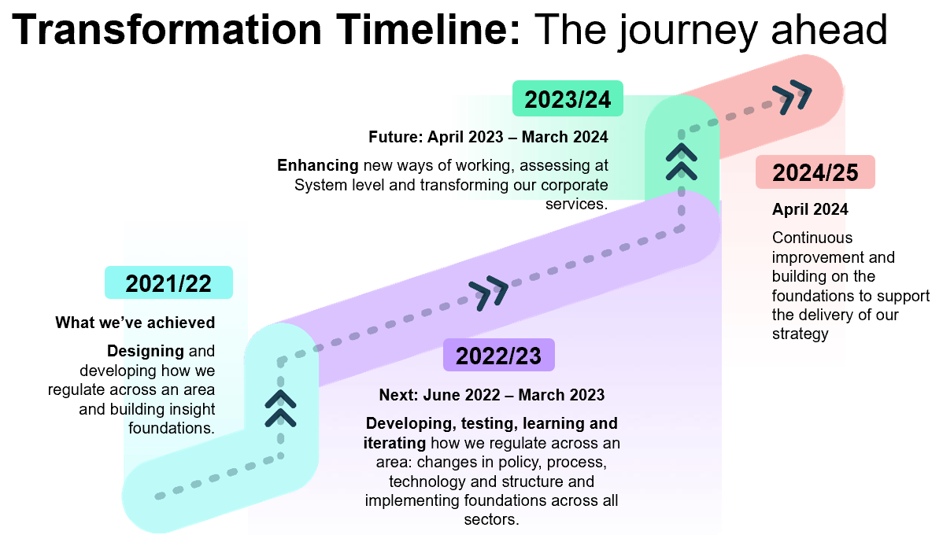

Our People Plan 2022-25 reflects the strategic people priorities and cultural ambitions of the organisation, which have evolved as a result of the large-scale transformation programme currently underway.

This People Plan has been developed to specifically focus on 3 areas of priority which link closely to the organisation’s strategy. It will adapt in its priorities and focus where needed to meet the requirements of the business as we move through our transformation. Our delivery plan will set out what colleagues can expect and will see over the next three years and our progress will be reported to our CQC Board twice a year via People Committee.

Your employee lifecycle

The employee lifecycle sets out your employment touchpoints within an organisation from a modern “best in class” people function. Our aim is to deliver through our People Plan, the shift to a trusted, confident and empowered organisational culture that ensures individual and team performance positively impacts people using health and care services.

Within each element of the employee lifecycle we aim to have our people at the heart of all our processes and engagement to build on our strong foundations, to develop our collective purpose and to cement ourselves as a high performing organisation. Creating an exceptional working experience that begins as colleagues join us, where they continue to receive investment and development throughout the employment cycle.

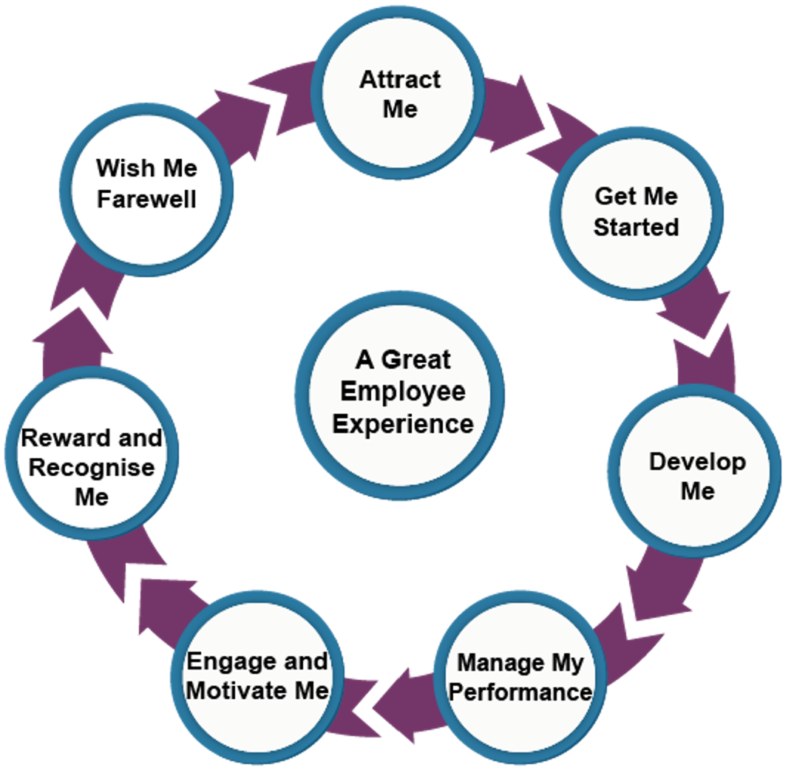

At the heart of our work our focus is:
- Attracting and recruiting the right colleagues using an innovative and progressive attraction and recruitment techniques.
- Providing an inclusive and welcoming induction programme.
- Supporting our colleagues both new to CQC and new to role with the right tools and guidance needed to progress well.
- Setting clear parameters for our people and leaders to manage performance with a focus on development and continuous feedback.
- Engaging in meaningful and timely dialogue with a view to these insights informing improvements.

- Recognising achievements and value our people’s contribution.
- Our leaving well programme highlights the positive experiences we want to continue, along with the areas where we can improve.

Areas of priority

Our purpose won’t change – but how we work will be different. Our priorities have been identified as the three components which will drive our people workforce strategy, deliver our transformation programme and enable everyone to perform at their best. Our new People Plan sets out a strategic vision for our workforce and how our people priorities will deliver our transformation from a people perspective, to ensure the services we deliver are timely, focussed and works in parallel with the changing needs of the business.

Throughout the next 3 years, we will continue to evaluate the needs of the business, ensuring that we attract the skills and knowledge needed to create the new infrastructure to enable our new ways of working. We will measure our progress and continue to implement improvements and replicate good practice.

We have a number of activities which are underway and will continue to develop and ensure these are focused and designed in line with our new ways of working.

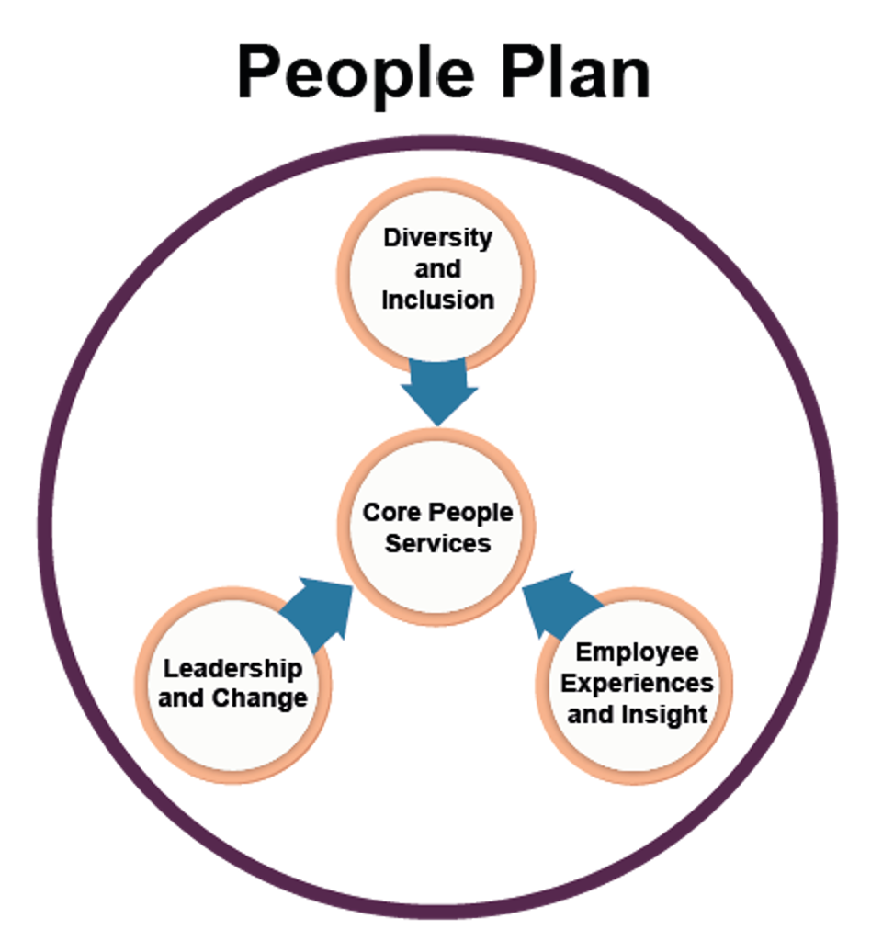

Core People Services

Our People function provides the organisation with the core service provision colleagues can expect from a HR function to deliver its corporate strategy and objectives and to enable a great employee experience. We intend to streamline our services by introducing modern, intuitive and automated people processes.
A new HR system will revolutionise our people processes and give us the ability to transform how we work; we want to work smarter, engage with our colleagues and encourage them to take responsibility for their own career development.
This system will be designed to support the processes and purpose of the organisation now and in the future, based on core capabilities that can flex and adapt to accommodate the changing needs of the business.
This system will be customer centric for both internal and external customers, accessible and easy to use. It will change how the organisation operates within people processes and build more accountability and capability.

Diversity and Inclusion
We understand the benefits of having diverse teams and the importance of having a truly inclusive culture, where teams can reach their potential without facing barriers. We understand the value in seeking out diverse views and the benefits this bring to the organisation. We want to build a sense of belonging and recognise and celebrate the behaviours that drive inclusion. Creating an environment where people are proud of who they are and see CQC as a place where they thrive and can make a difference.
- We will continue to review what we do and embed best practice and use benchmarking tools to evidence our progress.
- We will continue to develop our Inclusive recruitment toolkit to attract and onboard the best diverse talent, using inclusive advertising and monitor any adverse impact.
- Our talent management approach will identify and develop diverse talent and monitor equity/fairness of career progression and access to inclusive career pathways. Our Talent assessment and development programme will provide an objective assessment of talent identification, allowing people to build upon existing skills and experience and progress into other roles within CQC.
- We will shape our Workforce Race Equality Standard (WRES) and Workforce Disability Equality Standard (WDES) action plans to address the activities agreed with our Race Equality Network (REN) and Disability Equality Network (DEN).

People's Experiences and Insights

We will be clear on the composition and strength of our workforce, enabling leaders to make data driven workforce decisions. We will focus on connecting the full range of people data insights to create a great employee experience. As a data-led culture, we will use these insights from people systems, surveys and other feedback mechanisms and interactions with our colleagues to track and monitor progress and better improve people experiences.

- In line with the transformation programme and utilising technology, develop a skills matrix for everyone in the organisation that clearly identifies the essential skills each role requires in order to be successful. Once identified, ensure that individuals are matched to these skills requirement and that learning, and development programmes are available to address priority areas.
- Further develop our technological and data driven approach to learning and development to ensure that all colleagues can access and manage their learning as and when it is required.
- The implementation of a new recognition platform which enables peer to peer recognition will provide valuable insights and bring to life the desired behaviours to support the transformation.

- Our new pay progression scheme will underpin our transformation programme and enable us to deliver our strategy through recruiting, retaining and rewarding colleagues for their capabilities using a framework which will drive high performance
- We will continue to produce informative and relevant People data packs drawn from a range of people insights that inform our actions and decision making and are used to drive our improvements. These data packs will continue to inform our workforce resourcing and composition.

Leadership and Change
We will recognise all our people as leaders. This shift will emphasise our belief that everyone has a vital role to play in shaping the direction and culture of our organisation and that everyone has a critical contribution in helping us achieve our strategic aims. Our leaders will be confident and capable in their role working collectively towards our shared purpose and organisational strategy, provided with the tools, knowledge and skills needed to lead others and to overcome the changes and challenges of today and tomorrow.
- Deliver a new 2023-25 leadership development programme based on the principle that everyone at CQC is a leader, focused on the key skills for our future leadership ambition and aligned to our cultural drivers.
- Facilitate the development of Strategic Leadership Team (SLT) and Leadership Group events to support leadership skills development and our cultural direction.
- Deliver the Inclusive Leadership Programme to ensure that our under-represented colleagues gain access to high quality learning programmes which enable their career progression and ensure greater representation at all levels. We will continue to deliver and build the “Successful Manager” programme including the Change Management module for all line managers undergoing change.
- Our development offer for our leadership teams will include Strengths Deployment Inventory (SDI) development and those in first line management roles will have the resources needed to lead their teams.

- Coaching will be promoted to our Executive Leadership teams to support through change and our workplace coaching offer will be offered all colleagues up to Executive level 3.
- Ensure that we continue our move away from training to learning by ensuring that everyone has the opportunity to transfer new skills and knowledge back to the workplace and adapt as necessary to ensure performance improvement. Ensure that line managers have the skills to support this.

People Plan: Delivery plan
Area of priority | Key deliverables | Expected outcome | Executive Lead | Programme Lead | Timescales
Core People Services | The introduction of an HR system to revolutionise our people processes and transform how we work; this system will be designed to support the processes and purpose of the organisation now and in the future, based on core capabilities that can flex and adapt to accommodate the changing needs of the business. | Increased colleague engagement with our HR processes and an improved ESR self-service offer.  Improved reporting capability for diversity and inclusion.  Automation of currently manual and admin heavy processes including talent management and elements of the recruitment process.  Easily accessible ‘one stop shop’ for colleagues for a range of HR activities, processes, policies, recruitment and learning.  Increase the percentage of disabled colleagues agreeing that CQC has made appropriate reasonable adjustments to enable them to carry out their work. | Head of Resourcing | People Analytics and Insight Manager | Programme of work beginning again in August. April 2023 implementation
Diversity and Inclusion | We will continue to Develop our Inclusive recruitment toolkit to attract and onboard the best diverse talent using inclusive advertising and monitor any adverse impact. | Increased ability to attract and recruit diverse talent.  Confident, skilled and knowledgeable hiring managers and selection panels who understand their roles and responsibilities when it comes to diversity and inclusion resulting in candidates having a better experience. This will improve CQC’s reputation in the market as an inclusive employer.  Increase in the representation of disabled colleagues and Black and Minority Ethnic colleagues at Executive grades.  Increase the overall likelihood figure so that Black and Minority Ethnic colleagues are equally likely to be appointed from shortlisting compared to white colleagues.  Increase the percentage of disabled colleagues and Black and Minority Ethnic colleagues believing the CQC provides equal opportunities for career progression or promotion. | Head of Resourcing | Recruitment Manager | Continued development: October 2022  New updates ready to publish Q1 2023/24.
Diversity and Inclusion | Our talent management approach will identify and develop diverse talent and monitor equity/fairness of career progression and access to inclusive career pathways. Our Talent assessment and development programme will provide an objective assessment of talent identification, allowing people to build upon existing skills and experience and progress into other roles within CQC. | Talent management processes embedded across the organisation from our Executive colleagues and throughout the organisation.  Our apprenticeship strategy will maximise our levy spend and grow emerging talent to help close skills gaps.  Our talent strategy brings together the various early talent initiatives already in place including graduate scheme recruitments.  Our published career pathways for all areas of the business will provide colleagues with a route to their next role and understand what they need to do to get there. | Head of Resourcing | Talent Manager | In order of priority, benchmark current talent practices for each business area and begin to develop the approach for each area beginning with Operations. Other areas of priority – TDI and Technology. Q2 July onwards through to start Q4 January 2023.  Career pathways – to be delivered (for areas that are ready) in line with the new HR system April 2023  Apprenticeship and early talent strategies – by the end of March 2023
Diversity and Inclusion | We will reflect on our progress against our Diversity and Inclusion strategy ‘Our Inclusive Future 2020-2023’ to drive our remaining actions and consider our future areas of focus. |  | Head of Organisational Development | Diversity and Inclusion Manager | 2022 Q2 Regular rhythm of data reporting established  Q3 Review of strategy action plan  Q4 Developing our future strategy
Diversity and Inclusion | We will shape our Workforce Race Equality Standard (WRES) and Workforce Disability Equality Standard (WDES) action plans to address the activities agreed with our Race Equality Network (REN) and Disability Equality Network (DEN). | Decreases in the number of disabled and Black and Minority Ethnic colleagues reporting bullying and harassment.  Increases in the declaration rates for disability, ethnicity and sexual orientation.  Increase in the representation of disabled colleagues and Black and Minority Ethnic colleagues at Executive grades | Head of Organisational Development | Diversity and Inclusion Manager | Inclusive Leadership Pathway launches October 2022  Reverse Equality Mentoring will launch Q3 2022  Implementing a "Share and Declare" PowerBI dashboard and campaign Q2 2022  QI Project on “Improving recruitment outcomes for Black and Minority Ethnic candidates" is currently underway  QI Project on "Reasonable Adjustments" is currently underway
Employee experiences and insight | In line with the transformation programme and utilising technology, develop a skills development approach that clearly identifies the essential skills each role requires in order to be successful. Once identified ensure that individuals are matched to these skills requirement and that learning, and development programmes are available to address priority areas. | Individual and collective prioritised development plans focused on the needs of new roles arising from the transformation programme.  Revised induction programmes based on new role requirements. | Head of Academy | Academy Learning Consultants | Data & Insight - Completed  Operation Group – October 2022
Employee experiences and insight | Further develop our technological and data driven approach to learning and development to ensure that all colleagues are able to access and manage their learning as and when it is required. | Outcomes to be established within the procurement of the new HR system | Head of Academy | Academy Programme and Performance Manager | Aligned to the procurement of the new HR system
Employee experiences and insight | The implementation of a new recognition platform which enables peer to peer recognition will provide valuable insights and bring to life the desired behaviours to support the transformation. | A move to peer-to-peer recognition will enhance colleague’s feelings of being valued and will promote the behaviours and capabilities required to deliver our strategy.  A social recognition platform will provide us with a richer dataset to be able to understand the cultural principles of trust, empowerment and confidence | Head of Organisational Development | Organisational Development Manager | Implementation of peer-to-peer recognition platform Q4 (2022/23)
Employee experiences and insight | Our new pay progression scheme will underpin our transformation programme and enable us to deliver our strategy through recruiting, retaining and rewarding colleagues for their capabilities using a framework which will drive high performance. | Our CQC reward package will enable us to retain the skills and capability required to enable our transformation, our capability framework and approach to pay progression will be fit for purpose. | Head of Organisational Development | Senior HR Advisor | Business case will be submitted in July 2022  Phase 1 revalorisation of pay scales: October/November 2022  Phase 2 capability framework: January/March 2023
Employee experiences and insight | We will build our engagement approach, establishing our regular survey rhythm and connecting our resulting actions with the organisational Listening strategy. | To be confirmed | Head of Organisational Development | Organisational Development Manager | 2022 Q2 Agree future survey rhythm and establish working group  Focus groups aligned to culture and Diversity & Inclusion
Employee experiences and insight | We will continue to develop and produce informative and relevant People data packs drawn from a range of people insights that inform our actions and decision making and are used to drive our improvements. These data packs will continue to inform our workforce resourcing and composition | To be confirmed | Head of Resourcing | People Analytics and Insight Manager | To be confirmed
Leadership and change | We will build on our work establishing our cultural principles and drive activities to embed our ways of working across the organisation | To be confirmed | Heads of Organisational Development | Organisational Development Managers | 2022 Q2 Agreement of cultural measures  Q2 Review of organisational meeting habits and look at how we build best practice  Q2 Launch of leadership peer support groups  Q2/3 Work with Early Adopter teams to support ways of working and share learning with wider Operations  Q3 All Staff conference aligned to cultural principles
Leadership and change | Deliver the Inclusive Leadership Programme to ensure that our under-represented colleagues gain access to high quality learning programmes which enable their career progression and ensure greater representation at all levels. | Increased representation of Black and Minority Ethnic colleagues and those with a disability.  Increase in the representation of disabled colleagues and Black and Minority Ethnic colleagues at Executive grades.  Increase the overall likelihood figure so that Black and Minority Ethnic colleagues are equally likely to be appointed from shortlisting compared to white colleagues.  Increase the percentage of disabled colleagues and Black and Minority Ethnic colleagues believing the CQC provides equal opportunities for career progression or promotion. | Head of Academy | Academy Learning Consultant | Launch October 2022
Leadership and change | Deliver a new leadership development programme based on the principle that everyone at CQC is a leader, focused on the key skills for our future leadership ambition and aligned to our cultural drivers. | Individuals in the organisation will become more engaged and confident with the future leadership direction for CQC and their role within it.  Individual and team contributions are more clearly understood, thereby driving a high performing organisation. | Head of Organisational Development | Organisational Development Manager | Summer 2022-Spring 23 –  12 month procurement process due to value.  Spring 2023-25 programme delivery.
Leadership and change | We will continue to deliver and build the “Successful Manager” programme including the Change Management module for all line managers undertaking change. | Build the capability for managers to lead and support change within the organisation | Head of Academy | Academy Learning Consultant | Underway and aligned to transformation timelines
Leadership and change | Our offer for team development will be further defined and designed to enable line managers to have the ability to develop the effectiveness and wellbeing of their teams | Team development activity for teams going through transformation that builds awareness of personality and preferences for ways of working that increases the effectiveness and dynamics within the team. | Head of Academy | Academy Learning Consultant | Proposals to People Committee October/ November 2022
Leadership and change | Executive Coaching will be promoted to our Executive Leadership teams to support through change and our workplace coaching offer will be offered to all colleagues up to Executive level 3. | Coaching assignments that leads to increased individual effectiveness and performance. | Head of Academy | Academy Learning Consultant | Currently underway
Leadership and change | Ensure that we continue our move away from training to learning by ensuring that everyone can transfer new skills and knowledge back to the workplace and adapt as necessary to ensure performance improvement.  Ensure that line managers have the skills to support this. | The delivery of learning that is applied to the workplace and leads to individual and team performance increase | Head of Academy | Head of Academy  Commissioning and Quality Manager | Currently being explored as a cross directorate QI project with recommendations expected to be presented to the People Committee in Q4 2022/23

