The state of adult social care services
2014 to 2017
Data appendix
All ratings charts are from 5 May 2017 based on ratings published by CQC
Figure 1: Adult social care overall ratings

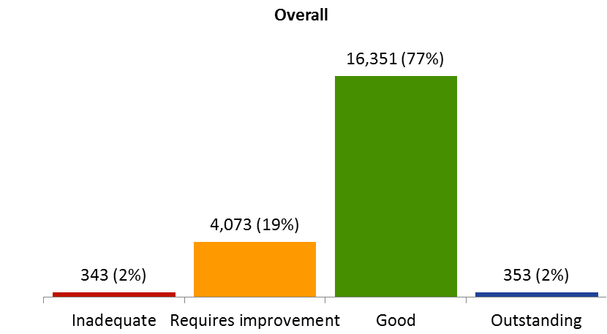

Figure 2: Overall adult social care ratings by region

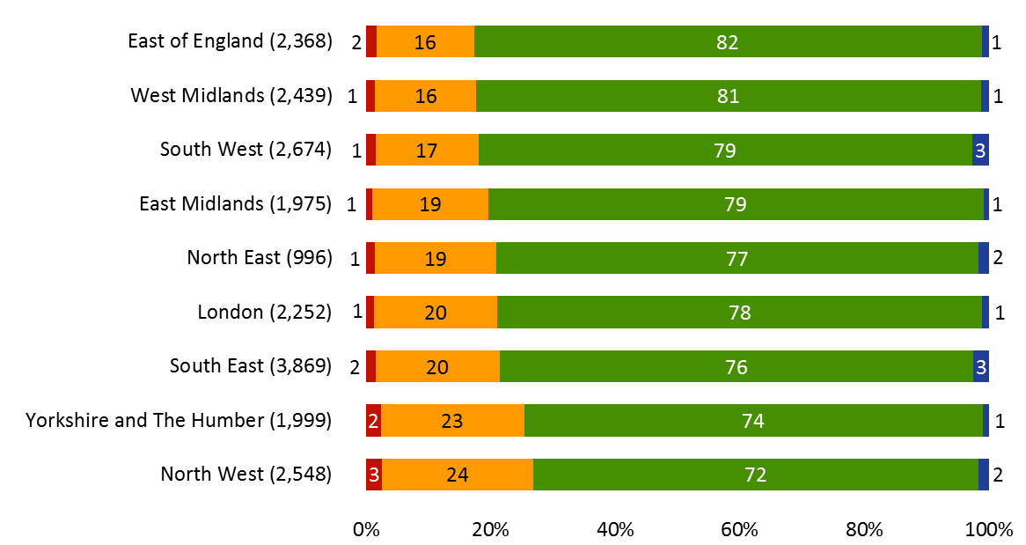
Figure 3: Adult social care ratings by local authority area

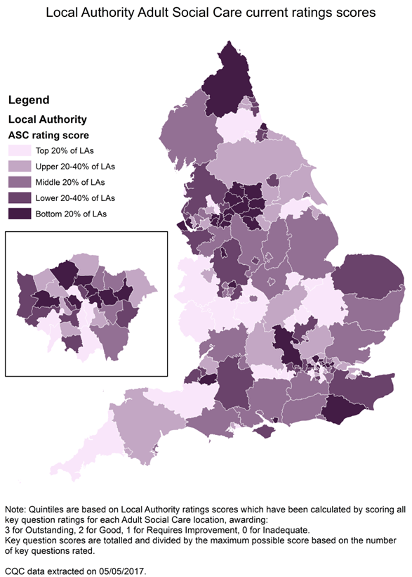
Figure 4: Nursing home, residential home and domiciliary care ratings by local authority area
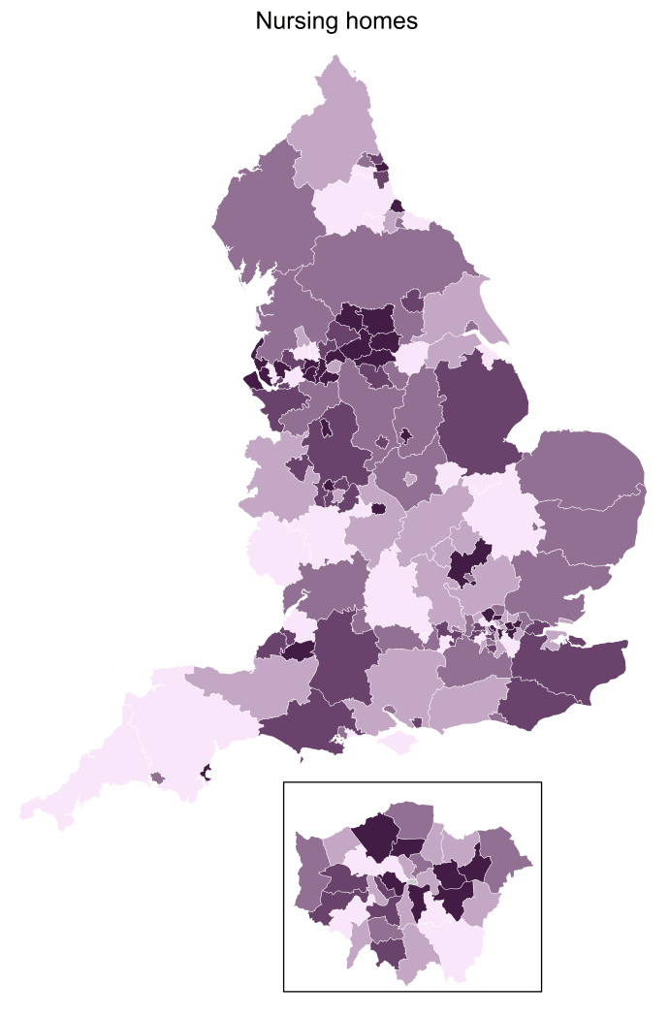

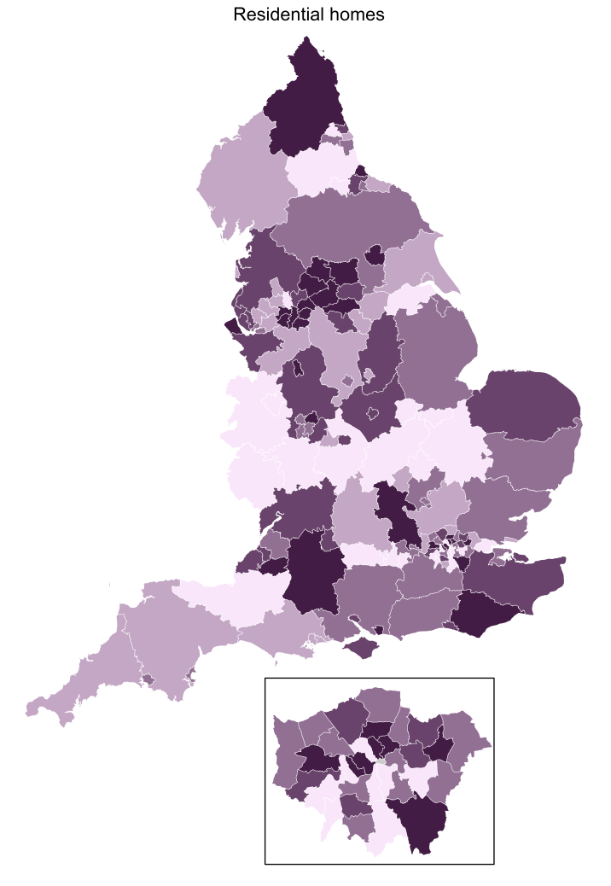
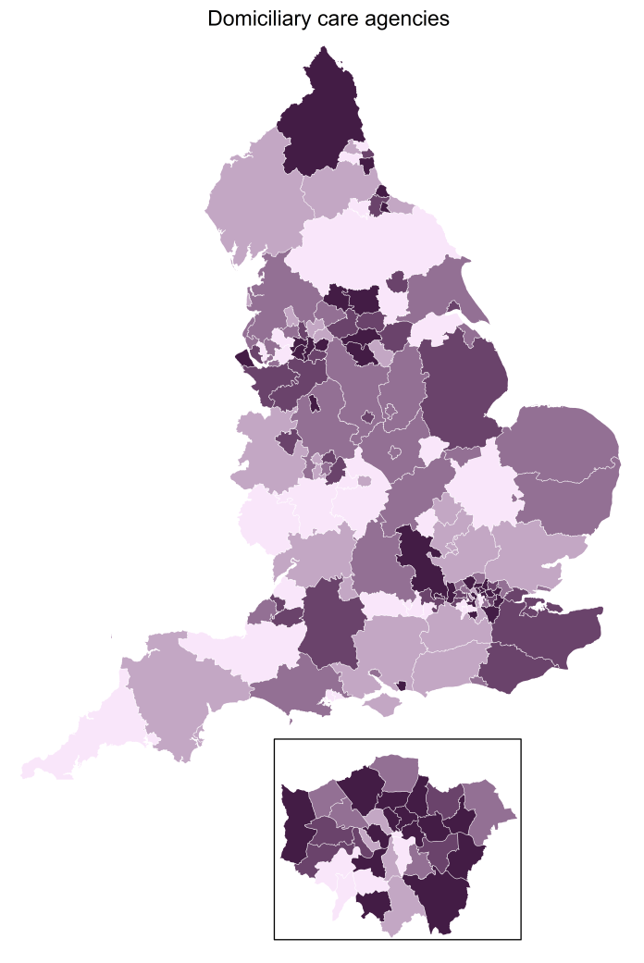
Figure 5: Adult social care ratings by key question

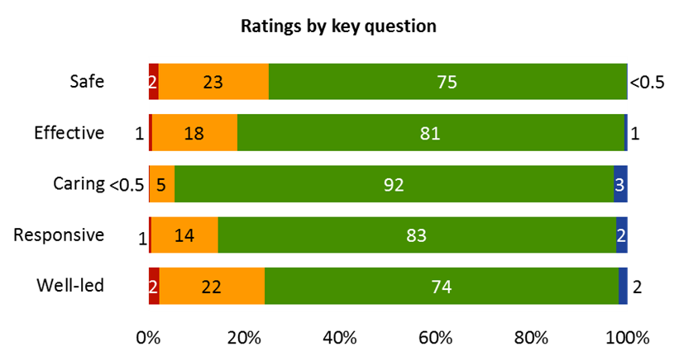

Figure 6: Adult social care market trends
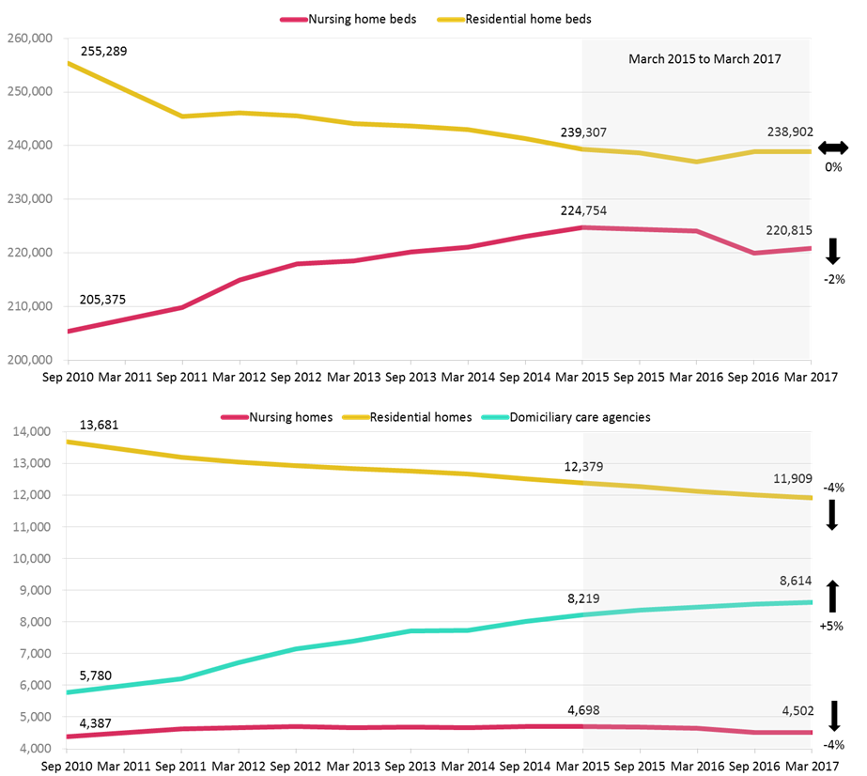
Figure 7: Current overall ratings by service type

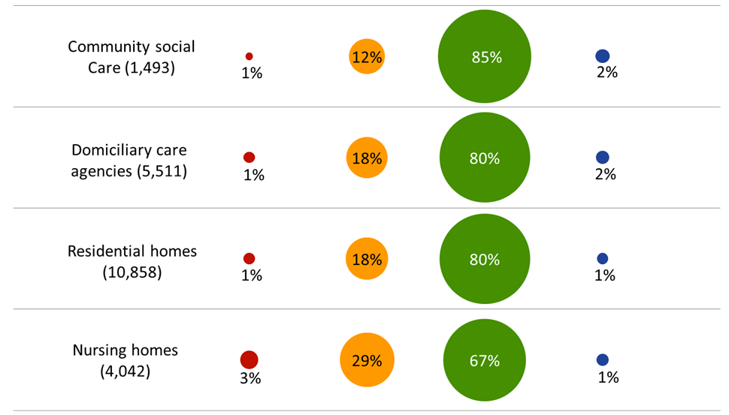
Figure 7a: Current key question ratings by service type
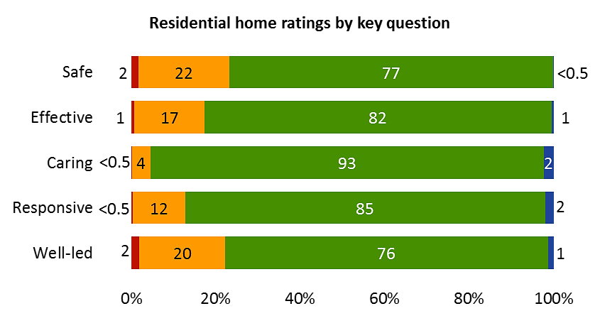
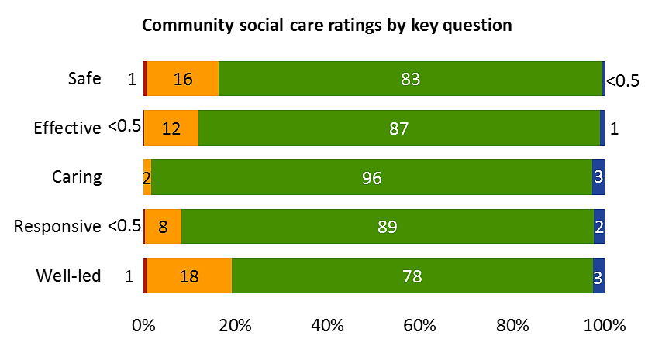
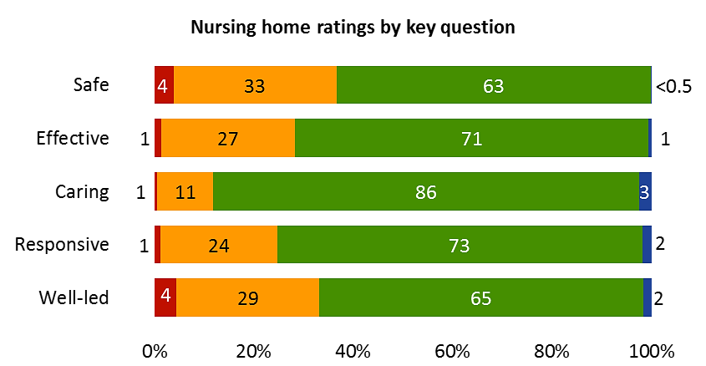

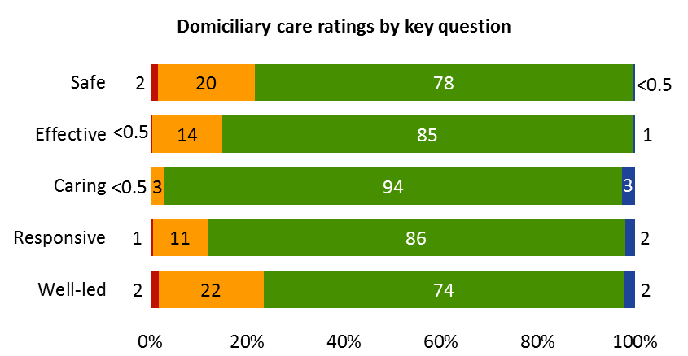

Figure 8: Current overall ratings by size and type of care home
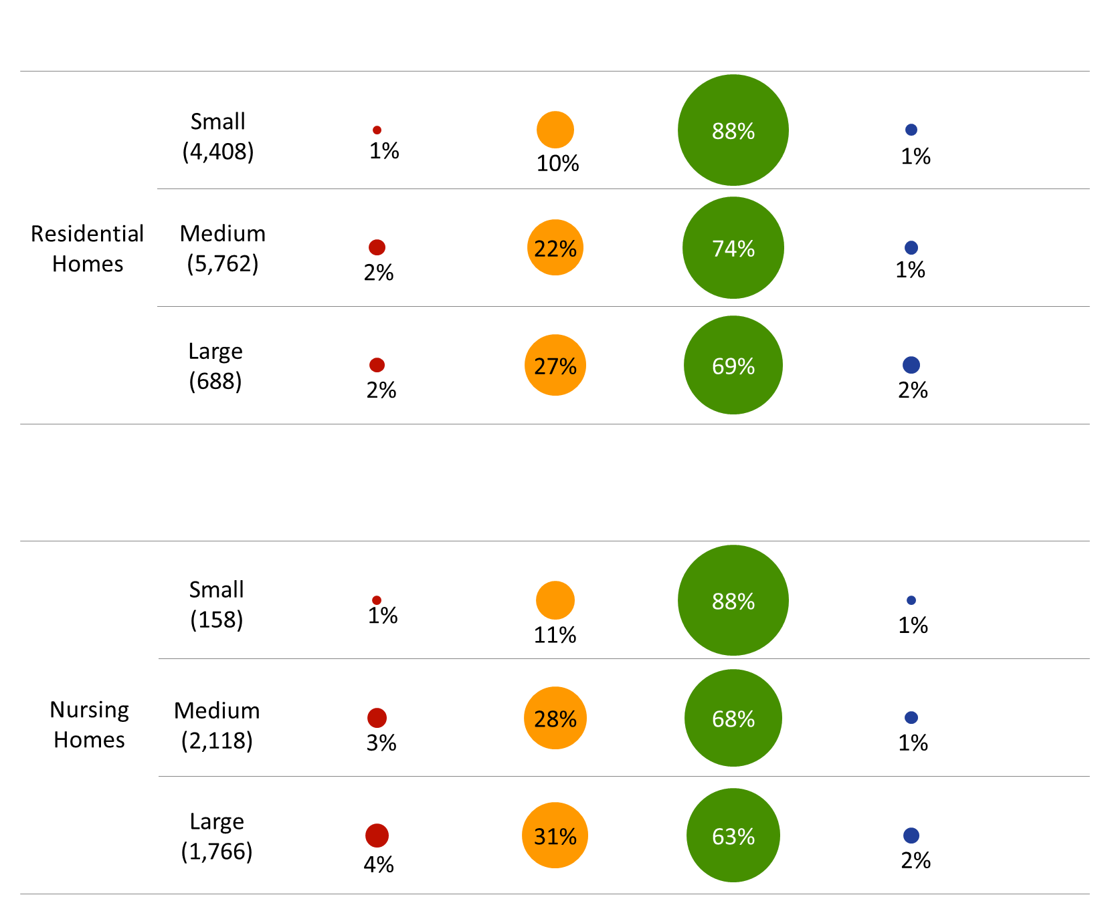
Figure 9: Current overall ratings by size of domiciliary care service

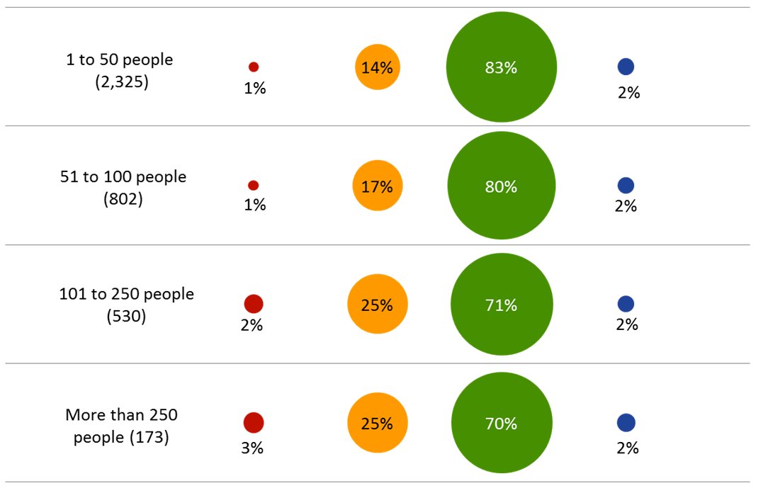
Figure 10: Current overall ratings by services with and without a learning disability specialism
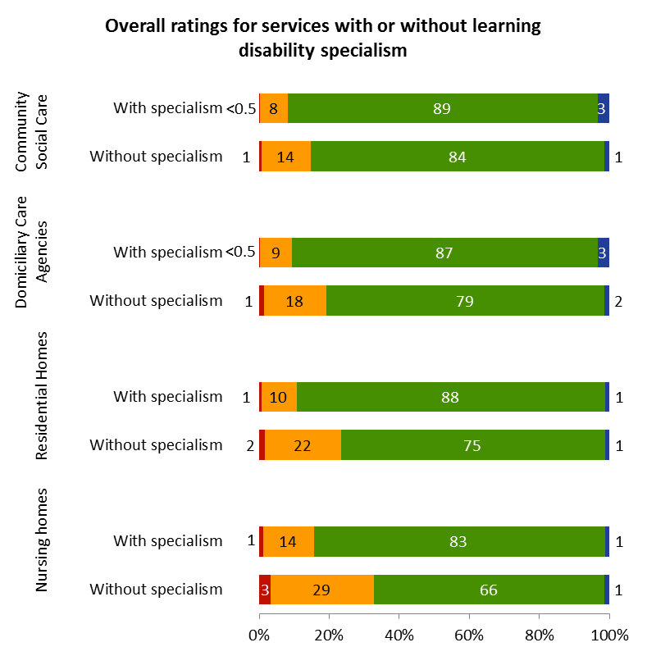
Figure 12: Shared Lives overall ratings

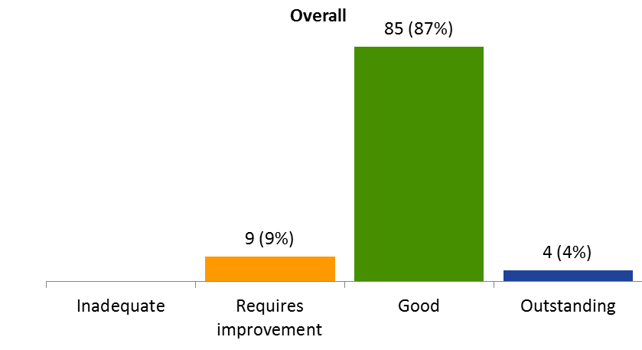

Figure 13: Enforcement actions against locations rated inadequate

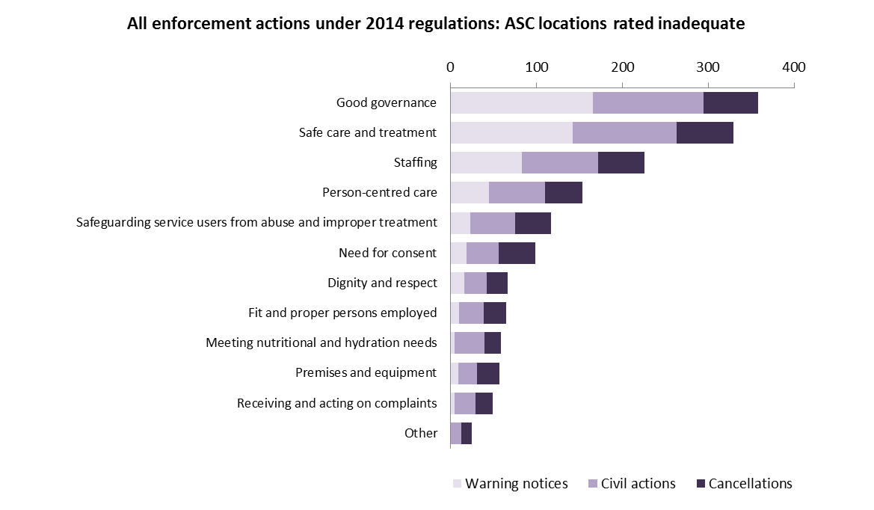

Figure 15: What has happened to locations first rated inadequate?

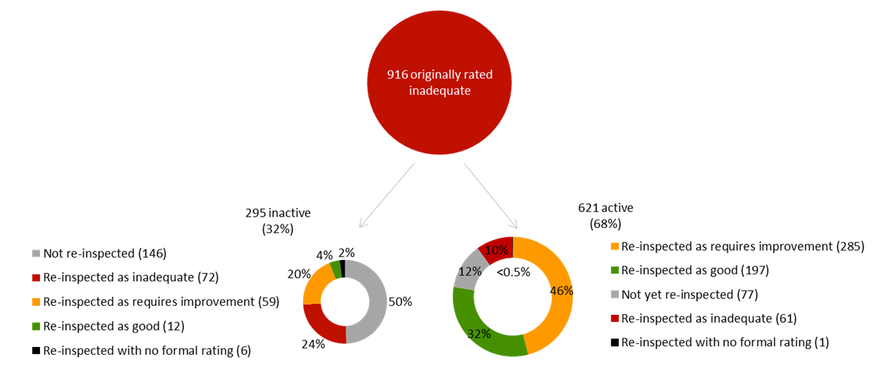

Figure 16: Re-inspection of inadequate services – all providers

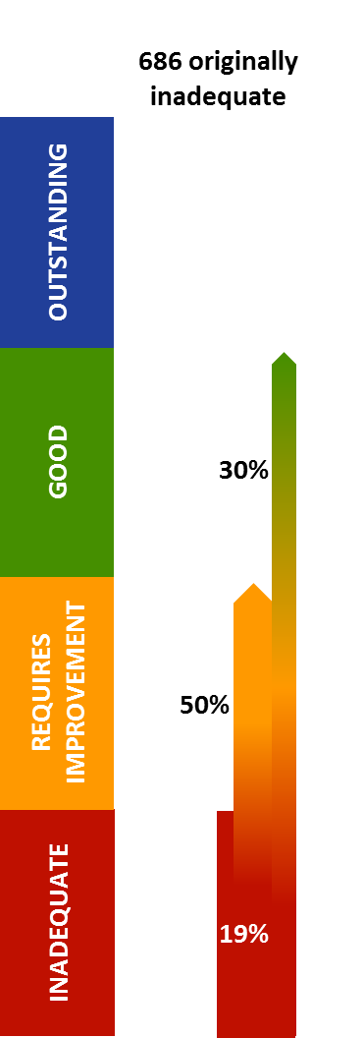
Figure 17: Re-inspection of inadequate services – corporate locations and non-corporate locations
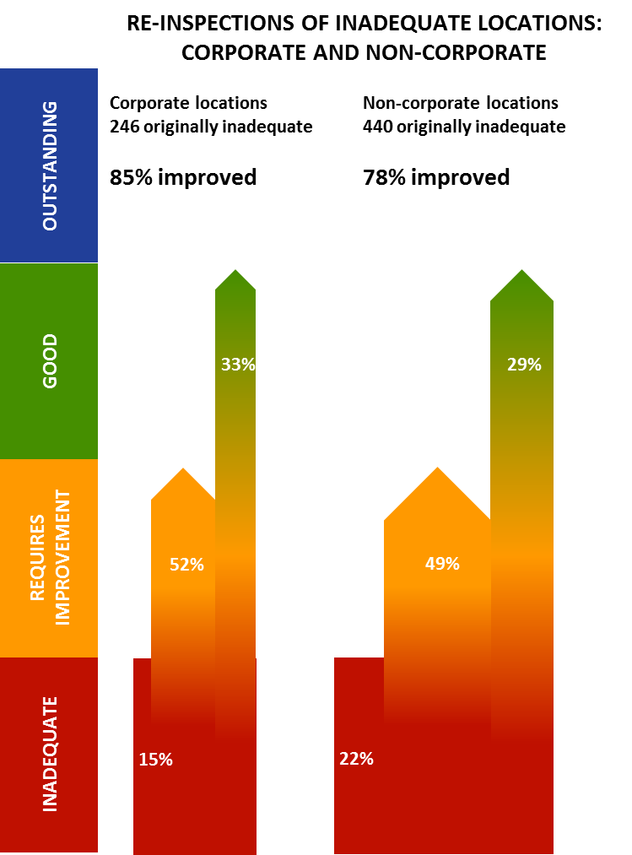
Figure 18: Re-inspection of requires improvement services
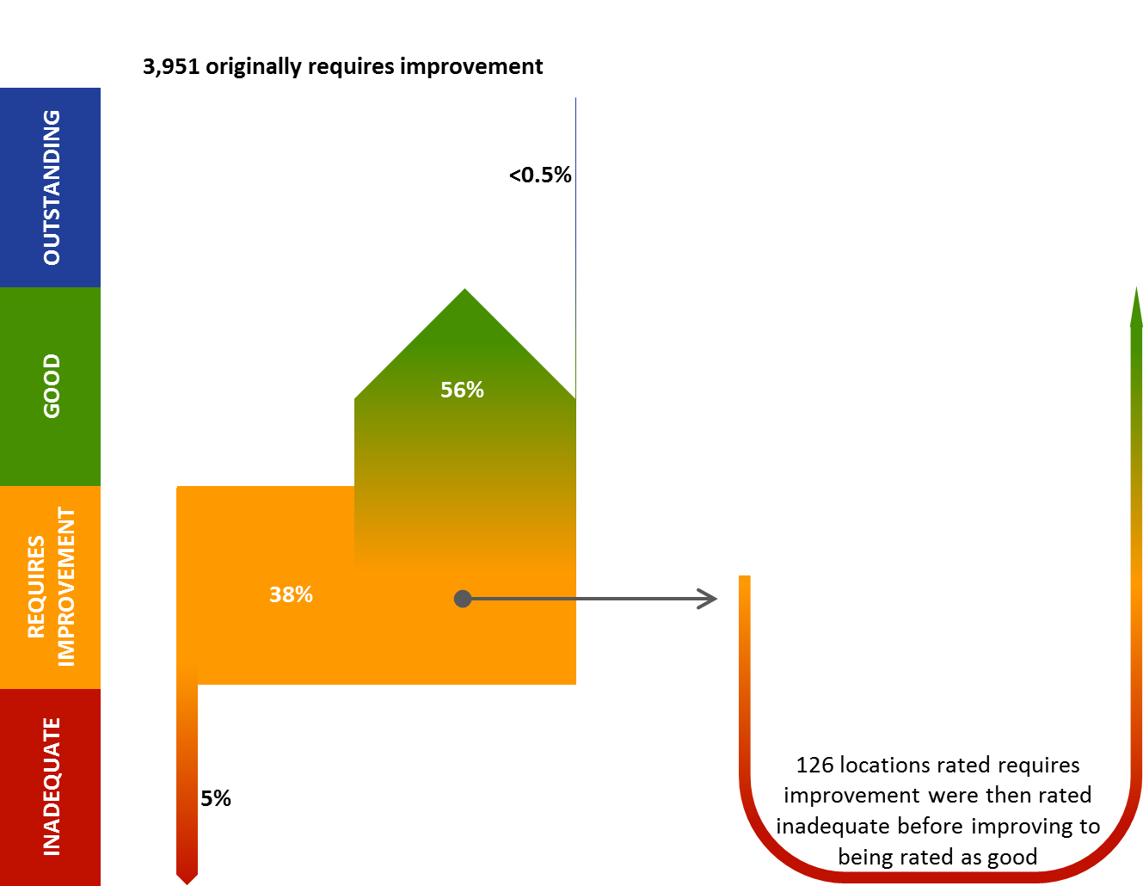
Figure 19: Re-inspection of good and outstanding services

