Independent analysis of responses:
Consultation on the Care Quality Commission’s new strategy
Consultation Report
06/05/2021

Client | Care Quality Commission
Title | Independent analysis of responses: Consultation on the Care Quality Commission’s new strategy
Dates | last published 06/05/2021  last revised 25/05/2021
Status | Final
Version | Version 1.0
Classification | Restricted External
Project Code | 11230-3
Authors | Doug Jefferson, Annie Milburn, Igor Augustynowicz, Jemima Martin
Quality Assurance by | Helen Ashley, Jessie Cunnett
Main point of contact | Eden Foley
Telephone | 07543223695
Email | eden.foley@traverse.ltd

If you would like a large text
version of this document, please
contact us.
Not for disclosure to third parties – The Freedom of Information Act 2000
This document contains commercially sensitive and confidential information.
The contents of this document should not be copied, reproduced or disclosed to any third party without prior written permission from a Director at Traverse.

t. 0207 239 7800 | p. 2 Angel Square, London, EC1V 1NY
e. info@traverse.ltd | w. www.traverse.ltd

Contents

Executive summary 4
Introduction and methodology 8
1.1. Background 8
1.2. Respondent categories 11
2. People and communities 13
2.1. Responses to question 1a 13
2.2. Comments on people and communities 14
3. Smarter regulation 24
3.1. Responses to question 2a 24
3.2. Comments on smarter regulation 25
4. Safety through learning 37
4.1. Responses to question 3a 37
4.2. Comments on safety through learning 38
5. Accelerating improvement 45
5.1. Responses to question 4a 45
5.2. Comments on accelerating improvement 46
6. Core ambitions 53
Assessing how well health and care services work as a local system 53
6.1. Responses to question 5a 53
6.2. Comments on assessing how well health and care services work as a local system 55
Tackling inequalities 60
6.3. Responses to question 6a 60
6.4. Comments on tackling inequalities 61
7. Equality Impact Assessment 66
7.1. Responses to the draft equality and human rights impact assessment 66
8. Other comments about the consultation 71
8.1. General comments on CQC 71
8.2. Comments on the consultation process 71
Appendix A 72

Executive summary
The Care Quality Commission (CQC) is developing a new five year strategy, to run from 2021 – 2026. They consulted on this between the 7th January 2021 and the 4th March 2021.The strategy is built around four key themes:
- People and communities;
- Smarter regulation;
- Safety through learning; and
- Accelerating improvement.
Running throughout these four themes are two core ambitions: assessing how well health and care services work as a local system, and looking at how services and local systems are acting to reduce inequalities in health and care systems.
Overall the consultation received 790 responses from organisations, individuals and focus group events. This report provides a summary of the views of respondents to the consultation.
Overall views and common points across themes
Support for the strategy
There is a high level of support with many respondents welcoming aspects related to the new five year strategy. This was reflected in both the closed questions, which asked respondents to what extent they supported the ambitions set out in the key themes, and in the open questions where respondents were invited to add their own comments and reasons why they held this particular view.
Data and wider collaboration
There is support for the use of smart data enabling CQC to use artificial intelligence and innovative analysis methods. There is also support for aligning data systems so that more information on the performance of different service providers is accessible to those looking for this information. Respondents comment that ensuring more information is up to date and accessible to all will help keep people receiving care informed, and allow them to choose the care that is most appropriate for them. Respondents also feel that the Covid-19 pandemic has shown how remote solutions to collaboration work effectively and in a way that is time-efficient for care-services. They think this strategy helps to further build on that.
Respondents welcome the focus on encouraging closer collaboration between CQC and service providers. They feel closer collaboration with service providers will help to identify improvements to practices and improve care. They also welcome the proposal to share good practice and become a source of advice for service providers, something that represents a positive development and should improve the way care is delivered.

Lack of detail
Across the four key themes, respondents express concern about a lack of detail provided in the strategy document. Many respondents feel that because of this they are unable to comment in detail, and whilst the strategy sounds positive and says the right things they don’t understand what CQC will do to change in practice.
Many respondents also question how CQC will be able to put into practice what it is proposing in the new strategy. This is particularly common when respondents comment on how CQC will ensure it captures a full range of views from people who use services. Several respondents feel that ensuring all voices are heard is a challenge when some groups can find it harder to speak up about their experience of care.
Funding and influence
Many respondents who support the overall aims of the strategy, express concern that some of what CQC is proposing is not within its control. Respondents feel that what really drives health and social care is how service providers are funded and comment that without adequate funding, service providers will not be able to act in a way that improves health and social care, regardless of how CQC chooses to regulate the sector.
Some respondents feel the strategy implies CQC will demand more of service providers that are already struggling to deliver their core activities.
Physical inspections
Respondents express concern that an over-reliance on smart data may lead to a culture where physical inspections are minimised. They suggest this could lead to a situation where issues could be missed, and as such, emphasise the need to continue visiting sites to observe care in practice. Concerns about a lack of physical inspections include:
- potentially excluding the views and experiences of people who are not comfortable using online forms;
- not speaking directly with people who deliver care services;
- missing crucial safety incidents that are not shown in data submitted to CQC; and
- not identifying positive changes that can be shared across service providers.
People and communities
Across the people and communities theme there is a high level of support for the strategy and, in particular, broad support for people being at the centre of the way health and social care is regulated. Respondents feel this reflects wider trends in health and social care with pathways focusing on a person’s journey through health and care services.

Whilst respondents were supportive of the ambition expressed in the strategy, they raise questions about how feedback from people who use services would be obtained. There is concern that some people will be very vocal and proactive at providing feedback to CQC, questioning if this feedback will all be fair. Some respondents feel the challenge will be in ensuring that all people who use services are able to speak up about the level of care they receive.
Smarter regulation
There is a high level of support for CQC’s ambition to adopt a more targeted and dynamic approach. In particular, respondents support ensuring ratings are current and able to be updated when a service changes. Respondents also comment favourably on targeting when services need to be visited so CQC can respond directly when identifying if a service provider is performing poorly.
Respondents do, however, feel that CQC needs to ensure that this approach does not lead to fewer site inspections as they feel this is an important component of regulating the quality of health and social care. They also question how different data systems will be aligned and what methods CQC will adopt to ensure the data received is reliable. This is a common concern amongst providers / commissioners.
Safety through learning
Respondents express high levels of support for CQC focusing on safety issues. In particular, respondents feel that focusing on the whole organisational culture of a service provider is important to ensure that safe practices are instilled throughout its services.
Whilst supportive of the overall aims, respondents question how CQC will implement this change. This includes questioning how CQC will build expertise within services and support service providers to provide safe care. They also question how CQC will share examples of good safety across health and social care sectors and systems.
Accelerating improvement
Respondents support CQC developing collaborative relationships with service providers and offering them guidance and support. They welcome CQC moving towards working with providers rather than being seen solely as a body identifying faults.
However, respondents express some concern about how this role would fit into CQC’s remit as a regulator. They feel that it could potentially undermine the regulation of health and social care if CQC is trying to adopt a supportive role alongside a regulatory role.

Assessing how health and social care work as a local system
Respondents express support for CQC assessing how health and social care work as a local system. They feel that moving towards a more collaborative approach will help to improve outcomes. They feel this will help to promote collaboration between service providers and throughout the health and social care system. They also suggest this reflects that health and social care services are not delivered in isolation and that it is important for CQC to recognise this in the way it regulates health and social care.
Whilst the majority of respondents express support, some respondents question aspects of how CQC will be able to put this into practice, in particular how this relates to the current remit of CQC. There is concern that CQC can only look at how services are delivered once they are commissioned and that it is important for CQC to assess how health and social care services perform within the practical constraints related to funding and resources.
Reducing inequalities
Respondents are generally supportive of the ambition to reduce the level of inequalities in the way people receive care and think this is an important consideration. They feel that this is an issue that has only been heightened by the Covid-19 pandemic.
However, respondents feel that CQC as a regulator of health and social care has limited influence to make changes to such a large and complex issue. Respondents comment that inequalities stem from wider societal influences and therefore question how much of an impact CQC, commissioners and service providers could have. Respondents also comment on the need to be mindful of the impact the strategy could have on inequalities in healthcare. In particular, they mention those with learning disabilities and those who may not have access to digital tools, who could find it harder to comment on health and social care services if online data is extensively used.

Introduction and methodology
  - Background
The Care Quality Commission (CQC) is currently in the process of developing a new five year strategy, to run from 2021 – 2026. As part of this, CQC began engaging in October 2019 and has undertaken a series of engagement projects to get feedback and input into the new five year strategy. This report covers the most recent phase of activity, where CQC held an open, formal public consultation on its proposed five year strategy. This opened on the 7th January 2021 and closed on the 4th March 2021.The strategy is built around four key themes:
- People and communities;
- Smarter regulation;
- Safety through learning; and
- Accelerating improvement.
Running throughout these four themes are two core ambitions: assessing how well health and care services work as a local system, and looking at how services and local systems are acting to reduce inequalities.
CQC also produced a draft Equality and Human Rights impact assessment, and asked for respondents’ views on the opportunities and risks to improving equality and human rights detailed in the draft impact assessment.
This report summarises the responses, from the public and a wide range of organisations, to the consultation on these proposals.
    - Consultation process
CQC provided a webform for respondents to submit their responses to the consultation as well as a dedicated email address allowing for responses in different formats. A full copy of the webform questionnaire is included for reference in Appendix A.
Due to the COVID-19 pandemic, CQC was unable to hold focus groups in person during the consultation period. Despite this CQC proactively engaged with stakeholders across all audience groups, raising awareness of its proposed future direction and inviting all stakeholders to share their views through bespoke engagement events. These events included:
- hosting six expert by experience events, inviting active users of health and social care services to feedback on their proposals, focusing on the people and communities theme;
- hosting three focus groups targeted at members of the public who are most likely to receive poor care, as well as a series of one-to-one interviews ensuring seldom heard communities were represented; and
- a roundtable event gathering safety experts from an array of industries to explore the safety through learning theme in greater detail.
As well as encouraging individual attendees at these online events to respond directly to the consultation, summary notes from these activities were also submitted for analysis.
The collection of responses was managed by CQC. The analysis of responses, of which this report is the output, was conducted by Traverse. Traverse is an independent company which specialises in qualitative analysis and supporting organisations to effectively engage and then respond to feedback received.
To support the analysis of responses a team of analysts used a bespoke database to collate all responses together and then allow the responses to be coded at a sentence level. The team created a coding framework which was used to group similar topics and themes together. This coding framework used plain text codes, each of which corresponded to a different issue, and analysts were encouraged to apply as many codes as necessary to a response to ensure that all the appropriate issues had been captured.
Senior analysts regularly reviewed the coding framework, adding new codes where appropriate and revising the coding framework to ensure similar ideas and themes were captured together. These have been summarised and reported on below.
    - Report structure
The structure of this summary report follows the themes in the consultation document, The world of health and social care is changing. So are we. In each chapter of this report comments are broken down into sub-sections covering supportive comments, concerns, and suggestions. The chapters are:
- Chapter 2 - People and communities;
- Chapter 3 - Smarter regulation;
- Chapter 4 - Safety through learning
- Chapter 5 - Accelerating improvement;
- Chapter 6 - Core ambitions; and
- Chapter 7 - Equality impact assessment
Respondents also made comments about topics such as the overall role of CQC, the consultation process, and topics that were outside the scope of this consultation. All these other comments are discussed in Chapter 8.
    - Reading the report
The purpose of this report is to provide a summary of respondents’ feedback on the consultation proposals, allowing the reader to obtain an overview of their views.
As with any consultation of this kind, it is important to remember that the findings are not necessarily representative of the views held by a wider population and do not constitute a representative sample. Rather, the consultation was open to anyone who chose to participate.
Another consideration to remember is that whilst responses were sought on particular topics, respondents often repeat the same statements in answer to each question. These responses have been reported on in the theme that they are related to.
Respondents raise issues that they feel are consistent throughout the strategy, making the point in relation to more than one question or theme. Readers should therefore note that some of the cross-cutting themes highlighted in the executive summary are included in each chapter because respondents raise an issue in response to more than one theme.
It is common in consultation responses that respondents provide greater detail or variety in expressing their concerns than they do when expressing their support. Readers should therefore note that the relative lengths of sections of this report (e.g. “supportive comments” compared to “concerns and challenges”) are not necessarily a reflection of the balance of opinion.
As well as receiving responses from individuals, CQC arranged some focus groups and the notes from these discussions were then submitted to the consultation. Also, some responses were received where organisations had arranged meetings with various individuals within their organisation to discuss the strategy. We count these as one response therefore readers should note that where we use quantifiers such as a few respondents or a small number of respondents, this may include the views of organisations representing many members.
We report on all comments to ensure all views are considered. However, to give the reader a sense of how many respondents raised similar issues in their responses, quantifiers are used:
- A small number – 1-10
- A few – 11-25
- Some – 26-50
- Several – 51-100
- Many – 101-400
- Most – more than 400
As part of the consultation, respondents were asked several questions about their relationship to the health and social care sector to help identify different groups of stakeholders. This report summarises comments received from across all stakeholder groups into themes. However, where there is a clear difference in the types of comments made by different stakeholders, this is discussed in the report.
We have included quotes to illustrate the points that have been made. These are reproduced verbatim. We have not named individuals or organisations who have been quoted, however we have noted their sector.

  - Respondent categories
In total the consultation received 790 responses. Table 1 shows a breakdown of the channel through which responses were received.
Response channel | Number of responses
Online response form | 611
Letters and emails | 114
Notes from engagement events | 65
Total | 790
Table 1: Number of responses received via each channel
Table 2 shows a breakdown of responses to each of the open questions. It also shows the number of responses received via letter / email or in another question that relate to that theme.
Question / theme | Number of responses via the question in the online form | Number of responses to this theme via letter / email or in another question
Question 1b | 515 | 138
Question 2b | 494 | 133
Question 3b | 472 | 114
Question 4b | 453 | 95
Question 5b | 418 | 81
Question 6b | 411 | 166
Question 7b | 364 | 17
Table 2: Responses to each open question by response channel

CQC identified four stakeholder categories based on the information respondents provided through the response form or based on criteria identified by CQC. Table 3 shows a breakdown of the responses received from each stakeholder category.
Respondent category | Number of responses
Patient/public/voluntary and community sector | 213
Provider/commissioner | 398
CQC employee* | 65
Other stakeholder** | 114
Total | 790
Table 3: Number of responses received from each stakeholder category
*Some of these responses were from CQC teams, rather than individuals
**Other stakeholder category includes: parliamentarian / councillor, regulator or arm’s length body, student / researcher, trade body or membership organisation.
- People and communities
This chapter sets out the responses to the people and communities theme. Respondents using the consultation response form were asked one closed question and one open question at the end of this section:
- To what extent do you support the ambitions set out within this theme? [5 options were provided to choose from]
- Please give more details to explain why you chose this answer.
This chapter features the views of all respondents who answered the closed question and all comments from respondents on the issues raised in the open question, whether they responded using a response form, or through another response channel.
  - Responses to question 1a
Question 1a was answered by 618 respondents. This does not include any respondents who did not answer using a response form. Figure 1 below displays the overall responses to this question. Figure 2 displays a breakdown by stakeholder type.

Figure 1: Bar chart displaying responses to question 1a
The vast majority of respondents who answer question 1a (80%) either fully or mostly support the ambitions set out in the people and communities theme. Only 21 of the 618 respondents do not support the ambitions at all.

Figure 2: Bar chart displaying responses to question 1a by stakeholder type
The majority of all stakeholder types either mostly or fully support the ambitions set out within the people and communities theme.
  - Comments on people and communities
Question 1b was answered by 515 respondents, however this section also includes comments from 138 respondents who commented on issues about the theme in email or letter format rather than directly answering the question via the response form.
    - Supportive comments
Many respondents express support for the general ambitions outlined in the strategy in broad terms. Most of these respondents make general comments such as “fully support” or “I agree with the sentiment” without offering further clarification.
However, some of these respondents express support for the ambitions but follow this with concerns or questions about how the strategy will be implemented. Where respondents go into detail, their concerns are discussed in 2.2.2.
Empowering people
Many respondents express support for the proposed strategy by commenting on the importance of placing people who use services at the centre of conversations about their care. Patient/ public and voluntary and community sector organisations, and providers and commissioners were particularly supportive as they feel that it is important to view health and social care policy and practice from the perspective of the individuals who are using the services. They feel putting people who use services at the centre is crucial in providing tailored care that can appropriately support individual needs.
“Giving a promise that people's experiences will be listened to, check and attended to in a timely manner. This will improve health care in communities.”
(Other stakeholder)
Some respondents comment that this represents a change from how CQC has sought feedback previously and how health and social care services have been regulated in the past. They comment that it had often felt like providing feedback was more of a box-ticking exercise and welcome this change.
Some respondents comment positively on the proposals to increase public awareness of CQC. Patient/public and voluntary sector respondents in particular comment on the current lack of awareness of CQC as a regulator. They feel it is important for more people to be made aware of the role of CQC, and to be prompted to use information from CQC when making choices about care.
Providers and commissioners who support the emphasis on raising public awareness of CQC often comment that there is a lot of misunderstanding about the role of CQC and that this is a welcome focus in the strategy.
Listening and responding
Several respondents support the strategy because of the focus it places on getting feedback on the entire journey for a person who uses services, including how different service providers interact with each other. Respondents feel this will give a more in-depth view of care and will also help to identify persistent issues in a system. For example, if there is a gap between referral for services and a service being available in a local area, leaving some service users isolated.
Some respondents express support for the focus CQC places on working with other organisations, including other regulators and commissioners. Some of these respondents feel this will aid CQC in collating feedback from a greater number of sources and establish a clearer perspective on the level of care provided. Other respondents feel that because CQC will be working more closely with commissioners, it will encourage greater collaboration and ensure all relevant parties in health and social care are aligned.
Several respondents express support for the emphasis CQC places on adapting the way feedback is received so that feedback can be collected by various partner organisations.
Some respondents comment positively on the proposal to provide more opportunities to give feedback through different channels. Some of these respondents feel the focus on outcomes will also make this feedback more meaningful and allow change to follow as a result. They also feel that increased feedback opportunities will help focus more on the needs of marginalised groups.
Transparency
In a similar way, several respondents express support for the increased transparency they feel will follow as a result of CQC showing how it used feedback and acted on it. They feel this will give the public a clearer picture of what good care looks like and what they can expect from a service. A small number of respondents explicitly comment on the commitment to making inspection reports more accessible and up to date will help inform people who use services. They also feel this will help inform people about the levels of care they should expect.
Some respondents comment on the need to ensure that all voices of those who use services are captured in feedback and, whilst welcoming the broad theme, feel CQC needs to undertake further work to ensure that this is put into practice. These concerns are explored further in section 2.2.2.
Prioritising people and communities
Some respondents express support for the focus within the strategy on people and communities. Some of these respondents comment positively on the aim of CQC to work more closely with local communities. These respondents often suggest that as care is delivered in a local setting, CQC working to understand the local context is an important development.
Other respondents comment on the importance of holding local care systems accountable for the care provided. They feel that by focusing on assessing local care systems, CQC will ensure that better local health and social care services are delivered.
    - Concerns and challenges
Some respondents express general concern about the people and communities theme. These comments tend to be non-specific such as statements that the theme needs “careful consideration”. Where respondents go into more detail about the specific nature of their concerns, it is discussed below.
General
Several respondents feel that the strategy lacks detail making it unclear what CQC is actually proposing to do or how it will implement change. Most of these respondents comment in general terms about needing “more clarification” on the practical steps involved or that it is “not clear how” this will be done. Some respondents comment on particular areas where they feel the strategy needs to add more detail. These include:
- how ratings will be applied across services;
- how services will respond to community needs; and
- how young people will have their voices considered.
A few respondents believe the strategy will not do enough to identify failures and inadequacies in people’s care. They state that taking action against service providers will not necessarily address the root of the problem. They feel service providers need more support to ensure health and social care services improve. Therefore, the strategy needs to go further to ensure quality people’s care.
A small number of respondents question whether this theme of the strategy is necessary as there is an existing widespread trend in promoting person-centred care.
Other concerns a small number of respondents comment on include:
- communities being prejudiced against certain groups of people who receive services; and
- that the strategy is too wide-ranging to be practically realised.
Assessments
Several respondents express concern about the level of expectation that service users may have and how this will be managed when CQC assesses their feedback. Respondents suggest that many service users may have unrealistic expectations about the level of care they should receive and worry that as a result, service providers will be judged against an unrealistic standard of care.
A common concern amongst some of these respondents is that in both health and social care there is significant financial pressure and that it should be understood that the level of care that can be provided is potentially limited due to funding. This concern is particularly prominent amongst commissioners and providers.
Some respondents express concern about how CQC will assess service provision in a local area when this is dependent on what services have been commissioned. Whilst they recognise CQC will aim to work with commissioning groups, they feel that inspections and assessments will identify issues with local systems of care that are beyond the scope of individual providers to address. They feel the strategy does not deal with this issue and that attention needs to be focused on how services are commissioned.
A few respondents fear that assessments and CQC ratings will be dependent on other services in the area. They worry that as a result of trying to assess local care systems, one service within the system may be unfairly rated as a result of underperformance by another service.

“If pockets of community provision are excellent and others are poor it will be demotivating and inappropriate if an area is highlighted as 'needs improvement' or given some other negative comment from CQC. This will also potentially drive people away from using services in that area and also may discourage healthcare professionals from working there further destabilising the healthcare provision”
(Patient / public / voluntary and community sector)
A few respondents express concern that the proposed strategy will result in increased scrutiny and more burdensome regulation for services. Providers and commissioners worry about the stresses on the broader health and social care system and that an increase in regulation would cause additional stress.
A few respondents, particularly those from patient/public and voluntary and community sector organisations, express concern that the strategy intends to reduce the number of on-site inspections. These respondents feel that in-person inspections are key to the regulatory process and fear that fewer inspections will result in CQC missing poor quality care. They also argue that site inspections will help ensure all voices of those who use services are heard.
A small number of respondents express concern that the viewpoint of those who provide services has not been advocated for in the strategy. They argue that the staff have critical insights that should not be overlooked. Crucially, the impacts of high staff turnover and low pay have significant impacts on care quality.
A small number of respondents feel the strategy should consider local needs and community demographics. They worry that the strategy places too much emphasis on feedback and outcomes, and not enough on the impact of local health inequalities and deprivation on the quality of care.
A small number of respondents worry that CQC’s approach to regulation is ineffective and that there is too much variability in the way in which risks have been identified and dealt with.
A small number of respondents express other concerns about how assessments will be delivered as a result of this strategy. These include:
- being too focused on individual services within a care home rather than examining how a care home is run;
- service providers needing to deliver care services using their own delivery processes; and
- how highly specific services that don’t fit in a local model will be treated.

People’s feedback
Several respondents express concern about how CQC will collect the data it is after. These respondents feel feedback systems are not identical across services, so different data will be generated and question how accurate the data will be. Others express concern over how willing people who use services will be to share feedback with CQC.
Some respondents fear that it is difficult for CQC to gather accurate feedback and that the strategy does not appropriately account for this. Concerns include:
- a fear of negative repercussions will discourage the submission of genuine feedback;
- it will remain difficult to obtain feedback from the most vulnerable service users and disadvantaged groups;
- services can be selective about feedback they share with CQC; and
- that CQC tends to give disproportionate weight to negative feedback.
A small number of respondents comment on the data protection laws that are in place and the barrier this could cause to getting services to share data. A small number of respondents question how the data will be protected and if there is a risk that personal information could be exposed.
A small number of respondents want to know how CQC will respond to people’s feedback on services, and request that CQC informs service users of the changes made to care services as a result of their feedback.
A small number of respondents express concern that CQC’s complaints procedures are not robust or easily accessible.
Implementation
Several respondents question how CQC will be able to implement the proposals to regulate organisations across the health and social care sector. Some of these respondents feel there is a lack of partnership between service providers and doubt CQC will be able to inspect services that are not working cohesively.
Some respondents question how CQC will engage with local communities. A few respondents feel that to engage with local communities CQC will have to go beyond its current role and this will require additional time and resources.
A small number of respondents think that communities may not engage effectively with service providers. These respondents comment that different groups in communities may have conflicting priorities on what services are important. They also question whether service providers need to work with whole communities when building a person-centred care system.

A small number of respondents question what CQC means when it says “Working in Partnership”. They feel it is not clear if this refers to partnerships between local commissioning groups, between service providers or between these groups and CQC.
A small number of respondents express some concern that implementation of the strategy will ultimately increase the burden on providers. A small number of respondents feel that this strategy may put unrealistic pressure on service providers with limited resources who need to deliver care. Similarly, a small number of respondents question how care staff – already under pressure – will be able to implement actions needed to support the strategy. They ask whether additional resources will be provided to help complete the paperwork and auditing required.
A small number of respondents worry that it is frequently difficult for people to access the services that they require. These respondents worry about inequality in provision of care and feel that CQC needs to better understand the difficulties that people face in accessing some services. They note there is a potential burden for people using services who would need to advocate for themselves, and therefore feel there is a risk of these individuals being overlooked.
Service type
A few respondents express concern that CQC needs to better recognise the differences between types of service. Providers and commissioners in particular worry how regulation can account for the variation between service size and between the public and private sectors.
Role of CQC
Some respondents express concern that the proposed strategy is outside of the scope of CQC. These respondents feel that CQC lacks the necessary legislative powers and question whether CQC will have the mandate to implement the changes set out in the strategy.
A few respondents feel that CQC takes an adversarial approach to regulation and express concern that CQC will be unable to implement the strategy unless it is able to change this approach.
A small number of respondents feel that CQC lacks the relevant skills and expertise to effectively deliver the strategy. Similarly, a few respondents express concern that CQC lacks both the resources and funding necessary to implement the proposed changes.
A small number of respondents worry that CQC needs to focus more heavily on catalysing collaborative, systemic cultural change.
A small number of respondents express concern that CQC does not adequately share good practice with providers and note that this kind of guidance would be extremely useful.

A few respondents also express general concerns about CQC, including:
- criticism that CQC’s regulation is slow to evolve;
- concern that CQC has failed service users and their families through poor regulation;
- general concerns that CQC is not fit for purpose; and
- concern that CQC should reflect more deeply on what has not worked and where it has fallen short in recent years.

    - Suggestions
Feedback
Some respondents make suggestions about how people’s feedback on services could be provided. These include:
- allowing respondents to give feedback over the phone;
- additional funding for experts who can speak on behalf of people who use services who cannot provide feedback through standardised routes;
- integrating existing feedback mechanisms across health and social care;
- reviewing complaints that have been made about a service;
- expanding the range of digital tools that could be used to provide feedback; and
- organising patient/service user participation groups.
Some respondents make suggestions about the people CQC needs to receive feedback from to ensure that feedback is useful and actionable. These include:
- getting feedback from those who provide services to ensure their insight is captured;
- reaching all groups, so it’s not just a vocal group who are listened to; and
- ensuring participation groups include a wide sample of the local population.
Regulation and inspections
A small number of respondents suggest that CQC inspections should focus on services individually as opposed to across a system. These respondents feel service providers cater to specific communities and needs with their own particular commissioning constraints. Respondents also comment on the need for inspections to be proportional to the size of the service so they can properly scrutinise larger services, and not overly burden smaller services. A small number of respondents also suggest CQC inspections for GP surgeries are not proportional and should be more light touch.
Some providers and commissioners suggest that more careful consideration should be given to gathering feedback from a range of people, particularly seldom heard and disadvantaged communities. This includes:
- a range of age demographics, including children;
- people with learning disabilities;
- neurodiverse people, such as those with autism;
- people who may have difficulties communicating; and
- service users’ families.
A small number of respondents suggest that inspection teams should have specialist inspectors with technical knowledge in appropriate disciplines.
Other suggestions include:
- appropriate inclusion of Patient Participation Groups;
- paying appropriate attention to feedback from people who provide services;
- reviewing the complaints procedure, including a focus on negative experiences; and
- updating Key Lines of Enquiry to appropriately reflect the aims of the strategy.
Services
A few respondents suggest that CQC should inform service users about what health and care services are available, including signposting so that they are, for example, not always relying on their GP. This includes information on how the care system works so that service users can provide relevant feedback.
Some respondents suggest that CQC should link with other organisations to ensure the public are able to develop a more thorough and rounded view of the services. Suggestions include working more closely with other agencies such as Healthwatch.
A few respondents feel that there should be more engagement with local communities to better understand their individual needs. These respondents feel that engaging with local communities could help CQC monitor what health and social care needs there are in the local community. Suggestions include engaging more with providers or organisations in specific areas, such as community pharmacies, in order to give a more accurate picture of the community as a whole.
A few respondents suggest that CQC should engage more proactively with those who uses services to determine the needs of communities and service users.

More detail requested
Some respondents suggest more detail could be provided on a variety of matters. These include:
- the definitions of “Good” and “Outstanding” care;
- further clarity on how CQC will collate, use and weight collected data;
- how CQC defines communities and how CQC will account for unregistered community groups relevant to services; and
- how the ratings will be measured.
Other suggestions
Some respondents suggest that CQC should co-design its regulation with other partners. A number of these encourage CQC to work more closely with people who use services. A similar number also suggest CQC co-design its regulation with service providers. Providers and commissioners in particular comment in this way, as service providers feel they can provide valuable input. These respondents express enthusiasm for working more closely with CQC to be able to express their ideas.
A few respondents suggest that in viewing the overall system it will be necessary for CQC to consider the role of commissioners and their influence on what level of services are provided.

- Smarter regulation
This chapter sets out the responses to the smarter regulation theme. Respondents using the consultation response form were asked one closed question and one open question at the end of this section:
- To what extent do you support the ambitions set out within this theme? [5 options were provided to choose from]
- Please give more details to explain why you chose this answer.
This chapter features the views of all respondents who answered the closed question and all comments from respondents on the issues raised in the open question, whether they responded using a response form, or through another response channel.
  - Responses to question 2a
Question 2a was answered by 608 respondents. This does not include any respondents who did not answer using a response form. Figure 3 below displays the overall responses to this question. Figure 4 displays a breakdown by stakeholder type.

Figure 3: Bar chart displaying responses to question 2a
The vast majority of respondents who answer question 2a (77%) either fully or mostly support the ambitions set out in the smarter regulation theme. Only 30 of the 608 respondents do not support the ambitions at all.

Figure 4: Bar chart displaying responses to question 2a by stakeholder group
The majority of all stakeholder types either mostly or fully support the ambitions set out within the smarter regulation theme.
  - Comments on smarter regulation
Question 2b was answered by 494 respondents, however this section also includes comments from 133 respondents who commented on issues about the theme in email or letter format rather than directly answering the question via the response form.
    - Supportive comments
Many respondents express general support for the overall ambitions set out in the smarter regulation theme of the strategy. However, some of these respondents follow this with concerns about how the strategy will be implemented. Where respondents go into detail, their concerns are discussed in 3.2.2.
Targeted and dynamic
Many respondents comment positively on the ambition to keep ratings and information about service providers up to date. They feel this will help provide a more accurate and up-to-date reflection of services which will aid members of the public when choosing a provider. Providers/commissioners are supportive of up-to-date ratings as they feel that this will allow them to better showcase when they make improvements to their services and believe it will provide a solution to the current long waits between inspections.
Many respondents express support for CQC taking a more dynamic regulatory approach. Respondents feel that this increased flexibility will help CQC better keep pace with changes across the broader health and social care landscape.
Several respondents express support for using a range of assessment tools instead of relying solely on inspections to collect data. Respondents note that this will help give a more holistic view of a service and support continued monitoring. Respondents stress the importance of qualitative data in providing accurate views of a service.
“We absolutely welcome the proposal that site visits are only one part of the performance assessment and that other tools and techniques will be used to continuously assess the quality of services.”
(Provider / commissioner)
Several respondents express support for a targeted approach to the regulation process. Respondents are in favour of a more focused inspection regime that is risk-based as they feel that this will concentrate more effectively on areas of greatest need. Providers/commissioners note that a targeted approach should help achieve a more proportionate approach to regulation, of which they are in favour.
Similarly, a few respondents express support for responsive regulation that will provide services with more timely feedback and encourage CQC to respond faster where risk has been identified.
Data collection
Several respondents express support for increasing the use of technology to enable CQC to streamline its data collection processes. Respondents feel that this will give access to a wider variety of data, and that this data will help facilitate a more efficient regulation process.
Several respondents comment positively on CQC’s aim for a more efficient data collection process as they feel that it will reduce the administrative burden on service providers. Providers find certain aspects of the current regulatory process overly burdensome, such as:
- inspections in their current format;
- filling out the Provider Information Return (PIR);
- duplication of information/data requests; and
- data submission processes for multi-location providers.
Providers/commissioners in particular are supportive as they feel the proposed strategy will ensure less cumbersome regulation moving forward.

A few respondents expressed support for increased sharing of data and facilitating better information sharing between providers, CQC and other relevant stakeholders. Respondents feel that sharing information with ease will likely reduce multiple data requests and will help provide better care overall.
Some respondents support CQC giving increased focus to feedback, particularly through more in-depth conversations with service users, their families and staff during site visits. Respondents feel that this is a vital means through which to collect accurate and in-depth information about services and will ensure that ratings are more reflective of service user experiences. Respondents also note that it will be important for CQC to gather data on staff experiences working in services.
Regulation
Some respondents express support for making assessment information more accessible, including the proposed move away from long inspection reports. Respondents value an approach that makes key information easier to access and understand. In particular, respondents comment positively on service users and the public being better able to understand regulation information.
Some respondents are supportive of CQC taking a more collaborative approach to regulation. Respondents feel that ongoing dialogue and a greater emphasis on openness and trust will result in a more supportive regulatory process.
A few respondents support CQC reviewing the way it registers services. Respondents support CQC expanding its definition of what it considers a service provider as they feel that this may help give a more accurate picture of the activities and types of care a service provides. These respondents are also supportive of the proposed move to register all the parts of an organisation that provide care as this should help increase accountability.
A few respondents express support for considering the social and ethical responsibilities of providers as part of the regulation process. Respondents were particularly supportive of environmental sustainability as an area that they feel is relevant.
A few respondents are supportive of the proposed strategy as they feel it will result in a more consistent approach to regulation. Respondents feel that the smarter regulation approach will help to reduce variability in the inspection process.
A small number of respondents express support for more honest and transparent regulation. Respondents feel that increased transparency will increase both public and provider trust in the regulatory process whilst better ensuring adherence to regulation and overall increasing quality of care.
Some respondents support the proposal to consider services within the broader health and social care system. Respondents feel that considering the system as a whole and how services are working together will help support the service user journey and ultimately strengthen the health and care environment.
“Very much support theme in addressing system as a whole. The only way to move the system as a whole is to get people thinking on this basis.”
(Provider / commissioner)
A small number of respondents support the strategy’s proposal to help foster a more constructive learning environment by sharing examples of best practice. Providers/commissioners indicate that this will be a helpful learning tool to ensure service improvement.
A small number of respondents express support for CQC developing a clearer definition of its quality standards as they feel that this will help develop a stronger industry standard.
A small number of respondents support the smarter regulation theme as they feel that the proposed changes will ultimately serve to provide better health and social care to service users. Providers/commissioners note that fostering a proactive approach to regulation through continual monitoring should help to ensure services are consistently providing better care.
    - Concerns and challenges
Several respondents express general concerns in relation to the smarter regulation theme. These comments consisted of basic sentiments such as “I believe the ambitions to be unrealistic” and that there is “no point” in the proposed strategy.
Where respondents included more detail about the specific nature of their concerns, this will be covered in the following sections.
Data collection
Several respondents express concern over the strategy’s aim to move to a more targeted inspection process. These respondents feel that on-site inspections are the best way to gain an accurate impression of a service and worry that risks will not be identified if CQC conducts in-person inspections less frequently. Respondents express apprehension that as a result, CQC will be less able to identify more complex or intangible problems such as the existence of closed cultures. They feel this could be a particular issue for people who face additional challenges in speaking up, such as those with learning disabilities or autism.

Several respondents express concern about the accuracy of the data that CQC intends to collect under the new strategy. These concerns include:
- that data collection methods are appropriately secure;
- that the data collected is reliable;
- concern that data sets across the sector are not comparable which may pose problems for consistency; and
- general concern that digital collection of data is insufficient to gain a full picture of a service.
Similarly, a few respondents express concern about sourcing up-to-date data. Their experience is that currently the data that CQC holds is quite often out of date and note that this needs to be remedied.
Several respondents are concerned that the proposed strategy will result in an increased administrative burden on providers if they are required to submit more data to CQC. This is of particular concern to smaller providers who have fewer staff and resources to manage an increase in regulatory workload.
Some respondents express concern about the handling and management of data. These concerns include:
- how CQC will implement appropriate data sharing agreements;
- how data analysis methods would be quality assured, particularly in the context of artificial intelligence (AI) reproducing systemic biases; and
- that there is a lack of digital skills and literacy in the sector to be able to effectively implement the proposed changes.
A few respondents comment that they are concerned the smarter regulation theme relies too heavily on the use of data sets. Respondents note that data is an important tool but express concern that CQC’s approach should not be solely data driven as this would not give an effective, quality overview of services.
A few respondents express concern that a risk-based approach will mean that data collected will be most focused on potential negatives. Respondents, particularly providers/commissioners, feel it is crucial to balance concerns about risk by also acknowledging good practice and where services have made improvements.
A few respondents express concern about how CQC will identify risks under the proposed strategy. Respondents are particularly keen to better understand what threshold of risk will trigger an inspection under the new strategy. CQC employees in particular express concern about some services being undetectable until a major risk event occurs.

Assessments
Several respondents raised concerns about the inconsistencies in the current assessment process. These respondents express frustration about the subjectivity of the inspection and rating processes and note this as an important area of improvement for CQC.
“A lack of consistency from inspections is an issue, as a national provider we see this a lot.”
(Provider / commissioner)
A few respondents express concern that a focused, risk-based approach to inspections will not allow CQC to gain a good overall view of a service. They worry that this approach does not properly contextualise parts of a service’s operation within its whole.
Similarly, some respondents express concern that assessment processes should be more outcomes focused. These respondents feel that a small level of risk in services is unavoidable and that assessments often focus disproportionately on specific incidents of risk instead of acknowledging overall good practice.
A few respondents express concern that moving to a shorter style of inspection report will result in the loss of useful detail. These respondents feel that this will limit the ability to share best practice.
Implementation of the strategy
Several respondents feel that the strategy lacks sufficient detail to effectively illustrate how CQC proposes to implement changes. This includes general comments about the strategy’s lack of detail such as “this needs more clarification.” These respondents feel that the strategy is too vague for them to appropriately comment on the proposed changes.
Some respondents express concerns around the feasibility of implementing the proposed strategy. These respondents feel that limitations such as the existing lack of integrated digital systems means it is hard to envisage how the strategy would be implemented.
A few respondents express a lack of trust in CQC to deliver the changes outlined in the strategy. Some of these respondents feel that CQC has not previously implemented proposed changes and therefore have a lack of faith that this strategy will actually come to fruition.
A few respondents raise concerns about the capacity of system providers’ own IT systems to deal with the proposed changes to data collection. They are concerned that there is significant variation in digital capabilities among providers and that this will impact their ability to adhere to the changes. Additionally, there is some concern over the costs of upgrading digital systems if this is deemed necessary.

“Whilst there have been great advances made in IT and digital technology in recent months, we are concerned about the capacity within many care homes to utilise new systems and so timing, investment and support will be important.”
(Patient / public / voluntary and community sector)
A few respondents express concern about the wider constraints of the health and social care system. These respondents worry that providers are sometimes penalised for circumstances that are outside of their control such as funding and feel that CQC should account for such circumstances in its regulation.
A small number of respondents are concerned about the significant impact that COVID-19 has had on the health and social care sector. They feel that this may affect CQC’s ability to effectively implement the strategy and note that CQC’s regulation needs to better adjust to account for the impacts of COVID-19 such as increased risk thresholds.
A small number of respondents express concern that CQC does not have sufficient influence, or regulatory power, to implement the proposed strategy.
Regulation
Several respondents express concern that the proposed strategy needs to better account for the variation between types and size of services across the sector. These respondents feel that it is difficult for CQC to compare different types of services that operate and collect data in different ways. They also raise concerns that smaller providers will struggle to provide as much data as larger providers.
A few respondents have concerns about the CQC registration process. These concerns include:
- the registration process being too complex;
- the registration process being overly burdensome;
- concern around the costs of registration for small-scale and individual providers; and
- concern around clinics that have been registered with CQC but have had no formal in-person inspection.
A small number of respondents express concern about CQC’s intention to take providers’ social and ethical responsibilities into consideration. These respondents, particularly providers/commissioners feel that this aim is either irrelevant to CQC’s remit, or that this aim will be extremely challenging for service providers as they are already under immense pressure.

Role of CQC
A few respondents feel that CQC has an adversarial approach to regulation. They are concerned that the inspection process can be unnecessarily stressful and that CQC takes an overly prescriptive approach to regulation. A number of these respondents express concern that this is a motivating factor in staff leaving the sector.
A few respondents express concern that CQC does not have sufficient resources to implement the proposed strategy. These include concerns about necessary skills, capacity and technology and concern that gathering and analysing additional information remotely will take more time than in-person inspections.
A few respondents express concern about the scope of CQC’s regulation and how this relates to other organisations and regulatory bodies. Respondents are concerned that parts of the strategy may be outside the remit of CQC and fear that CQC may end up duplicating the role of other organisations. Some of these respondents also note that CQC’s advice can be contradictory to that of Local Authorities.
A small number of respondents express concern that CQC has poor regulation standards. These respondents feel that there are many services that do not provide good quality of care and that CQC does not appropriately hold these services to account.
A small number of respondents express concern that CQC is not a supportive regulator. They feel that they do not have supportive contacts at CQC and that CQC has not provided adequate support and leniency to providers during the COVID-19 pandemic.
A small number of respondents express concern that CQC is slow to adapt to change and relies on outdated regulatory data and processes.
This section also included some general concerns about the role of CQC and its regulation. These respondents raise concerns about CQC regulation being restrictive and not encouraging or supporting innovation, as well as concern that CQC does not focus on the right things.
    - Suggestions
Assessments
Some respondents commented with suggestions on the inspection process, including:
- continuing to inspect good/outstanding services;
- more timely follow-ups after inspections;
- inspecting the senior leadership of services;
- providing an inspection within six months of registration;
- focus most on failing services;

- piloting inspection processes with large community providers, and assessing how they work in practice;
- being clear about action points following inspections; and
- the ability of service providers to request inspections if they feel that it is necessary for them to be able to demonstrate improvements.
A few respondents suggest that CQC inspectors need to have a better knowledge and understanding of the services that they are reviewing. These respondents suggest that better training for inspectors, for example in digital literacy, would help facilitate a more consistent inspection process. A number of these respondents additionally suggest that inspectors should have good knowledge of the type of service that they are inspecting.
A few respondents commented with suggestions on how inspection reports could be improved, including:
- tailoring reports to the type of service or system;
- different types of reports for service providers vs service users;
- ensuring that adequate detail is still provided for service providers and relevant Local Authorities;
- aligning reports so that they can be easily compared by Trusts;
- publishing current Key Performance Indicators in reports; and
- including more clarity in ‘outstanding’ reports to give a stronger impression of the requirements needed to gain an outstanding rating.
A few respondents suggest that CQC should conduct unannounced inspections or inspections that are outside of business hours, such as in the evenings or at weekends. They suggest that this would give a more accurate impression of a provider’s standard of care and ensure the care provided is actually consistent.
Data collection
Some respondents suggest that there should be adequate opportunity for service providers to contextualise the data that CQC collects about them. Providers/commissioners were most likely to suggest that the proposed changes to the assessment process must include a robust mechanism through which providers are able to challenge inaccuracies in data about them.
“should consist of opportunity for providers to show how they intend to change their ratings and improve care. And perhaps that is signed off by CQC once evidenced and assurance sought. All of which is publicly provided on the ratings page.”
(Provider / commissioner)
Some respondents suggest that with the proposed changes to data collection for assessments, CQC should be transparent about what data it is using and how it is using it to assess providers. Respondents, particularly providers/commissioners, suggest that this clarity is especially important for being able to understand the ratings process.
A few respondents suggest that CQC should maximise use of existing data, for example from national clinical audits.
Regulation
Several respondents suggest ways in which they feel CQC could better align its systems with other organisations to provide a stronger regulatory process. Suggestions include:
- closer collaboration and information sharing with commissioners;
- closer collaboration with existing organisations and other regulators, including Healthwatch and NHS England & Improvement;
- joint inspections with other organisations; and
- the inclusion of other accreditation awards in CQC regulation.
Several respondents suggest that CQC must work towards establishing better relationships and an ongoing dialogue with providers. These respondents feel that relationships with the regulator are key for success and are keen for increased opportunity to help shape the regulatory process.
Some respondents suggest that CQC should provide more support, training and guidance to providers to help them improve, particularly when they may be struggling. Providers would value being able to request support and guidance without worrying that it may impact their ratings. Other suggestions on how CQC can support providers include:
- support throughout the digitalisation period;
- more guidance from CQC in general, for example recommendations on issues such as increasing staffing levels;
- making guidance clearer; and
- a common understanding of agreed behaviours/standards for all parties during inspections.
A few respondents suggest that as part of the strategy CQC should provide clear timelines for the proposed changes, including:
- a clear timeline for organisations to become digital;
- clear timelines for inspections/assessments under the new strategy; and
- clear timelines for information requests and the return of reports and feedback from CQC.
A small number of respondents suggest CQC should account for the impact that commissioning has on service provision. These respondents, particularly providers / commissioners feel that the commissioning process has a powerful effect on the quality of care and should therefore be considered in the way CQC regulates.
A small number of respondents suggest that in considering the social and ethical responsibilities of service providers there should be clear expectations from CQC of what this entails. These respondents also suggest that if social and ethical responsibilities are to be assessed, there should be a degree of flexibility for providers to account for their different circumstances.
A few respondents suggest ways that they feel CQC should review its approach to regulation, these include:
- reviewing inspection questions;
- reviewing the approach to failing services;
- making use of subject experts;
- revising Key Lines Of Enquiry categories and targets;
- reviewing processes for workforce speaking up/whistleblowing; and
- continually reviewing its regulatory approach.
Other
A few respondents suggest that information and changes to ratings need to be effectively communicated to both providers and the public. These suggestions include:
- publicising service feedback;
- advertising changes and information in communities e.g. through social media, local council pages, community centres;
- publishing Mental Health Act reports and publicly sharing how this information is used for assessments; and
- better communicating changes to providers through mainstream channels such as the CQC website.
Other suggestions in this theme include:
- the need to include and consult unpaid carers;
- more training for those who provide services;
- more focus on increasing the number of people who want to work in health and social care; and
- the need to work at a local/regional scale to achieve the ambitions set out in the strategy.
More detail requested
Many respondents suggest there is a need for further detail in relation to the strategy. Respondents cite the following areas:
- the new ratings process and how often they will be updated;
- how CQC will monitor the social and ethical responsibilities of organisations;
- what digital systems CQC will be using to collect and store data;
- what specific data CQC will be collecting and how it will be analysed;
- how the registration process will evolve further;
- how the new strategy will align with emergency measures introduced as a result of COVID-19; and
- clarification on whether the Provider Information Return will form part of CQC’s data collection under the new strategy.
- Safety through learning
This chapter sets out the responses to the safety through learning theme. Respondents using the consultation response form were asked one closed question and one open question at the end of this section:
- To what extent do you support the ambitions set out within this theme? [5 options were provided to choose from]
- Please give more details to explain why you chose this answer.
This chapter features the views of all respondents who answered the closed question and all comments from respondents on the issues raised in the open question, whether they responded using a response form, or through another response channel.
  - Responses to question 3a
Question 3a was answered by 610 respondents. This does not include any respondents who did not answer using a response form. Figure 5 below displays the overall responses to this question. Figure 6 displays a breakdown by stakeholder type.
Figure 5: Bar chart displaying responses to question 3a
The vast majority of respondents who answer question 3a (84%) either fully or mostly support the ambitions set out in the safety through learning theme. Only 23 of the 610 respondents do not support the ambitions at all.

Figure 6: Bar chart displaying responses to question 3a by stakeholder type
The majority of all stakeholder types either mostly or fully support the ambitions set out within the safety through learning theme.
  - Comments on safety through learning
Question 3b was answered by 472 respondents, however this section also includes comments from 114 respondents who commented on issues about the theme in email or letter format rather than directly answering the question via the response form.
    - Supportive comments

Many respondents express general support for the proposals outlined in the strategy, without providing further clarification.

Many other respondents comment more specifically and support the strategy’s focus on safety. Respondents comment that the focus on safety should be a key part of CQC’s work, by learning from the mistakes of others and setting out procedures to prevent safety being breached. Moving away from a punitive approach towards learning from incidents is broadly supported, as is the vision for a rapid response to safety concerns. Some respondents comment that it is important to act on this change so that when mistakes occur, these are learned from and action to protect people is taken.

Some respondents support the standardising of safety definitions as part of the strategy. They feel this provides a clear benchmark to work from and means there will be consistency amongst service providers as they will have a common understanding. Some respondents feel it allows safety to be measured and sets clear expectations on what is considered safe. Some respondents support the strategy’s emphasis on working with a wide range of stakeholders to establish what a consistent definition of safety should be and how this will be put into practice. A few respondents comment that they look forward to working collaboratively to define what a safe culture looks like in practice.

Several respondents support the proposals to increase the focus on learning. This is particularly common amongst providers / commissioners. They feel that sharing learning and training across service providers will help ensure the workforce are suitably trained in the best methods of care.

Some respondents comment that more training is needed for people who provide services, and support efforts to work with service providers and commissioners to achieve this. They feel this is already happening in some areas in health and social care, and support CQC in trying to foster further collaboration.
“we like that the strategy has an overall theme of joined up care between services external to just the Trust. It will encourage better relationships between services and provide more holistic overall care. The opportunity to share good practice will be at the forefront for us.”
(Provider / commissioner)

A few respondents specifically comment that learning from feedback is essential, and that a culture of learning will lead to a safer health and social care system. A number of respondents also express support for:
- the emphasis on learning from other service providers;
- the promotion of role models exemplifying positive leadership and good behaviours;
- the sharing of best practice to improve safety; and
- the focus on consistent learning and improvement.

Some respondents support the strategy’s focus on the importance of organisational culture in relation to safety. They argue that by ensuring the culture of an organisation is open, problems can be identified, and lessons can be learned. Respondents often comment on how this is important to implement throughout the health and social care landscape and how all organisations, including arm’s length bodies, partner organisations, commissioners and service providers each have a role to play in ensuring the collective culture emphasises safety.

A small number of these respondents comment that CQC will have a responsibility to support and help service providers achieve best practice, providing clear ways to improve, rather than focusing on identifying service providers only for failings.
    - Concerns and challenges
Implementation
Several respondents express concern about how this strategy will be implemented in practice and how CQC will achieve the goals set out in the strategy.
Some of these respondents express general support for the strategy but feel more information is needed. Areas where respondents feel more detail is required include:
- how the ideas in this theme will be monitored and inspected;
- how serious incidents would be handled, particularly where these are frequent;
- how tangible evidence of improvement would be demonstrated;
- how the focus on improvement and learning through safety will work together; and
- how the assessment of safe care will apply in scenarios in which people are in contact with multiple health and social care services.
“How will you assess culture across an organization and/or at core service level?”
(Provider / commissioner)
Some respondents express concern that the timeline CQC expects changes related to the strategy to be enacted in is not outlined. They feel this should be included in a strategy document, so service providers know the timeline for the implementation of the strategy. Other areas where respondents feel further detail is required include:
- how CQC will work with other service providers;
- how CQC will work with other arm’s length health bodies; and
- how they will implement changes in a local setting where care is delivered.
Several respondents express concern about how training and knowledge sharing will work in practice. Some of these respondents feel that training is not particularly well-regulated at present. This is a common concern amongst the patient /public /voluntary and community sector respondent group. Several providers / commissioners comment that having the resources to suitably train people who provide services will be a challenge. Respondents feel that this could place additional burdens and requirements on service providers who will need to respond to the strategy.
“Again proper funding is necessary for a real learning culture to develop. Staff need space to learn and there is less scope for this to happen when there is a shortage of staff and services.”
(Patient / public / voluntary and community sector)
A small number of respondents question whether CQC has the resources to enact the proposed strategy. A few respondents question how the various types of service providers will be joined up and assessed equally. Other respondents feel that CQC has historically not been very good at working with service providers and worry that they will therefore not be able to collaborate effectively to improve safety.
A few respondents express concern about working with commissioners, particularly as CQC does not regulate commissioners. They therefore question how CQC intends to regulate systemic issues that may be rooted in commissioning rather than how care is delivered.
A small number of respondents feel that setting a standard definition of safety will be a challenge. They comment that at present there is no national agreement on what is meant by safety across the various health and social care sectors. Some of these respondents also feel it is unclear how a standard definition of safety will be applied in practice for different services.
A few respondents argue that there should not be a single definition of safety as the meaning will vary depending on the person who receives the service and their care needs.
Assessments
Many respondents comment on the actions that will need to be undertaken following assessments. Some of these respondents comment on current situations where they feel issues identified in assessments and inspections do not get followed up and addressed either by service providers or by CQC. They therefore question how CQC will move from identifying safety issues, to ensuring they are addressed in practice.
Several respondents comment on the overall quality of assessments that CQC undertakes. They express concern:
- that there is no evidence that assessments and inspections lead to improved levels of care;
- that any negative finding in an assessment could be considered a safety issue;
- how safety practices will be sustained rather than just applied for CQC visits;
- how CQC will assess safety to a set standard when there are different safety settings depending on where care is delivered.
A few respondents question whether CQC inspectors have enough experience and training to be able to fulfil the role required of them. These respondents feel that inspectors have previously not been familiar with the field of care a service is providing and thus made suggestions that were not possible. Therefore, they express concern that inspectors will continue to make safety suggestions that are not applicable to the type of service. A few respondents question whether service providers will be unfairly penalised by CQC as a result.
Some respondents express concern about the amount of time it can take for new ratings to be updated and the potential to give a false view of the situation. They suggest this could be exacerbated in the event of a safety concern, where it is vital that people who use services are aware of any safety concerns. These respondents feel it is important that in the event of a safety concern with service providers these should be immediately reflected in the ratings.
“Safety is also a clear priority for the CQC. However, the way that the current rating system works undermines this. As we and others have said in previous consultation responses, it should not be possible to be rated ‘good’ overall if the organisation ‘requires improvement’ on patient safety.”
(Patient / public / voluntary and community sector)
Some respondents express concern about how the rating bands may not correspond to the reality on the ground. Others feel there should be greater clarity on how service providers could improve to be rated “outstanding” with some examples of what “good” or “outstanding” looks like in practice.
A few respondents comment that more inspections are needed, not less and worry that the new strategy will lead to safety issues being missed. They suggest that if the new strategy is too focused on a risk-based approach, then inspections will only occur if high-risk concerns are raised. They feel this could lead to an inspection approach which is reactive rather than pre-emptive.
Several respondents express concern that while focus has to be on safety, there needs to be recognition of positive risk taking, for example, reducing a person’s access to life experiences may be safer but not healthier. They comment that CQC should identify that not all risk is by definition bad.
A few respondents worry the strategy does not have enough of a focus on whistleblowing and ensuring that service providers encourage cultures that support this. They feel this should be openly acknowledged and mentioned in the strategy.
Conversely a few respondents express concern that a focus on complaints will lead to CQC adopting an adversarial approach. A similar number of respondents express concern that some service providers, who have been open and honest have received heavy criticism. These respondents feel this could motivate service providers to hide issues instead of sharing learning. A small number of respondents comment that when false allegations are made these have not been checked or cross-referenced.
Related to concerns about an adversarial approach, a few respondents, in particular providers / commissioners, express concern that CQC inspectors tend to want to impose their authority and are eager to penalise providers. Respondents worry that this could mean minor faults may be identified, but safety concerns could be missed.
Other concerns
Several respondents comment on the need to ensure people receiving services can raise concerns about safety. Some of these respondents, in particular patient / public / voluntary and community sector respondents highlight examples of poor care they have witnessed and the difficulty they have found in drawing attention to this. They feel it is important CQC listens when it is informed of poor examples of care by people using services.
Some respondents express concern that the organisational culture needed to embed safety as outlined is a large task and a step-change from the present culture.
“Safety culture is the key and is often very poor within the NHS.” (Provider / commissioner)
Some respondents feel that it is beyond the power of CQC to encourage a culture change. A small number of respondents doubt this will be implemented from their previous experience of working with CQC. They feel that CQC is not open to hearing from people who have years of experience in health and social care. Others comment that the resources required to act in the way outlined will stretch service providers who are trying to focus on core-delivery, particularly during a pandemic.
A few respondents express concern about the sharing of data across different types of services such as care homes as opposed to within the NHS. A few respondents question how CQC would make comparisons across different regions when there is no national data set.
    - Suggestions
Several respondents suggest that CQC should consider how it interacts with stakeholders to enact the safety through learning aspect of the strategy. Some of these respondents suggest CQC needs to work more collaboratively with local councils, commissioners and service providers to help instil the safety culture across the health and social care landscape. Other respondents suggest if information from bodies such as NHS England, Healthwatch and other arm’s length health bodies was collated, CQC would be able to identify safety issues. A few respondents suggest that CQC should examine what other organisations are doing and reference documents, a small number in particular reference the National Patient Safety Strategy, to ensure there is not a duplication of tasks.

Several respondents suggest ways that CQC should look to share learning through training and developing expertise. A common suggestion is that the leadership of an organisation should be the focus of learning, so they adopt best practice and pass it down through the organisation. Others suggest CQC should ensure learning is shared across CQC teams which can pass it through to service providers. A small number of respondents suggest CQC should do more to educate service providers about what inspectors are looking for in relation to safety. These respondents feel CQC should not underestimate its influence as a regulatory authority to drive change.
Some respondents suggest that site assessments still need to be carried out to ensure safety lessons are learned. There is also a suggestion that assessments should examine how service providers embody a safety culture by examining aspects such as staffing levels and how open the organisation is to learning and making changes.
Some respondents suggest using clear language and a clear definition for safety. More specifically, respondents suggest:
- looking at safety in terms of equipment and clinical governance arrangements;
- patient experience forming part of the view of safety; and
- seeking learnings of how safety cultures are fostered by other high-risk industries.
A small number of respondents make suggestions about particular behaviours that should be prohibited and accounted for in the new definition of safety. These include the unnecessary use of restrictive interventions and concerns about abuse.
A few respondents also highlight the need to draw attention to service providers that have achieved a good safe standard.
Other suggestions include:
- publishing specific reports where lessons to improve care have been identified;
- collecting data from other means such as CCTV;
- further engagement with service providers and professional bodies;
- further engagement with providers to provide updates on safety aspects and discuss any safety concerns; and
- making a series of visits at different times of the day to particular high-risk areas like Learning Disability services.
- Accelerating improvement
This chapter sets out the responses to the accelerating improvement theme. Respondents using the consultation response form were asked one closed question and one open question at the end of this section:
- To what extent do you support the ambitions set out within this theme? [5 options were provided to choose from]
- Please give more details to explain why you chose this answer.
This chapter features the views of all respondents who answered the closed question and all comments from respondents on the issues raised in the open question, whether they responded using a response form, or through another response channel.
  - Responses to question 4a
Question 4a was answered by 603 respondents. This does not include any respondents who did not answer using a response form. Figure 7 below displays the overall responses to this question. Figure 8 displays a breakdown by stakeholder type.

Figure 7: Bar chart displaying responses to question 4a
The vast majority of respondents who answer question 4a (79%) either fully or mostly support the ambitions set out in the accelerating improvement theme. Only 28 of the 603 respondents do not support the ambitions at all.

Figure 8: Bar chart displaying responses to question 4a by stakeholder group
The majority of all stakeholder types either mostly or fully support the ambitions set out within the accelerating improvement theme.
  - Comments on accelerating improvement
Question 4b was answered by 453 respondents however this section also includes comments from 95 respondents who commented on issues about the theme in email or letter format rather than directly answering the question on the response form.
    - Supportive comments
Several respondents express broad support for this theme of the strategy, with a few providing short general statements such as “agree” and “I fully support” without further clarification. Several respondents comment that a focus on accelerating improvement will be beneficial for all or that improvement is desirable. Some respondents welcome this theme’s commitment to continuous improvement, commenting that this is a good ambition.
Collaboration and supporting providers
Many respondents appreciate the ambition to support collaboration between service providers, commenting that services collaborating with each other and sharing knowledge and good practice is key to sector-wide improvement. These respondents welcome a shift in CQC’s role from a solely regulatory body to a body which will support service providers to improve. Providers / commissioners in particular comment positively on the idea of a more collaborative relationship between CQC and service providers.
“I have always felt that relationship, partnership and collaboration should form part of the relationship between providers and the regulator as the aim is the same. Better and more open relationships benefit everyone.”
(Provider / commissioner)
Information, communication and innovation
Some respondents comment on CQC’s role in communicating with service providers by providing clear information. A few of these respondents welcome the strategy’s commitment to clear communication of expected standards to service providers so that they can better understand how to improve. They also suggest CQC could share the actions that were put into place by other service providers to drive improvement. Other respondents welcome the strategy’s ambition to communicate benchmarking data, expressing that this will facilitate improvement.
Some respondents highlight the importance of encouraging innovation in the sector and comment on CQC’s role in supporting and encouraging this. A few respondents suggest CQC could share positive stories of innovation with a further few specifically mentioning encouraging the use of new technologies.
Prioritisation and a focus on users
Some respondents welcome the identification and prioritisation of the areas that are struggling and suggest that the offer of support should be flexible depending on need. Some providers and patients comment positively on putting the person receiving care and their needs at the centre of improvement policy with a few of these encouraging a more active role for the user.
“We also support the active involvement of people who use the service.”
(Patient / public / voluntary and community sector)
Other supportive comments
A few respondents make supportive comments on various other aspects of the strategy, these include:
- the aim to reduce health inequalities;
- the aim to ensure that all types of service and locations have equal and consistent access to support; and
- the focus on an evidence-based approach to inform improvement and regulation.

A small number of respondents also comment positively on the following:
- shorter inspection reports;
- self-evaluation and analysis;
- CQC being highly responsive; and
- the positive role of CQC as a partner.

    - Concerns and challenges
Implementation
Several respondents, across all respondent types, express concern regarding how the strategy will be implemented. Some of these respondents criticise the strategy using terms like “vague” or “woolly” or suggesting that the strategy is lacking in real meaning. Others request further clarification and detail around how the strategy will actually be implemented, with a few respondents requesting delivery plans, timelines, further guidance and definition of terms used. A few respondents state that they cannot comment on this theme until more detail is provided.
Some respondents, while supporting the ambitions of the strategy, express doubt about how it will be put it into practice. A few of these respondents urge CQC to consider the complexities of delivering such a strategy and highlight issues such as delivering system change and the differing circumstances of individual services.
Some respondents raise concerns about the practicalities of service providers collaborating and highlight the need for a robust framework to ensure the ambition outlined by CQC is a success on a national level. A few of these respondents express doubt about the feasibility of collaboration. Of these, a small number comment on the implications that collaborations may have on competition between services and a small number feel CQC should consider how service providers differ in organisational structure and what needs they are addressing.
“Collaboration in the health and care sector has always been challenging, providers are chasing similar pots of money and care has traditionally been the ‘˜poor cousin’ so there will be some work to do to improve collaboration and until there is a government review of how care is funded true collaboration will be difficult to achieve.”
(Provider / commissioner)
A few respondents highlight the need to consider differences between service providers in different regions when considering rolling out this strategy. A small number of respondents feel an important area of concern is ensuring there is equality of access to health and social care across regions. A small number of respondents comment that services are difficult to access in certain areas of the country or raise concerns around the lack of services for specific vulnerable groups. A small number of respondents comment that failing services should be given shorter timescales to improve. A similar number of respondents feel this theme of the strategy is late in being recognised or should be implemented as quickly as possible.
Wider health policy
Several respondents, across all respondent types, express concern about the viability of accelerating improvement in the context of current underfunding and a lack of resources across the sector. Of these respondents, some specifically mention the numbers of people providing the service is not sufficient for current health care needs. They comment on the impact of austerity and the COVID-19 pandemic on the health care sector and question how without adequate funding, real improvement can be generated.
A few respondents feel that CQC needs to manage its expectations with regard to how much it can expect services to rapidly improve bearing in mind the financial constraints and the impact of COVID-19.
A small number of respondents express concern about current training of the workforce across the sector including skills development, management and leadership and the efficacy of National Vocational Qualifications. A further small number of patient / public / voluntary and community sector respondents question CQC’s influence in implementing real change.
The role of CQC
Several respondents express concern about the proposed changing role of CQC. These respondents mostly comment that CQC moving to a more supportive role might undermine or weaken its role as an independent regulator or that a supportive role is incompatible with a regulatory role. A small number of these comment on how information shared by service providers would be used across the CQC’s different roles.
“If CQC are taking on a supportive, improvement role – facilitating those exploratory conversations – how will you reassure providers that what they share there won’t result in them being penalised by our regulatory/enforcement role. There needs to be a clear distinction.”
(Provider / commissioner)
Several more respondents ask questions or raise concerns about the role of CQC. Some of these comment that CQC must remain independent and manage expectations with regards to what it’s capable of, particularly in relation to how services are commissioned in practice. A few of these comment that the expanded remit may overlap with that of other arm’s length health bodies such as NHS England and NHS Improvement (NHSE&I) as well as NICE.

Some respondents comment that CQC will not be able to support service providers as much as is necessary to drive improvement or comment that they do not support service providers enough currently. Of these, a few comment that CQC will need to change its relationship with service providers so that it can be trusted as a source of support.
Other respondents express concern at the lack of commitment to research, with some specifically mentioning clinical research, within the strategy, highlighting that this is vital to accelerate improvement. A small number of these urge CQC to focus more on researching new methods of providing high quality care as well as ensuring that all voices are heard.
A few respondents, mainly providers / commissioners, raise concerns regarding the extra burden of bureaucracy that this theme of the strategy may put upon already struggling services. Some of these respondents mention that this, in turn, may take focus away from people who receive services. A small number of these respondents specifically mention the impact of the COVID-19 pandemic on service providers.
A further few respondents comment negatively on the current perception of CQC, including comments about its trustworthiness, value and style of management.
A small number of respondents express that this theme of the strategy must not lead to a culture of blaming service providers, with some commenting that they may be struggling to meet the improvement levels due to funding issues or demand.
Assessments
Some respondents comment that fostering a positive relationship between inspectors and service providers is vital, including thinking about what inspectors can do to better support service providers when they are found in need of improvement. Of these, a few raise concerns about the impact a poor rating might have on people who provide the service.
Some respondents comment that the approach to CQC providing benchmarking data needs to allow for the diversity of services within the sector and that this necessarily makes some data incomparable.
“We would like to see benchmarking data being developed further to support comparisons with other similar organisations, often level of investment, demographics, wider market understanding etc does not allow for accurate benchmarking.”
(Provider / commissioner)
Of these, a small number of respondents raise questions regarding the commercial sensitivity of benchmarking data. A similar number of respondents comment that benchmarking could restrict the potential for individualised improvement.

Some respondents express concern around the quality of CQC assessments including issues such as a lack of consistency, an inability to capture whole system quality, and the accuracy of quality assessment due to methods of gathering data. Of these, a few specifically suggest shorter and clearer reports. Others comment that inspections are too long or that good service could be ignored or stifled by a narrow view of improvement.
A few respondents comment on the current lack of sharing of best practice and knowledge following on from assessments. Some of these request that CQC takes an active role in sharing best practice in the future, whereas others comment that CQC could facilitate sharing of information between service providers.
A small number of respondents feel this theme highlights the need for quality, observation based, onsite inspections rather than relying on information received online.
    - Suggestions
Several respondents make specific suggestions about ways in which CQC could support service providers to accelerate improvement.
These include:
- giving direct, solutions-focused, advice to help services improve;
- providing tools for improvement, such as resources and templates, to service providers;
- education and training of staff, including coaching of managers, workshops and education of service providers prior to registration;
- being accessible and flexible to service providers differing needs; and
- having up-to-date resources to signpost service providers to.

Several respondents make suggestions regarding CQC’s role in sharing knowledge and good practice between providers. Some simply suggest that CQC should be active in sharing best practice whilst others make more specific suggestions including:
- creating mechanisms for sharing best practice such as facilitating peer to peer learning;
- publishing reviews, including complaints and how they are being handled;
- publicising and celebrating successes; and
- mechanisms to share data and analysis.

A few respondents make suggestions around the sharing of benchmarking data with some simply highlighting its importance and other suggesting that it must be consistent and must consider the differences between services. Some respondents make suggestions around collaboration between service providers such as building on existing local collaborations and networks and building on collaborations formed during the pandemic. Others suggest collaborating with existing health arm’s length bodies such as National Institute for Health and Care Excellence (NICE) and Medicines and Healthcare products Regulatory Agency (MHRA) or with commissioners and Local Authorities to ensure CQC has accurate benchmarking data.
Some respondents suggest improvements around the strategy’s assessments and inspections, including that inspections should be more consistent, targeted and frequent. A small number of respondents particularly mention re-inspections after services have improved should be conducted promptly. A further small number of respondents suggest a change in the culture of CQC to be less adversarial would help identify problems early. Another small number suggest that after inspections, actions should be taken and deadlines for improvement set and met. A small number of respondents suggest that CQC should invest in and train regional inspectors.
A few respondents make suggestions around innovation and technology including embedding research into the strategy. Others make suggestions that CQC could encourage further digitalisation of patient management systems. A small number of respondents suggest that some measured risk taking is important to support innovation.
“We would recommend the support of innovation and research that can support more effective integrated working (data sharing, digital solutions)”
(Other stakeholder)
A small number of respondents make suggestions about how this theme could be implemented when considering the differences between service providers. A small number of respondents offer more detail about types of service providers, including considering the differences between care settings for people with a learning disability or autism, housing-with-care settings and hospice care.
A few respondents make other suggestions including:
- encouraging culture change, including patient involvement;
- increasing public awareness of the role of CQC;
- listening to charities and the voluntary sector;
- better communication with service providers;
- covering holidays to ensure a 365 day a year service; and
- CQC communicating how it reflects on its own practice.

- Core ambitions
This chapter sets out the responses to the overall views on CQC’s strategy and core ambitions. Throughout the strategy, CQC has an ambition running through its four themes to:
- Assess how well health and care services work as a local system; and
- Look at how services and local systems are acting to reduce inequalities.
Respondents using the consultation response form were asked two closed and two open questions on CQC’s core ambitions:
- To what extent do you support our ambition to assess health and care systems? [5 options were presented]
- Please give more details to explain why you chose this answer.
- To what extent do you think the ambitions in the strategy will help to tackle inequalities? [5 options were presented]
- Please give more details to explain why you chose this answer.
This chapter features the views of all respondents who answered the closed questions and all comments from respondents on the issues raised in the questions above, whether they responded using a response form or through another response channel.

Assessing how well health and care services work as a local system
CQC asked two questions about assessing how well health and care services work as a local system.
  - Responses to question 5a
Question 5a asked respondents “To what extent do you support our ambition to assess health and care systems?” and gave respondents five options with which to respond. The question was answered by 608 respondents. This does not include any respondents who answered through channels other than the response form. Figure 9 below displays the overall responses to this question. Figure 10 displays a breakdown by stakeholder type.

Figure 9: Bar chart showing overall responses to question 5a
The vast majority of respondents who answered question 5a (82%) either mostly or fully support the ambition to assess health and social care systems. Only 34 of the 608 respondents do not support the ambition at all.
Figure 10: Bar chart showing overall responses to question 5a by stakeholder group
The majority of all stakeholder types either mostly or fully support the ambitions to assess health and social care as a local system.
  - Comments on assessing how well health and care services work as a local system
Question 5b asked respondents “To give more details to explain why you chose this answer.” This question was answered by 418 respondents however this section also includes comments from 81 respondents who commented on issues about the theme in email or letter format rather than directly answering the question on the response form.
    - Supportive comments
Several respondents express general support for the strategy and ambition of CQC, echoing that collaboration and system working is central to the improvement of quality and safety of care. A number of these respondents express concern about how this may be implemented or suggestions that CQC should consider, these are discussed in more detail in section 6.2.2. and 6.2.3.
Many respondents feel the overall core ambition of assessing how health and care services work as a local system will be supported by this strategy. Several respondents, a majority of them providers / commissioners, support the movement away from silo working and towards greater collaboration between service providers and across the health care system.
“We mostly support this ambition because the drive for Trust and system-wide improvement is favourable. It will help integrated systems to work better collectively to deliver improved quality of care.”
(Provider / commissioner)
Several respondents believe that services are not delivered in isolation, and that improvement of the overall quality of health and social care, as well as improvements in safety are boosted by greater collaboration. Some respondents believe this has been made necessary with the creation of integrated care systems.
A small number of respondents express a desire for CQC to work with service providers more, and welcome greater collaboration.
Some respondents comment on particular aspects of the strategy which they feel support the overall assessment of health and social care systems. These include:
- sharing of learning across health and care systems;
- getting feedback from people who use services;
- getting feedback from people who provide services;
- the increased focus on people who use services as key contributors to assessments;
- improving consistency in the measurement of the quality of care; and
- fostering a collaborative approach across the entire health and social care landscape.
    - Concerns and challenges
A few respondents feel broadly negative about CQC, in particular provider / commissioner and patient / public / voluntary and community sector respondents who view CQC as an ineffective organisation. As a result, they question whether CQC will be able to be a system wide promoter of good, innovative solutions. Providers / commissioners express particular concern that CQC has a history of not helping or supporting care provision.
A small number of respondents, in particular those amongst the patient / public voluntary community sector group argue CQC is moving beyond the core role of a regulator and aiming to do too much. They question whether CQC has the resources to carry out its core role as well as supporting other aspects of care.
Strategy
A few respondents also question whether or not the strategy will improve care as they feel there is no proof that repeated inspections improve performance.
In line with comments across the themes, several respondents express concern with the lack of detail in the proposals. Before they feel they would be able to comment further these respondents would like more clarity on various aspects including, how some terms will be defined and the timetable for implementation. A small number of respondents express concerns that CQC is conflating health and social care even though they feel these are distinct and require their own due diligence.
A few respondents question if the health and social care system can be realistically rated against a framework, and request that more detail needs to be given on the upcoming ratings strategy and how it will improve care.
Implementation
A few respondents question how the proposed strategy will be implemented. In line with other themes, several respondents comment in broad terms that they do not feel there is clarity in how CQC will move from the words in the strategy, to practice. These respondents wish to see a framework as well as clearer definitions for what CQC expects to see across systems.
Specific elements respondents express concern about include:
- who the lead service provider being held to account would be;
- whether assessing health and social care as a local system is too ambitious and wide ranging ambition for CQC to implement;

- respondents’ experience with CQC - casting doubt they will not deliver as promised in the future; and
- that CQC does not have the resources or the power to implement the level of change outlined.
A few respondents comment on the local implementation of the proposed changes, and question how they would work at a local service delivery level. They feel that CQC needs to account for the difference between types of service providers and where they are based, as these factors will impact the level of care that can be provided.
“The implementation of these ambitions must be fit for all services and there should be a level of differentiation with the approach for Acute and Community Healthcare Providers.”
(Provider / commissioner)
A few respondents question whether the new strategy will lead to an improvement in quality of care, citing a lack of efficacy of inspections.
A small number of respondents feel CQC should include clear targets to outline how the strategy would be deemed as successful so CQC can measure their success against it.
A few respondents question the health and social care landscape’s ability to implement positive systems change, partially due to budgetary/finance constraints. They argue that health and care systems will not be able to align their systems and function well together until there are sufficient resources in place. As such they question whether CQC will be able to assess health and social care systems as a whole.
Assessments and inspections
Some respondents worry that due to the way CQC intends to assess health and social care, individual service providers may find their assessment impacted by the performance of other service providers. A few respondents fear this will mean one poor service provider could ruin the reputation of an entire local healthcare system. This is particularly common amongst providers / commissioners who question if this will be fair.
Several respondents comment on the role of commissioners in the provision of health and social care services. These respondents believe that service providers can only implement what is commissioned. Therefore, evaluating service providers and systems, without looking at the influence of commissioners on the quality of care will be ineffective.
A few respondents express concern that the burden on service providers will increase as a result of the strategy. They feel that the new strategy demands more of service providers to ensure CQC can assess care systems. They argue that service providers are already stretched and an increase in responsibilities could divert people who provide services from focusing on providing care.
A few respondents feel that inspections are not frequent enough and that CQC inspectors don’t always have relevant knowledge to carry out inspections. They suggest this indicates a need for further training of inspectors.
A small number of respondents question how local geographical differences will be accounted for. They worry service providers in one location may not be comparable to service providers in a location with a different population spread. They feel CQC should use local data to ensure it only compares service providers against those delivering similar care in similar populations.
Role of CQC
A few respondents, in particular providers / commissioners, worry that CQC does not support service providers enough and criticises too much. They question whether this will change as proposed in the strategy document. They would like to move away from inspections that they feel can be simply a tick-boxing exercise, and towards a system of open and honest learning. However, they feel CQC has not behaved like this before and question if it will now.
“There are, however, concerns about the way the CQC intends to drive forward a culture of open, honest, learning against the backdrop of potentially damaging publications.”
(Patient / public / voluntary and community sector)
A small number of respondents comment on the use of regional data. Some of these participants would like the data to be used to focus on tackling regional health inequalities, whereas other respondents worry that the collection of this data is inconsistent across regions.
A few respondents feel that the health and social care landscape has a lack of joined up services. Respondents believe that there is not enough collaboration, sharing and communication happening between service providers. Whilst respondents believe this collaboration is central to providing quality health and social care, they question if CQC will be able to address this, particularly in light of the pandemic which they feel has highlighted these issues. Some of these respondents support the aim of the strategy but feel CQC needs to be more explicit in how it will address these concerns.
In a similar way, a small number of respondents express concern about the lack of joined up digital systems in the current health and social care landscape, for example some services still use paper records. They suggest that digital communications need to be improved.
Lastly, a few respondents comment on the remit of CQC. A few of these respondents are worried that CQC is trying to carve out a greater role for itself, is being too ambitious, and should focus on its core role as a regulator.
    - Suggestions
A few respondents suggest that there should be more detail provided on various aspects. These include:
- how CQC plans to gather information;
- how CQC proposes to perform assessments;
- what parts of a service would be examined; and
- how service users would be engaged.
A small number of respondents ask for more detail to be given around the sharing of good practice, encouraging CQC to do this more often and enquiring as to how it plans to do it.
A few respondents suggest that CQC should give more detail around the integration of these plans with the Integration and Innovation White Paper, now that CQC is to be given more powers to investigate local authorities.
Several respondents suggest that there needs to be greater collaboration between service providers to help support the ambition to assess care systems. These include:
- ensuring all service providers have access to one system with the details of people receiving care;
- combining people who provide services into teams with similar skill sets to provide flexible resources;
- having all service providers in an area managed by one local NHS Trust; and
- CQC working in a multi-disciplinary way.
A small number of respondents suggest that there should be greater cooperation between commissioners, regulators and arm’s length health bodies. Respondents suggest CQC working with other bodies would ensure consistency of approach and identify broader issues. Organisations that CQC should look to cooperate with include:
- Healthwatch;
- Health Education England; and
- Local authorities.
A few respondents suggest that CQC should work to inform providers about the new strategy and ensure that health and social care staff fully understand it.
Some respondents suggest that CQC needs to ensure inspections are proportional across regions and type of provider. Respondents mention the importance of assessing each service fairly, tailoring inspection methods appropriately to each case, and ensuring parity across regions.

Tackling inequalities
Alongside the core ambition of assessing health and social care systems, CQC has an ambition to improve people’s care by looking at how services and local systems are acting to reduce inequalities.
  - Responses to question 6a
Unlike other questions which asked to what extent respondents supported the strategy, question 6a asked respondents “To what extent do you think our ambitions in the strategy will help to tackle inequalities?” and gave respondents five options with which to respond. The question was answered by 606 respondents. This does not include any respondents who answered through channels other than the response form. Figure 11 below displays the overall responses to this question. Figure 12 displays a breakdown by stakeholder type.

Figure 11: Bar chart showing overall responses to question 5b
Half of respondents (50%) either mostly or fully support the ambition to tackle inequalities. Overall respondents offer a more mixed response with more respondents selecting “don’t know” in comparison to other options. This is reflected in the open questions as discussed below.

Figure 12: Bar chart showing overall responses to question 5b by stakeholder group
All stakeholder groups share similar levels of confidence that CQC’s ambitions will help to tackle inequalities.
  - Comments on tackling inequalities
Question 6b asked respondents “To give more details to explain why you chose this answer”. This question was answered by 411 respondents however this section also includes comments from 166 respondents who commented on issues about the theme in email or letter format rather than directly answering the question on the response form.
    - Supportive comments
Many respondents comment in support of the focus on reducing inequalities as they believe it to be an important consideration. Respondents believe that this should be a central part of how CQC works. Similarly, many respondents believe that the proposals will help to overcome inequalities in health and social care. Many respondents also feel that collaborative working is the best way to ensure equality for those receiving services. A few of these respondents believe that CQC should identify and turn the spotlight onto inequalities to help overcome them.
Several respondents express support for the detection of inequality by CQC, stressing the importance of continuous, proactive monitoring of services and thorough engagement with people who use services from diverse backgrounds. Similarly, a small number of respondents mention the importance of care being accessible to everyone across a system.
“These statements are very supportive of a more inclusive approach with an understanding of those areas where inequalities lie.”
(Provider / commissioner)
A few respondents support a more thorough focus on specific groups which have their own needs and problems across the health and social care system. These groups include:
- those with learning disabilities;
- ethnic minorities;
- those over 65; and
- people with various other physical disabilities.
Several respondents support service providers working together as a way to address inequalities. These respondents believe it is important to look at systems as a whole to find and address inequalities in previously overlooked areas. They also feel that CQC assessing care as a whole will help ensure that CQC has sight of inequalities and can help address them.
A small number of respondents explicitly support the sharing of best practice as a way of reducing inequalities, indicating that CQC has a vital role to play in the sharing of information, both with providers and the public.
    - Concerns and challenges
Implementation
Consistent with other themes, some respondents express concern about the lack of detail in the proposals, finding the ambition generic and broad. These respondents often support the ambition that sits behind the strategy and consider this a very important focus. However, they feel less able to say the strategy will reduce inequalities as they think it is such a large area that actually making a difference will be a challenge that would require support from many sectors.
“There is not enough details really to see how you will play this out - as every home care is very different to other areas - it's delivered in an environment providers have very little control over so is much more adaptable and flexible.”
(Provider / commissioner)
Specifically, respondents inquire about how seldom heard groups will be reached, what inequalities will be measured and how, and how inequalities will be tackled successfully when larger socio-economic factors are the root of the problem. A small number of respondents ask for more clarity from CQC on how impacts will be measured and what data will be used to ensure that ambitions are being met.
Similarly, some respondents express concern that CQC lacks the influence required to make the kind of drastic changes that are needed to tackle inequalities. Some respondents are sceptical that the proposals will be put into practice and thus sceptical they will have an impact on health inequalities.
A few respondents do not trust CQC to implement this strategy successfully as they feel CQC has a reputation for bias and poor decision making. They question whether CQC really intends to make the changes that would have an impact or considers this just a political exercise. Similarly, a small number of respondents raise concerns around the make-up of CQC staff not being diverse.
A few respondents question how CQC will support service providers if it plans to assess across systems with regional inequalities that are often out of the service providers’ control.
“Again, the CQC will need to support services, not just pronounce them good or not. COVID-19 put a magnifying spotlight on inequalities, but the people have known about inequalities for many years because it is their lived experience. Organisations need practical support to make changes, not just words.”
(Provider / commissioner)
Some respondents comment on the role that funding plays in inequality. They feel that unless unequal funding in services is tackled, and the government is lobbied for more money, then inequalities across the system will persist.
Specific groups
Several respondents question how CQC aims to engage with specific groups. Of those, a small number of respondents comment about the lack of support for people over the age of 65, despite being a protected characteristic in the Equality Act. Respondents express concern that people in this age group may be less likely to be reached by online methods of engagement and that their voice may be less prominent as a result.
A few respondents voice concerns about ethnic minority groups and their unequal access to quality health and social care. They feel this has been shown in the recent pandemic with ethnic minorities having systematically worse health outcomes. Respondents question what CQC will do to address this as they feel there is insufficient evidence that CQC will do anything differently as a result.
A small number of respondents raise the issue of the digitally excluded, mentioning that it is good CQC recognises this but wishing for a clearer plan in this area and also a recognition that greater use of technology doesn’t always lead to improvements in care, especially when it is introduced at pace. They also comment that the strategy could lead to an increase in digital exclusion if more data is moved online.
A few respondents are concerned about the challenges faced by people with learning disabilities and those living with Autism, for example, when accessing care. These respondents express concern about how ignored both these groups have been by CQC and question how CQC will engage these groups. A number of these respondents feel CQC has not shown due care and attention to this group previously, grouping a myriad of conditions within learning disabilities as one homogenous group. They question if CQC has learnt lessons from the past.
“For the same flawed reasons leading to systemic failure, the aim of the Transforming Care Agenda remains largely unfulfilled. It fails to recognise that the individuals with complex Learning Disabilities, Autism and associated health and mental health have varying types and levels of complexities and that as such, as in the wider society, there are a number of distinctly different groups within this cohort. The fact that CQC is continuing to treat this as a single cohort shows that there have been no lessons learnt from the systemic failure of Transforming Care and in particular to exit a CORE GROUP of individuals from ATUs [Assessment and Treatment Units], or (now) prevent their admission in the first place.”
(Provider / commissioner)
Similarly, a small number of respondents are concerned for those who struggle to communicate verbally, stating they are often ignored. These respondents request that CQC supports those individuals to ensure they can comment on the care they receive.
A few respondents are concerned with people’s access to services, asking for more detail on how CQC plans to help people overcome barriers and stop the ‘postcode lottery’. Respondents feel that inequalities are not only prevalent within service provision but often are more about how people receiving services access care itself.
A small number of respondents feel that cultural change has always been a challenge and doubt that it can be effectively implemented within services. They therefore doubt the strategy will help to reduce inequalities.
A small number of respondents comment on CQC ratings. Some of these feel that poor ratings can actually worsen inequalities, whilst others suggest ratings are given out unfairly by CQC inspectors. They argue that studies have shown that ethnic minority providers are judged more harshly than other groups. They feel that this exacerbates existing inequalities and worry that CQC will not reduce health inequalities. A small number of respondents feel systemic racism is prevalent in other aspects of health and social care and that ethnic minorities are more likely to be judged harshly by CQC and other arm’s length health bodies.

Finally, a few respondents believe that the focus on inequalities in the strategy is unnecessary. They feel that improving outcomes across the health sector would be a better focus, rather than focussing on specific groups.
    - Suggestions
Some respondents suggest various improvements for how CQC engages with groups, what groups it engages with, and what information it gains. A few respondents suggest CQC should do more to engage groups that are seldom heard or hard to reach, and people who use services should play a part in driving improvement. A small number of respondents raise the importance of better feedback from people who provide services. Lastly, a small number of respondents suggest training of CQC staff to better understand service users and address inequalities.
“Extra patience and understanding is needed to ensure awareness of risks of any culturally-based deference and reluctance to speak up. Cultural intelligence training can be helpful.
(Other stakeholder)
A few respondents suggest that CQC should offer more detail on how it plans to ensure equality of service provision and clear up issues such as the prioritising of certain groups by Integrated Care Systems. Respondents stress that currently not everyone has the same quality of care.
Similarly, a small number of respondents suggest CQC should clearly display outcomes from assessments so people can see what CQC has found, although this may be dependent on receiving reliable data from assessments. They feel this will help ensure accountability. Suggestions for what they should share include:
- examples of best practice;
- successful integrated local systems; and
- whether health inequalities have been reduced.
A small number of respondents suggest specific promotion of certain services to the public should be undertaken to raise awareness of the health and social care sectors and services available. They feel this will help ensure different groups have access to services by being aware of what services are available and what the rights are for a person receiving care.
Other suggestions include:
- treating patient safety as a human rights issue;
- setting up a framework to assess health and social care systems’ progress in reducing inequalities; and
- including dentistry as a critical health service.
- Equality Impact Assessment
  - Responses to the draft equality and human rights impact assessment
CQC also produced a draft equality and human rights impact assessment as part of its strategy and asked respondents to comment on this in question 7:
- We’d like to hear what you think about the opportunities and risks to improving equality and human rights in our draft equality impact assessment. For example, you can tell us your thoughts on:
    - Whether the ambitions in the strategy will have an impact on some groups of people more than others, such as people with a protected equality characteristic.
    - Whether any impact would be positive or negative.
    - How we could reduce or remove any negative impacts.
This was answered by 364 respondents however this section also includes comments from 17 respondents who commented on issues about the theme in email or letter format rather than directly answering the question on the response form.
Many respondents who comment on this question do so by making broader points related to section 6.4. Where appropriate these comments have been discussed above, however there is some overlap with how respondents discuss the draft equality and human rights impact assessment and how they comment on the impact the strategy will have on reducing inequalities.
    - General comments
Some respondents express general support for the approach adopted by CQC. Most commonly these respondents do not offer further clarification beyond “the draft is great” however some respondents make specific suggestions about aspects that they feel should be included in the document. Where respondents have offered further detail, this is included below.
Some respondents comment that the focus on equality is welcome and is a positive development. They feel this will help to reduce inequalities and the opportunities identified are a welcome development, particularly for minority groups that may be underrepresented.
“The aim of the strategy to continue to support people with protected characteristics is very welcomed. In our provision of mandatory training for our staff we often have interesting discussions about the Equality Act. It raises a lot of awareness and fosters good working and caring experiences.”
(Provider / commissioner)
Some respondents feel this is an important way to strengthen the delivery of health and social care services. Those respondents who offer more detail feel this will offer guidelines to services so they are aware of important considerations, or that the identification of issues will lead to them being dealt with, improving care.
A small number of respondents express support for the equality impact assessment for other reasons, such as:
- it will support organisations to develop a culture that recognises equalities;
- the ratings methods will highlight variations in care amongst groups; and
- this will help identify the risk poverty poses to health outcomes.
Some respondents explicitly offer no comment on the document.
Some respondents feel the document was lacking in detail about what practical steps would be undertaken as a result of the assessment. Most respondents comment in general terms such as “the draft is not specific enough” without offering further clarification. A few respondents comment on particular elements of the assessment that they feel need more detail; these include:
- specific recognition of impacts on groups with protected characteristics;
- the impact of the strategy on unpaid carers;
- how CQC expects organisations to adhere to the Public Sector Equality Duties;
- how CQC will ensure it hears from those groups who are seldom heard;
- how CQC will reduce risk to vulnerable groups; and
- how involved different groups have been with inputting into the strategy.
Some respondents feel this is an unnecessary document and CQC should focus solely on regulating care.
A few respondents feel that whilst the mitigation measures in the assessment are positive, putting these into practice will not be achievable under current funding levels.
A few respondents express a general lack of trust in CQC and doubt it will implement what it suggests. Related to this a few respondents express concern that CQC is not a diverse organisation and so does not intrinsically understand how vulnerable or excluded groups should be engaged.
A few respondents comment that CQC needs to consider other elements further in the assessment, these include:
- staff who suffer under human rights abuses;
- unconscious bias amongst staff and in Artificial Intelligence (AI) data collection;
- how to recognise local issues on a case-by-case basis;
- if the focus on safety will lead to risk aversion that disproportionately effects some groups; and
- managing conflicting interests between distinct groups.

    - Suggestions
Specific groups to consider
A few respondents suggest that specific groups need to be considered more thoroughly as part of the assessment. The most common group identified as needing to be given more consideration was those with learning disabilities or who are otherwise less able to speak up. Respondents feel it is important to recognise how CQC can reach out to these groups, get their feedback and listen to their voice.
A small number of respondents suggest CQC should recognise the need for there to be appropriate advocates for people who cannot speak about care for themselves.
Other groups identified by respondents that should be particularly included in an equality impact assessment include:
- ethnic minorities who have worse health outcomes;
- women;
- older people who make up a greater percentage of patients;
- LGBTQ members;
- migrant communities who do not have English as a first language; and
- people with mental health concerns.
A small number of respondents suggest there should be more focus on geographical inequalities in health and social care. They suggest that local data could be collected to ensure up to date information is gathered and used to identify where there are areas of deprivation in health and social care.
Minimising negative impacts
A few respondents comment on the need to embed a culture of equality into health and social care to ensure any negative impacts are minimised.
“I think that in order to minimise any negative impact we need to ensure that services and organisations across health and care are all actively in support of this new approach and willing to change and adapt as necessary.”
(Provider / commissioner)

A small number of respondents suggest the freedom to speak up or whistle blow should be explicitly mentioned in the assessment. They feel this is needed to ensure any human rights violations or concerns are brought to light.
A small number of respondents suggest that training in human rights and equality is important to ensure negative impacts as a result of the strategy are not included in care.
Other suggestions respondents make to minimise negative impacts include:
- ensuring inspections are designed to reflect the interests of people receiving care, particularly if they have specific needs; and
- ensuring appointments to all posts in health and social care use blind shortlists.
Exploring opportunities
Some respondents make suggestions as to how the assessment could identify opportunities to explore further how to reduce inequalities. They suggest engagement groups drawn from a diverse range of people would help identify potential impacts and opportunities to address them. They suggest CQC should establish what methods of engagement work for different groups and how it can include them in discussions about health and social care.
A few respondents suggest that CQC should work with other organisations to ensure that risks are identified and addressed. Respondents suggest several organisations and partnerships that CQC should work closely with on this topic, including:
- Integrated Care Systems;
- NHS England and NHS Improvement; and
- Other charitable organisations such as Sue Ryder.
A few respondents also suggest the use of more experts by experience to provide a link between service users and inspectors.
Other suggestions for how CQC can ensure there is further opportunity to ensure human rights are considered include:
- raise public awareness of CQC’s role to invite feedback on services;
- share good practice of health and social care organisations who have improved equality so lessons can be learnt; and
- learning from organisations outside health and social care about how they have managed these risks.

A few respondents suggest how the document could be improved; these include:
- defining what equality and human rights mean;
- changing the language so CQC commits to actions; and
- including the human rights frameworks CQC is working to in the main document.
A few respondents suggest CQC should undertake a review of how successful it is in mitigating negative impacts as a result of the strategy.
- Other comments about the consultation
Some respondents made comments about aspects of CQC unrelated to the strategy or about the consultation process that did not fit any of the above questions. These are included below.
  - General comments on CQC
A small number of respondents comment on care that they have received highlighting both positive and negative examples. These include examples such as their experience of getting an appointment with a GP or how long they have had to wait to receive specialist care.
Some respondents express concern about how CQC performs its duties and feel that CQC is not an effective regulator of health and social care, without linking their comments to the proposed strategy. A similar number of respondents also feel CQC is wasteful with resources and should not be funded in general. A few respondents feel CQC lobbies government to get funding for CQC, but not for service providers.
Some respondents express general distrust of CQC and what they believe CQC is trying to achieve.
  - Comments on the consultation process
Several respondents comment favourably on the consultation of the proposed strategy. They welcome the opportunity to have input to the strategy and CQC’s willingness to work with organisations.
A few respondents express concern about the consultation. A small number of these respondents express concern that the consultation document was unclear and not easy to understand. They feel some of it was inaccessible including too much jargon.
A small number of respondents feel CQC should not be consulting on a new strategy until the COVID-19 pandemic has been dealt with. They feel this is already a stressful time for those in health and social care and that this is not the time for upheaval or for care workers to be able to read and respond to a new strategy.
A small number of respondents express concern about elements of the response form. These concerns include:
- the colour of the text makes it hard to read;
- asking how many people you represent shows CQC are only interested in some types of response; and
- the question on gender was unnecessary.
Some respondents were unable to access the draft equality impact assessment and so did not feel they could respond to this question.

Appendix A
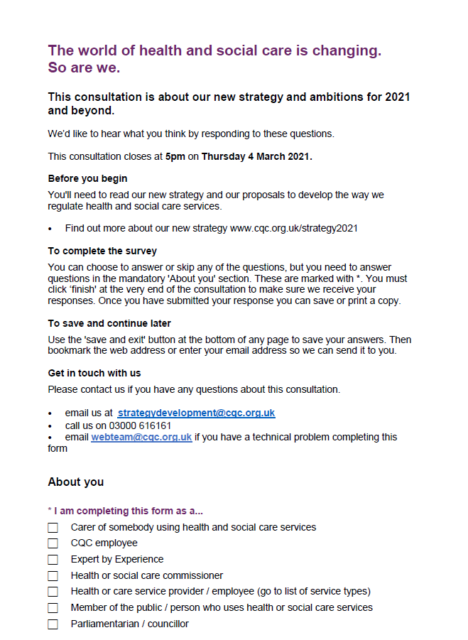A copy of the online response form.

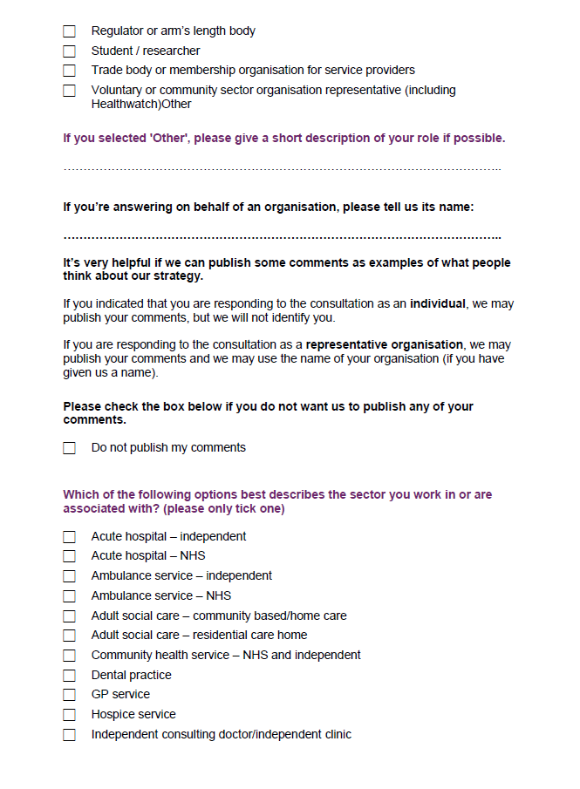
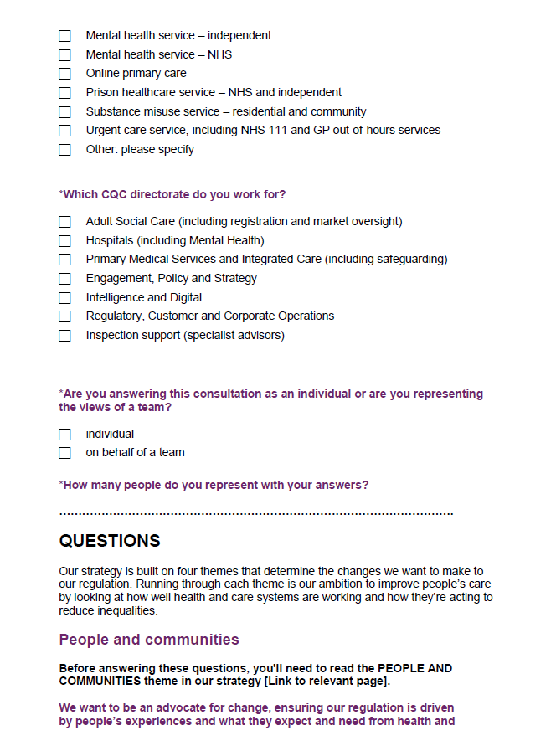

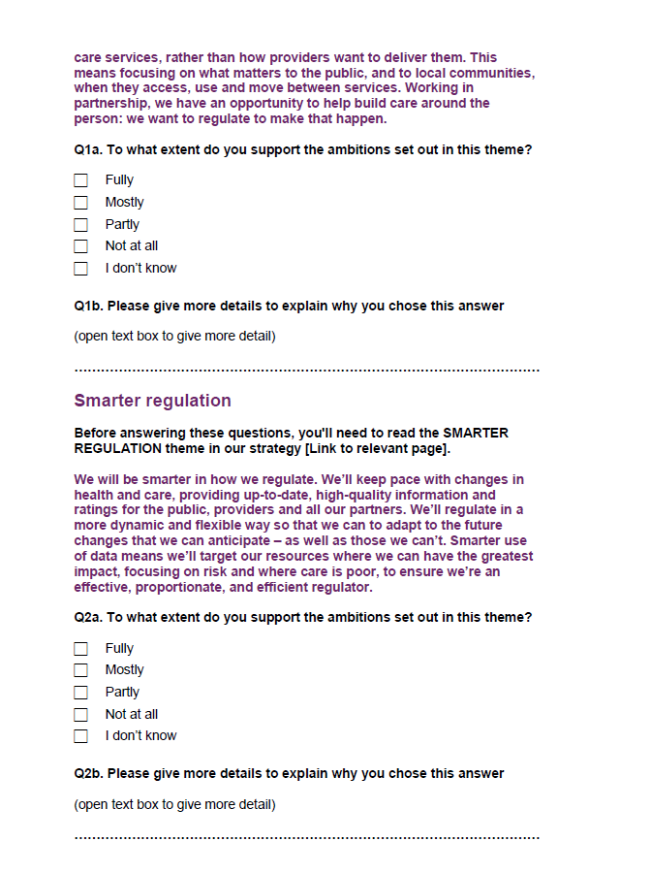
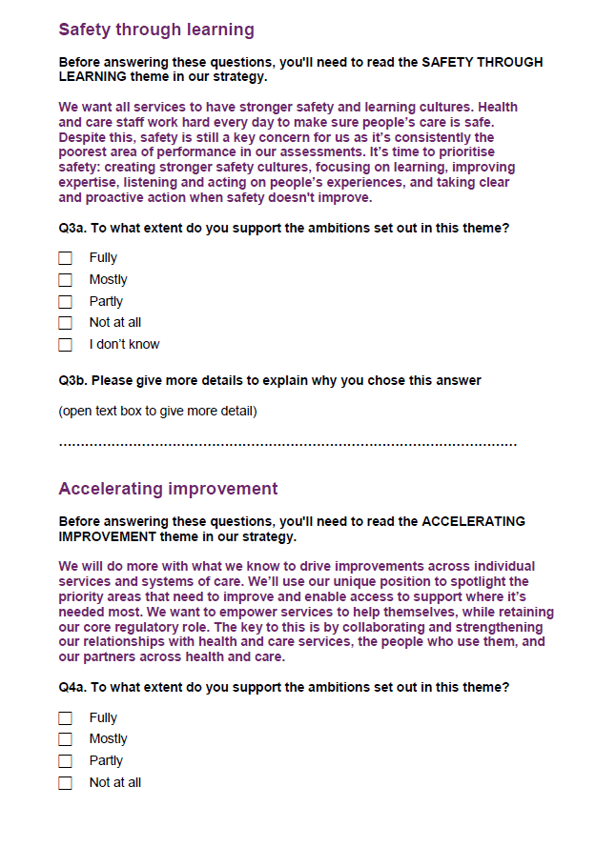

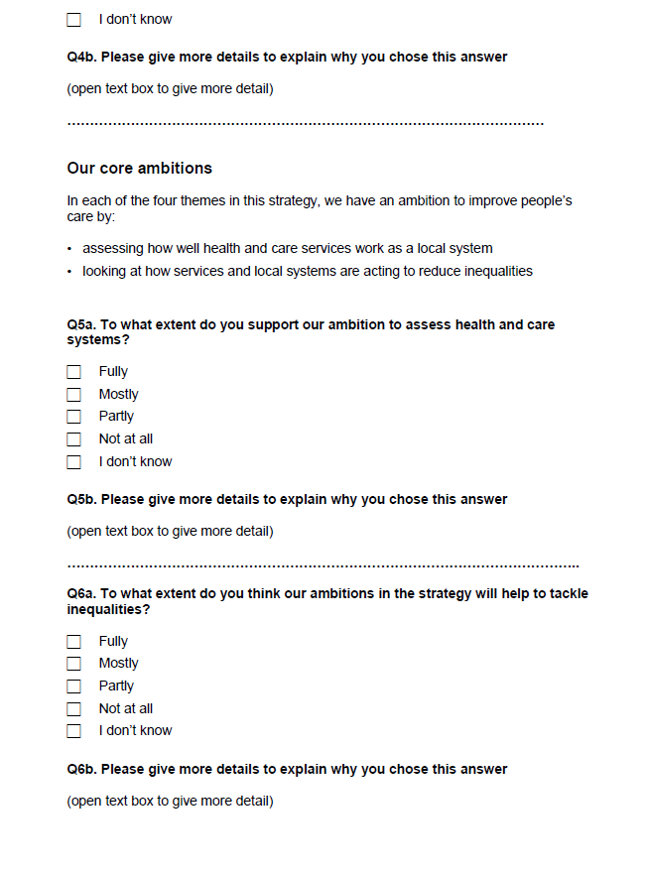

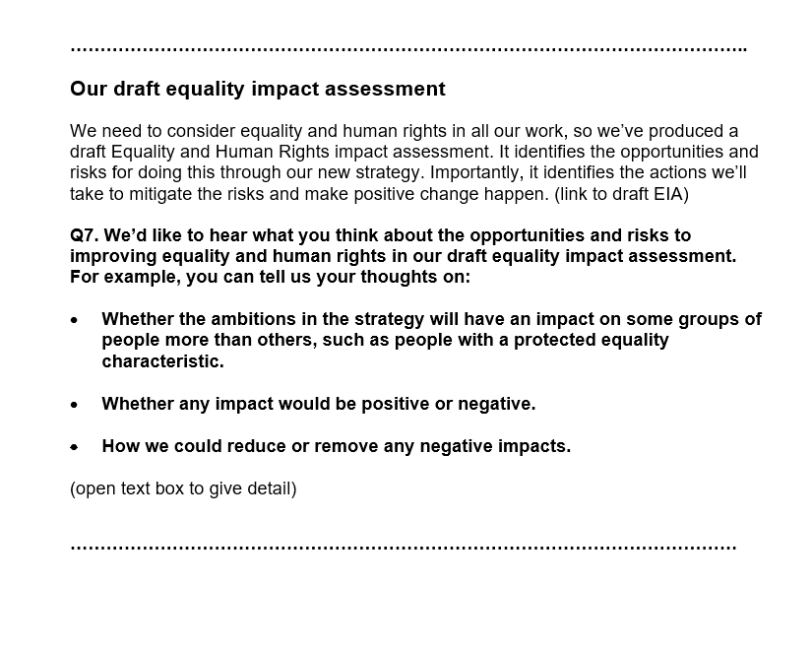

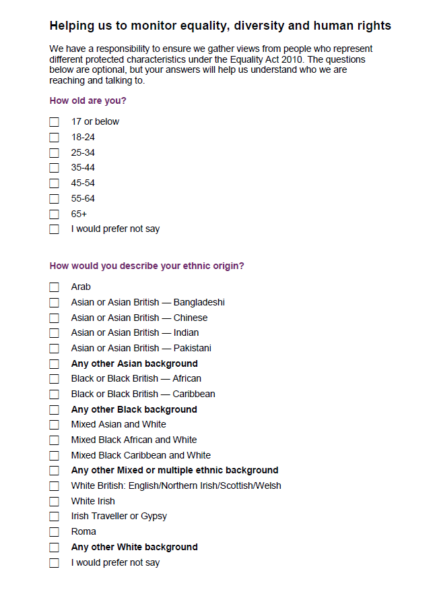

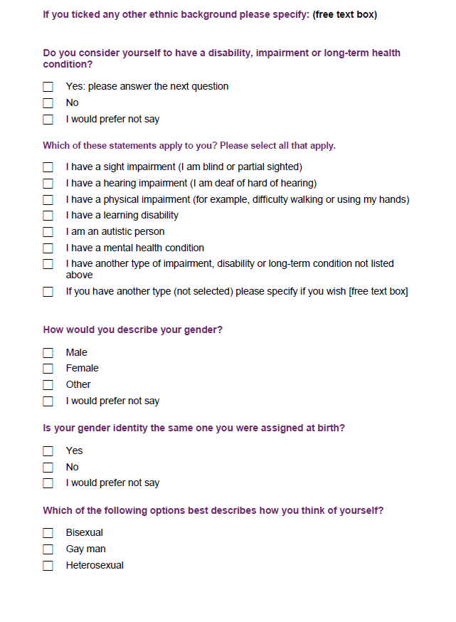

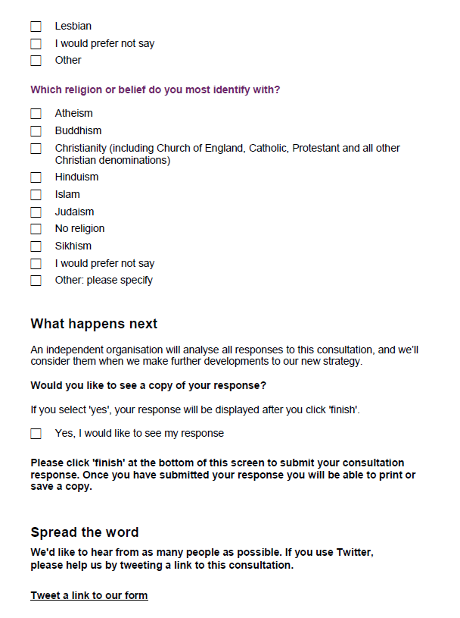

If you would like a large text version of this document, please contact us.
Not for disclosure to third parties – The Freedom of Information Act 2000.
This document contains commercially sensitive and confidential information.
The contents of this document should not be copied, reproduced or disclosed to any third party without prior written permission from a Director at Traverse.
0207 239 7800
2 Angel Square, London, EC1V 1NY
info@traverse.ltd
www.traverse.ltd

