Appendix B: Data appendix

Public survey
With the support of voluntary sector partners, we ran several public surveys to ask people who use services and their relatives or carers about their experiences of DNACPR decisions during the pandemic. In total, 613 responses were collected: 69 from individuals with a DNACPR decision and 544 from relatives or carers of individuals with a DNACPR decision. Individuals with a DNACPR decision were asked about their own experiences during the process. Relatives or carers were asked to answer about their loved ones’ experiences, on behalf of their relative or friend, as well as questions about their own experiences.
It is recognised that the data collected is not representative of all the experiences of people across the country. However, it does allow us to capture the lived experiences of those who have had a DNACPR decision, and their relatives or carers.

Figure 3: Breakdown of protected characteristics of the 613 individuals with a DNACPR decision identified from our public survey
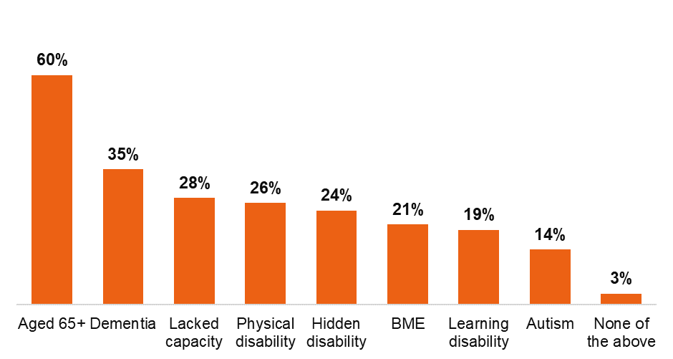
The chart above shows the breakdown of protected characteristics of the 613 individuals with a DNACPR decision that responded to our survey (either directly or via relatives or carers responding on their behalf). Figures add up to more than 100% as individuals may have reported more than one protected characteristic.

Figure 4: Breakdown of how DNACPR decisions were applied
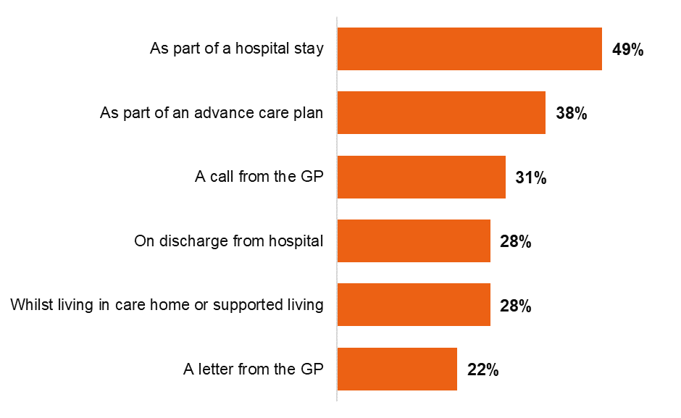
298 out of the 613 DNACPR decisions were applied as part of a hospital stay (49%) and 234 had been part of advance care planning (38%). Figures add up to more than 100% as DNACPR decisions may have been applied by more than one of the options on the chart.

Figure 5: The percentage of individuals with a DNACPR decision and relatives or carers that were aware that a DNACPR decision had been applied
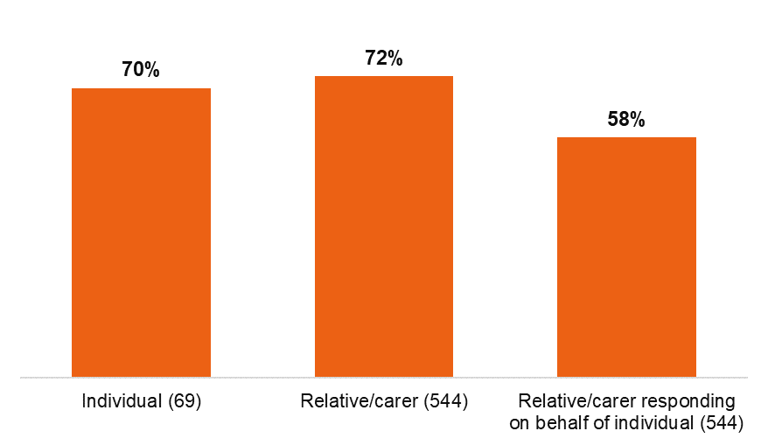
70% of individuals with a DNACPR decision and 72% of relatives or carers of individuals with a DNACPR decision reported that they were aware of the decision at the time that the DNACPR had been applied. Where a relative or carer had responded to the question on behalf of an individual with a DNACPR decision, only 58% stated that the individual had been aware of the decision.

Figure 6: The percentage of individuals with a DNACPR decision who felt best interests and capacity were considered
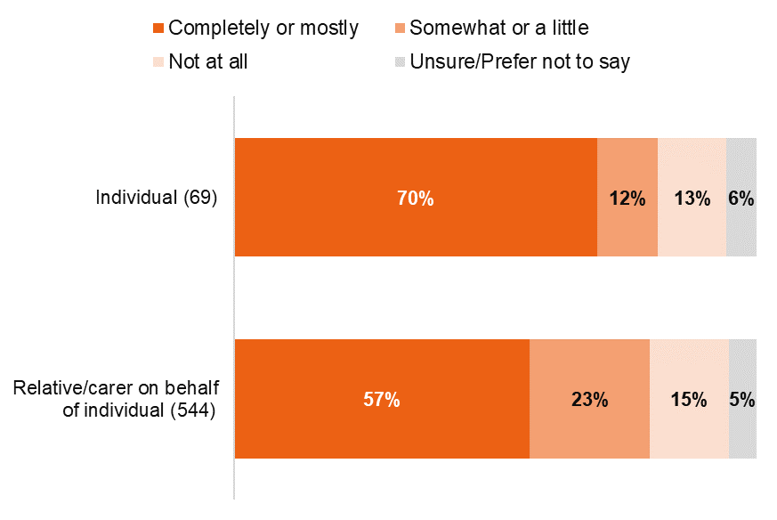
70% of individuals with a DNACPR decision reported that their best interests and capacity to consent were completely or mostly considered. Where a relative or carer has responded for the individual this figure is lower, 57%.

Figure 7: The percentage of individuals with a DNACPR decision who felt supported to participate in a conversation about their decision
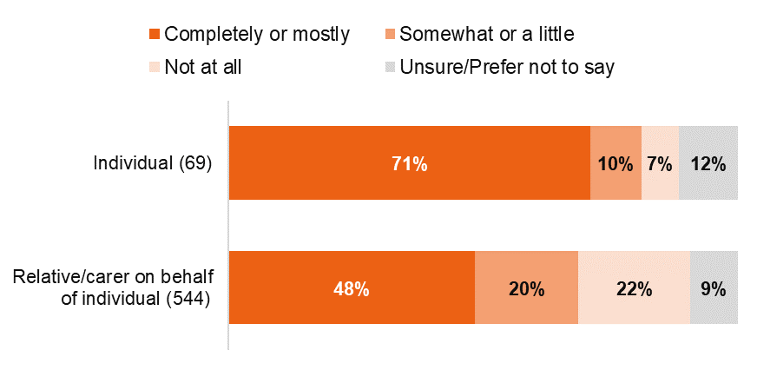
Figure 8: The percentage of individuals with a DNACPR decision and relatives or carers who felt listened to and able to speak up
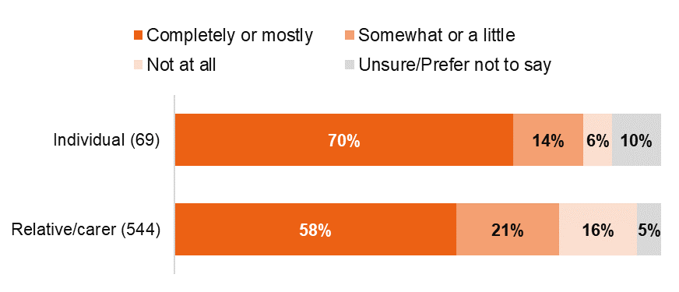
High proportions of individuals with a DNACPR stated that they were supported to participate in a conversation about the decision (71%) and felt completely or mostly listened to and able to speak up (70%). Responses were less positive from relatives or carers with just under half (48%) stating that their relative/friend with a DNACPR was completely or mostly supported to participate in a conversation about the decision and 58% stating that they felt completely or mostly listened to and able to speak up themselves.

Figure 9: The percentage of individuals with a DNACPR decision and relatives or carers who were involved in a conversation about medical treatment once their, or their loved one’s, DNACPR decision had been applied
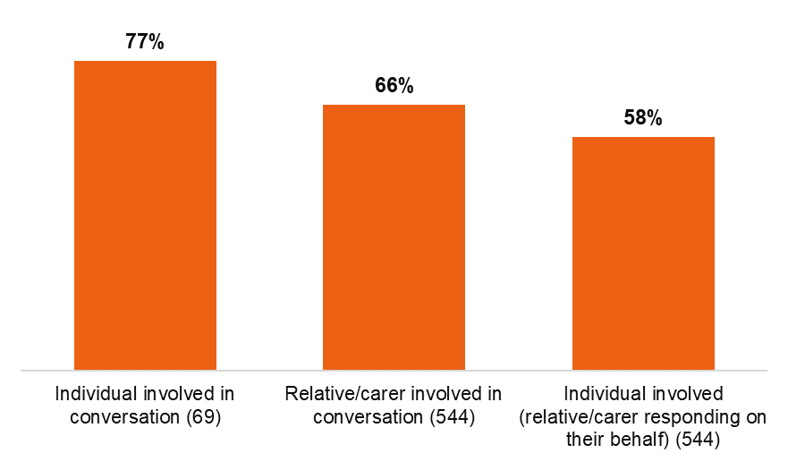
While individuals with DNACPRs responding on their own behalf reported fairly high involvement in conversations about medical treatment after the DNACPR was applied (77%), relatives or carers reported less involvement for themselves (66%) and less involvement of their loved one who they were responding on behalf of (58%).

Figure 10: The percentage of individuals with a DNACPR decision who felt that the decision caused delays or prevented other medical treatment
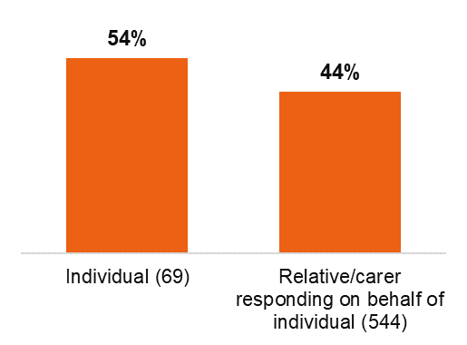
54% of individuals with a DNACPR decision and 44% of relatives or carers responding on behalf of an individual with a DNACPR stated that the decision had caused delays or prevented other medical treatment.

Figure 11: The percentage of individuals with a DNACPR decision who received enough information about the decision
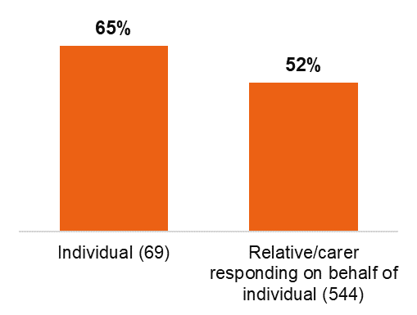
Only 65% of individuals with a DNACPR decision and 52% of relatives or carers answering on behalf of individuals stated that enough information about the DNACPR decision was provided.

Figure 12: The percentage of individuals with a DNACPR decision and relatives or carers who were aware of who to contact in case they had any concerns surrounding the DNACPR decision process
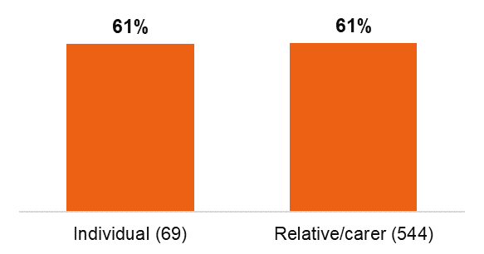
61% of individuals with a DNACPR and 61% of relatives or carers knew who to contact with concerns around the DNACPR decision and process.

Figure 13: The percentage of individuals with a DNACPR decision that felt that they had experienced unfair or discriminatory treatment
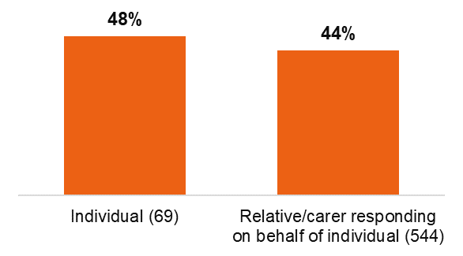

Figure 14: The impact of DNACPR decisions on trust and confidence in the health and care system for individuals with a DNACPR decision and relatives or carers
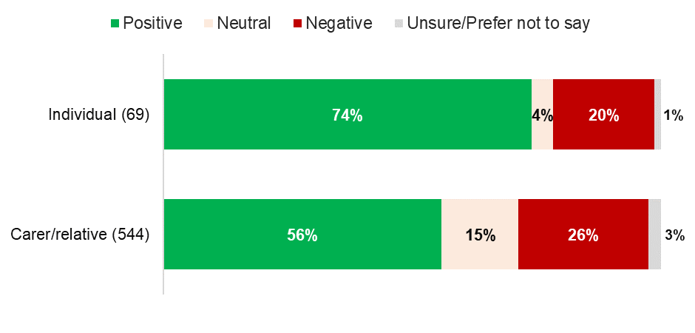
Unfair or discriminatory treatment was reported by both individuals with DNACPR decision and by relatives or carers responding on behalf of individuals. The DNACPR process appears to have had more of a negative impact on relatives or carers than the individuals with decisions in place.

Figure 15: Survey responses from individuals with a DNACPR decision – breakdown by the individual’s protected characteristics
 | Protected characteristics of individual with DNACPR applied
 | Aged 65+ | Dementia | Lacked capacity | Physical disability | Hidden disability or disabling health issue | Black or minority ethnic group | Learning disability | Autism | None of the above
Number of respondents | 41 | 23 | 21 | 22 | 28 | 22 | 21 | 18 | 4
I was aware that the DNACPR decision had been applied | 80% | 61% | 76% | 73% | 75% | 55% | 67% | 89% | 75%
My best interests and capacity to consent were completely/mostly considered | 76% | 78% | 81% | 82% | 68% | 86% | 76% | 94% | 50%
I was completely/mostly supported to participate in a conversation about DNACPR | 73% | 78% | 81% | 73% | 71% | 91% | 76% | 94% | 75%
I felt completely/mostly listened to | 73% | 78% | 76% | 68% | 68% | 82% | 71% | 94% | 75%
I was involved in conversation about my medical treatment after DNACPR had been applied | 83% | 78% | 100% | 95% | 71% | 86% | 86% | 100% | 75%
I was provided with sufficient information about my DNACPR | 73% | 65% | 81% | 82% | 71% | 64% | 62% | 94% | 50%
I knew who to contact if I had any concerns about the DNACPR | 66% | 48% | 71% | 64% | 61% | 64% | 67% | 94% | 50%
DNACPR decision has had a positive impact on my trust and confidence in health and care system | 71% | 78% | 90% | 73% | 71% | 95% | 81% | 94% | 50%
My DNACPR has not caused delays or prevented other medical treatment | 46% | 30% | 19% | 45% | 54% | 18% | 19% | 6% | 75%
I have experienced fair treatment during the DNACPR process | 49% | 39% | 29% | 50% | 54% | 41% | 38% | 11% | 75%

Figure 16: Survey responses from relatives or carers responding on behalf of individuals with a DNACPR decision –breakdown by the individual’s protected characteristics
 | Protected characteristics of individual with DNACPR applied
 | Aged 65+ | Dementia | Lacked capacity | Physical disability | Hidden disability or disabling health issue | Black or minority ethnic group | Learning disability | Autism | None of the above
Number of respondents | 325 | 193 | 149 | 140 | 122 | 106 | 98 | 70 | 14
My relative/friend was aware that DNACPR had been applied | 55% | 52% | 51% | 56% | 59% | 71% | 76% | 80% | 57%
I was aware that the DNACPR had been applied | 74% | 77% | 80% | 72% | 71% | 81% | 86% | 83% | 57%
My relative/friends best interests and capacity to consent were completely/mostly considered | 58% | 62% | 63% | 59% | 55% | 61% | 70% | 81% | 50%
My relative/friend was completely/mostly supported to participate in a conversation about DNACPR | 44% | 50% | 44% | 53% | 52% | 59% | 65% | 77% | 57%
I felt completely/mostly listened to | 58% | 62% | 64% | 58% | 51% | 64% | 72% | 76% | 57%
My relative/friend was involved in conversation about their medical treatment after DNACPR had been applied | 56% | 53% | 50% | 56% | 57% | 72% | 74% | 80% | 57%
I was involved in conversation about my relative/friend's medical treatment after DNACPR had been applied | 64% | 76% | 76% | 70% | 60% | 71% | 79% | 86% | 57%
My relative/friend was provided with sufficient information | 48% | 55% | 53% | 53% | 50% | 70% | 70% | 79% | 50%
I knew who to contact if I had any concerns about my relative/friend's DNACPR | 56% | 65% | 65% | 62% | 61% | 71% | 79% | 87% | 57%
My relative/friend's DNACPR has had a positive impact on my trust and confidence in health and care system | 49% | 60% | 57% | 58% | 55% | 74% | 79% | 90% | 50%
My relative/friend's DNACPR has not caused delays or prevented other medical treatment | 62% | 58% | 45% | 53% | 56% | 28% | 30% | 29% | 79%
My relative/friend has experienced fair treatment during DNACPR process | 60% | 59% | 46% | 53% | 52% | 35% | 29% | 27% | 64%

The tables above provide the survey results broken down by protected characteristics of the individual with a DNACPR (that is, in figure 16 it is not the protected characteristics of the relative or carer). Please note that the total number of respondents in figures 15 and 16 is more than 69 and 544 respectively, as individuals with a DNACPR decision could have more than one protected characteristic.

Adult social care provider information request
We sent a voluntary information request to around 25,000 adult social care providers (including care homes, nursing homes, domiciliary care agencies, supported living schemes, Shared Lives and extra care housing). While responsibility for making DNACPR decisions does not predominantly rest with adult social care providers, we asked them a range of questions to understand their views of the experiences of people in these settings. We asked about the number of inappropriate DNACPR decisions put in place since 17 March 2020, what made them inappropriate and if they remained on people’s records at the point of submission of the information request.
In total, 2,171 responses were submitted between 7 December to 21 December 2020. However, a number of data quality issues were identified in the responses, which were likely a result of services incorrectly interpreting the questions. These issues meant the data was cleaned and analysis was only undertaken on 2,048 responses.
The relatively low response rate affects our confidence in the findings and means the results may not be generalisable. However, it is important to record and share the experiences of people working in services.
We wanted to understand how many DNACPRs were in place on 16 March 2020 compared to the number that had been applied since 17 March 2020.

Figure 17: People with a DNACPR decision in place, in the adult social care settings that responded to our information request (7 to 21 December 2020)
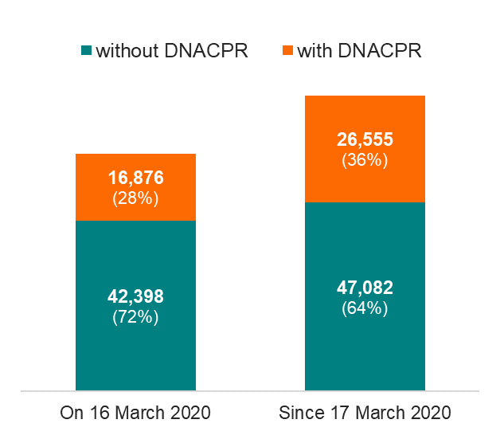
Of the sample that responded to our information request, the percentage of people in adult social care settings with a DNACPR decision increased from 28% on 16 March 2020 to 36% since 17 March 2020 (until the time the information request was submitted 07-21 December 2020).
Figure 18: The number of inappropriate DNACPR decisions reported by adult social care locations that responded to our information request
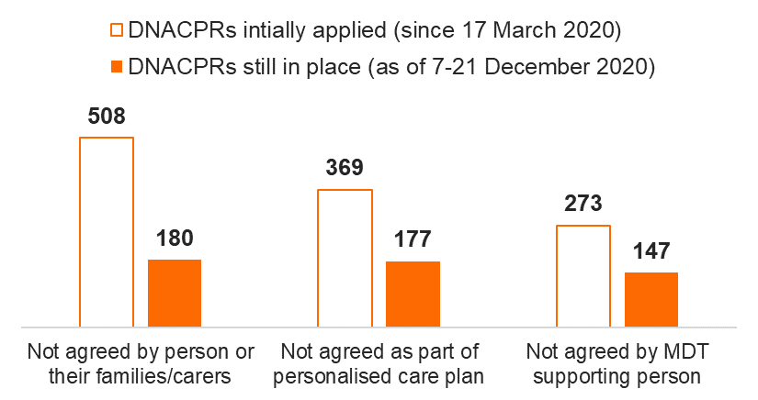

Of the people who had a DNACPR since 17 March 2020, some had not been agreed with the person or their relatives or carers (where the individual lacks capacity), as part of a personalised care plan, or with the multidisciplinary team supporting the person. A number of these still remained on people’s care plans when this survey was completed in December 2020.
119 of the 2,048 (6%) adult social care services that responded to our information request felt that the people their service provided care for were subject to blanket DNACPR decisions, at any time since 17 March 2020. Please note that 624 services responded ‘N/A’ to this question, including 148 that stated that they had at least one person in their service with a DNACPR within the time periods included in the information request.

Review of DNACPR forms
During the fieldwork we reviewed the DNACPR records of 166 people who have been affected during the pandemic. These did not consider every example of DNACPR decision since the pandemic, but allowed us to consider a larger number of decisions. We accessed care records through a range of care settings (acute, mental health hospitals, care homes and GP services).

Figure 19: Breakdown of how the DNACPR decisions that were reviewed were applied
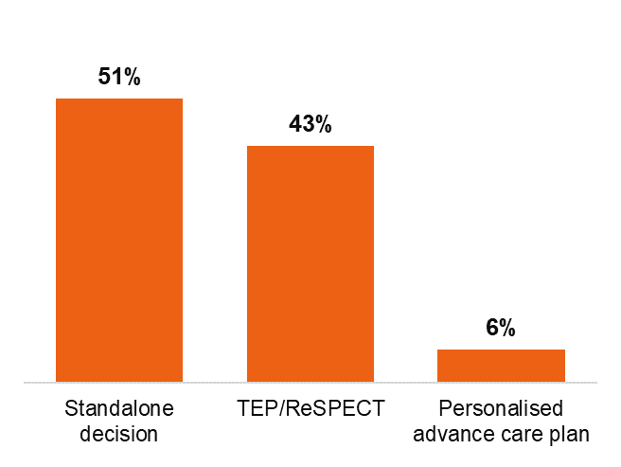
Just over half (51%) of the reviewed DNACPRs were put in place as part of standalone decisions. DNACPRs in place as part of treatment escalation plan (TEP) or ReSPECT plans were the next most common (43%), whereas personalised advance care plan DNACPRs accounted for only 6% of reviewed forms.

Figure 20: Findings from the review of DNACPR forms across all forms and inspection settings
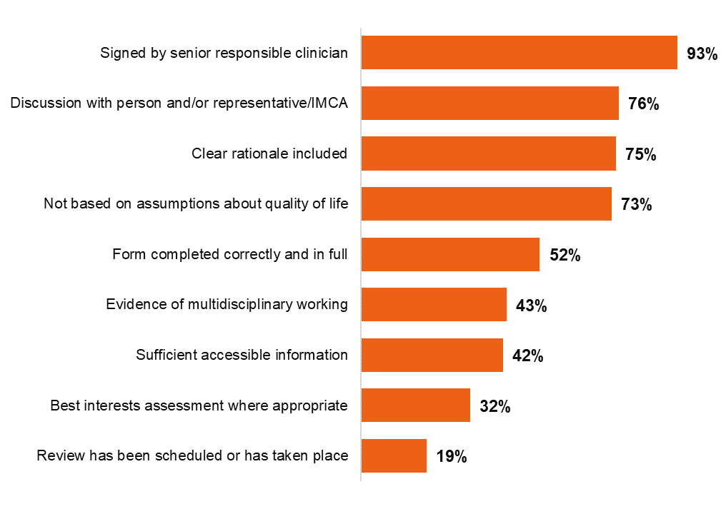
Findings varied considerably across the DNACPR form review questions. 93% of DNACPR forms (154 out of 166) had been signed by a senior responsible clinician, whereas only 19% (32 out of 166) included evidence of a review being scheduled or having had taken place.
Percentages based on 166 DNACPRs, except for sufficient accessible information for decision making (156) and best interests assessment where appropriate (103).

