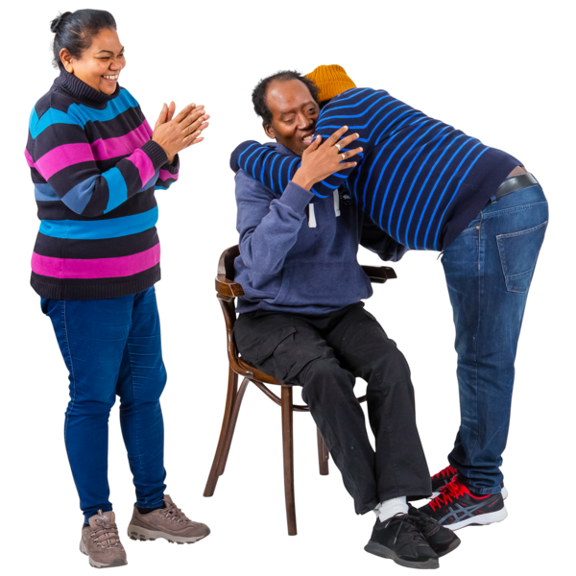
Our guidance for care homes, hospitals and hospices on helping people have visitors
Please tell us what you think
January 2024
 | Easy read version of ‘Draft guidance for providers on how to meet Regulation 9A: visiting and accompanying in care homes, hospitals and hospices: Consultation
 |  |  |  | About this booklet
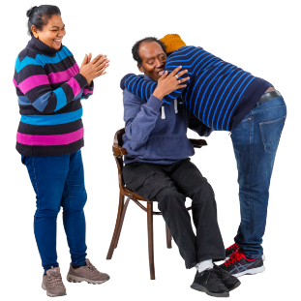 |  |  | Visiting people in health and care services (like hospitals and care homes) is very important to their health and happiness.
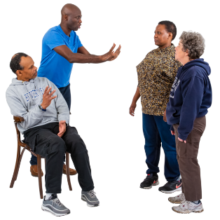 |  |  | There have been some problems with people not being able to see visitors in health and care services or having to go to appointments alone.
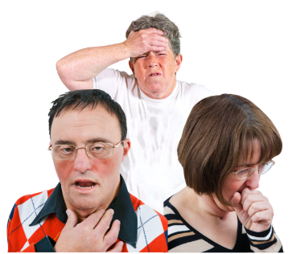 |  |  | This happened a lot when people were getting sick with coronavirus.
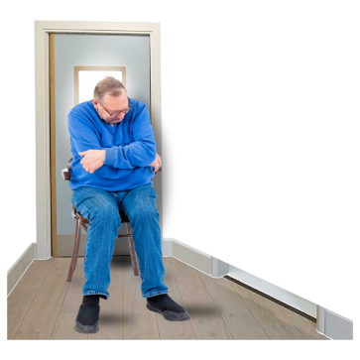 |  | It was done to stop more people getting sick, but it had a bad effect on lots of people’s health and happiness.
 |  | After this, the government made some new rules about visiting in care homes, hospitals and hospices and asked people what they thought of them.
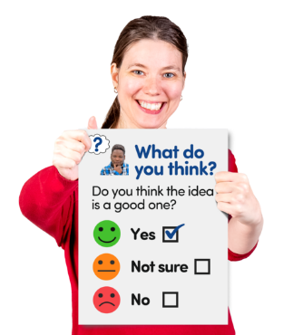 |  | 1,400 people gave their views and most of them thought the new rules were a good idea.
 |  | From April 2024, we will start to check that care homes, hospitals and hospices follow these rules.
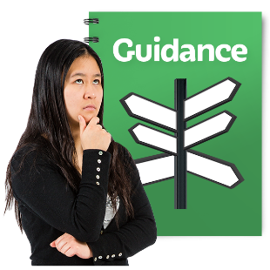 |  | To help them follow these rules, we have written guidance for care homes, hospitals and hospices.
 |  | You, or someone who supports you, can type into this document, or you can print it off and write on it.
Email us your document file, or scan or photo of your written answers by 20 February 2024 to:
visitingconsultationenquiries@cqc.org.uk

 | Questions about you
(Put a cross in the box next to which answer describes you best)

Are you:
 | ☐ a member of the public or someone who uses health and care services, like a hospital or care home
 | ☐ someone who works in health and care services
 | If you would like to describe yourself in a different way, please tell us in the space below.
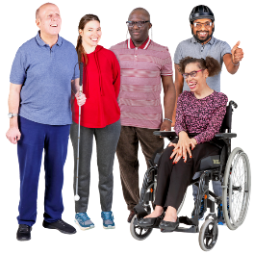 | Do you have a disability or long-term health condition or illness?
 | ☐ Yes
 | ☐ No
 | ☐ I do not want to say
 | If you said yes to the last question, please tell us about your disability or long-term health condition or illness in the space below?
 | Questions about our guidance
 | Receiving visits
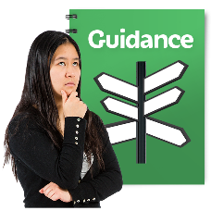 | Our guidance says that care homes, hospitals and hospices:
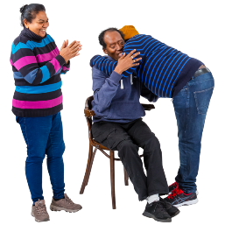 | - must support people who use their service to receive visits in person from people they want to see
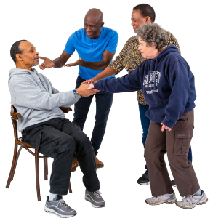 | - must do all they can to make this easy.
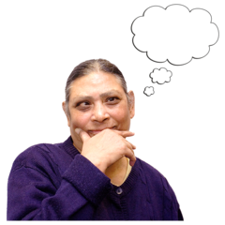 |  | Question 1: Do you agree that our guidance clearly says that care homes, hospitals and hospices must help people using their services to receive visits from people they want to see?
 |  | Put a cross in the box next to the answer you want.
 |  | ☐ Strongly disagree
 |  | ☐ Disagree
 |  | ☐ Neither agree or disagree
 |  | ☐ Agree
 |  | ☐ Strongly agree
 |  | If you would like, please tell us why you think this in the space below.
 | Going out on visits
 | Our guidance says that:
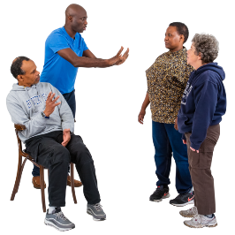 | - care homes must make sure people using their service do not feel they are stopped or put off from going out on visits to see friends or family if they want to
 | - staff must support people who live in a care home to carry on doing different things they enjoy in the places where they live and elsewhere
 | - when they come back, the care home must not make people follow unfair rules, like having to stay on their own for a long time, which might stop them wanting to go out again.
 |  | Question 2: Do you agree that our guidance clearly says that care homes must make sure people using their service do not feel they are stopped or put off from going out on visits if they want to?
 |  | Put a cross in the box next to the answer you want.
 |  | ☐ Strongly disagree
 |  | ☐ Disagree
 |  | ☐ Neither agree or disagree
 |  | ☐ Agree
 |  | ☐ Strongly agree
 |  | If you would like, please tell us why you think this in the space below.
 | Bringing someone with you on appointments
 | Our guidance says that:
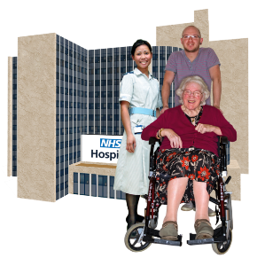 | - hospitals or hospices must let people bring someone with them for day appointments (care or treatment that does not need them to stay in overnight) if they want
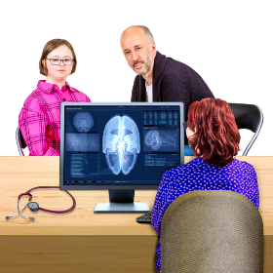 | - this is so people do not have to attend the appointment alone
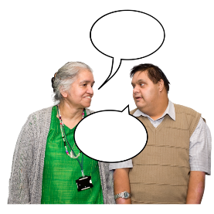 | - it may also help with communication and sharing information if needed.
 |  | Question 3: Do you agree that our guidance clearly says that hospitals or hospices must let people bring someone with them on day appointments if they want?
 |  | Put a cross in the box next to the answer you want.
 |  | ☐ Strongly disagree
 |  | ☐ Disagree
 |  | ☐ Neither agree or disagree
 |  | ☐ Agree
 |  | ☐ Strongly agree
 |  | If you would like, please tell us why you think this in the space below.
 | Receiving visitors and going out in a way you like
 | Our guidance says that:
 | - services must support people to receive visitors, or go out on visits, in a way they like
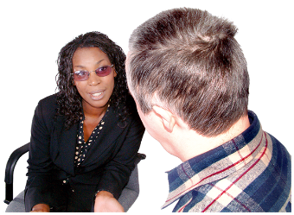 | - if this is not possible, services should talk with the person and their family or friends or other supporters and offer them as many different options as possible.
 |  | Question 4: Do you agree that our guidance clearly says that services must support people to receive visitors or go out on visits in a way they like?
 |  | Put a cross in the box next to the answer you want.
 |  | ☐ Strongly disagree
 |  | ☐ Disagree
 |  | ☐ Neither agree or disagree
 |  | ☐ Agree
 |  | ☐ Strongly agree
 |  | If you would like, please tell us why you think this in the space below.
 | Putting controls on visits
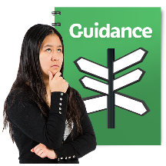 | Our guidance says that:
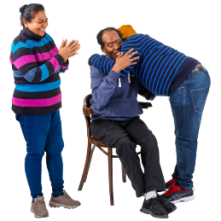 | - services must support people to receive or go on visits, or bring someone with them for appointments if they want
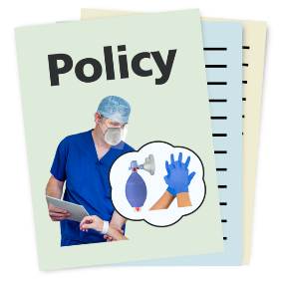 | - if there are any problems, we expect services to make any changes needed to let this happen safely, rather than stopping it
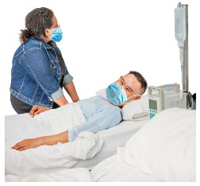 | - for example, this may include asking visitors to wear a face mask if there are lots of people ill
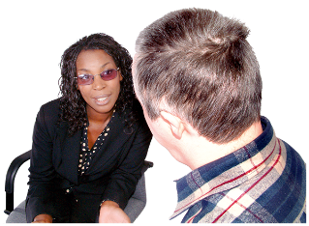 | - these changes should always follow the choices and needs of people using the service
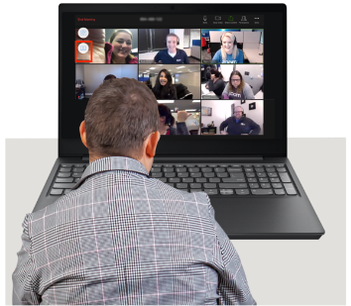 | - services should work together with people using the service and their families and friends, to work out if there is a special situation that means they have to control visiting, going out on visits, or bringing someone on appointments
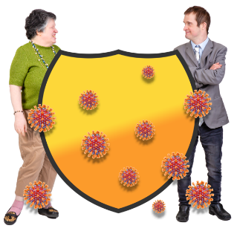 | - these controls could be to protect the people, staff or visitors if there is a danger to their health or safety
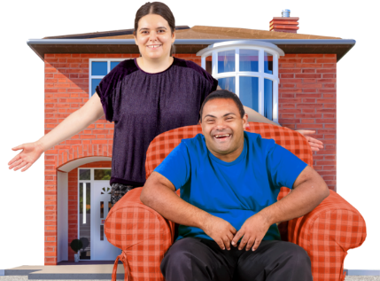 | - these changes or controls should always be the option least likely to get in the way of people's right to see their visitors when and how they want
 | - services should think of ways to support people to see their friends or family if these changes or controls are stopping normal visits, like using video or phone calls, until visits in person can start again
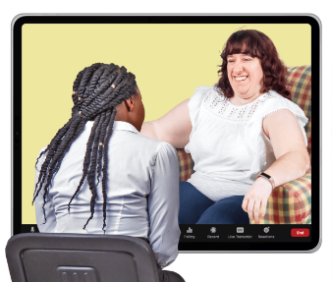 | - services should treat each change or control as a separate case that should be worked out together with the people involved
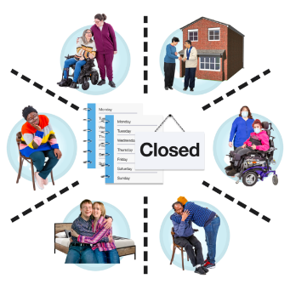 | - we do not expect services to make any changes or controls that happen to everyone (called blanket decisions) or that happen for a long time.
 |  | Question 5: How much do you agree that our guidance clearly says that any changes or controls on people receiving or going on visits, or bringing someone with them for appointments, must be based on people’s health and safety?
 |  | Put a cross in the box next to the answer you want.
 |  | ☐ Strongly disagree
 |  | ☐ Disagree
 |  | ☐ Neither agree or disagree
 |  | ☐ Agree
 |  | ☐ Strongly agree
 |  | If you would like, please tell us why you think this in the space below.
 |  | Other ideas
 |  | Question 6: Do you have any other ideas for improving our guidance?
 |  | If so, please tell us in the space below.

What happens next?
Thank you for giving us your views on our guidance.
We will say what changes we have made, so we can start using the guidance from April 2024.

